Softablitz 2026

Team: Ghost Coders

Team ID
209

Team Info
Member 1: Shivang Verma (2026CA095, MCA, shivangverma0584)
Member 2: Ashutosh Anand (2026CA023, MCA, ashutosh_anand_6634)
Member 3: Chhavi Jain (2026CA030, MCA, chhavijain0907)

Description of the problem
Sharing files between nearby devices usually means uploading them to a cloud service, using a chat app, or carrying a drive. These routes are slow for large files, depend on the internet, and hand data to a third party. Existing direct methods rarely tell the receiver clearly what is arriving, and they do not prove the file arrived unchanged.
The Sling Ring lets devices on the same local network send files directly to each other, with no central server. Nothing is transferred unless the receiver explicitly agrees, both sides watch the transfer in real time, and every received file is checked against a SHA-256 checksum, so the user knows whether it arrived intact or corrupted.

App name: SlingRing

Process flow of the app
- Launch. The app starts a local server that listens for transfer requests and opens its JavaFX window.
- Announce and discover. Each device announces itself on the local network using mDNS. Nearby devices appear in a live list that updates as devices join or leave. If discovery is blocked, the user can enter an IP address manually.
- Select and target. The sender chooses a file (file picker or drag and drop) and selects a nearby device.
- Hash. The sender computes the file's SHA-256 checksum.
- Request. The sender sends a transfer request with the sender's name, file name, size, and checksum. No file data is sent yet.
- Accept or refuse. The receiver sees the request, then accepts (and picks a save folder) or refuses. The sender is notified immediately.
- Transfer. On acceptance, the file is streamed directly to the receiver. Both sides see a progress bar with speed and time remaining, and either side can cancel.
- Verify. The receiver hashes the saved file and compares it with the sender's checksum. Both sides see "intact" or "corrupted".
- Record. The outcome is saved to a local transfer history file.

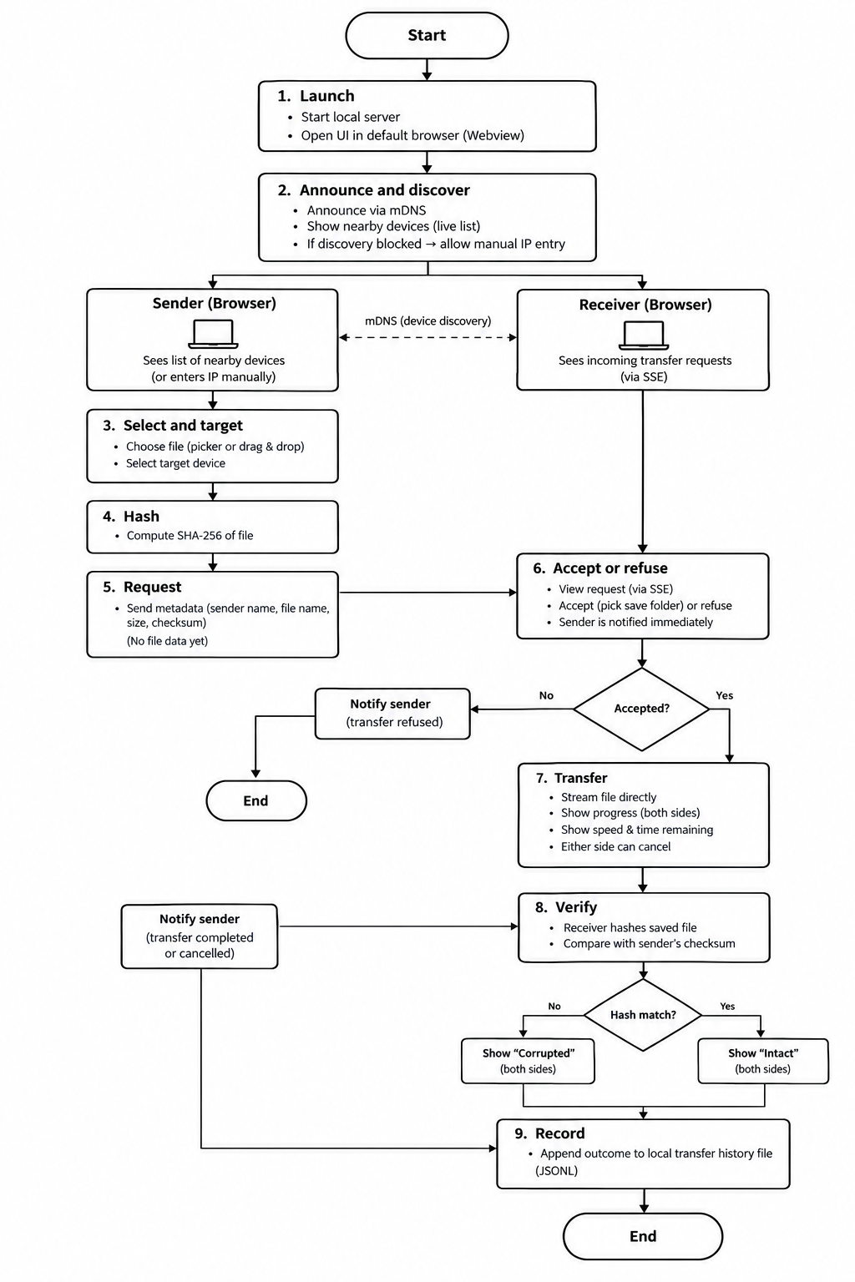

Features announcement

Core features
- Automatic discovery of nearby devices, shown in a live list, with a manual IP fallback
- File selection and drag-and-drop sending directly to a chosen device
- Receiver consent: view sender name, file name, and size, then accept or refuse and choose where to save
- Real-time transfer progress with speed and estimated time remaining, and cancel from either side
- Automatic SHA-256 integrity verification with a clear intact or corrupted result
- Native JavaFX desktop interface, with only the transfer endpoints reachable by other devices

External libraries/APIs
Library | License | Maintained by | Alternatives considered | Why we chose it
JavaFX (controls, fxml) | GPL v2 + CPE | OpenJFX project (open source, Gluon-led) | Swing, SWT, browser UI on Spring Boot | Native desktop UI with FXML views and controllers. ObservableList and property binding keep the device list and progress bars in sync. FileChooser, DirectoryChooser and drag and drop return real file paths, so files are read in place with no upload or staging copy. No web framework or browser is needed.
JmDNS | Apache 2.0 | Community (open source) | Raw UDP broadcast, SSDP/UPnP libraries, Bonjour SDK | Pure Java implementation of mDNS/DNS-SD, with no native install. It is the standard approach for LAN service discovery and works across Windows, macOS, and Linux. Less actively developed than larger libraries, which we offset by keeping the manual IP entry for networks that block mDNS.
Jackson | Apache 2.0 | FasterXML (company-backed) | Gson | Used for the transfer metadata and the history file. It handles Java records cleanly, and timestamps are stored as ISO strings, so no extra date module or dependency is needed.
Java HttpClient (JDK 11+) | OpenJDK license | OpenJDK | Apache HttpClient, OkHttp | Built in, supports streaming request bodies and timeouts, and adds no dependency to maintain.
MessageDigest (JDK) | OpenJDK license | OpenJDK | Guava, Commons Codec | SHA-256 is part of the standard library, so no extra library is needed.
JDK HttpServer (JDK) | OpenJDK license | OpenJDK | Spring Boot (Tomcat), Javalin, Quarkus | Built in, supports streaming request and response bodies, and needs no dependency. It serves only the four /peer/** endpoints, because the UI is not served over HTTP. Runs one lightweight virtual thread per request, so a held-open consent request never blocks others.
JUnit 5 | EPL 2.0 | JUnit team | TestNG | The standard Java test framework, with first-class Maven Surefire support. Used for checksum, file name sanitizing and progress tests.

Core Engineering Architecture

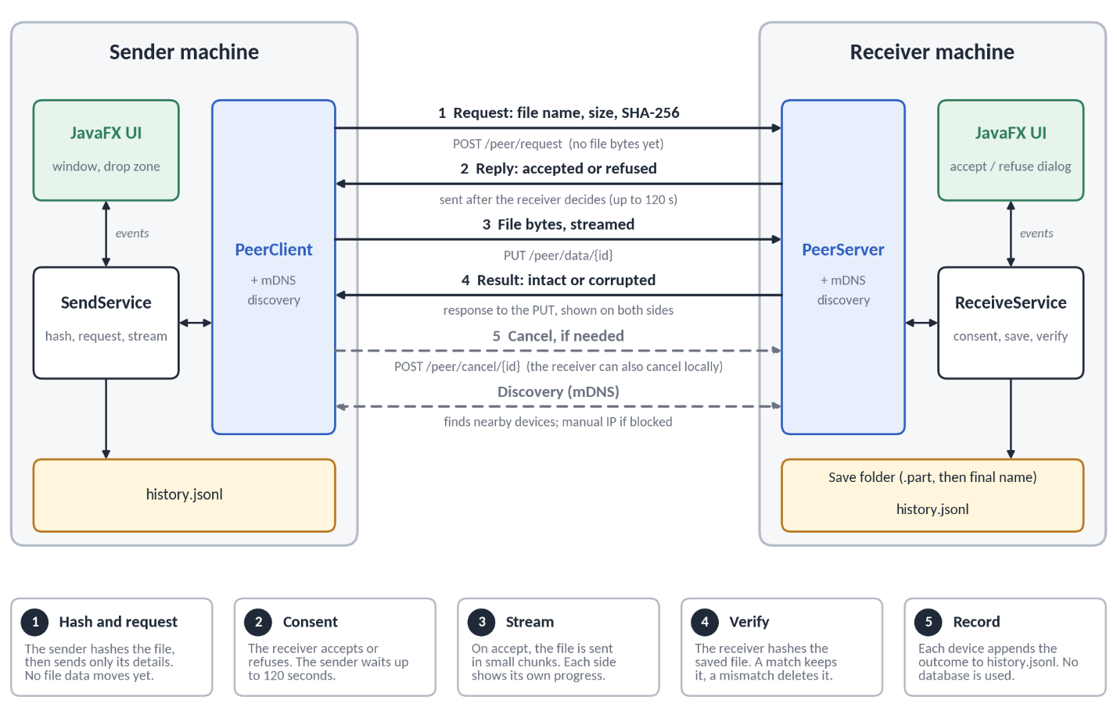

Concern | The naive way | Why it fails | Our way | Why it wins
Sending | Read the whole file into memory and push it at once | Out-of-memory errors on large files, and data moves before anyone agrees | Metadata handshake, then consent, then streamed bytes | Constant memory, and nothing crosses without the receiver’s agreement
Integrity | Assume TCP delivered the file correctly | Cannot detect disk errors or truncation at the application level | SHA-256 computed by the sender and verified on the receiver | Any difference is caught and reported as corrupted. This detects accidental damage, not a deliberate attacker
Saving | Write directly into the destination folder | A cancelled or failed transfer leaves a broken file that looks real | Write to a temporary .part file in the save folder, then rename it into place only after the hash matches | Files appear under their real names only after verification, and a failed transfer leaves nothing behind
Cancel | Close the window or kill the thread | Leaves open sockets and half-written files | A cancel flag checked inside the copy loop, with cleanup in a finally block | Clean abort with no leaks
Live updates | UI polls the backend every second | Needless load and visible lag | In-process EventBus pushing to the JavaFX thread | Instant updates with no polling and no network round trip
Discovery | Hardcode IP addresses | Breaks when networks change and does not scale | mDNS with a manual fallback | Works automatically, and degrades gracefully when blocked
Network exposure | Every endpoint open to the LAN | Anyone on the network could drive the UI or send requests to it | Only the /peer/** endpoints are served over the network; the UI is a native JavaFX window, not a web page | Small attack surface, and no local web page for other sites to attack

Class diagram

Class | Role
DiscoveryService | Announces this device and detects others on the local network (mDNS)
PeerRegistry | Keeps the live list of nearby devices
Peer | A discovered device (id, name, address)
SendService | Computes the checksum, requests permission, and streams the file
ReceiveService | Holds incoming requests for accept or refuse, saves the file to a temporary file, verifies it, and moves it into place
PeerClient | Sends requests and file data to another device over HTTP
TransferSession | State of one transfer on one device
ProgressTracker | Tracks bytes, speed, and time remaining, and handles cancel
ChecksumUtil | SHA-256 for integrity verification
TransferSessionRegistry | Owns all sessions, and records outcomes and notifies the UI
HistoryStore | Appends each finished transfer to the history file (JSONL)
EventBus | Streams live events (devices, requests, progress) to the user interface
App | JavaFX entry point: creates and connects all services, starts the server and discovery, and opens the main window
PeerServer | Serves the four /peer/** endpoints (info, request, data, cancel) that other devices can reach
TransferRequest | The handshake sent before any file data: sender name, file name, size, and checksum, validated on arrival
TransferState | Lifecycle of a transfer, from hashing and waiting to intact, corrupted, refused, cancelled, or failed
Decision | The receiver's answer to a request: accepted, refused, or timed out
FileNames | Sanitizes untrusted file names and picks a destination that never overwrites an existing file
MainController | Main window: device list, drop zone, and live transfer list
RequestDialogController | Shows an incoming request and lets the user accept (with a save folder) or refuse
ManualIpDialogController | Manual IP entry when discovery is blocked

