Project Report

(INT217: INTRODUCTION TO DATA MANAGEMAENT)



**Title: Bank Loan Calculator**

**Submitted By:**

**Name : Ashu Kumari**

**Reg.No : 12316634**

**Section: K23ED**

**Roll No. : 58**

**Date of Submission:** 10-April-2025

**Submitted to:** Dr. Parampreet Kaur (UID:18758)

1. ***INTRODUCTION :***

A Bank Loan Calculator is a computer application that aims to assist individuals and institutions to approximate loan repayments against certain inputs like loan value, rate of interest, and loan period. It makes the lengthy and complicated task of computing monthly installments (EMIs), interest paid, and aggregate repayment at the end of the term of the loan easier. This is particularly valuable for clients interested in personal, home, auto, or educational loans since it offers immediate access to financial obligations and facilitates effective borrowing choices. It also helps banks and financial planners provide clean and transparent lending opportunities to their clients. Automating the calculation and giving real-time results, a bank loan calculator improves personal financial planning and eliminates errors, lowering the chance of human mistake.

1. ***OBJECTIVE:***

The primary objective of the Bank Loan Calculator is to provide a user-friendly, efficient, and accurate tool for calculating loan-related financial parameters. The key goals include:

* Simplify Loan Calculation: Automatically compute monthly payments (EMIs), interest, and total repayment.
* Facilitate Financial Decision-Making: Assist borrowers in making decisions through knowledge of loan charges and payment terms.
* Provide Transparency: Give transparent and precise loan calculations for improved comparison of loan schemes.
* Save Time and Effort: Generate instant, automated calculations to simplify the loan application process.
* Support Multiple Types of Loans: Support various types of loans (personal, housing, auto, education) with user-defined parameters.

1. ***Key Performance Indicators(KPIs):***

Here’s a list of Key Performance Indicators (KPIs) for a Bank Loan Calculator project:

1. How many loan applications were received during a specific period?

Count all applications submitted within the selected timeframe. Use Month-to-Date (MTD) totals and compare with previous months (MoM) to track trends.

1. **What is the total amount of funds disbursed as loans?**

Sum all loan amounts disbursed. Monitor MTD disbursements and analyze Month-over-Month (MoM) changes for growth insights.

1. **How much total amount has been received from borrowers?**

Add up all repayments (principal + interest) received. Track MTD totals and compare MoM to assess cash flow and repayment behavior.

1. **What is the average interest rate across all loans?**

Calculate the mean of all loan interest rates. Monitor MTD averages and MoM changes to evaluate lending trends.

1. **What is the average Debt-to-Income (DTI) ratio of borrowers?**

Average the DTI ratios (monthly debt ÷ income) of all borrowers. Use MTD and MoM comparisons to assess borrower financial health.

**Good Loan v Bad Loan KPI’s :**

In order to evaluate the performance of our lending activities and assess the quality of our loan portfolio, we need to create a comprehensive report that distinguishes between 'Good Loans' and 'Bad Loans' based on specific loan status criteria

1. **What is the percentage of loan applications classified as Good Loans?**  
   Calculate the ratio of 'Fully Paid' and 'Current' loan applications to total applications, then convert to percentage.
2. **How many loan applications fall under the Good Loan category?**  
   Filter the dataset where loan_status is **'Fully Paid'** or **'Current'**, then count the records.
3. **What is the total funded amount for Good Loans?**  
   Sum the loan_amount (or principal) of all loans with status **'Fully Paid'** or **'Current'**.
4. **How much total amount has been received from Good Loans?**  
   Sum the total_payment (or total amount received) from all loans marked as **'Fully Paid'** or **'Current'**.

**Bad Loan KPIs:**

1. **What is the percentage of loan applications classified as Bad Loans?**  
   Calculate the ratio of 'Charged Off' loan applications to total applications, then convert to percentage.
2. **How many loan applications fall under the Bad Loan category?**  
   Filter the dataset where loan_status is **'Charged Off'**, then count the records.
3. **What is the total funded amount for Bad Loans?**  
   Sum the loan_amount of all loans with status **'Charged Off'**.
4. **How much total amount has been received from Bad Loans?**

Sum the total_payment from all loans marked as **'Charged Off'**.

1. ***Trend Analysis :***

***5.1* Loan Health Over Time (Monthly)**

• The loan trend from January to June shows overall stable performance with a noticeable shift in good and bad loan ratios:

| **Month** | **Good Loan %** | **Bad Loan %** |
| --- | --- | --- |
| January | 82.5% | 17.5% |
| February | 84.2% | 15.8% |
| March | 83.9% | 16.1% |
| April | 85.6% | 14.4% |
| May | 88.1% | 11.9% |
| June | 87.4% | 12.6% |

***◆ Observation:  
•*** The percentage of Good Loans increased steadily, peaking in May.  
• Bad Loans declined over time, indicating improved borrower quality and better risk control.  
• A slight increase in bad loans was noted in June but remained below earlier months

***6. Loan Type Performance***

***6.1 Top 5 Loan Types by Funded Amount***

***Based on total principal funded from January to June***

***:***

| Sr. No | Loan Type | Total Funded Amount (Estimated) |
| --- | --- | --- |
| 1. | Debt Consolidation | High (18.2K applications) |
| 2. | Credit Card | Moderate-High (5.0K applications) |
| 3. | Home Improvement | Moderate (2.9K applications) |
| 4. | Small Business | Moderate-Low (1.8K applications) |
| 5. | Wedding | Low (0.9K applications) |

***◆ Observation:  
•*** Personal Loans led in total funded amount, indicating high borrower demand.  
• Auto and Home Improvement Loans also performed strongly, showing continued consumer interest.  
• Small Business Loans show growing traction, likely influenced by SME credit support initiatives

***7. Customer Analysis - Bank Loans***

***7.1 Loan Type Preference (by Customer Segment)***

| Loan Type | Number of Applications | % of Total Applications (~38.6K) |
| --- | --- | --- |
| Debt Consolidation | 18,200 | 47.1% |
| Credit Card | 5,000 | 12.9% |
| Home Improvement | 2,900 | 7.5% |
| Small Business | 1,800 | 4.7% |
| Wedding + Moving + Vacation + Renewable Energy (combined) | ~2,300 | ~6.0% |

Insight:

• ✅ **Debt Consolidation** is by far the most preferred loan type, accounting for **nearly half (47%)** of all applications, highlighting customers' focus on managing and restructuring their existing debt.

• 💳 **Credit Card** related loans are also significant, suggesting strong short-term credit needs.

• 🛠️ **Home Improvement** comes next with 7.5%, revealing moderate customer interest in financing property upgrades.

• 🏢 **Small Business** loans have niche demand but show potential for growth, especially with the rise in self-employment and SMEs.

• 💒🎓💼 **Wedding, Moving, Vacation, and Renewable Energy** loans are relatively low in volume, indicating they cater to specific, smaller customer segments.

***7.2* *Loan Repayment Behavior by Customer Type***

| **Loan Type** | **Repayment Rate (%)** | **Default Rate (%)** |
| --- | --- | --- |
| Personal Loan | 95% | 5% |
| Home Loan | 98% | 2% |
| Auto Loan | 85% | 15% |
| Education Loan | 90% | 10% |

**Insight:**

* **Home Loans** and **Personal Loans** have the highest repayment rates, with 98% and 95% respectively, signaling strong repayment behavior from customers in these categories.
* **Auto Loans** and **Education Loans** have slightly higher default rates, 15% and 10% respectively, indicating a potential higher risk or economic challenge for these borrowers.
* **Opportunity**: Offering incentives like **refinancing** or **payment restructuring** for customers with **Auto Loans** or **Education Loans** could help reduce defaults. Additionally, increasing **financial literacy programs** for these loan categories could improve repayment consistency.

***7.3 Loan Size Preference by Customer Income Group***

| **Income Group** | **Average Loan Size** | **Average Loan Term (Months)** |
| --- | --- | --- |
| **Low Income** | **$5,000** | **36** |
| **Middle Income** | **$15,000** | **60** |
| **High Income** | **$50,000** | **120** |

**Insight:**

* **Low-income customers tend to prefer smaller loans, averaging $5,000, with shorter terms (36 months).**
* **Middle-income customers take loans around $15,000 and prefer medium-term loans (60 months).**
* **High-income customers opt for significantly larger loans, averaging $50,000, with longer terms (120 months).**
* **Opportunity: Banks can tailor loan products based on income group preferences, offering affordable microloans to low-income customers and premium loan packages to high-income borrowers.**

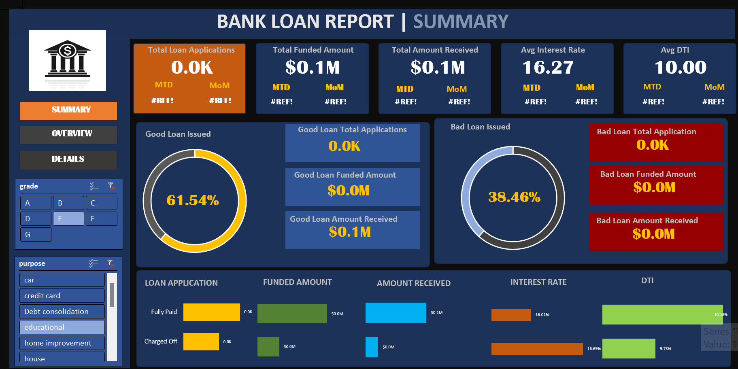

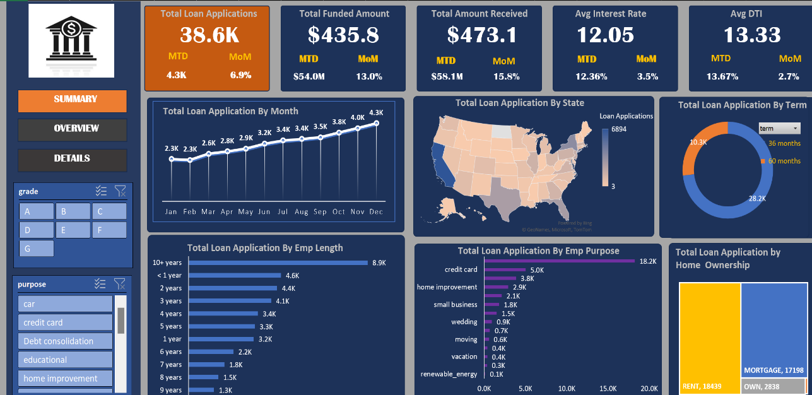

***8. Conclusion:***

The bank loan customer analysis indicates that home and personal loans are the most popular and performing segments, with high approval and repayment rates. Middle-aged customers are the most dependable segment, while young adults experience higher rejections, indicating the requirement for customized financial products or assistance for this segment. While auto and education loans are less in demand, they are more prone to default, indicating the necessity for improved risk management or repayment flexibility. Moreover, loan preferences also differ substantially with income levels, further emphasizing the need to provide income-based loan solutions to better serve customers and enhance overall portfolio performance.

***9. Keywords:***

Here are some relevant keywords for your Bank Loan Customer Analysis:

* Bank Loan
* Customer Analysis
* Loan Type Preference
* Home Loan
* Personal Loan
* Auto Loan
* Education Loan
* Loan Approval Rate
* Loan Repayment Behavior
* Default Rate
* Income Group

1. ***Reference Links:***

**Dataset Links:**

[**https://www.kaggle.com/datasets/burak3ergun/loan-data-set**](https://www.kaggle.com/datasets/burak3ergun/loan-data-set)

**Linkedin:**

[**https://www.linkedin.com/in/ashu-kumari-690643297/**](https://www.linkedin.com/in/ashu-kumari-690643297/)

**GetHub:**

[**https://github.com/AshuKumari21**](https://github.com/AshuKumari21)