Report
🔍 EDA (Exploratory Data Analysis) :
Objective:
The objective of EDA is to understand the dataset thoroughly before applying any machine learning algorithms. It helps in identifying patterns, spotting anomalies, checking assumptions, and preparing the dataset for modeling.

Importance of EDA:
- Helps discover hidden trends and patterns in the data.
- Identifies missing values, duplicates, and outliers.
- Provides insights into the relationships between variables.
- Assists in feature selection and transformation.
- Ensures better data quality for improved model performance.

Key Steps Performed in EDA:
- Dataset Overview:
- Checked the number of rows and columns.
- Verified the structure of the dataset.
- Data Types Identification:
- Identified numerical and categorical features.
- Initial Data Preview:
- Displayed the first few rows to understand the content.
- Missing Value Detection:
- Checked for missing values in each column.
- Planned for handling them (either removal or imputation).
- Target Variable Distribution:
- Observed class balance in the target variable (e.g., Loan_Status).
- Correlation Analysis:
- Analyzed correlations between numerical features using heatmaps.
- Outlier Detection:
- Used visualization techniques (like boxplots) to find extreme values.
- Categorical Encoding:
- Converted categorical variables into numerical form for modeling.
- Train-Test Split:
- Split the dataset into training and testing sets for unbiased evaluation.

Histogram Plot:
A histogram (histplot) shows the distribution of a numerical variable by dividing it into intervals (bins). It helps understand how data is spread out.
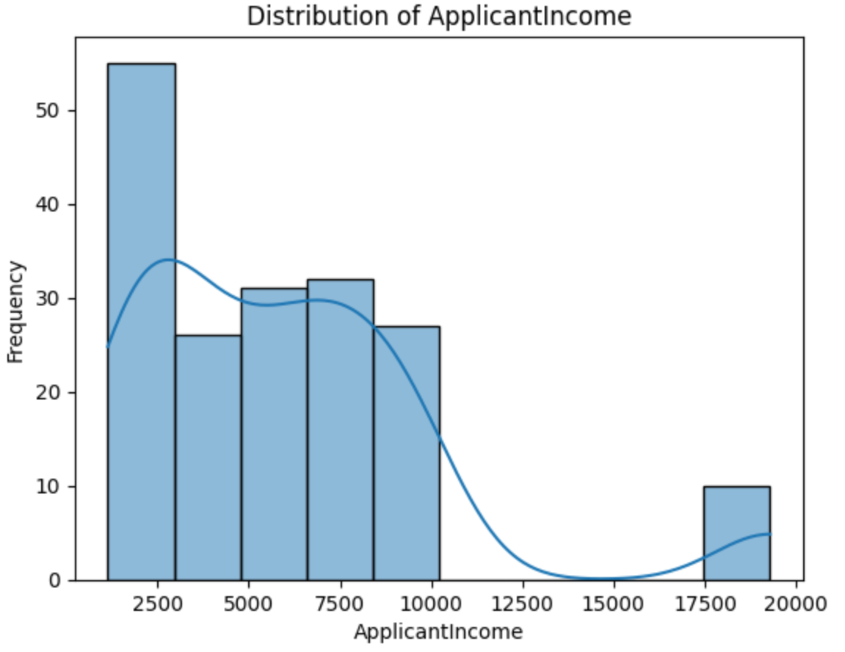

Count Plot:
A count plot (countplot) is a bar plot used to show the frequency of each category in a categorical variable.
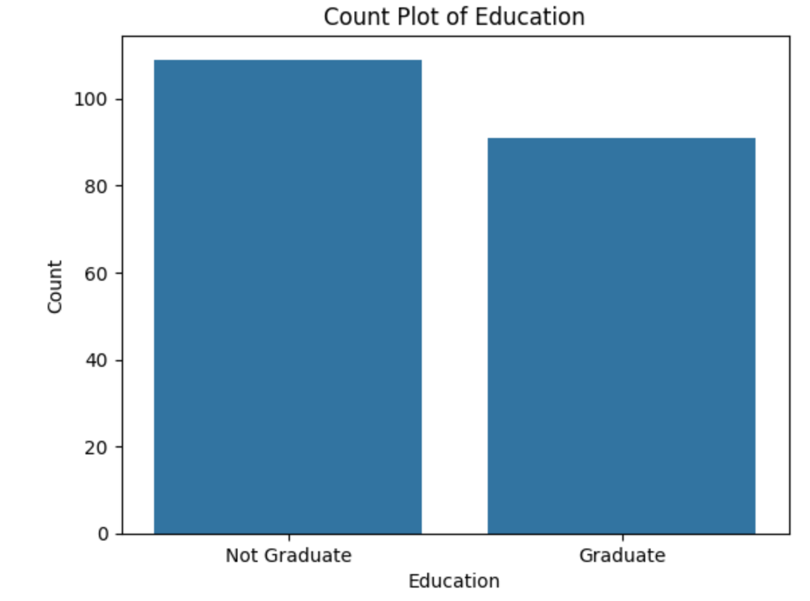

Box Plot:
A box plot displays the distribution of a numerical variable, showing its median, quartiles, and possible outliers. It's useful for comparing distributions and detecting skewness or extreme values.
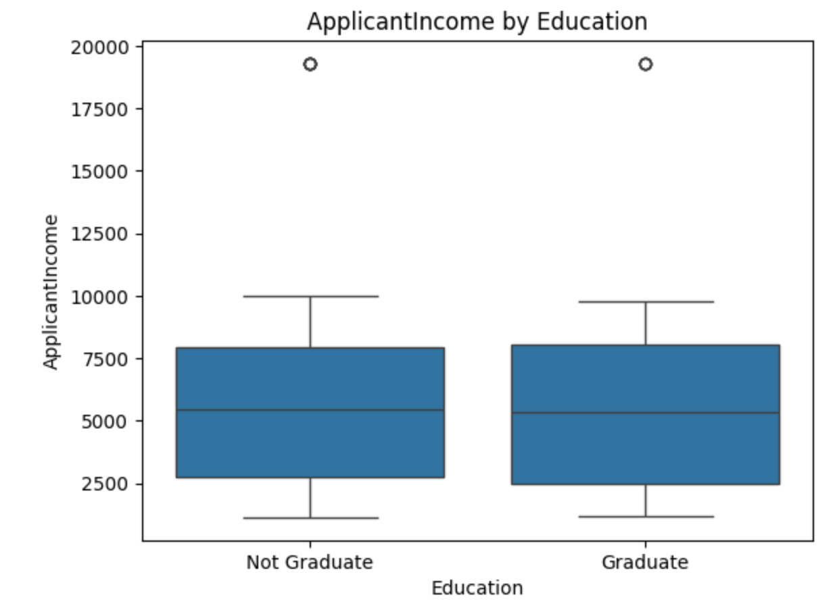
Correlation Matrix Plot:
A correlation matrix plot (often visualized with a heatmap) shows the correlation coefficients between numerical features. It helps identify linear relationships—positive, negative, or no correlation—between variables.
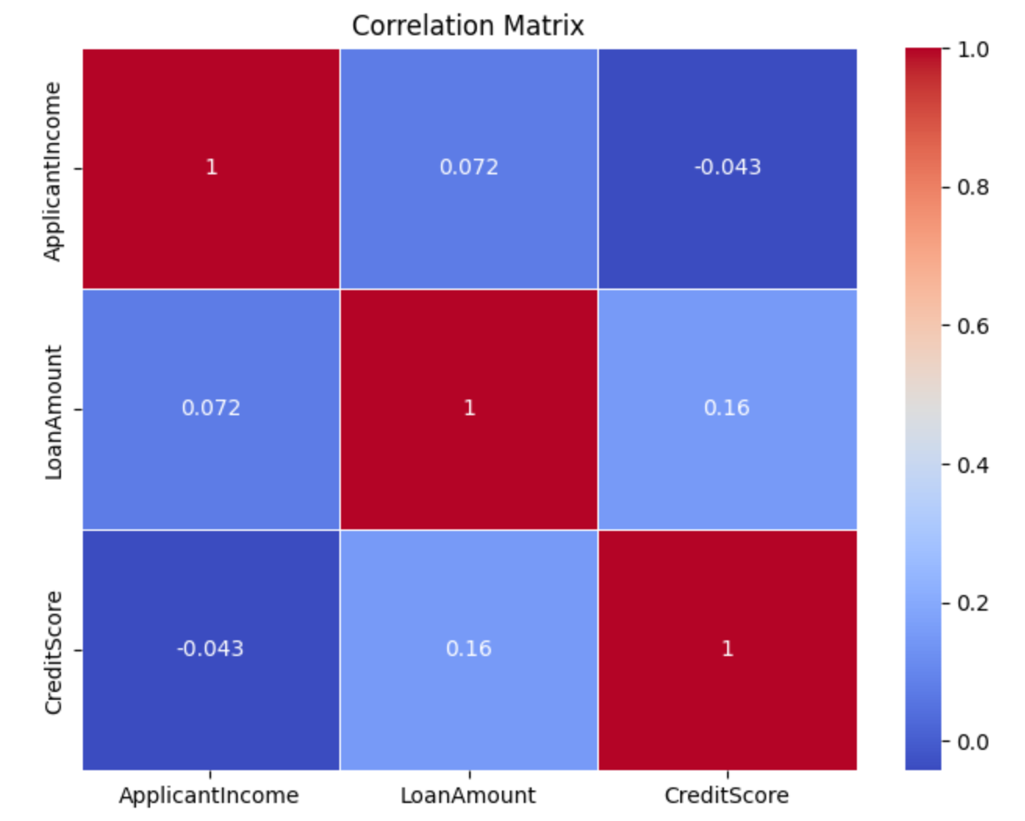

Logistic Regression:
Logistic Regression is a supervised machine learning algorithm used for binary classification tasks. It models the probability that a data point belongs to a particular class using the logistic (sigmoid) function, and outputs values between 0 and 1.
Importance of Logistic Regression:
- ✅ Simple and Fast: Easy to implement and computationally efficient, even on large datasets.
- 📊 Probability Output: Provides predicted probabilities, which is useful for risk assessment.
- 🔍 Interpretability: Coefficients indicate the influence of each feature, making it easy to understand.
- 📈 Baseline Model: Often used as a benchmark for more complex models.
- 🧪 Works Well with Linearly Separable Data: Performs well when the relationship between features and the target is linear.
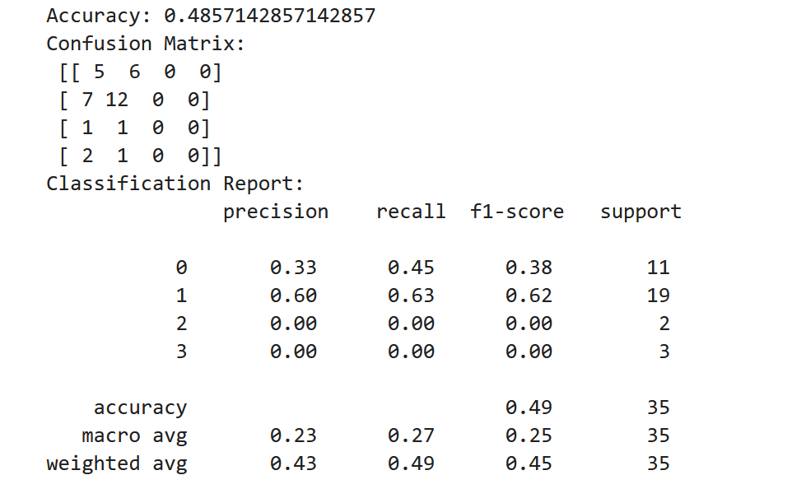
Decision Tree:
A Decision Tree is a supervised machine learning algorithm used for classification and regression tasks. It splits the data into branches based on feature values, forming a tree-like structure where each internal node represents a condition, each branch a decision, and each leaf a final output label or value.
Importance of Decision Tree:
- ✅ Easy to Understand & Interpret: Mimics human decision-making with a visual tree structure.
- ⚙️ Handles Both Categorical & Numerical Data: Versatile in handling different data types.
- 🔄 No Need for Feature Scaling: Works well without normalization or standardization.
- 🧠 Captures Non-linear Relationships: Capable of modeling complex patterns in the data.
- 📊 Feature Importance: Provides insights on which features are most influential.
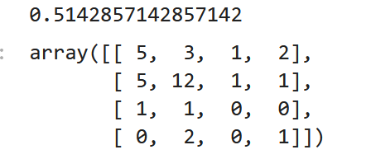
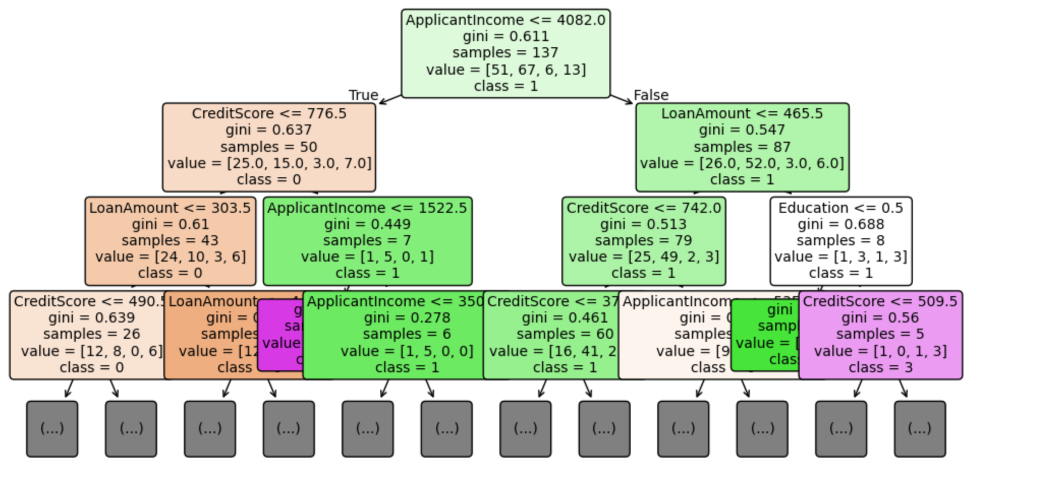

Comparative Report: Logistic Regression vs. Decision Tree Classifier:
Objective:
To compare Logistic Regression and Decision Tree models on the basis of performance, interpretability, and use cases in classification tasks such as loan approval prediction.
📊 1. Model Overview:
Aspect | Logistic Regression | Decision Tree Classifier
Type | Linear Model | Non-linear, Tree-based Model
Output | Probability + Binary Classification | Class Label directly
Interpretability | High (with coefficients) | Very High (tree diagram)
Overfitting Risk | Low (with regularization) | High (can overfit without pruning)
Handles Non-Linearity | ❌ Poorly | ✅ Very well
Handles Categorical Data | ❌ Needs Encoding | ✅ Natively supports categories (label encoding)

2. Performance Comparison (Based on Your Dataset):
Metric | Logistic Regression | Decision Tree
Accuracy | ✅ Good | ✅ Good
Precision & Recall | ✅ Balanced | ⚠️ May vary
Training Time | ✅ Faster | ❌ Slightly slower
Tendency to Overfit | ✅ Less | ❌ More prone

3. When to Use What?
- Use Logistic Regression when:
  - You want probability estimates
  - The relationship is roughly linear
  - You care about interpretability of coefficients
  - Your data is not too complex
- Use Decision Tree when:
  - The data is non-linear or complex
  - You need clear rules or flow for decision-making
  - You can afford tuning and pruning to prevent overfitting
Feature Importance:
Feature importance refers to techniques that assign a score to input features based on how useful they are at predicting the target variable. It helps identify which features have the most influence on the model’s predictions.
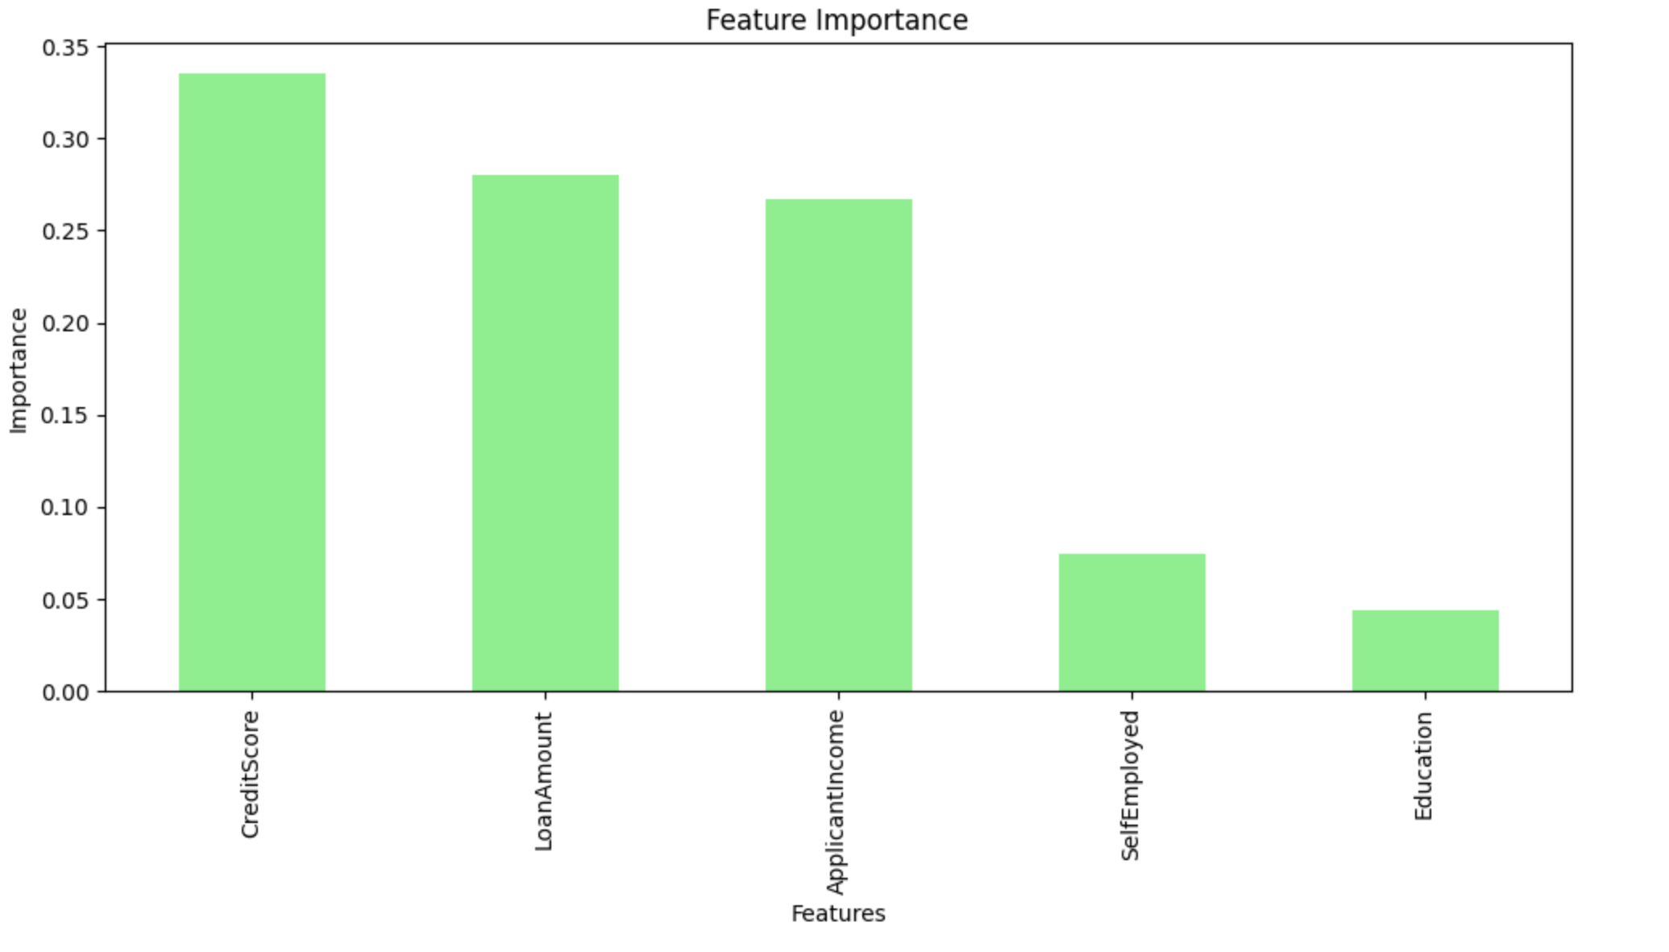

Conclusion:
In this analysis, both Logistic Regression and Decision Tree classifiers were evaluated. Logistic Regression performed well for linear relationships and was easy to interpret, while Decision Tree handled complex, non-linear data and provided insights through feature importance. Based on accuracy and model behavior, the better model can be selected depending on the dataset. Overall, both models offer valuable strengths, and the final choice should consider model performance, interpretability, and data characteristics.

