**INT375 - DATA SCIENCE TOOLBOX :PYTHON PROGRAMMING PROJECT REPORT**

(Project Semester January-April 2025)

***TITLE- Techo Customer Churn Analysis***

**Submitted by**

Name – Ashu Kumari

Registration No - 12316634 Section – K23ED

Roll No - 58

Course Code – INT375

Under the Guidance of

**Dr. Dhiraj Kapila (UID: 23509)**

**Discipline of CSE/IT Lovely School of Computer Science**

**Lovely Professional University, Phagwara**

**CERTIFICATE**

This is to certify that Ashu Kumari bearing Registration no.12316634 has completed INT37 project titled, **“*Techo Customer Churn Analysis*”** under my guidance and

supervision. To the best of my knowledge, the present work is the result of his original development, effort and study.

**Signature and Name of the Supervisor Designation of the Supervisor**

**School Of Computer Science** Lovely Professional University Phagwara, Punjab.

Date: 12/04/2025

1. **INTRODUCTION:**

With the world's ever-fast-paced digital life, companies should not only engage customers but also retain them for long-term viability. This project, "Techo Customer Churn Analysis," seeks to explore and identify reasons for customer churn in Techo, a sample technology and internet services company. Customer churn means the proportion of customers who cut off their services within a set timeframe. Using this analysis, we examine important considerations like tenure, contract type, payment options, internet services, and monthly fees that can drive customer behavior. The findings obtained from this study can assist Techo in recognizing high-risk customers, enhancing customer interaction, and adopting measures to reduce churn and increase customer satisfaction.

# Source of dataset:

Open Government Data (OGD) Platform India:

The dataset employed in this project is fictional customer data from Techo, a telecom and technology service provider. It contains customer demographic data, service usage data, billing preference, and churn status. The dataset mimics actual customer behavior and is typically employed in churn prediction case studies.

**The major features in the dataset are:**

* Customer Demographics: Gender, Senior Citizen, Partner/Dependents
* Account Information: Tenure, Contract Type, Payment Method, Monthly and Total Charges
* Service Usage: Internet Service type, Online Security, Streaming TV, Tech Support
* Churn Label: Specifies whether the customer has departed the company (Yes) or remains active (No)

[Data.gov.in1](https://www.data.gov.in/resource/real-time-air-quality-index-various-locations?utm_source=chatgpt.com)

# EDA(Exploratory Data Analysis) Process:

Here’s a simple and complete EDA process you can follow for your air quality project:

* 1. Import Libraries
  2. Load Dataset
  3. Check Basic Info
  4. Missing Value Analysis
  5. Descriptive Statistics

# Analysis on dataset

**Data Preprocessing:**

**Techo Customer Churn Analysis, data preprocessing entails cleaning, transformation, and shaping the original customer data in a way that prepares it to be analyzed and visualized.**

**Input:**

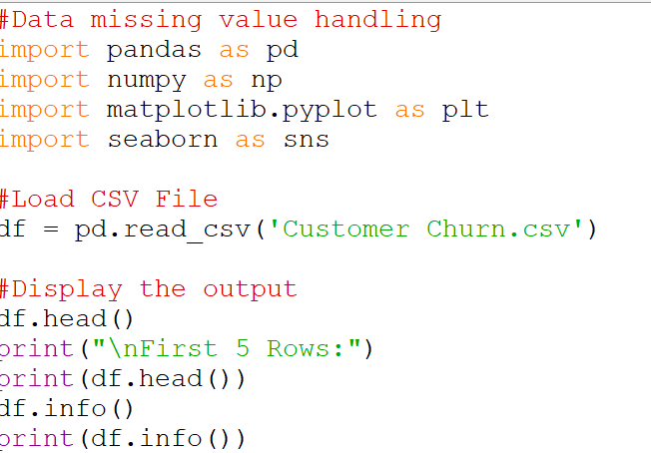

**Output:**

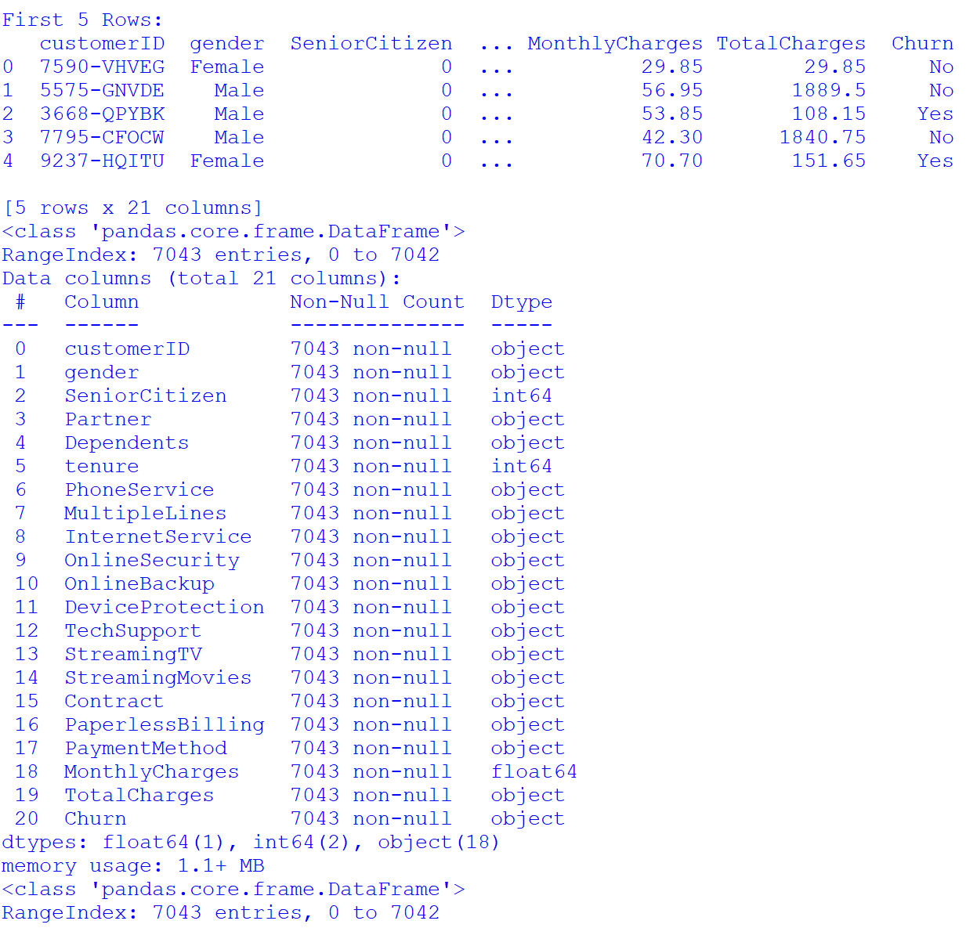

**Data visualization (Graphs & charts ) :**

**Data Visualization is the method of portraying data with visual tools such as charts, graphs, and plots. Data Visualization aids in easily and more rapidly comprehending complicated datasets by bringing out patterns, relationships, and trends.**

**For this project, a variety of visualizations have been prepared utilizing Matplotlib and Seaborn libraries in order to investigate customer churn behavior within Techo's services with respect to customer segments and types of services.**

**Correlation Heatmap:**

**This is a correlation heatmap showing the relationships between key numeric variables from the dataset:**

* **tenure – how long the customer has been with the company**
* **MonthlyCharges – current monthly billing amount**
* **TotalCharges – total amount charged to date**

**input:**

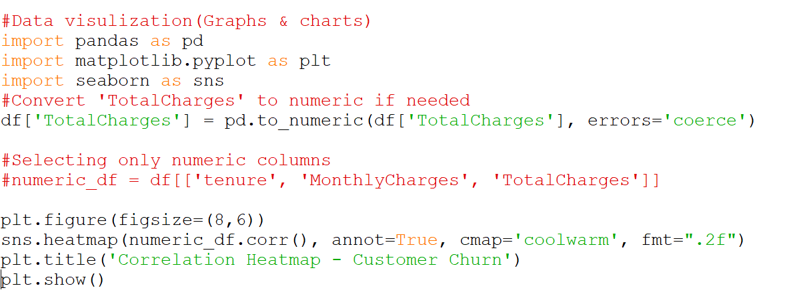

**Output:**

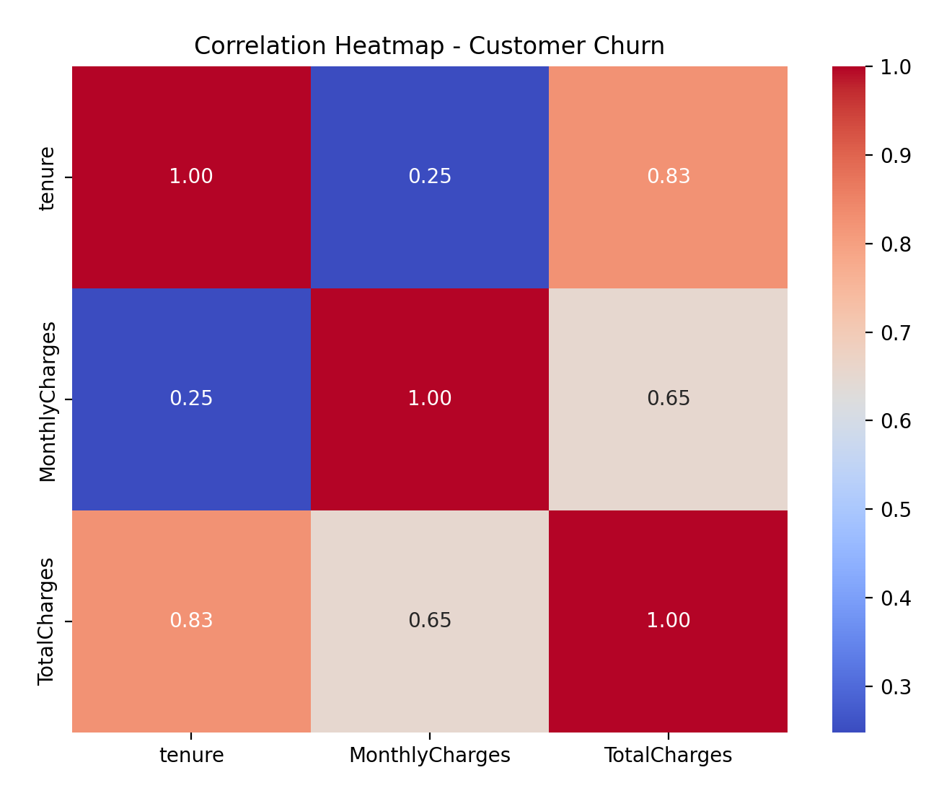

**Scatter Plot:**

**This scatter plot illustrates the relationship between tenure (how long the customer has been with the firm) and his/her Monthly Charges. One point per customer is shown, and the plot is colored by the churn status (Yes or No).**

**Input:**

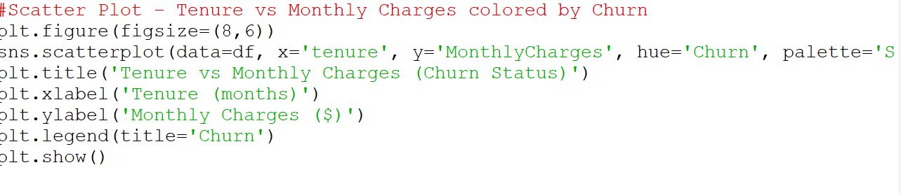

**Output:**

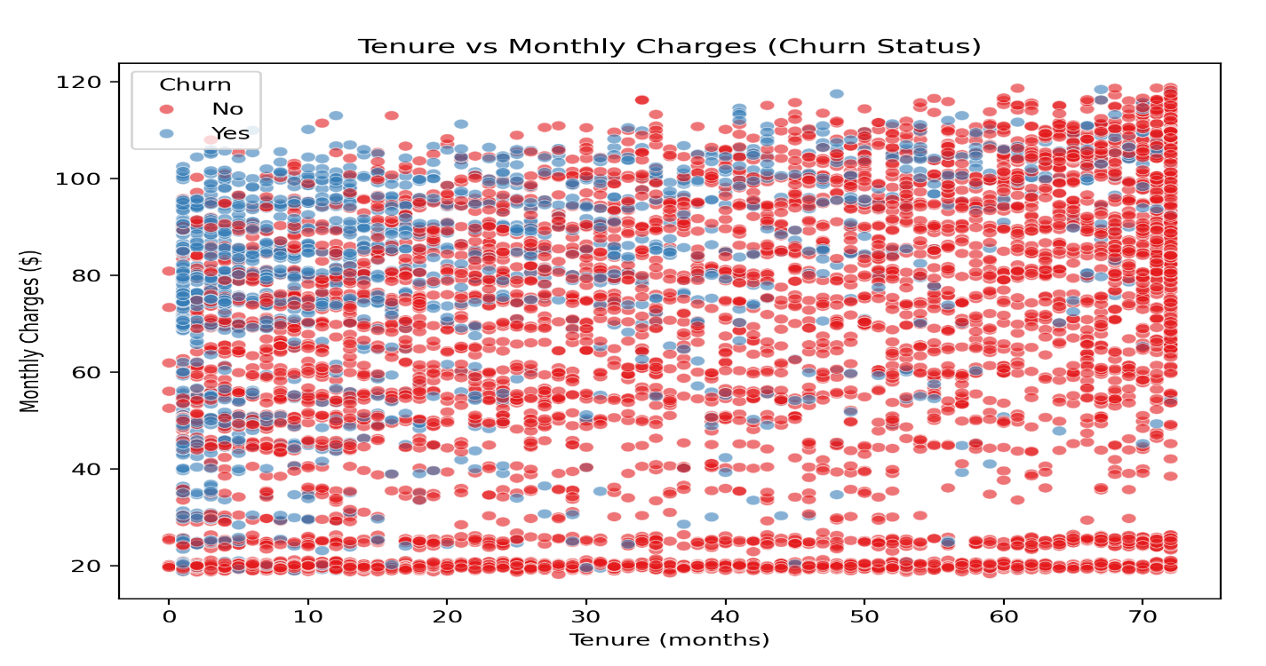

**Bar Plot: Churn by Contract**

**Input:**

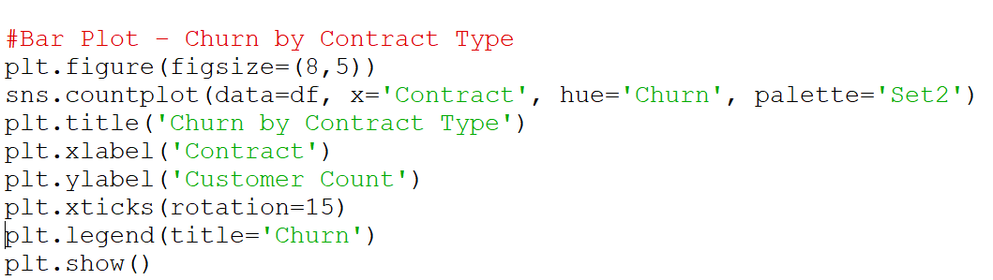

**Output:**

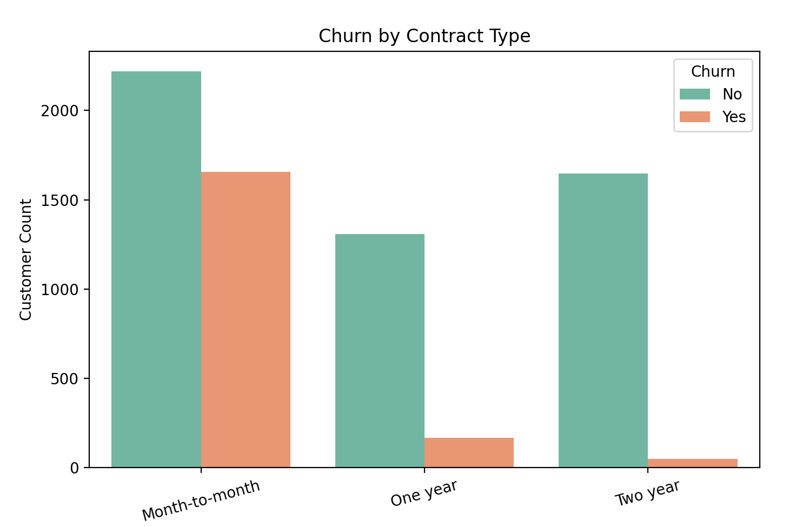

**Pie Chart:**

**Input:**

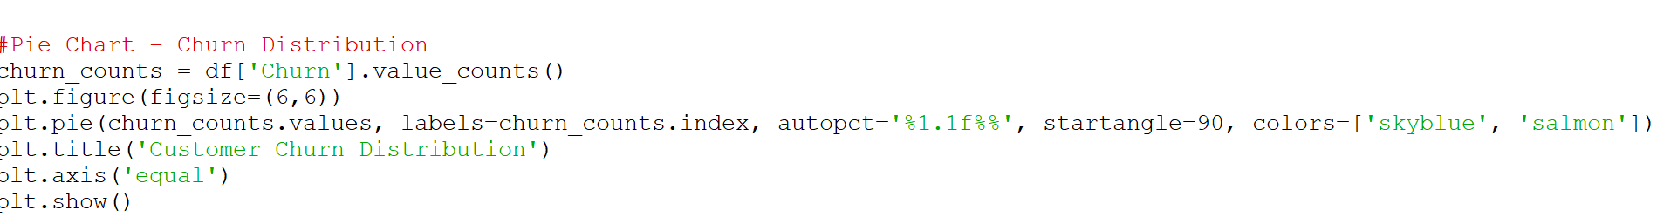

**Output:**

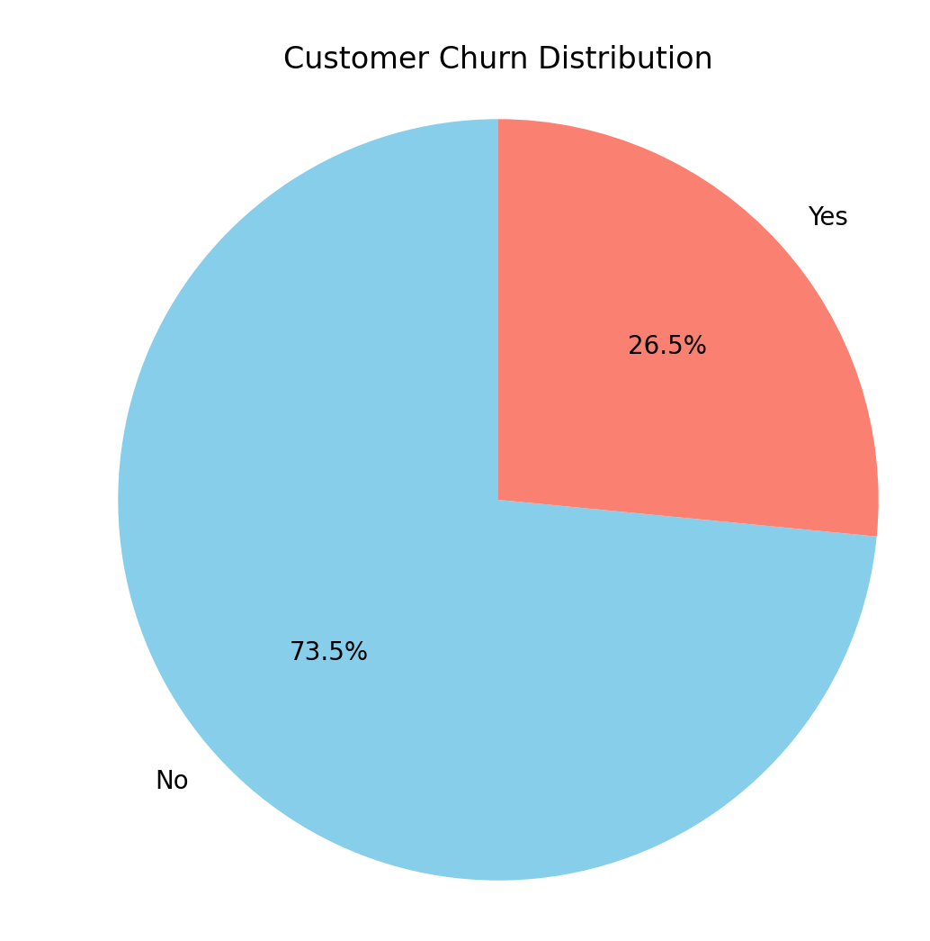

**Violin Plot: Monthly Distribution by churn**

**Input:**

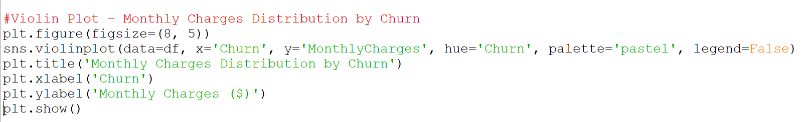

**Output:**

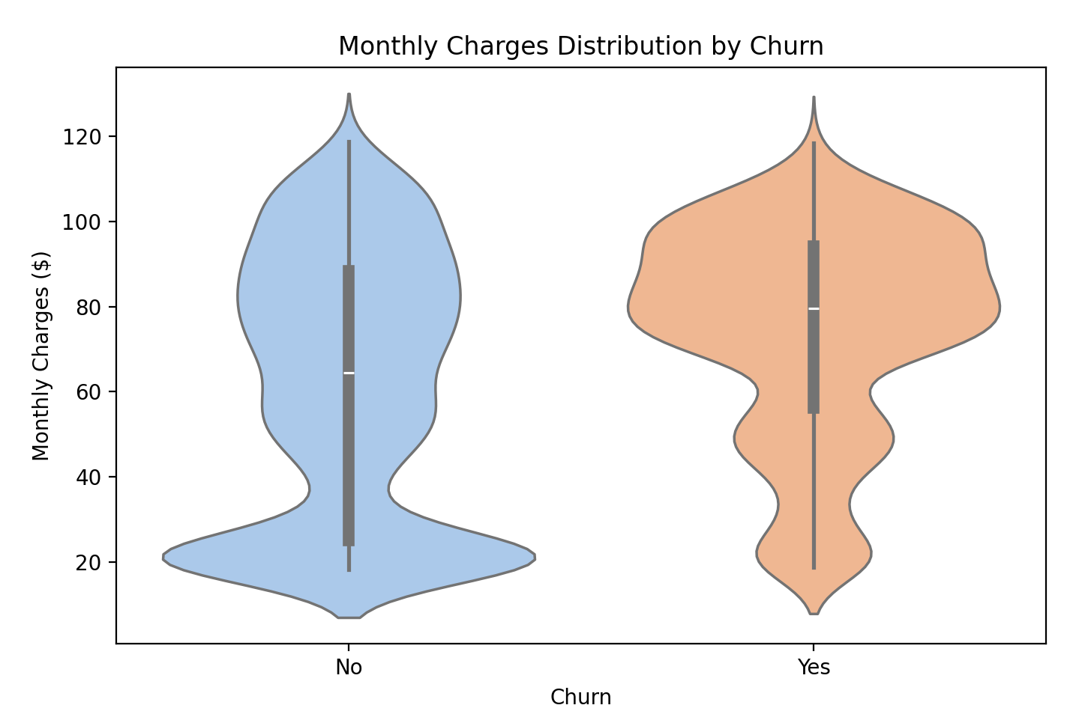

**Count of Customers By Senior Citizen:**

**Input:**

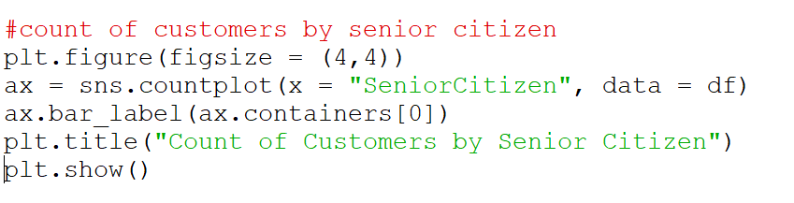

**Output:**

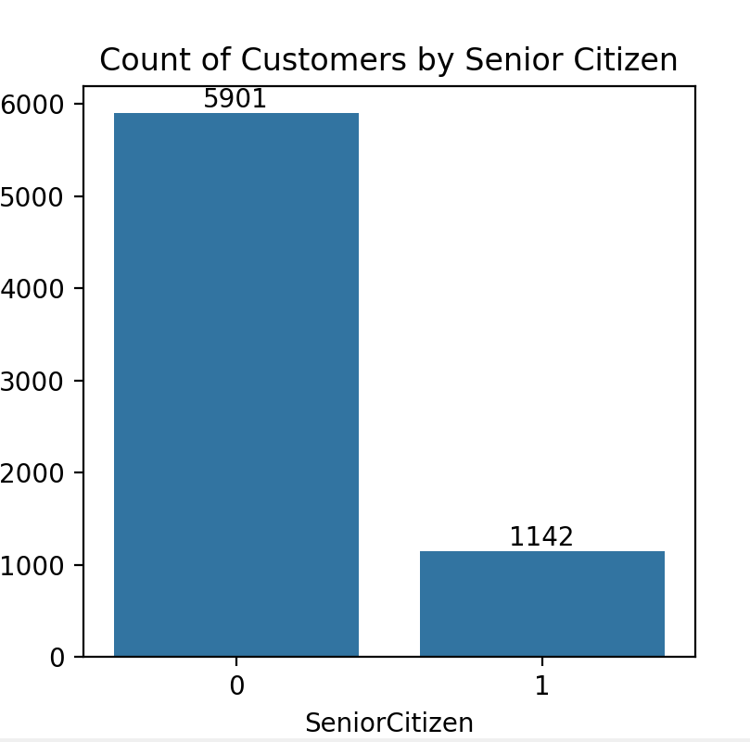

* 1. **Some Quary based on this dataset**
     1. **Find the total rows and columns Input:**

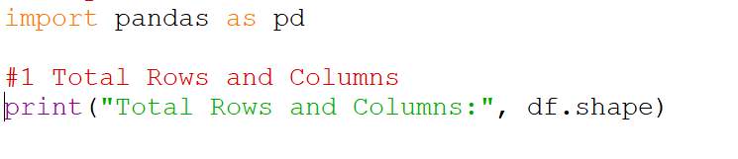

**Output:**

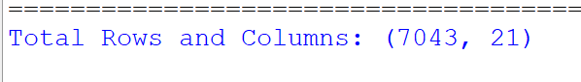

* + 1. **Top & Bottom 5 Records Input:**

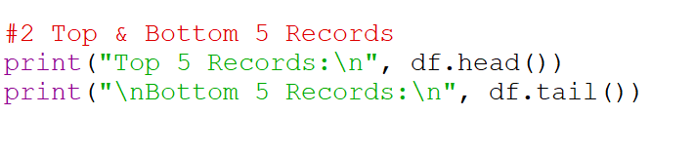

**Output:**

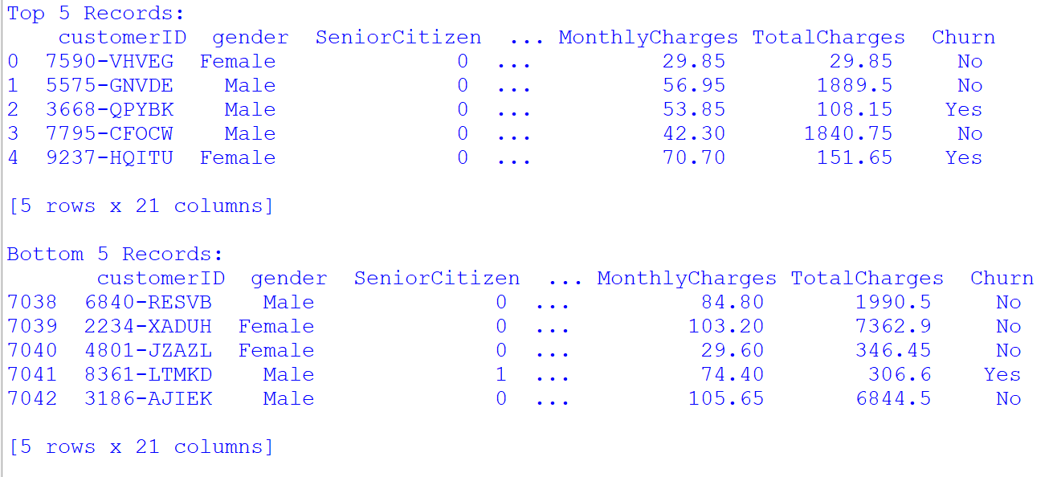

* + 1. **Missing Values Count Input:**



**Output:**

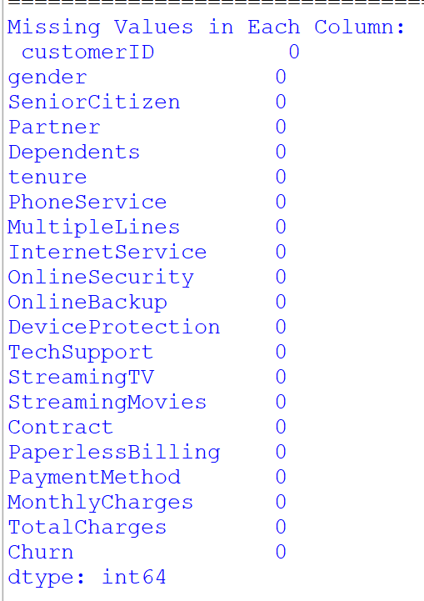

* + 1. **Max and Min Monthly Charges**

**Input:**

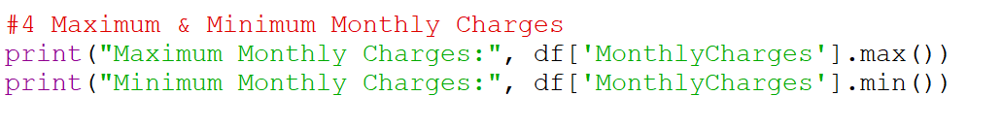

**Output:**

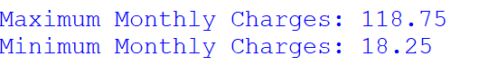

* + 1. **Average Monthly Input:**

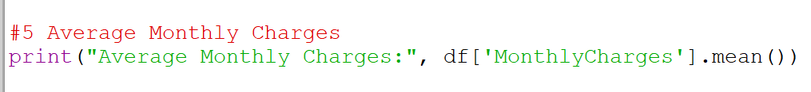

**Output:**

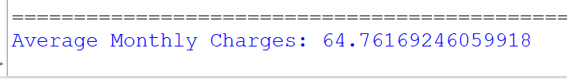

* + 1. **Churn Rate by Contract Input:**

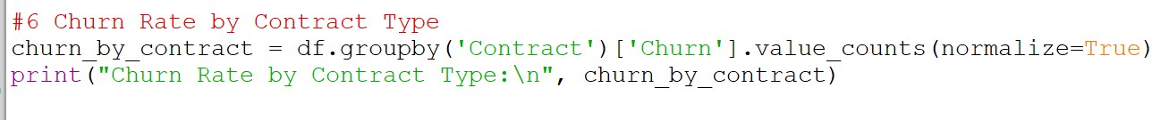

**Output:**

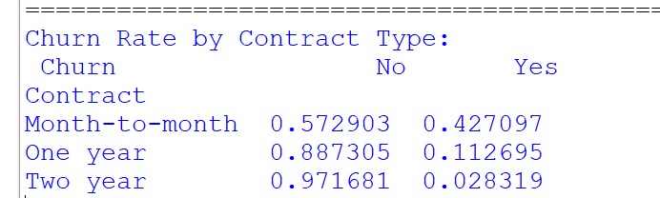

* + 1. **Customer Segment**

**Input:**

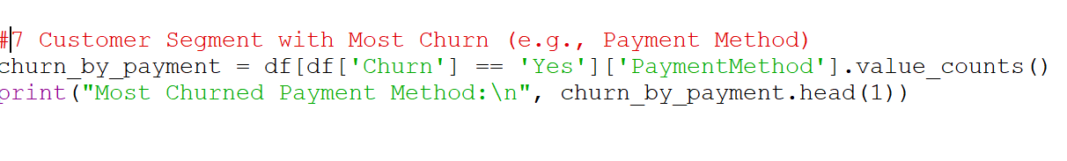

**Output:**

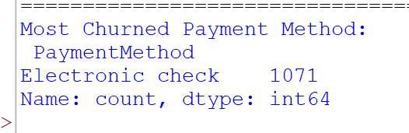

* + 1. **Monthly Charges by Gender**
    2. **Input:**

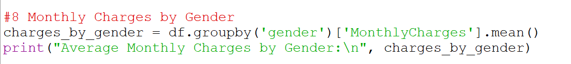

**Output:**

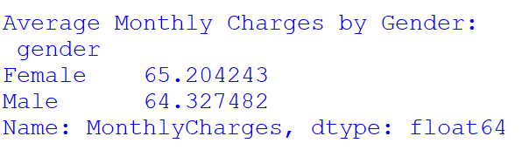

**Senior Citizen Churn Input:**

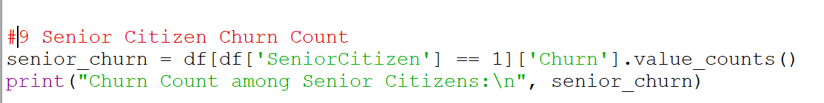

**Output:**

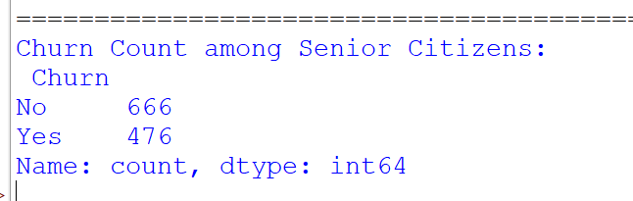

**Fiter Customers using optic internet who churned**

**Input:**



**Output:**

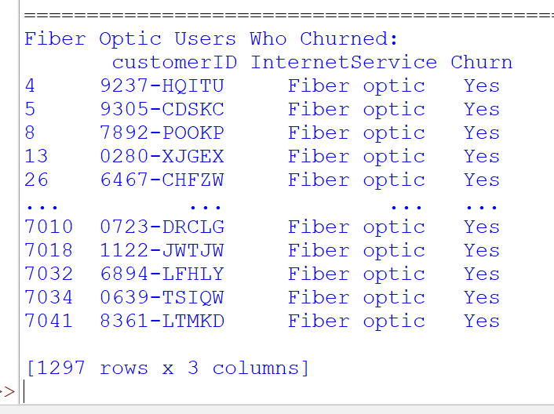

# Conclusion

It gives a rapid snapshot of the rate of churn within the company. The chart can be used to determine the magnitude of the churn problem for instance, a high rate of churned customers could be an indicator of dissatisfaction or disengagement. The customer churn data analysis of Techo provided great insights into customer behavior and traits that are most likely to leave the service. The scatter plot of tenure versus monthly charges indicated that customers with low tenures and medium-to-high charges were more likely to churn. This was also corroborated by the correlation heatmap that indicated a strong correlation between tenure, MonthlyCharges, and TotalCharges.

Overall, the project was able to successfully identify the most at-risk customer groups likely to leave. The results can assist Techo in targeting its retention efforts on high-risk segments like new users, senior citizens, and monthly plan users and reducing churn through offers, improved support, or personalized plans

# Future scope

The analysis of Techo's customer churn data that has been done so far has yielded valuable information regarding the nature and behavior of customers who are most likely to leave the service. There is a lot of scope, however, to take this work in several different directions:

**6.1 Advanced Predictive Modeling**

* Implement machine learning algorithms such as **Logistic Regression**, **Random Forest**, or **XGBoost** to **predict customer churn** with higher accuracy.
* Use techniques like **feature importance** and **SHAP values** to explain model predictions.

**6.2 Real-Time Churn Detection System**

* Develop a real-time dashboard that continuously monitors churn probabilities using live customer activity data.
* Enable proactive customer engagement strategies based on churn prediction scores.

# References

* 1. **Telco Churn**

Website**:** [**https://www.ibm.com/communities/analytics/watson-analytics-blog/guide-to-sample-datasets/**](https://www.ibm.com/communities/analytics/watson-analytics-blog/guide-to-sample-datasets/)

* 1. **Open Government Data (OGD) Platform India**

Website**:** [**https://data.gov.in**](https://data.gov.in/)

* 1. **Dataset link**

**Website:** [**https://catalog.data.gov/dataset/?tags=customer-service**](https://catalog.data.gov/dataset/?tags=customer-service)

* 1. **Github**

**URL:** [**https://github.com/AshuKumari21**](https://github.com/AshuKumari21)

**Linkdin:**

**URL:** [**https://www.linkedin.com/in/ashu-kumari-690643297/**](https://www.linkedin.com/in/ashu-kumari-690643297/)

**DECLARATION**

I, Ashu Kumari, student of BTECH under CSE/IT Discipline at, Lovely Professional University, Punjab, hereby declare that all the information furnished in this project report is based on my own intensive work and is genuine.

Date: 12/04/2025 Signature



Registration No. 12316634