sARIMA

ARIMA or Auto Regressive Integrated Moving Average is a time series method for statistical analysis usually used to predict future trends by understanding past data. There are two types of ARIMA models namely, seasonal and non- seasonal.

The non-seasonal model takes into account three parameters: p, d and q where,

p : refers to the number of lags to be used to predict the series or it is the order of Auto Regressive term

q : refers to the number of lagged errors or it is the order of the Moving Average term

Now, the very first step in ARIMA model is to make the time series stationary as the term Auto Regressive refers to Linear Regression model.

So, in order to make the series stationary most common way is to difference the previous value from the present value.

Hence, d refers to the minimum number of differencing required to make the series stationary.

If the time series exhibits some seasonal patterns, then we need to add some additional terms which converts it to SARIMA or ‘Seasonal ARIMA’.

A pure Auto Regressive model is depicted mathematically as:

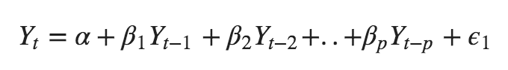

Where, Yt-1 is the lag 1 of the time series, β1 refers to the coefficient of lag 1 and α refers to the intercept term.

Similarly, Moving Average model is depicted mathematically as:

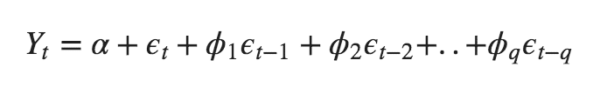

Where, error terms refer to the errors from the auto regressive models as errors Et and Et-1 are derived from following equations:

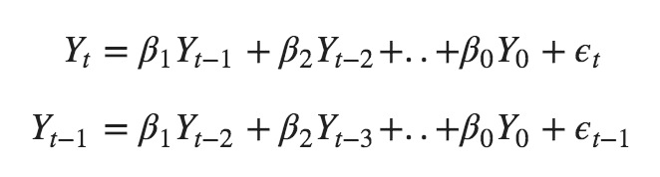

Now, the ARIMA model consists of at least one differencing to make time series stationary and then combination of Auto Regressive and Moving Average models. So, the mathematical equation for ARIMA becomes:

