Forecasting the data has now became a necessity for today’s world and especially in business sector including stock markets. To run the business in order to achieve the maximum profit, forecasting helps by providing an idea of future and a warning to improve the business. The purpose of forecasting can be achieved by time series analysis.

The observation made to store data in a sequence determined by the order of time is the time series and analysis done on that data in order to extract meaningful information for the deep understanding of pattern hidden among data in the sequence of time is the time series analysis.

The particular products to be in demand in future, the expected increase in the number of customers, the expected stock that the company should maintain all these questions can be answered if a model is determined by time series analysis for forecasting.

[1] The basis of forecasting techniques in time series is stats model which require a team of expertise to tune the parameters of the method. The different problems have different conditions which is satisfied by parameter tuning. [1] Maintaining a team of expertise is expensive and is not affordable by micro enterprise. Hence, the Facebook's Prophet can be seen as a best alternative to the mentioned problem.

**1-FACEBOOK PROPHET**

[1] The Prophet forecasting model available in Python and R is open source and is built in Stan. The parameters can easily be adjusted for tuning while integrating the core business knowledge. Missing data, outliers are handled easily and automatically. A beginner without much knowledge can also built a time series model for forecasting relating to different business problems.

The three main components of the Prophet model are trend, seasonality and holidays. Since they have independent importance and effects on forecast so an integrated formula for proper and complete forecasting was needed. Thus, a decomposable additive model was considered best for Prophet’s development.

**1.1 Decomposable additive model**

[2] When there are multiples of predictor variables from x1 ....... xt considering a general regression function y=f(x1 ....... xt) is very difficult. The generalized additive model ignoring the interaction between predictors is then considered. The formula for it 

can be simplified as 

Each function fn is estimated by smoothing spline or polynomial regression.

[3]The model is useful when magnitude of seasonal fluctuation does not change according to time series level.

Therefore, the forecasting Prophet model based on additive decomposable technique is given as-

y(t)= g(t) + s(t) + h(t) + εt

**1.2 Trend g(t)**

[3] It refers to a long term of time series in which the data increases or decreases which might not be linear. Trend can also change the direction sometimes as the time increases. An increasing trend can be changed to decreasing trend with the passage of time and vice versa. [1] This trend component can lead to overfit or underfit of model hence trend change points is allowed by Prophet which makes the model more flexible. The manual process of giving trend change point by user depending on the business understanding is also provided by Prophet. Figure (a) shows the Trend decreasing with time.

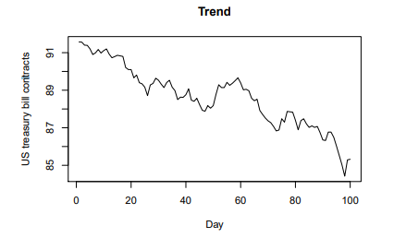 (a)[B-1]

**1.2 Seasonality s(t)**

[3] The time series having regular periodic fluctuations based on season like day/week/month/year such type of component represents seasonality. This fluctuation is always fixed and already known to happen at the coming time. For example – the first two weeks of every month experiences high rise in sale due to the salary which people get in the beginning of every month. This fluctuation is fixed and already know hence it is seasonality. Figure (b) shows the example of stationary seasonality.

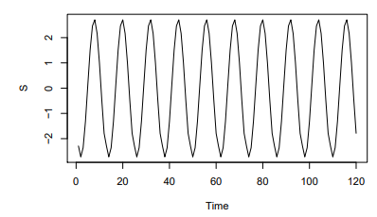 (b)[B-1]

**1.3 Effect of holidays h(t)**

The effect of holiday cannot be neglected during forecast. The list of holidays with date is provided to Prophet which are then modeled and are not used in forecast. The holidays are irregular and show decrease in busines activities at random time due the irregularities. Hence neglecting holidays degrades the model.

**1.4 Error term εt**

[4] The set of unconditional or unusual changes which are related to the particular business, person or circumstances and are not contained within the model denotes the error term. The Facebook Prophet also takes them into account.

**2 Prophet Working Model**

[4] The forecasting done by Prophet is based on two models depending on trend g(t)– Logistic growth model and Piece-wise linear model. These models can be altered to form new model according to specific requirements. The default usage is of piece-wise linear model for forecasting by Prophet. The choice of model to be used for forecast is very fragile and depends on several factors like rate of growth, the type of business model, size of company etc.

**2.1 Logistic growth model**

The logistic growth model is used when the data to be forecasted has non linear growth and saturation. [5] The initial state of data shows exponential growth which then starts changing into linear by the beginning of saturation and at the maturity the growth stops. Such types of data is best suited for logistic growth model for forecasting.

The equation for logistic growth model can be given as-



where g(t) represents trend, C stands for carrying capacity that is the curve’s maximum value, k represents the growth rate or steepness of the logistic curve, x0 represents the mid x-axis value of the logistic curve which is 0.

Figure (c) shows the logistic growth example

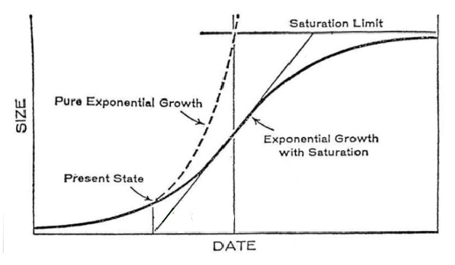 (c) [B-2]

**2.2 Piece-Wise Linear Model**

[5] This model is obtained by simple modification of linear model which proves to be very useful. The model is used when linear properties are exhibited by data which has shown growth or shrink trends in past. Since a single linear model is not capable enough to accommodate complete, exact information and give adequate description of best fit line so the domain of independent variable is broken into several parts depending on the points where slope of the model changes. The breaking of the domain is done so that the model should be tuned to give best fit line of regression even if it is not linear as a whole and broken into several pieces hence the name piece wise linear. [5] These breakpoints may be known or unknown before analysis but has to be estimated if not known. Figure (d) shows the example of Piece wise linear.

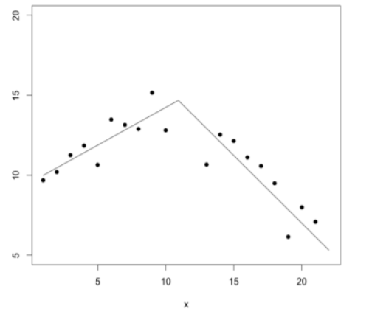 (d)[B-2]

A simple linear regression has equation - 

[6] Whereas Piece-wise linear regression has equation - 

Here x is independent variable, y is dependent variable, β is constant, C is the one break point on x-axis where the slope of the model changes, D is a variable having value as 1 when x>C and 0 when x<=C.

By putting the value of D if we simplify the above equation then it can be written as-

 when x>C and

 when x<= C

The range of independent variable varies, hence different linear relationships occur. [5] The default sets of Prophet for piece wise linear model specifies 25 potential breakpoints which are placed uniformly in the first 80 percent of time series also the provision of manually changing the breakpoints is provided.[5] By default in Prophet the growth rate is constant for this model hence the model is best suitable for growth without saturation.

**REFERENCES**

A- Theory

1- <https://towardsdatascience.com/a-quick-start-of-time-series-forecasting-with-a-practical-example-using-fb-prophet-31c4447a2274>

2- <https://www.youtube.com/watch?v=K6hbKZ5Ip4Q&list=LL&index=5>

3- <http://web.vu.lt/mif/a.buteikis/wp-content/uploads/2019/02/Lecture_03.pdf>

4- <https://www.geeksforgeeks.org/time-series-analysis-using-facebook-prophet/>

5- <https://medium.com/analytics-vidhya/how-does-prophet-work-44addaab6148>

6- <https://www.youtube.com/watch?v=JlPvHKh-xYQ&list=LL&index=2&t=58s>

B- Image Credits

1- <http://web.vu.lt/mif/a.buteikis/wp-content/uploads/2019/02/Lecture_03.pdf>

2- <https://medium.com/analytics-vidhya/how-does-prophet-work-44addaab6148>