**Git Branches:**

|  |  |
| --- | --- |
| **Panel** | **Branch** |
| Admin + Operator | Nikhil_reactjs |
| Customer | anas |
| Backend | zaid |

**Important files**

Admin + Operator:

Branch: Nikhil_reactjs

Inside **src**

File: **globalConstants.js** :

Backend **server urls exported;** testing, development and production server.

Uncommented one in use, all others commented.

Inside **src/components**

File: **Login.js**: Logs in the panel and **redirects to Admin or Operator** as per the credentials used to log in

File: **Logout.js**: Logs out from the panels

**ADMIN PANEL**

Inside **src/components/AdminPanel**

File: **Admin.js:**

Landing page after logging into Admin panel;

Main menu for all features under Admin panel.

*Database* section gives all Admin panel tables

File: **CountryDetails.js**:

Parent page for all tabs that display admin tables;

*fragmentdiv* displays all those components.

All the .get api requests to display tables inside this file.

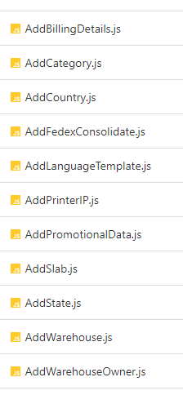 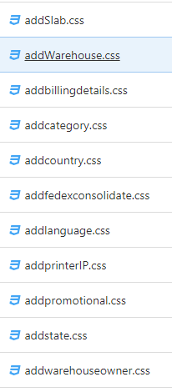

Above: Components for respective admin table in .js file and their corresponding css files.

These .js files are imported inside CountryDetails.js to display the component.

Inside these files: Display admin tables; Modal to add new details, POST requests for same; Update/Edit details PUT requests.

**OPERATOR PANEL**

Inside **src/components/OperatorPanel**

File: **BoxList.js:**

List of all manifested orders that are ReadyToShop.

Box with status New and Failed.

File: **CreateOrder.js:**

Creates Order sections with all the order details and product details

File: **CustomSettlement.js:**

All boxes after shipping but custom not settled.

File: **CustomerDetailCard.js:**

Customer information on the top-right corner of create-order.

File: **Dashboard.js:**

Dashboard in operator panel; first section of side-nav.

File: **EditBoxModal.js:**

Modal for edit option in boxlist; change status and send back to orderlist

File: **EditProductItem.js:**

Modal to edit product item. Imported in create order, edit order.

File: **IdleTimeModal.js:**

Modal to give warning to log-out after session time-out

File: **Operator.js:**

Landing page after logging into Operator panel using operator panel credentials;

Main menu for all sections under Operator panel.

Parent page where all menu components are imported.

File: **OrderList.js:**

List of all orders with all order status.

File: **OrderSelectionModal.js:**

Pending Existing List modal that appears for order status IM and WFC when ezzid is selected in create order ezzid select dropdown.

File: **ReadyToShip.js:**

Not in use and hidden for now.

Orders that were to be shipped were supposed to be here.

File: **Shipped.js:**

List of boxes after shipment and custom settlement completed.

File: **ProductItemListCard.js:**

Product Table Display for product details in create order and edit order.

File: **editOrder.js:**

Modal component for edit order in orderlist.

File: **viewOrder.js:**

Modal component for view order in orderlist.

**CUSTOMER PANEL**

Branch: anas

File: **globalConstants.js** :

Backend **server urls exported;** testing, development and production server.

Uncommented one in use, all others commented.

Inside **src/CustomerPanel/Context**

File: **UserContext.js**:

Exporting context using createContext

Inside **src/CustomerPanel/HomePage**

This was an attempt to include EzzyShip Website in customer panel code in react, not a working functionality right now.

Inside **src/CustomerPanel/Ledger**

File: **Ledger.js**:

Payment etc details.

Not in use right now.

File: **ViewLedger.js**:

Side-navigation

Inside **src/CustomerPanel/OrderList**

File: **List.js**:

All orders with details list view.

File: **OrderList.js**:

Side-navigation

Inside **src/CustomerPanel/RequestOrder**

Hidden. This was earlier implementation to upload invoice; now same functionality in orderlist in front of

File: **FileUpload.js**:

Upload File option

File: **RequestOrder.js**:

Side-navigation

Inside **src/CustomerPanel/UserProfile**

This was earlier implementation to upload Invoice

File: **Profile.js**:

Basic and address details of customer along with edit option.

File: **UserProfile.js**:

Side-navigation

Inside **src/CustomerPanel**

File: **Calc.js**:

Calculator display.

File: **Calculator.js**:

Side-navigation in calculator page.

File: **CustomerDashboard.js**:

Landing page after a customer logs in using their credentials.

File: **EditReadyToShop.js**:

Edit address modal in user profile section.

File: **Login.js, LoginES.js**:

Login page in English and Spanish, respectively.

File: **Payment.js**:

Add and update card details.

File: **PaymentAuth.js**:

Side-nav.

File: **ReadyToShop.js, ReadyToShopES.js**:

Shipping and Billing Address Modal in English and Spanish respectively.

File: **ReadyToShopNewUser.js**:

This screen appears after a new sign-up, to enter address details.

File: **SignUp.js, SignUpES.js**:

New user sign-up.

File: **SignUpDisplay.js**:

Not in use.