

| **TITLE :** "COVID-19 VACCINE DATA ANALYSIS"  **SUBTITLE :** "OPTIMIZING VACCINE DEPLOYMENT STRATEGIES”  **NAME :** Arshin K H  **REG .NO :** 810721243008 |
| --- |

**INTRODUCTION**

* Introduction to the COVID-19 pandemic and its global impact.
* Brief overview of the challenges posed by the pandemic, including healthcare system strain, economic downturn, and social disruptions.
* Thesis statement: This paper explores the role of design-led innovation in addressing the multifaceted challenges of the COVID-19 pandemic.

**UNDERSTANDING THE PROBLEM**

* Comprehensive analysis of the COVID-19 pandemic's impact on healthcare, economy, and society.
* Discussion on the importance of a multidisciplinary approach to tackling the challenges posed by the pandemic.
* Highlighting the need for innovative solutions to complement traditional medical interventions.

**DESIGN-LED INNOVATION FRAMEWORK**

* Introduction to the concept of design-led innovation and its significance in solving complex problems.
* Overview of the key components of a design-led approach, including user-centricity, empathy, and iterative prototyping.

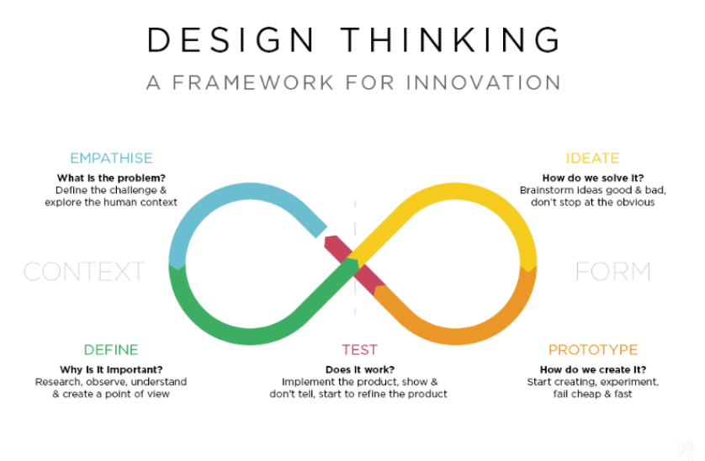

**APPLICATION OF DESIGN-LED INNOVATION TO COVID-19**

* Subsections focusing on specific areas where design-led innovation can be applied:
* Healthcare System Strengthening: Redesigning healthcare facilities, optimizing workflows, and enhancing patient experience.
* Medical Device Innovation: Rapid prototyping and iterative design to develop and deploy critical medical equipment.
* Digital Solutions: User-friendly apps, contact tracing systems, and telehealth platforms.
* Social Innovation: Designing interventions to address mental health, community support, and educational challenges.
* Economic Resilience: Innovative business models, job creation strategies, and sustainable economic recovery plans.

**Dataset Link:**[**https://www.kaggle.com/datasets/gpreda/covid-world-vaccination-progress**](https://www.kaggle.com/datasets/gpreda/covid-world-vaccination-progress)

**CONCLUSION**

* Recapitulation of the significance of design-led innovation in addressing the challenges of the COVID-19 pandemic.
* Emphasis on the importance of continued investment in design thinking and innovation for future crisis preparedness.
* Call to action for policymakers, healthcare professionals, designers, and innovators to collaborate in creating a more resilient and adaptable global community.