

|  |
| --- |
| **TITLE :** "COVID-19 VACCINE DATA ANALYSIS”  **SUBTITLE :** " MODEL TRAINING, EVALUATION”  **NAME :** ARSHIN KH  **REG .NO :** 810721243008 |

**INTRODUCTION**

* Model evaluation is an indispensable component of the machine learning pipeline, enabling us to gauge how well our models perform on a given task.
* It involves a systematic analysis of a model's predictive abilities, providing insights into its strengths and weaknesses
* During model evaluation, we use various metrics and techniques to assess a model's performance. such as classification or regression, and the specific goals we aim to achieve.
* Evaluation metrics include accuracy, precision, recall, F1 score, and ROC-AUC for classification tasks, and mean squared error (MSE) or R-squared for regression tasks.
* We will explore the fundamental concepts of model evaluation, including how to select appropriate evaluation metrics, how to prevent overfitting, and the importance of cross-validation

**DATA PREPARATION AND EXPLORATION**

* Data Source and Description about the data
* Specify the source of the dataset.
* Describe the features (e.g., total vaccinations', 'total vaccinations_per_hundred', 'people_vaccinated) and target variable (daily_vaccinations_per_million).

**DATA PREPROCESSING**

* Load the dataset and inspect the first few rows.
* Visualize distributions of key features ('total_vaccinations_per_hundred', 'people_vaccinated) and target variable (daily_vaccinations_per_million).
* Plot the distribution of the target variable (daily_vaccinations_per_million).

**MODEL TRAINING**

* Split the data into training and testing sets (e.g., 80% train, 20% test).
* Model Selection and Training
* Train the model on the training data.
* Provide code snippets and parameters used.

**MODEL EVALUATION**

* Explain the chosen performance metrics (e.g., accuracy, precision, recall).
* Present the confusion matrix and its interpretation.
* Model Evaluation Results
* Display accuracy, precision, recall, and F1-score.
* Provide any additional insights from the evaluation.

**##Importing**

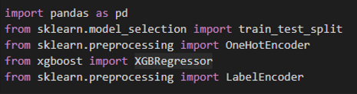

**##Loading Data**



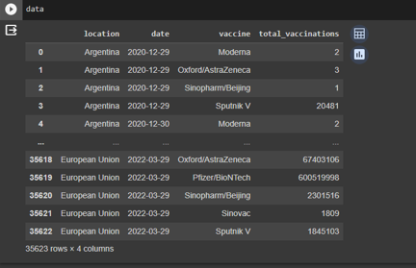

**##Training**

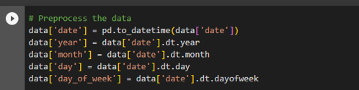

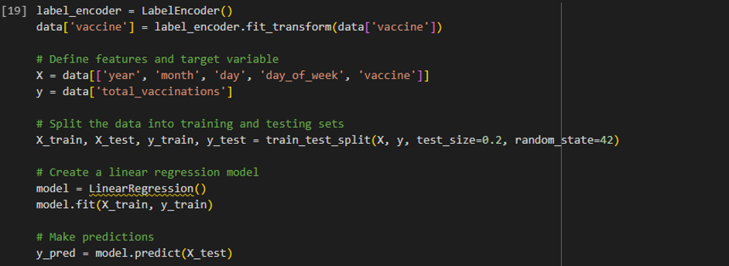

**#yPredict**

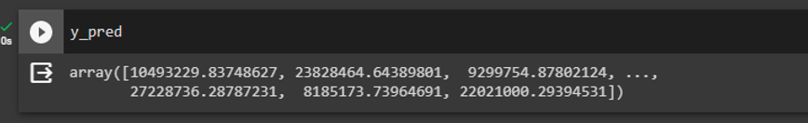

**##Plotting**

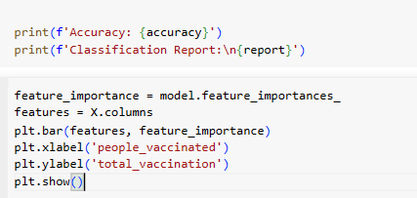

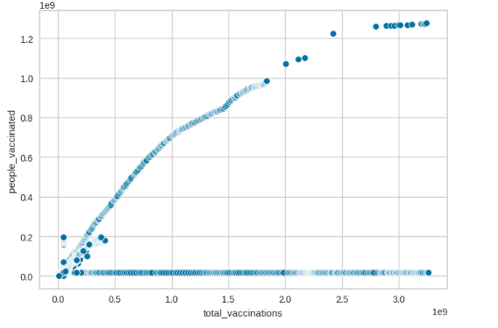

**Dataset Link:**[**https://www.kaggle.com/datasets/gpreda/covid-world-vaccination-progress**](https://www.kaggle.com/datasets/gpreda/covid-world-vaccination-progress)

**CONCLUSION:**

In conclusion, model evaluation serves as the compass guiding us in the complex landscape of machine learning. It is not merely a formality but a crucial step that determines the practical utility of our models. Additionally, cross-validation techniques provide a means to estimate a model's performance more reliably.

Model evaluation remains a cornerstone in the pursuit of accurate, reliable, and effective models. Mastery of these evaluation techniques equips us to make informed decisions and continually improve the performance of our machine learning solutions.