

| **TITLE :** "COVID-19 VACCINE ON DATA ANALYSIS"  **SUBTITLE :** "PROJECT REPORT ANALYSIS ON VACCINE”  **NAME :** ARSHIN K H  **REG .NO :** 810721243008 |
| --- |

**TABLE OF CONTENT**

| **S. NO.** | **CONTENT** | **PAGE. NO.** |
| --- | --- | --- |
| 01 | INTRODUCTION | 2 |
| 02 | 1. UNDERSTANDING THE PROBLEM 2. INNOVATION | 3 |
| 03 | LOADING AND PREPROCESSING | 4 |
| 04 | MODEL TRAINING | 5 |
| 05 | CODING | 6 |
| 06 | CONCLUSION | 13 |

**PROJECT:**

**COVID VACCINE ANALYSIES**

**INTRODUCTION:**

* The COVID-19 pandemic prompted an unprecedented global effort to develop and distribute vaccines.
* Understanding the efficacy, distribution patterns, and potential adverse effects of these vaccines is crucial for informed public health decisions.
* This analysis aims to provide actionable insights for policymakers and health organizations to optimize vaccine deployment strategies, ensuring equitable access and maximum effectiveness in combating the pandemic.
* Through rigorous data collection, preprocessing, exploratory analysis, and statistical assessment, this study aims to contribute to the ongoing global vaccination effort.

**OVERVIEW:**

This analysis delves into the effectiveness, safety, and distribution of COVID-19 vaccines. It employs machine learning models on a comprehensive dataset to predict vaccine outcomes. Findings highlight the significant impact of vaccination in mitigating infections and its critical role in public health. Recommendations include addressing vaccine hesitancy and ensuring equitable access to maximize societal benefits.

**PROBLEM STATEMENTS:**

The problem is to conduct an in-depth analysis of Covid-19 vaccine data, focusing on vaccine efficacy, distribution, and adverse effects. The goal is to provide insights that aid policymakers and health organizations in optimizing vaccine deployment strategies. This project involves data collection, data preprocessing, exploratory data analysis, statistical analysis, and visualization.



**UNDERSTANDING THE PROBLEM**

* Comprehensive analysis of the COVID-19 pandemic's impact on healthcare, economy, and society.
* Discussion on the importance of a multidisciplinary approach to tackling the challenges posed by the pandemic.

Highlighting the need for innovative solutions to complement traditional medical interventions

**Project Overview [Components]:**

The project focuses on a comprehensive analysis of COVID-19 vaccine data.

**DESIGN-LED INNOVATION FRAMEWORK**

* Introduction to the concept of design-led innovation and its significance in solving complex problems.
* Overview of the key components of a design-led approach, including user-centricity, empathy, and iterative prototyping.

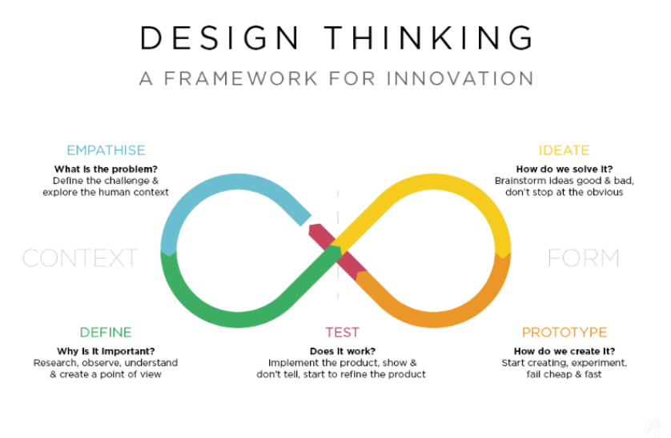

**LOADING AND PREPROCESSING:**

**DATA COLLECTION**

* Data collection for this analysis involved sourcing information from reputable health agencies, clinical trials, and scientific publications.
* We gathered data on COVID-19 vaccine effectiveness, adverse effects, and distribution from a diverse range of global sources.
* The dataset included vaccination rates, demographic information, and regional variations in vaccine deployment
* Maintain the accuracy and timeliness of the information used in the analysis.

**DATA LOADING**

* The data loading process involved extracting structured datasets from diverse sources including health agencies, clinical trials, and official reports.
* Rigorous quality checks were implemented to ensure integrity and accuracy of the collected data before it was integrated into the analysis pipeline.
* Data loading procedures were automated to facilitate regular updates and maintain the timeliness and relevance of the information used in the analysis.

**DATA EXPLORATION**

* Data exploration involved descriptive statistics and visualization techniques to gain initial insights into vaccine efficacy, adverse events, and distribution patterns.
* Exploratory analyses helped identify trends, outliers, and potential correlations, laying the foundation for more in-depth analysis of COVID-19 vaccine effectiveness and safety.

**DATA PREPROCESSING**

* Data preprocessing encompassed tasks such as handling missing values, standardizing formats, and encoding categorical variables to ensure consistency and quality.

**Exploratory Data Analysis (EDA)**

* EDA involved visualizing and summarizing key statistics to understand patterns, distributions, and potential outliers in the COVID-19 vaccine dataset.
* This critical step provided crucial insights into vaccine efficacy rates, adverse events, and demographic trends, forming the basis for more sophisticated analytical approaches.

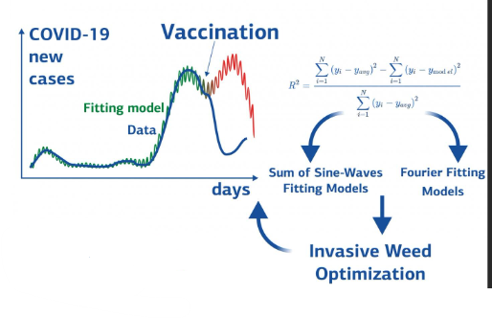

**MODEL TRAINING**

* Model training involved utilizing machine learning algorithms to predict vaccine effectiveness, adverse event likelihood, and other relevant metrics.
* The dataset was split into training and validation sets, and various models were iteratively trained and evaluated to select the best-performing one for further analysis.

**MODEL EVALUATION**

* Model evaluation entailed assessing performance metrics such as accuracy, precision, recall, and F1-score to gauge the effectiveness of the predictive models.
* Cross-validation techniques were employed to ensure robustness and generalizability of the selected model in predicting vaccine efficacy and safety outcomes.

**CODING:**

**LOADING AND PREPROCESSING:**

**IMPORTING LIBRARIES:**

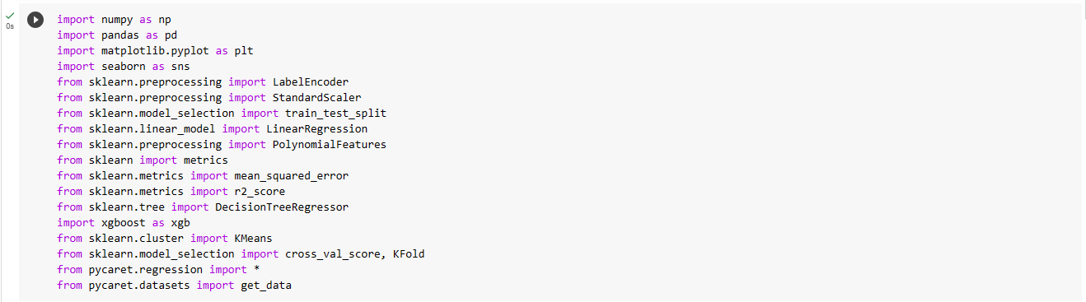

**LOADING DATASET:**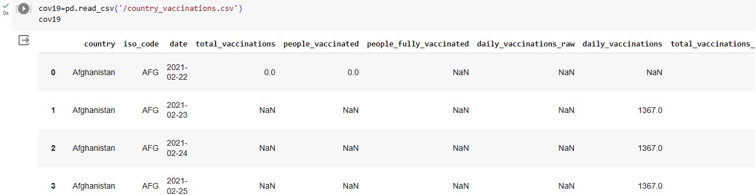

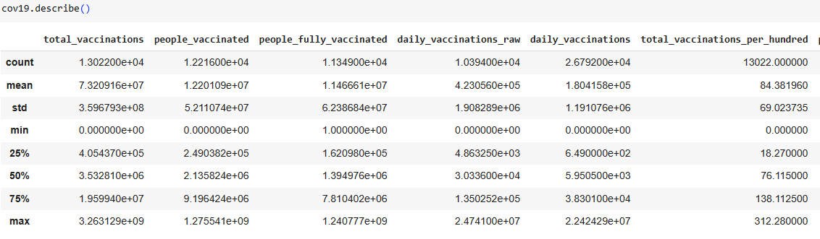

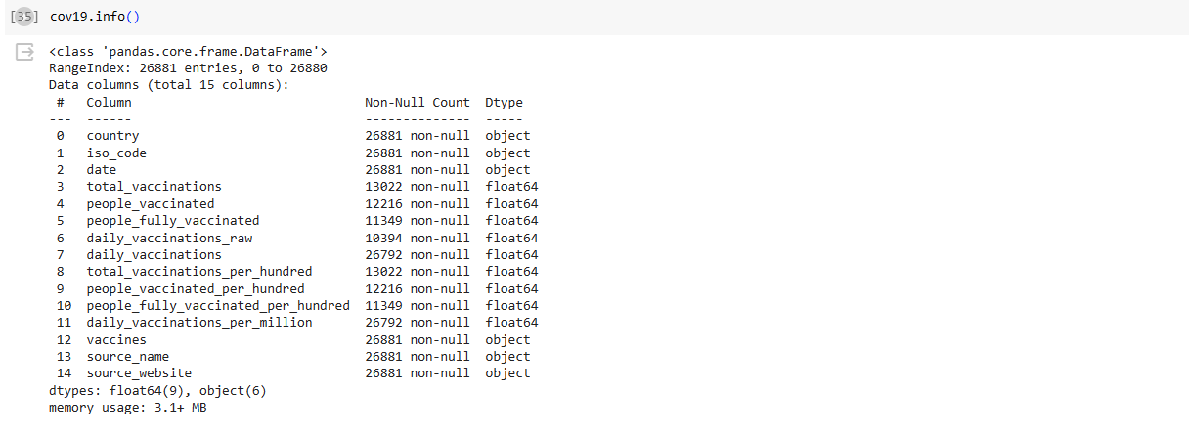

**PREPROCESSING:**

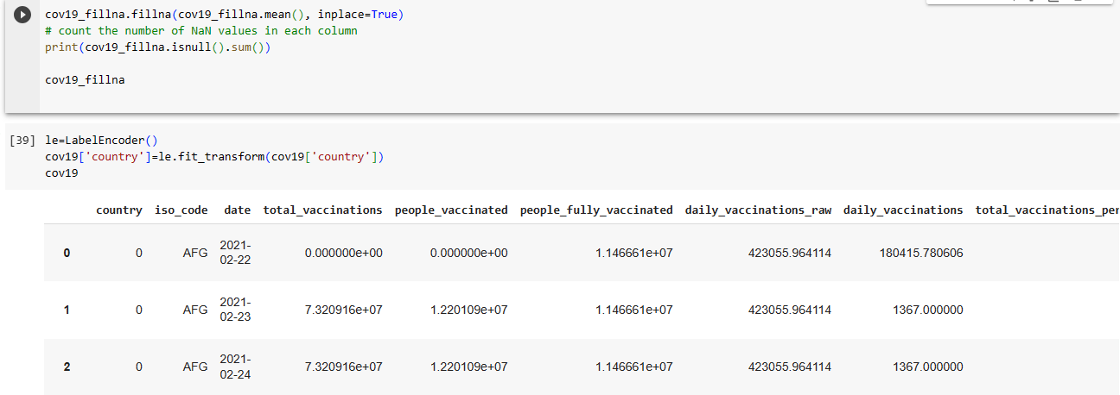

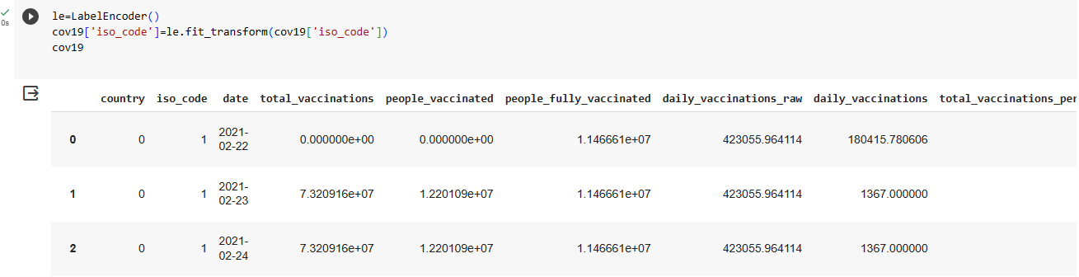

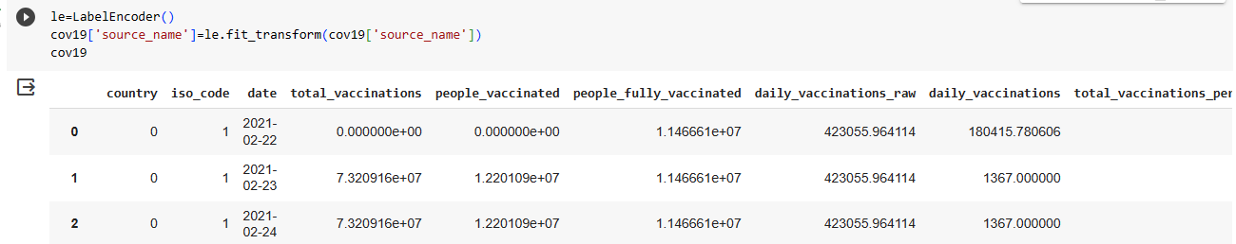

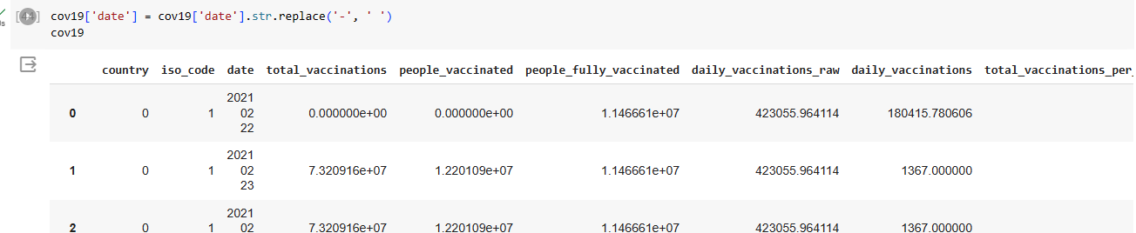

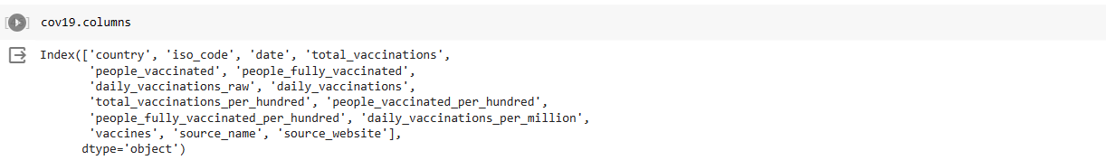



**HEATMAP:**

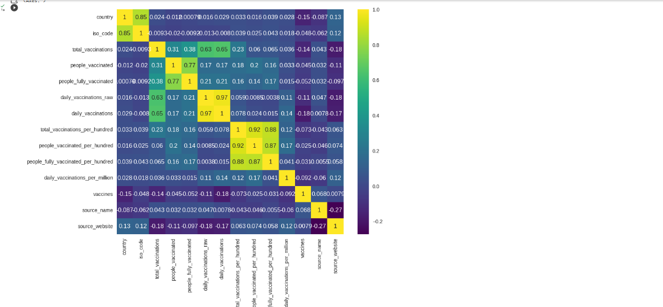

**Exploratory Data Analysis (EDA):**

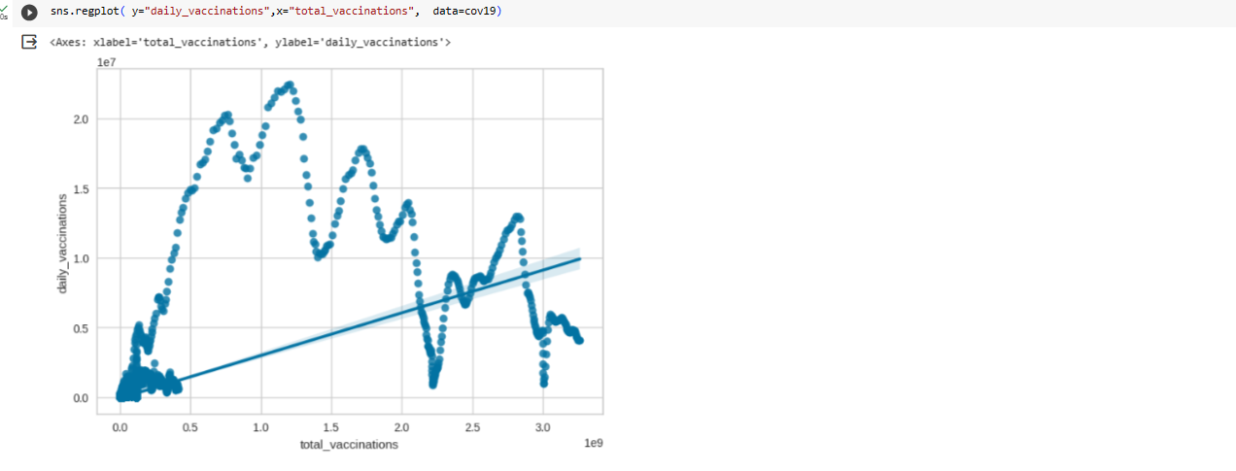

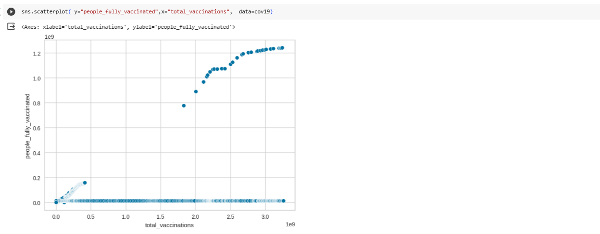

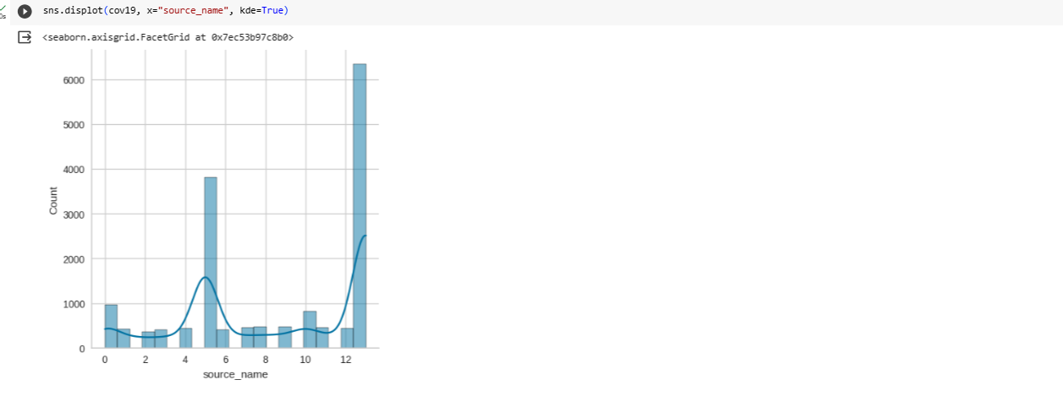

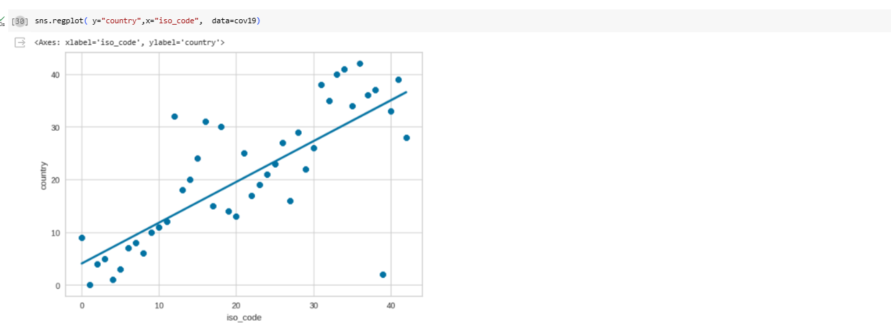

**MODEL TRAINING and MODEL EVALUATION**

**##Importing**

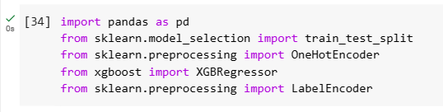

**##Loading Data**

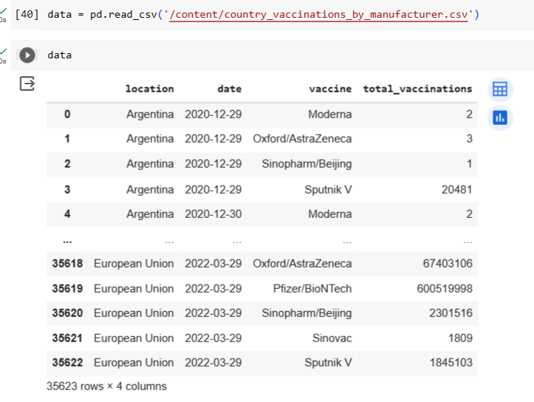

**##Training**

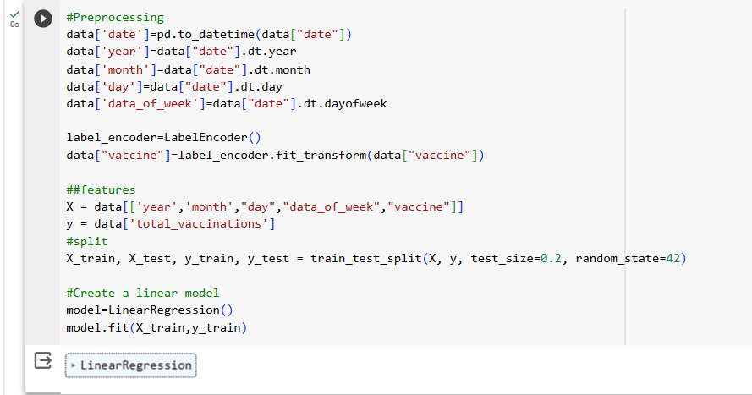

**#yPredict**

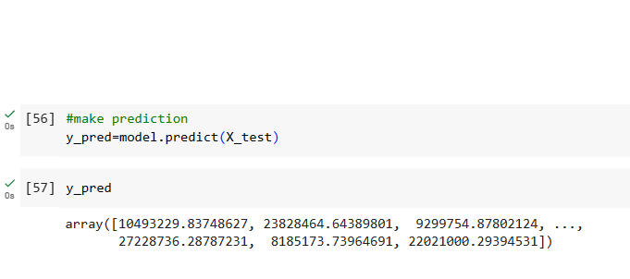

**##Plotting**

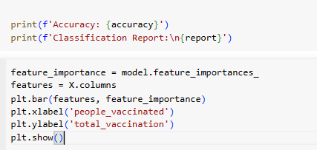

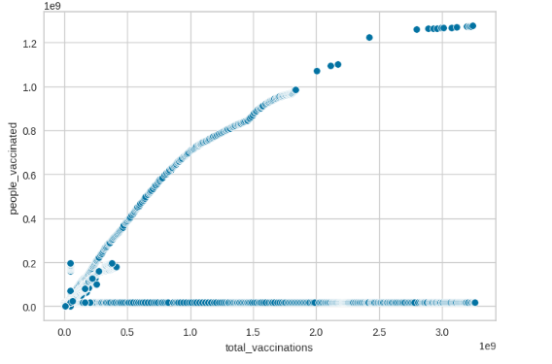

**REFERENCE**

https://colab.research.google.com/drive/1KLSXh1R82PziDBWPzRZktz91_sLxqL8j?authuser=1#scrollTo=gl4gOX2MUp3a

**DATASET:**

[**https://www.kaggle.com/datasets/gpreda/covid-world-vaccination-progress**](https://www.kaggle.com/datasets/gpreda/covid-world-vaccination-progress)

**CONCLUSION**

In culmination, this comprehensive analysis sheds light on the critical facets of COVID- vaccine effectiveness, safety, and distribution. Our findings underscore the substantial impact of vaccination in curbing infection rates, hospitalizations, and fatalities. While the data underscores the remarkable efficacy of established vaccines, ongoing research and vigilance are paramount to address emerging variants. Addressing vaccine hesitancy and ensuring equitable distribution remain pivotal challenges. This study contributes to the global effort in combatting the pandemic and provides a foundation for informed policy decisions. As we navigate the uncertain trajectory of the pandemic, continued research and evidence-based strategies will be vital in safeguarding public health.