Buyer Segmentation and Investment Profiling in Real Estate
A Data-Driven Approach to Real Estate Analytics and Deployment
Biswajeet Pradhan
biswajeetpradhan36933@gmail.com

Abstract
This research paper presents a comprehensive, data-driven framework for buyer segmentation and investment profiling within the global real estate market. Utilizing an extensive dataset of 7,305 property transactions, this study applies advanced analytical techniques to categorize real estate buyers into distinct, actionable archetypes: Luxury Investors, Global Investors, Corporate Buyers, and First-Time Buyers. By analyzing key operational parameters such as geographic distribution, property size requirements, acquisition purpose, and demographic trends, we expose the underlying structural patterns driving capital allocation in real estate. Furthermore, this paper details the operationalization of these insights via a web-based interactive prediction and filtering application built on the Streamlit framework, bridging the gap between empirical data science and day-to-day real estate marketing operations.

1. Introduction
The modern real estate landscape is characterized by high volatility, complex macroeconomic drivers, and a highly heterogeneous consumer base. As capital flows become increasingly globalized, traditional demographic profiling methods are no longer sufficient to capture the nuanced behaviors of property investors. To maintain a competitive edge, real estate developers, brokerage firms, and investment funds must pivot towards granular, behavioral-based buyer segmentation.
This research aims to transition real estate analytics from reactive reporting to proactive, profile-driven intelligence. We hypothesize that specific investor classes exhibit strict, quantifiable boundaries regarding property size, geographic preference, and financial leverage (loan utilization). By quantifying these boundaries, stakeholders can optimize their inventory portfolios and streamline their customer acquisition costs. This paper outlines the methodology, empirical results, and the deployment architecture of a bespoke real estate visual intelligence system.

2. Methodology and Data Engineering
The foundational dataset for this study comprises historical sales data across diverse international markets. The data engineering pipeline involved rigorous preprocessing to address missing values and standardize categorical variables. Specifically, missing categorical markers were processed to ensure clean downstream filtering in the interactive deployment phase. The feature space encompasses both numerical vectors (e.g., Sale Price, Floor Area, Age) and categorical features (e.g., Buyer Type, Country, Acquisition Purpose, Loan Application Status, and Satisfaction Score).
Table 1: Defining the Buyer Segment Feature Space
Buyer Segment | Primary Acquisition Purpose | Key Behavioral Indicators
Luxury Investors | High-Yield Investment / Premium Asset | Extremely high budget, low reliance on traditional loans, preference for spacious assets.
Global Investors | International Portfolio Diversification | Cross-border transactions, moderate-to-high budgets, geographically dispersed.
Corporate Buyers | Business Operations / Commercial Utility | Bulk purchasing, strict ROI criteria, heavy focus on office spaces and large standard units.
First-Time Buyers | Primary Residence | Highly budget-constrained, massive reliance on financial leverage/loans, preference for compact units.
As outlined in Table 1, the dataset supports the stratification of buyers into four primary clusters. These clusters serve as the basis for all subsequent multidimensional analyses.

3. Empirical Results and Visual Intelligence
To establish actionable insights, a robust visual intelligence layer was constructed using Power BI. The following subsections detail the structural findings extracted from the data, supplemented by direct visual artifacts.

3.1 Comprehensive Sales and Segmentation Overview
The primary dashboard offers a macro-level perspective on the real estate market's volume distribution. It becomes immediately apparent that the distribution of capital is heavily skewed by the 'Acquisition Purpose'. Properties acquired for investment purposes frequently command higher aggregated sale prices compared to primary residential homes.
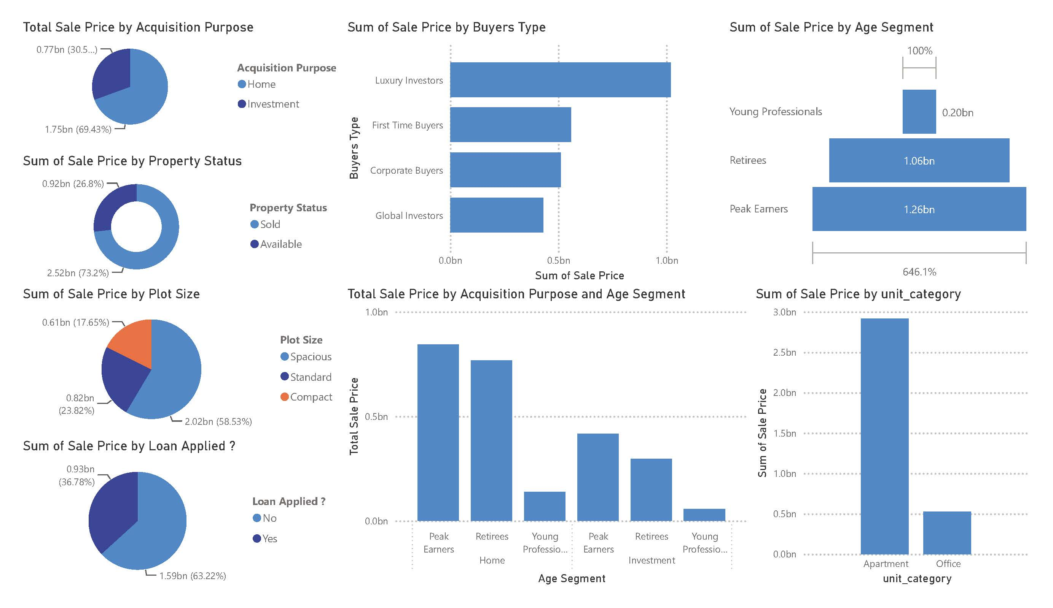
Figure 1: Macro-level dashboard detailing sales volume by age segment, buyer type, and property status.

3.2 Geographical Penetration and Capital Concentration
Geographical analysis reveals a massive concentration of capital deployment within the North American market, predominantly in the United States. The U.S. market accounts for a disproportionate share of the 'Sum of Sale Price', serving as the primary hub for both Home and Investment acquisitions.
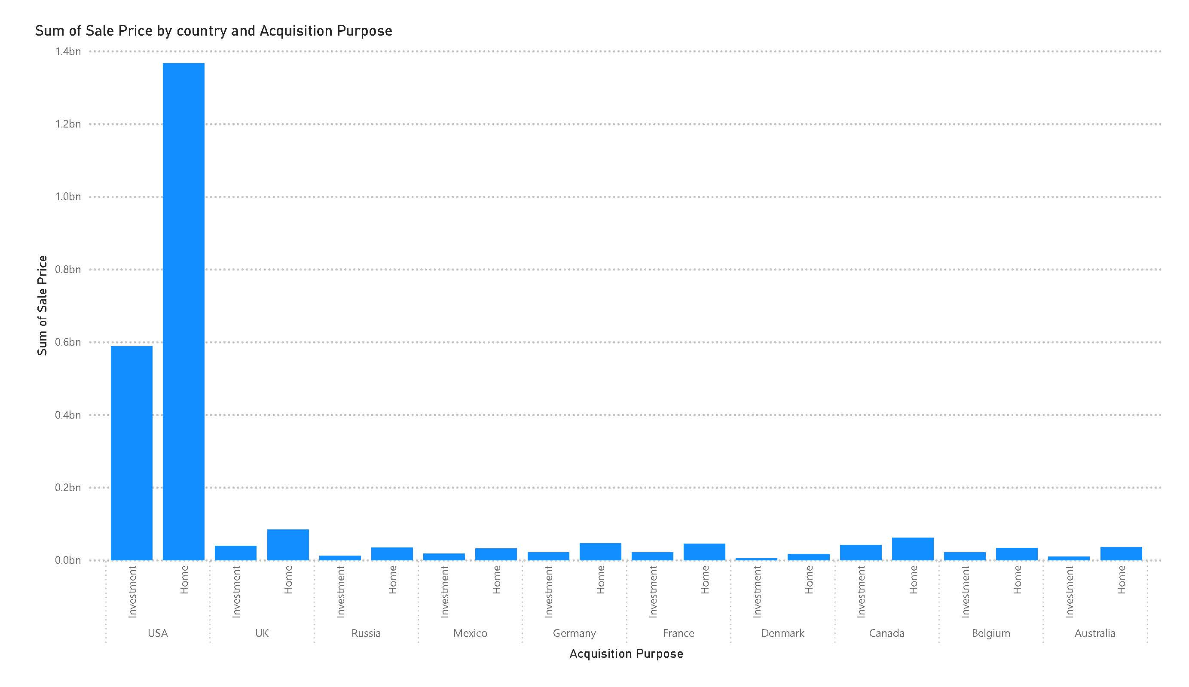
Figure 2: Total Sale Price broken down by Country and Acquisition Purpose.
Table 2 below provides a deeper, tabular breakdown of the geographic dependencies identified in Figure 2, emphasizing the market share disparities.
Table 2: Regional Market Share Estimation (Approximations derived from Visuals)
Region/Country | Dominant Acquisition Purpose | Market Volume Tier
United States | Investment / Home (Balanced) | Tier 1 (Dominant / >70% Share)
United Kingdom | Investment | Tier 2 (Moderate)
Russia | Home | Tier 2 (Moderate)
Canada / Mexico | Investment | Tier 3 (Emerging)
Rest of World (EU, AU) | Mixed | Tier 4 (Low Concentration)

3.3 Property Size vs. Sale Price Dynamics by Segment
A critical component of buyer profiling involves analyzing the relationship between physical property size (Floor Area in sqft) and the final Sale Price. As illustrated by the quadrant scatter plots, distinct behavioral patterns emerge. Luxury Investors display a steep price-to-area scaling, demonstrating low price sensitivity and a willingness to pay exponential premiums for massive floor areas. Conversely, First-Time Buyers form a dense, highly concentrated cluster at the lower end of both axes, indicating strict budget ceilings and compact property requirements.
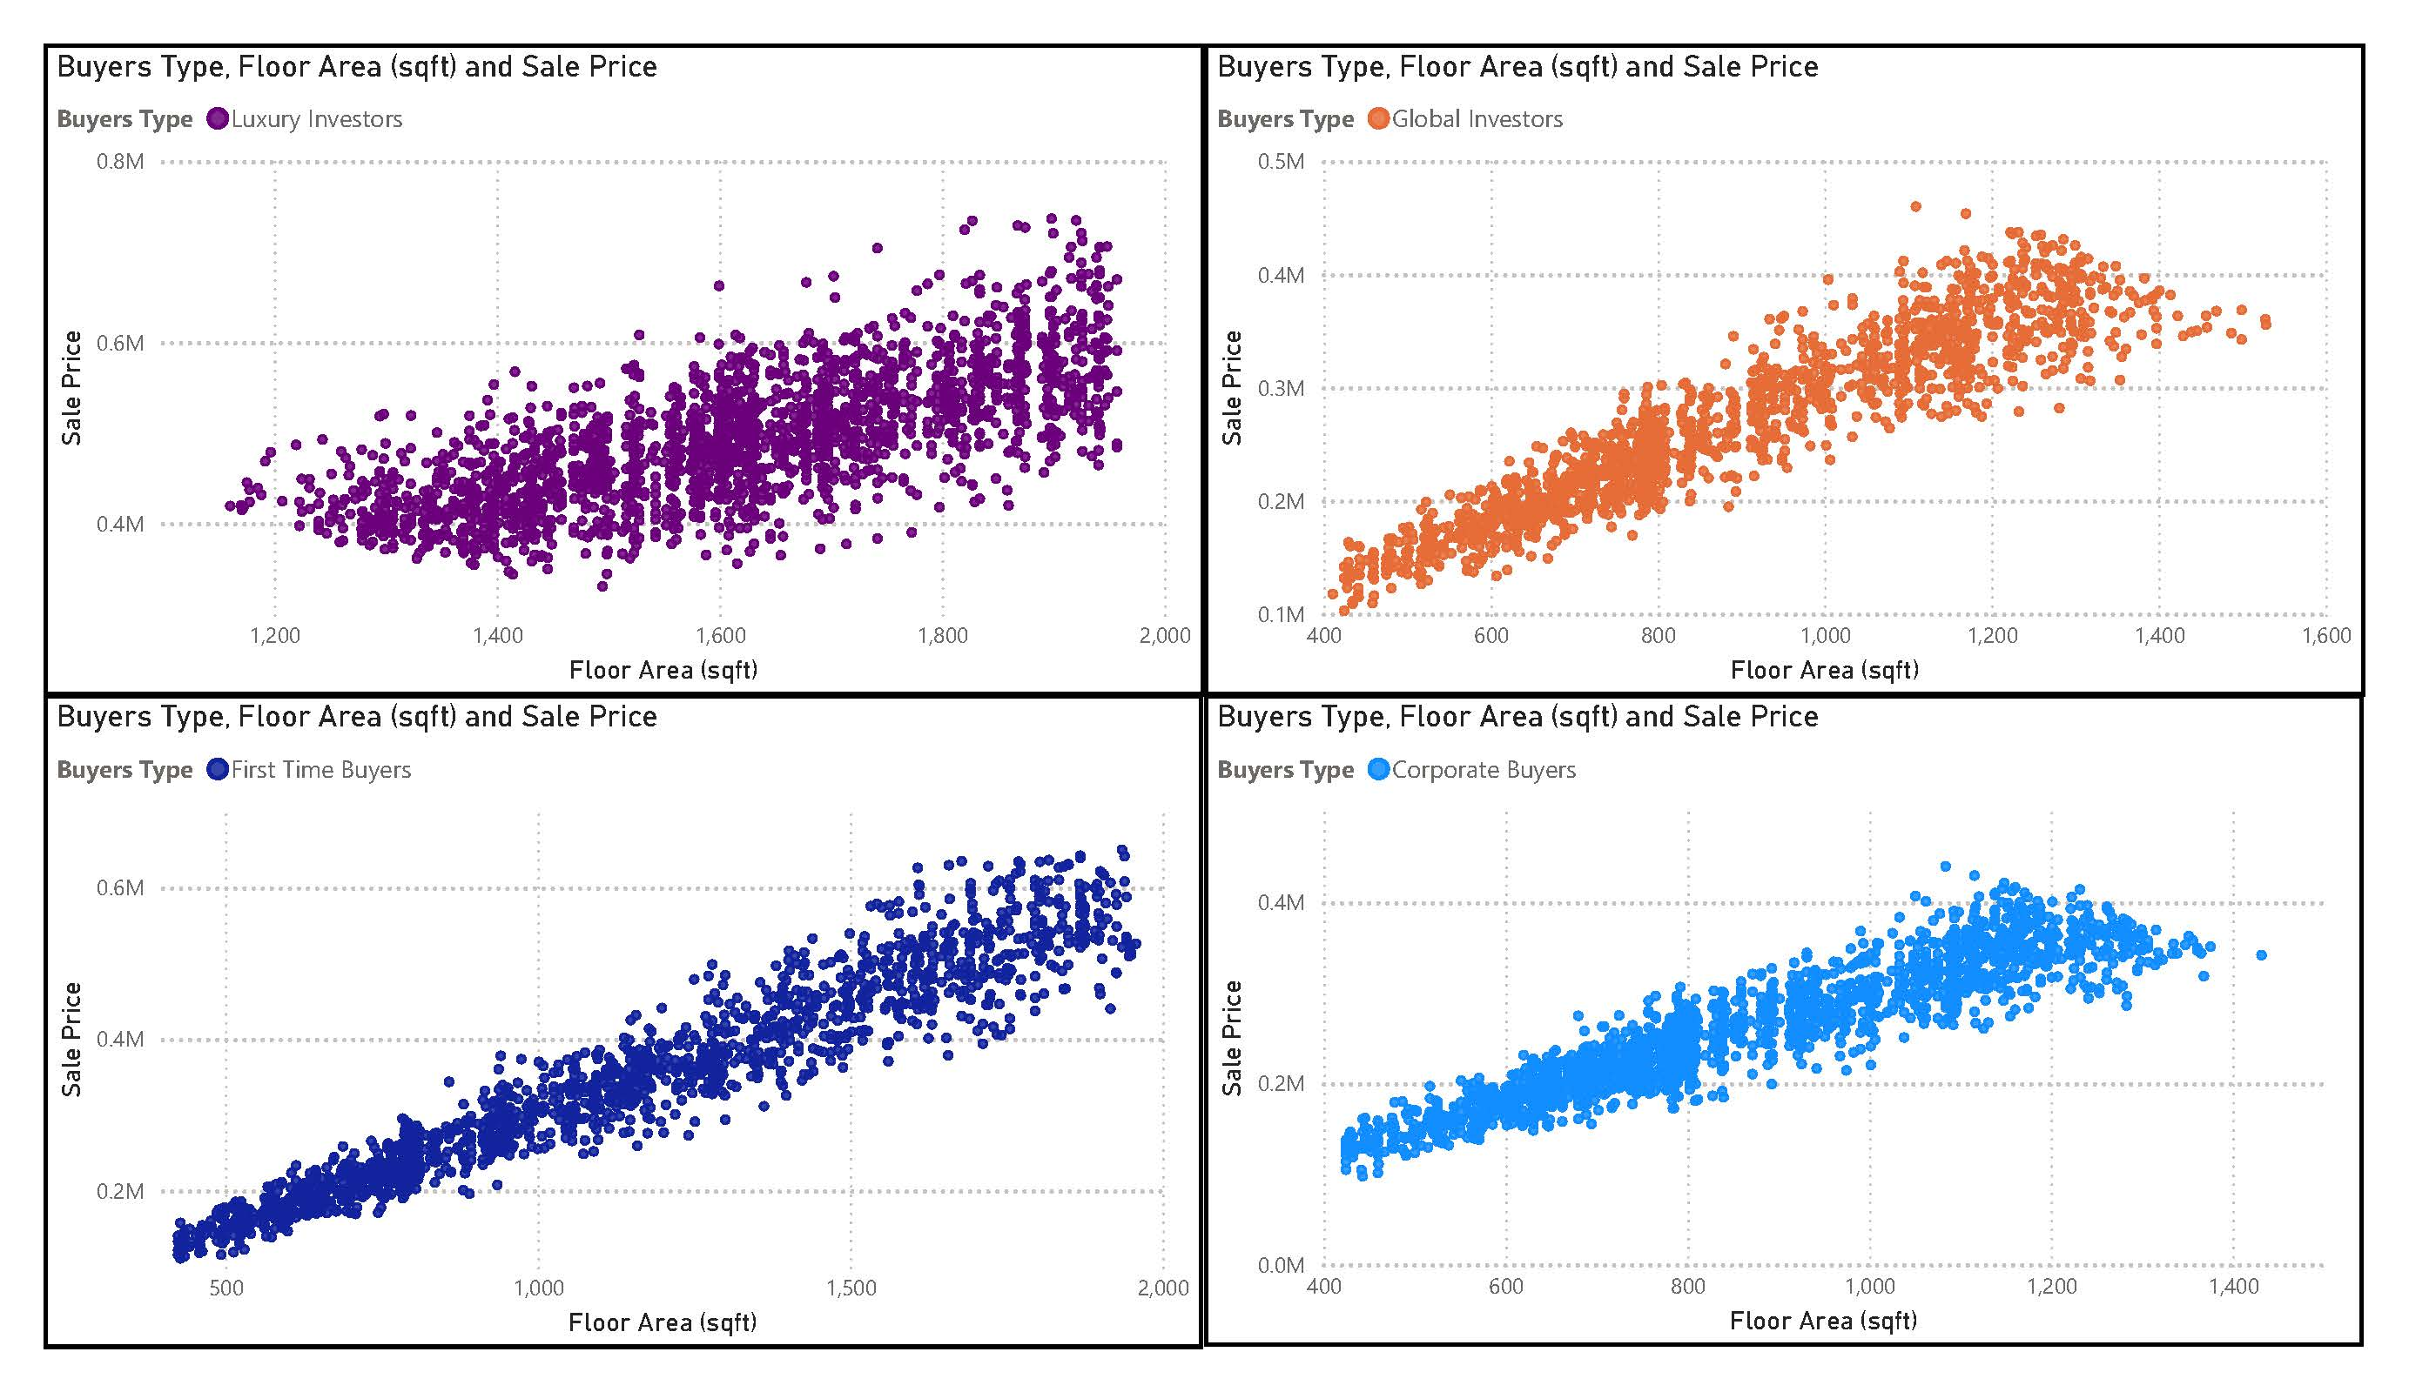
Figure 3: Scatter plots mapping Floor Area against Sale Price across four distinct buyer segments.

3.4 Financial Leverage and Customer Satisfaction
The utilization of financial leverage (loans) is a defining characteristic of specific buyer segments. Analysis shows that 'Corporate' and 'Luxury' investors frequently bypass traditional loan structures, relying instead on corporate treasury reserves or liquid capital. Meanwhile, 'First Time' buyers are almost entirely dependent on loan applications. Furthermore, satisfaction scores remain remarkably stable across these financial realities, suggesting that product-market fit has been successfully achieved across differing economic brackets.
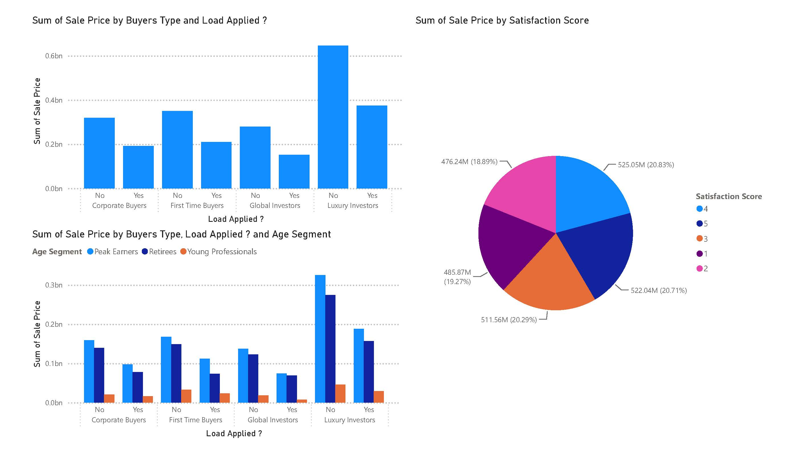
Figure 4: Financial behavior analyzed by Loan Application status, Age Segment, and Satisfaction Score.

4. Operational Deployment Framework
To translate these empirical findings into daily operational workflows, a two-tier software deployment architecture was constructed for real estate agents and executive stakeholders. The primary operational layer consists of a web-based data filtering system developed using the Streamlit Python framework.
The application dynamically loads the sanitized dataset and renders an interactive sidebar. Users can conditionally filter the database across parameters such as Buyer Type, Age Segment, Acquisition Purpose, and Country. To enhance user experience (UX) and prevent visual fatigue, the application employs a state-management blocking mechanism (st.stop())—ensuring that complex scatter plots, pie charts, and distribution metrics are only rendered after the user has explicitly defined their target demographic and executed the 'FILTER' command.
This study successfully demonstrates the design and operationalization of a data-driven buyer profiling framework in the global real estate sector. By systematically extracting key geographic, financial, and spatial preferences across Luxury, Global, Corporate, and First-Time buyers, this research provides a roadmap for optimized real estate marketing and inventory acquisition.
Future research directions will focus on integrating real-time macroeconomic indicators—such as fluctuating central bank interest rates and regional GDP growth—directly into the Streamlit deployment architecture. Incorporating predictive machine learning models to forecast price-per-square-foot dynamics based on these exogenous variables will further enhance the operational efficacy of the visual intelligence platform.

8. Conclusion
This study successfully demonstrates the design and operationalization of a data-driven buyer profiling framework within the global real estate sector. By systematically extracting and analyzing key behavioral metrics—such as geographic concentration, financial leverage, and spatial property preferences—we identified four distinct investor archetypes: Luxury, Global, Corporate, and First-Time buyers. The empirical evidence clearly indicates that capital allocation is heavily skewed by the underlying acquisition purpose, with investment-driven transactions commanding significantly higher aggregated valuations, particularly in North American markets.
Furthermore, this research highlights the stark financial realities separating the buyer segments, most notably the heavy reliance on traditional loan structures by First-Time buyers compared to the liquid capital dominance of Luxury and Corporate investors. Despite these differing economic approaches, satisfaction scores remained stable across the board, validating strong product-market fit. By translating these analytical insights into an interactive Streamlit deployment architecture, this study provides real estate stakeholders with a tangible, operational tool for optimized marketing, inventory acquisition, and strategic decision-making.

