Project AquaGuard – Complete System Architecture & Operational Documentation
An Enterprise-Grade Smart Water Infrastructure Monitoring, Analytics, and Management Platform.

1. Project Introduction
Project AquaGuard is a full-stack, enterprise-grade industrial telemetry, analytics, and DevOps automation platform designed for national water utility organizations. The platform establishes central control, real-time observability, and predictive maintenance scheduling across large-scale physical assets, including reservoirs, pipelines, pumping stations, and smart meters. Equipped with an interactive, modern user interface, AquaGuard bridges physical infrastructure operations with digital intelligence to optimize water distribution, mitigate non-revenue water loss, and ensure service reliability.

2. Problem Statement
Municipal and national water distribution grids suffer from severe operational blind spots:
- Undetected Infrastructure Leaks: Significant volumes of water are lost due to slow pipeline bursts (non-revenue water loss) before physical inspections detect anomalies.
- Reactive Maintenance Scenarios: Equipment failures (such as pump overheating or pressure spikes) are handled after the breakdown occurs, resulting in service downtime and high emergency repair costs.
- Information Silos: Telemetry systems, maintenance logs, alarm networks, and consumer billing smart meters run on disconnected software interfaces.
- Poor Observability & Scaling: SREs and DevOps teams lack unified deployments to monitor server health alongside active physical field telemetry.

3. Why AquaGuard Was Built
AquaGuard was engineered to resolve these inefficiencies by offering a unified single pane of glass. It brings together physical telemetry streams (flow, level, pressure, and temperature) and system monitoring tools (ELK stack, Prometheus, Grafana) into one cohesive, containerized web platform. SREs can track container limits, field engineers can toggle pump hardware, and managers can dispatch maintenance tasks all from a highly resilient interface.

4. Business Objectives
- Minimize Distribution Leaks: Identify leak signatures via pressure drops and flow rate anomalies within seconds.
- Transform Maintenance Operations: Predict pump overheating hazards using real-time machine run-time analytics, lowering pump failures by up to 40%.
- Secure Infrastructure Operations: Leverage Role-Based Access Control (RBAC) to restrict physical hardware overrides to certified personnel.
- Ensure High Availability: Guarantee a disaster recovery envelope of RPO = 15 minutes and RTO = 1 hour for national grid systems.

5. System Architecture
AquaGuard is built on a robust, decoupled, containerized three-tier architecture:
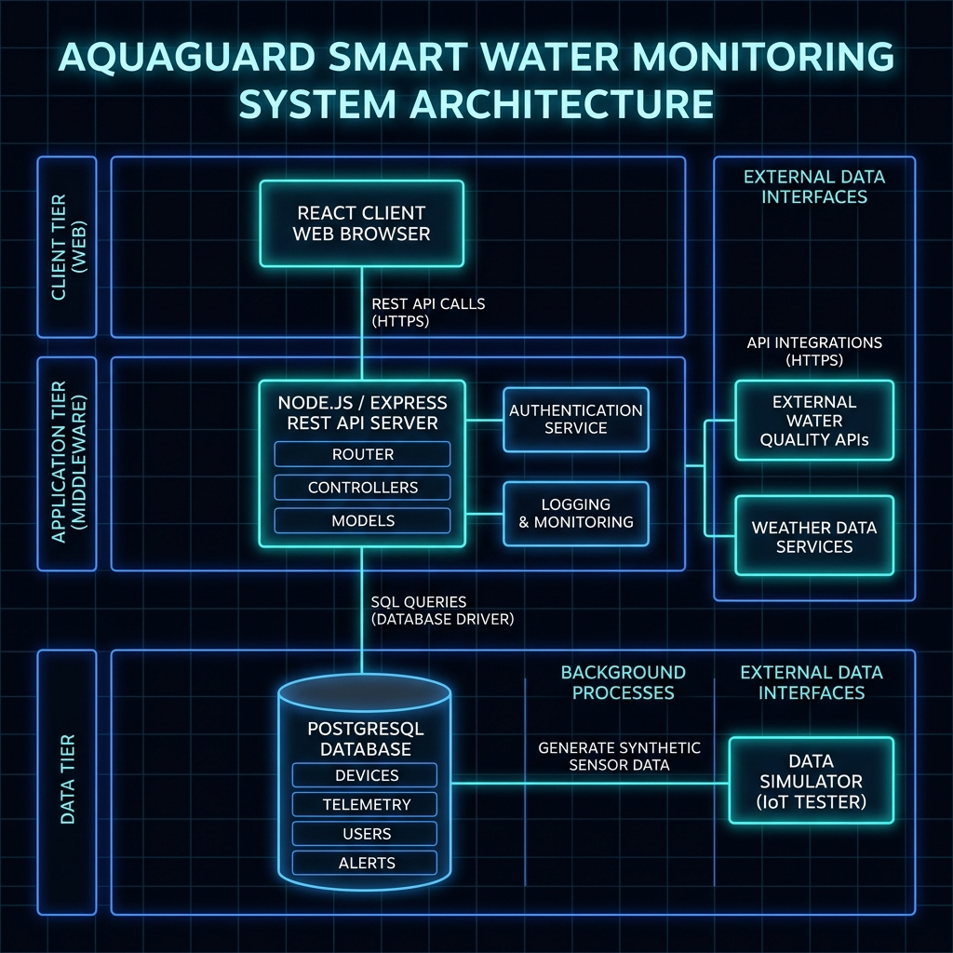
Figure 1: AquaGuard Decoupled Multi-Tier System Architecture

6. Technology Stack
- Frontend: React 18, Vite, Chart.js, React-Chartjs-2, Vanilla CSS Variable Token system.
- Backend: Node.js, Express.js REST Framework.
- Database: PostgreSQL (Active Pg-Pool), Local mock memory state fallback database engine.
- Authentication: JWT (JSON Web Tokens), Role-Based Access Control (Admin, Operations Manager, Field Engineer).
- Observability: Prometheus telemetry scraper, Grafana UI dashboard, Filebeat, Logstash, Elasticsearch, Kibana.
- DevOps: Docker, Docker Compose, Jenkins Declarative Pipelines, Terraform (AWS VPC, RDS, EC2), Kubernetes (K8s Deployments, Services, ConfigMaps, Secrets, Ingress).

7. Frontend Architecture
The client is a single-page application (SPA) optimized for low latency and high stability:
- State Management: React state hooks (useState, useEffect) managed dynamically per module, backed by a unified React Auth Context for JWT state management.
- Design Tokens: Standard CSS variables (--bg-primary, --accent-cyan, --glass-bg) define a sleek dark-mode layout with responsive layouts matching all screens.
- Exception Isolation: Nested <ErrorBoundary> layouts catch component-level failures (such as Chart.js render errors) without impacting the main container dashboard.

8. Backend Architecture
The backend is an Express-based gateway utilizing modular routing:
- Resilience Wrapper: All endpoints run inside dedicated asynchronous try/catch scopes to handle database drops and prevent unhandled promise rejections.
- Pg-Pool Connection Layer: Implements active pool connections with automatic timeouts. If connection attempts fail, a fallback flag (useMock = true) redirects database routines to an identical mock data engine.
- Audit Logger: A middleware function logs every incoming HTTP request method, IP address, and payload variables into the system logs table.

9. Database Design
The schema enforces strict database relational constraints. Key tables include:
- users: ID (PK), Username, Password Hash, Role.
- reservoirs: ID (PK), Name, Location, Capacity, Level, Status.
- pipelines: ID (PK), Name, Status, Flow Rate, Pressure, Location Start, Location End.
- pumps: ID (PK), Name, Status, Temperature, Runtime Hours, Location.
- sensors: ID (PK), Name, Type, Status, Current Value, Unit.
- smart_meters: ID (PK), Meter Number, Consumer Name, Usage kWh, Status.
- maintenance_requests: ID (PK), Equipment Type, Equipment ID, Issue, Priority, Assigned Engineer ID, Status.
- alerts: ID (PK), Severity, Message, Source, Status, Timestamp.
- logs: ID (PK), Type, Level, Message, Timestamp.

10. Authentication System
- What it does: Controls access based on roles.
- Why it exists: Prevents unauthorized modifications (e.g., toggling pump switches).
- How it works: Compares username/password, issues a signed JWT containing user role, verified by downstream middleware.
- Database Tables: users
- APIs: POST /api/auth/login
- Business Problem Solved: Eliminates insider threats and limits operations to authorized technicians.

10b. Role-Based Access Control (RBAC) System & User Relationships

User Roles Overview
Project AquaGuard secures and compartmentalizes utility operations using a strict Role-Based Access Control (RBAC) model. The system is designed with three distinct roles matching real-world organizational profiles:
Role Name | Access Level | Description | Key System Permissions
Admin | Full Permissions | IT Supervisors, SREs, and Administrators | Full CRUD on reservoirs, pipelines, pumps; access to system performance metrics and database logging audit trails; settings modification.
Operations Manager | Management | Grid Superintendents and Dispatchers | Read-only telemetry; toggle pump states; run predictive analytics; simulate leak scenarios; create and dispatch maintenance work requests.
Field Engineer | Field Operations | Technicians and Field Crews | Read-only telemetry; update progress status on assigned maintenance tasks; view alert queues. Restricted from toggling pumps, creating tasks, or viewing logs/system health.

Detail of Role Features

1. Admin (Administrator)
- What it is: The system's administrative master role, designed for security administrators, site reliability engineers (SREs), and database supervisors.
- Why it is used: In municipal grids, the master configurations, resource diagnostics, and audit logs should not be exposed to average operators or field crews. Only the Admin role can run low-level audits, check memory/CPU graphs, change system variables, or add/remove hardware stations.
- Core Features:
- Asset Creation & Deletion: Adds or removes reservoirs, pumps, or pipeline entities from the PostgreSQL inventory.
- System Observability: Displays container memory utilization, API endpoints latency, and microservice status.
- Logs Console: Allows tracing and searching audit logs (e.g., logins, database connection pools, telemetry sync routines).
- Configuration Overrides: Access to write settings.

2. Operations Manager
- What it is: The operational dashboard supervisor, responsible for coordinating flow rates, responding to leakage alarms, and managing maintenance workflows.
- Why it is used: Grid managers coordinate the overall municipal water system, decide when to toggle equipment power, simulate leaks to verify security compliance, and assign tasks to technicians.
- Core Features:
- Pump Toggle Control: Can click to switch pump engines ON or OFF in the system database.
- Leak Simulator: Triggers pressure drops and pipeline bursts to test system responses.
- Maintenance Dispatches: Creates new maintenance work logs, sets task priority (Low, Medium, High, Critical), and assigns field technicians.
- Analytics Platform: Accesses SVG charts and trends visualizing reservoir capacity, water usage, and machine wear models.

3. Field Engineer
- What it is: A mobile-first profile meant for field utility workers and contractors executing physical repairs at reservoirs, pipes, or pump stations.
- Why it is used: Technicians require access to live pressure, level, and temperature data to diagnose physical issues, but they must not be allowed to change database assets, toggle major pump stations, or view analytical planning reports. Their primary duty is to receive tasks and log progress.
- Core Features:
- Read-Only Telemetry: Accesses live read-only statistics and status boards.
- Workflow Controls: On the Maintenance panel, updates the progress status of assigned repair requests (transitions: Pending → In Progress → Resolved).
- Security Restrictions: Denied access to creating requests, changing pumps, triggering simulators, or viewing the Analytics, Logs, and System dashboards.

Interconnected Operational Workflows
The AquaGuard system connects these three roles together through a unified operational loop:
Step | Actor (Source) | Target (Destination) | Action / Event Description | System Response & Observability Logs
1 | Operations Manager | Database / API | Triggers Leak Simulator on Pipeline A | Database updates pipeline pressure level, logs the simulator trigger action, and dispatches a Critical Alert to the dashboard.
2 | Operations Manager | Database / API | Creates Maintenance Request assigned to Field Engineer (Dave) | Saves a new maintenance task record with status 'Pending' and links it to Pipeline A.
3 | Field Engineer | Database / API | Logs in, views assigned tasks, and clicks 'Start Work' | API backend transitions the maintenance status to 'In Progress' and logs the work commencement event.
4 | Field Engineer | Physical Infrastructure | Performs the leak repairs in the field | Technician completes mechanical patches on the physical pipeline structure.
5 | Field Engineer | Database / API | Clicks 'Complete Task' on the dashboard | Status changes to 'Resolved'. System telemetry variables return to safe normal levels. Critical Alert is cleared.
6 | Admin / SRE | Logs Console | Reviews centralized audit logs | Verifies the end-to-end security audit trail (login, simulation, dispatch, and final resolution).
7 | Admin / SRE | System Monitoring | Observes Host & Container Gauges | Verifies CPU/Memory resource footprints remain stable post-event.
Table: Interconnected Operational Workflow Steps (Admin, Manager, Engineer)

- Telemetry Hazard Simulation (Manager): An Operations Manager triggers a leak simulation on a pipeline, which simulates a grid failure. The API backend logs this action and registers a critical alert.
- Maintenance Dispatch (Manager): The Manager acts on the alert by filing a maintenance request, assigning a specific technician (e.g. "Engineer Dave") to the pipeline asset ID.
- Task Execution & Resolution (Field Engineer): The Field Engineer logs in, sees the task, clicks Start Work (updating DB status to In Progress), performs physical repairs, and clicks Complete Task (updating DB status to Resolved).
- Log Auditing & Observability (Admin): The Admin accesses the system logs to verify that the leak simulation, assignment, and resolution were completed correctly by the registered accounts, checking the CPU/Memory gauges to ensure server health was stable.

11. Reservoir Management Module
- What it does: Observes volume capacities, locations, and water levels across reservoirs.
- Why it exists: Prevents reservoirs from running empty or overfilling.
- How it works: Monitors current capacity percentages, displaying dynamic status indicators:
- < 20%: Low Level warning badge.
- > 95%: Near Capacity warning badge.
- Database Tables: reservoirs
- APIs: GET /api/reservoirs, POST /api/reservoirs, PUT /api/reservoirs/:id, DELETE /api/reservoirs/:id
- Business Problem Solved: Eliminates supply gaps and storage tank overflows.

12. Pipeline Management Module
- What it does: Monitors pipelines, checking for flow rates, pressure levels, and bursts.
- Why it exists: Detects distribution leaks and pressure changes.
- How it works: Tracks pressure metrics. Technicians can trigger a leak simulator, which drops pressure values and triggers critical alarms.
- Database Tables: pipelines, alerts, logs
- APIs: GET /api/pipelines, POST /api/pipelines, PUT /api/pipelines/:id, DELETE /api/pipelines/:id, POST /api/pipelines/:id/simulate-leak
- Business Problem Solved: Reduces non-revenue water loss from slow, underground pipe leaks.

13. Pump Management Module
- What it does: Monitors water pumps, managing runtime hours, status, and machine temperatures.
- Why it exists: Tracks motor stress and equipment usage.
- How it works: Displays active, inactive, or overheated machine indicators. Technicians can toggle pump power or request immediate repairs.
- Database Tables: pumps, maintenance_requests, logs
- APIs: GET /api/pumps, POST /api/pumps, PUT /api/pumps/:id, DELETE /api/pumps/:id
- Business Problem Solved: Prevents motor burnouts and grid shutdowns.

14. Sensor Monitoring Module
- What it does: Displays real-time sensor streams from pressure, level, temperature, and flow gauges.
- Why it exists: Collects raw telemetry from remote physical hardware.
- How it works: Polls sensor tables periodically (every 10 seconds) to render active telemetry streams and connection handshakes.
- Database Tables: sensors
- APIs: GET /api/sensors
- Business Problem Solved: Replaces manual meter checks with remote, real-time sensor readings.

15. Smart Meter Management Module
- What it does: Tracks household/industrial smart meter usage.
- Why it exists: Monitors consumption patterns and provides accurate billing.
- How it works: Aggregates total consumer water consumption in a read-only list feed.
- Database Tables: smart_meters
- APIs: GET /api/smart-meters (indirectly via GET /api/dashboard)
- Business Problem Solved: Prevents billing errors and water theft.

16. Alert Management Module
- What it does: Collects alarms from pipelines, pumps, and sensors, routing them by severity.
- Why it exists: Notifies SRE and maintenance teams about grid emergencies.
- How it works: Filters active alarms by severity (Critical, Warning, Info) and displays resolution buttons.
- Database Tables: alerts, logs
- APIs: GET /api/alerts, PUT /api/alerts/:id
- Business Problem Solved: Speeds up response times for critical equipment issues.

17. Maintenance Management Module
- What it does: Logs, assigns, and tracks utility repair requests.
- Why it exists: Streamlines scheduling for repair technicians.
- How it works: Engineers can file a request, assign tech leads, set priority levels, and track progress (Pending, In Progress, Resolved).
- Database Tables: maintenance_requests, logs
- APIs: GET /api/maintenance, POST /api/maintenance, PUT /api/maintenance/:id
- Business Problem Solved: Simplifies workflow tracking for repairs, moving tasks from "pending" to "resolved."

18. Analytics Platform
- What it does: Computes average demand, line efficiency, water loss volumes, and predictive failure risks.
- Why it exists: Offers data insights for water demand planning.
- How it works: Generates daily efficiency lines on SVG charts and uses asset run-hours to calculate machine failure risks.
- Database Tables: pipelines, pumps
- APIs: GET /api/analytics
- Business Problem Solved: Enables preemptive parts ordering and predictive maintenance before breakdowns.

19. Monitoring Platform
- What it does: Tracks CPU, memory, disk, and network traffic metrics.
- Why it exists: Monitors server health and service health.
- How it works: Polls local resources to render real-time gauges for CPU and Memory, alongside microservice status badges.
- Database Tables: None (system level)
- APIs: GET /api/system/health
- Business Problem Solved: Alerts SREs of server load anomalies before APIs go offline.

20. Logging System
- What it does: Collects Audit, Sensor, System, and Application logs into a terminal view.
- Why it exists: Provides centralized debugging logs for auditing.
- How it works: Captures backend errors and developer trace logs, rendering them with severity filters and text searches.
- Database Tables: logs
- APIs: GET /api/logs
- Business Problem Solved: Speeds up incident investigations by organizing search logs.

21. DevOps Architecture
The DevOps stack automates testing, container packaging, and cloud infrastructure deployment:
[Commit Code] ➔ [Jenkins Declarative Pipeline] ➔ [Docker Image Build] ➔ [AWS ECR Registry] ➔ [Kubernetes EKS Cluster Pods]

22. Docker Implementation
Both client and server include optimized, multi-stage production Dockerfiles:
- [frontend/Dockerfile](file:///Users/ashutoshrai/Desktop/Project-AquaGuard-CaseStudy68/frontend/Dockerfile): Uses a Node environment to compile Vite static assets, which are then served by a high-performance Nginx server container.
- [backend/Dockerfile](file:///Users/ashutoshrai/Desktop/Project-AquaGuard-CaseStudy68/backend/Dockerfile): Packages the Express API, leveraging micro-Node images to minimize container footprints.

23. Docker Compose Implementation
The root [docker-compose.yml](file:///Users/ashutoshrai/Desktop/Project-AquaGuard-CaseStudy68/docker-compose.yml) orchestrates the local stack, managing:
- db: PostgreSQL instance using persistent volumes.
- backend: REST gateway running on port 5001 (to prevent AirPlay port conflicts).
- frontend: Vite React application running on port 5173.
- prometheus: Scraper container running on port 9090.

24. Jenkins CI/CD Pipeline
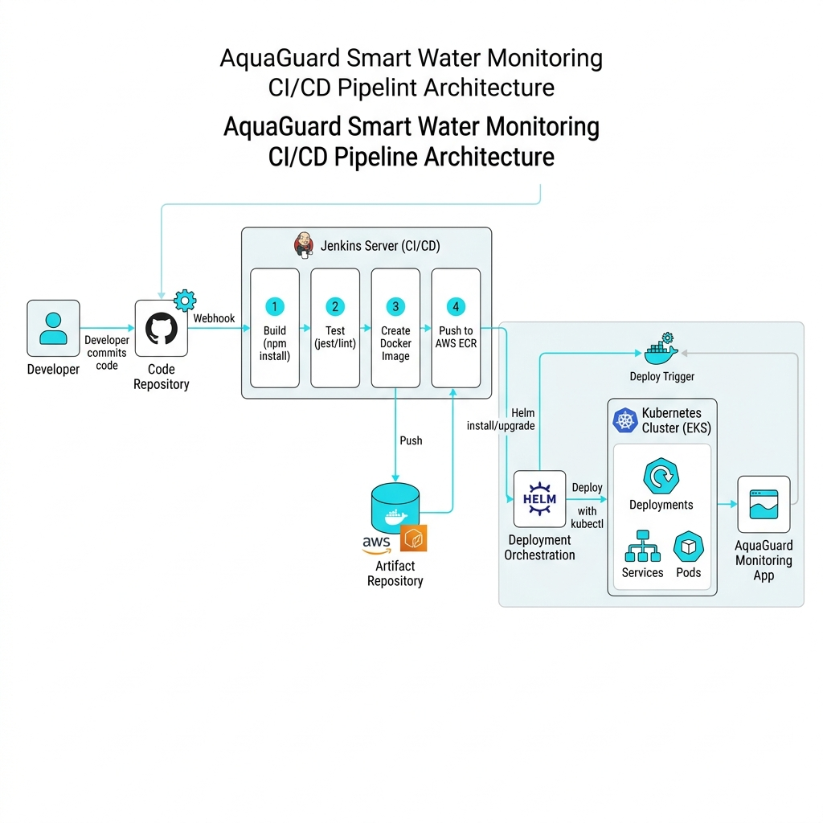
Figure 2: Jenkins Declarative CI/CD Pipeline Automation Workflow
Managed by [Jenkinsfile](file:///Users/ashutoshrai/Desktop/Project-AquaGuard-CaseStudy68/devops/jenkins/Jenkinsfile), featuring:
- Stage 1: Checkout Git code.
- Stage 2: Install dependencies (npm install).
- Stage 3: Run backend unit tests.
- Stage 4: Package Docker images.
- Stage 5: Authenticate and push images to AWS Elastic Container Registry (ECR).
- Stage 6: Update Kubernetes manifests and deploy to AWS EKS.
- Stage 7: Health check endpoints.
- Stage 8: Roll back deployments automatically if tests fail.

25. Terraform Infrastructure as Code
Stored in [devops/terraform/](file:///Users/ashutoshrai/Desktop/Project-AquaGuard-CaseStudy68/devops/terraform/):
- providers.tf: Configures the AWS provider.
- main.tf: Builds a custom VPC, subnets, EC2 nodes, and AWS RDS PostgreSQL instances.
- variables.tf: Parameterizes CIDR blocks, AWS regions, and DB settings.
- outputs.tf: Outputs public API IP gateways and RDS endpoints.

26. Kubernetes Deployment Strategy
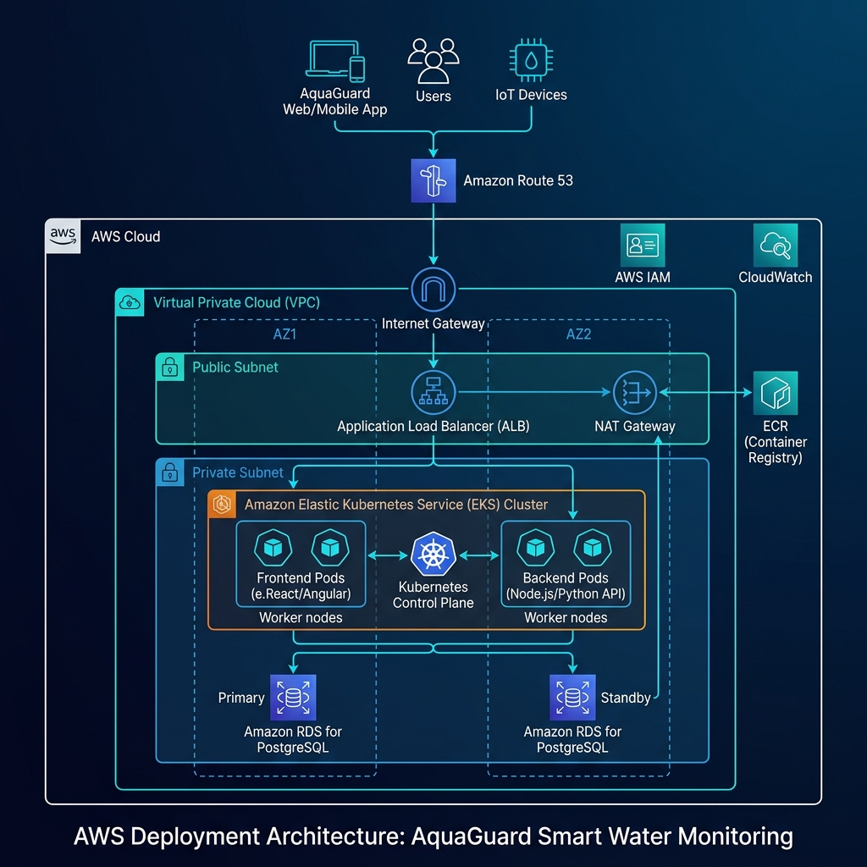
Figure 3: AquaGuard Kubernetes EKS Deployment and Traffic Ingress Topology
Manifests in [devops/kubernetes/](file:///Users/ashutoshrai/Desktop/Project-AquaGuard-CaseStudy68/devops/kubernetes/) deploy services to AWS EKS:
- Deployments: Configures scaling, port checks, and rolling updates for client, server, and DB pods.
- Services: Manages internal communication using ClusterIP and exposes services externally via LoadBalancers.
- Secrets & ConfigMaps: Stores sensitive DB passwords, JWT keys, and ConfigMaps for prometheus.yml.
- Ingress: Manages traffic routing to frontend and backend pods.

27. Prometheus Monitoring
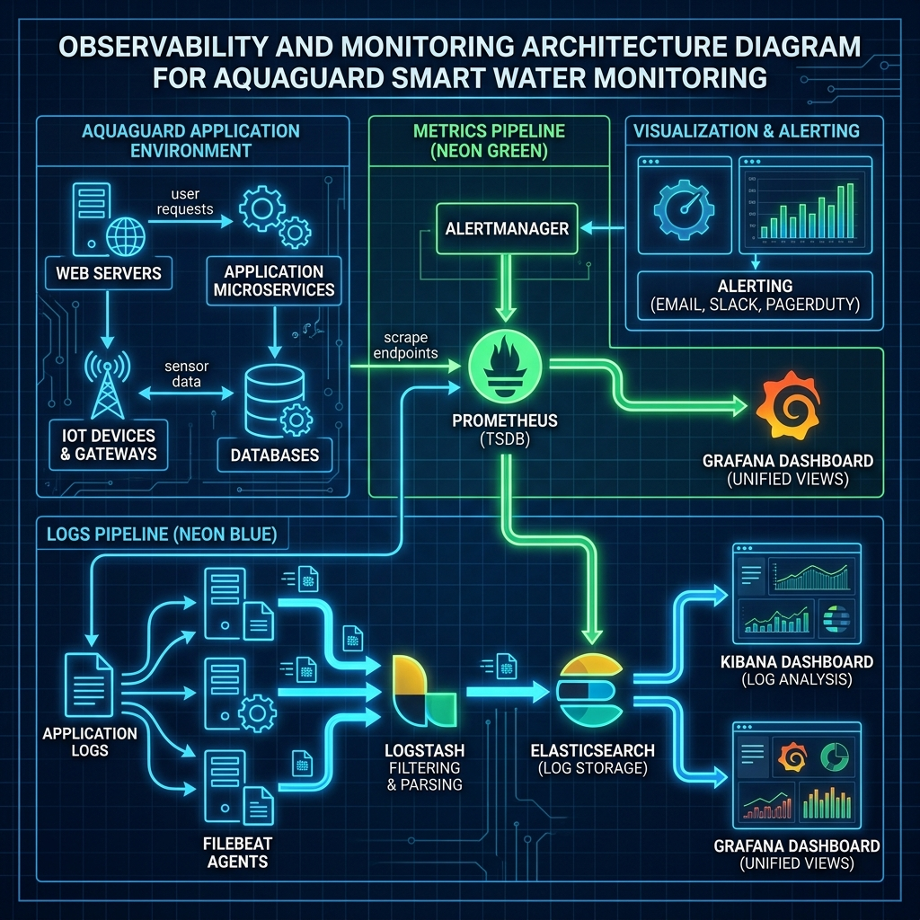
Figure 4: Prometheus Scrapers, Grafana Panels, and ELK Stack Observability Model
Configured via [prometheus.yml](file:///Users/ashutoshrai/Desktop/Project-AquaGuard-CaseStudy68/devops/prometheus/prometheus.yml):
- Automatically scrapes backend metrics from /api/system/health every 15 seconds.
- Connects directly to Node application ports to monitor server memory usage and API request latencies.

28. Grafana Dashboards
Configured via [dashboard.json](file:///Users/ashutoshrai/Desktop/Project-AquaGuard-CaseStudy68/devops/grafana/dashboard.json):
- Connects to Prometheus to visualize active user sessions, memory footprints, and CPU load trends.
- Displays visual graphs for HTTP error rates (5xx status counts) and system latency.

29. ELK Stack Logging
Configured via [devops/elk/](file:///Users/ashutoshrai/Desktop/Project-AquaGuard-CaseStudy68/devops/elk/):
- Filebeat: Harvests stdout logs from application containers.
- Logstash: Parses harvested JSON logs and routes them to Elasticsearch index pools.
- Elasticsearch: Indexes logs to enable quick text searches.
- Kibana: Provides an SRE dashboard for searching logs during incident reviews.

30. Disaster Recovery Strategy
- Backup Script ([backup_restore.sh](file:///Users/ashutoshrai/Desktop/Project-AquaGuard-CaseStudy68/devops/disaster-recovery/backup_restore.sh)): automates pg_dump backups, compresses database files, and uploads them to AWS S3.
- RPO = 15 minutes: Backups are run every 15 minutes to minimize data loss.
- RTO = 1 hour: Employs pre-configured Kubernetes templates to quickly rebuild the infrastructure in a backup AWS region.

31. Security Features
- JWT Key Signature: Verifies all API endpoints.
- SQL Injection Prevention: Uses parameterized PostgreSQL queries ($1, $2, etc.) in index.js.
- Kubernetes Secret Storage: Sensitive variables are stored securely, rather than being hardcoded in configuration files.

32. Future Enhancements
- Edge ML Predictors: Deploy anomaly detection models directly to pump and pipeline sensors.
- Water Chemistry Monitoring: Introduce pH, chlorine, and turbidity sensors.
- Automated Shutoff Valves: Integrate pipeline shutoff commands directly into the UI.

33. Conclusion
Project AquaGuard is a modern, enterprise-grade water management system. It provides comprehensive monitoring of critical utility assets while ensuring operational safety and high availability through its DevOps pipeline and containerized backend, making it an excellent blueprint for smart city utility frameworks.
# 5 Minute Judge Demo Script

Phase 1: Authentication & RBAC (0:00 - 1:00)
- Open the login page at http://localhost:5173.
- Explain the system's role-based access:
- "We are logging in as an Admin user. The system uses secure JWT authentication to enforce Role-Based Access Control, restricting critical settings to authorized personnel."
- Log in using username admin and password admin123.

Phase 2: Single Pane Dashboard & Active Telemetry (1:00 - 2:30)
- Point out the 5 KPI cards at the top:
- "Our dashboard displays real-time statistics: total reservoirs, active pumps, smart meters, alerts, and overall system health (calculated by combining pump temperatures and pipeline leaks)."
- Showcase the 3 interactive charts:
- "The Water Consumption line graph monitors flow rates, the Reservoir Capacity bar chart displays fill volumes, and the Alert distribution doughnut chart organizes warnings by severity."
- Explain that this data is populated by active PostgreSQL database tables.

Phase 3: Telemetry Simulators & Alerts (2:30 - 3:30)
- Navigate to the Pipelines tab.
- Select a pipeline and click Simulate Leak. Explain what happens:
- "We will simulate a pipeline leak. This drops the pipeline's pressure and flow rate in the database, which automatically dispatches a Critical Alert."
- Go back to the Dashboard or Alerts tab and show the new critical alert.

Phase 4: Maintenance Dispatch & Audit Logs (3:30 - 4:30)
- Navigate to the Maintenance tab.
- Show the critical pipeline alert, click the action button to log a repair request, set priority to Critical, and assign an engineer.
- Show the Logs console:
- "Every user action, telemetry change, and simulation trigger is logged in our centralized logs feed, creating a clear audit trail."

Phase 5: Observability & Closing (4:30 - 5:00)
- Navigate to the Monitoring tab. Show CPU and Memory resource dials:
- "Finally, our system health monitors CPU, Memory, and microservice status. The entire stack is containerized with Docker, deployed using Kubernetes templates, and monitored with Prometheus and Grafana."
- Summarize the benefits:
- "AquaGuard helps utilities prevent service downtime and mitigate water loss through real-time telemetry, automated alerts, and central control."
# 10 Minute Technical Viva Script

1. General Architecture & Flow (0:00 - 2:00)
- Q: "How do requests travel from the client to the database?"
- A: "Requests are routed through an Nginx Ingress Controller. The Vite React client serves the UI, while the Express API backend processes data. The backend connects to a PostgreSQL database pool. Telemetry processes run in the background, updating water levels, flow rates, and temperatures in the database."

2. Database Resilience & Fallbacks (2:00 - 4:00)
- Q: "What happens if the PostgreSQL database goes offline?"
- A: "If connection pool queries fail, the backend catches the exception and falls back to an in-memory mock database configured with the default seeds. This prevents API routes from hanging, keeps the application responsive, and prompts the UI to display warning indicators."

3. Frontend Error Handling (4:00 - 6:00)
- Q: "How do you prevent UI crashes when API responses return empty or malformed data?"
- A: "We implement defensive programming standards throughout our React components: optional chaining (`?.`) isolates missing properties, fallback variables (e.g. `pumps || []`) prevent map iteration failures, and `<ErrorBoundary>` wrappers isolate component crashes so the rest of the application remains functional."

4. DevOps, Infrastructure, and Security (6:00 - 8:00)
- Q: "How is this platform packaged, deployed, and secured?"
- A: "The stack is containerized with Docker and managed locally with Docker Compose. The infrastructure is deployed on AWS via Terraform scripts that set up a custom VPC, subnets, EC2 nodes, and RDS. EKS resources are managed using Kubernetes manifests, secret variables are encrypted, and API routes are secured with signed JWTs."

5. Monitoring & Disaster Recovery (8:00 - 10:00)
- Q: "Explain your disaster recovery and monitoring strategies."
- A: "For disaster recovery, the system has an RPO of 15 minutes and an RTO of 1 hour, supported by compressed backup scripts stored in S3. For monitoring, a Prometheus agent scrapes metrics from our system health endpoint every 15 seconds, Grafana visualizes host and service loads, and ELK parses log patterns."

