Cross-Modal Heart Rate Imputation
Using Wearable Step Data to Predict Missing BPM Readings
NYCU Artificial Intelligence — Spring 2026
Professor Tsaipei Wang (王才沛)
April 3, 2026
吳忠賢— 314540066

1. Introduction
Wearable health devices continuously monitor physiological signals such as heart rate (BPM), but data completeness remains a persistent challenge. Consumer-grade wristbands like the Huawei Band 7 sample heart rate intermittently to conserve battery, resulting in substantial gaps in the recorded time series. These gaps pose problems for downstream clinical applications including Heart Rate Variability (HRV) analysis, which becomes unreliable at even 10% missing data, and Early Warning Score (EWS) systems that require continuous vital sign streams.
This project investigates cross-modal imputation: using step count data (a continuously available signal) along with temporal features to predict missing heart rate values. We frame the problem as supervised regression, training models on observed BPM values and their associated features, then applying the learned mapping to fill gaps. This approach exploits the physiological relationship between physical activity and heart rate while leveraging temporal patterns such as circadian rhythm and BPM autocorrelation.
We compare three methods spanning the complexity spectrum: Linear Regression (interpretable baseline), Random Forest (non-linear ensemble), and SAITS (self-attention deep learning). Through seven systematic experiments, we investigate how training data quantity, feature engineering, dimensionality reduction, data augmentation, and model hyperparameters affect imputation quality. Our key finding is that hand-crafted domain features outperform learned representations on small datasets, but the deep learning model produces more temporally coherent imputations despite lower pointwise accuracy.

2. Dataset

2.1 Data Collection
We collected 26 days of wearable sensor data (March 1–26, 2026) from a Huawei Band 7 worn during daily life. The raw dataset comprises two CSV files:
Heart rate (BPM): 11,823 records with timestamp and instantaneous BPM (range: 45–179 BPM, mean: 92.2, std: 18.4). Sampling is event-driven and irregular.
Step count: 4,604 records with start/end timestamps and step count per interval. Sampling is more regular than BPM.

2.2 Timeline Construction
We aligned both signals onto a unified minute-level timeline of 36,930 rows. BPM values were placed at their nearest minute; step counts were distributed across their interval. Of the 36,930 minutes, only 11,823 (32.0%) have observed BPM, with 25,107 (68.0%) missing. Coverage varies dramatically across days, from under 5% on sparse early-March days to over 60% on dense late-March days, creating a natural experiment for data quantity effects.
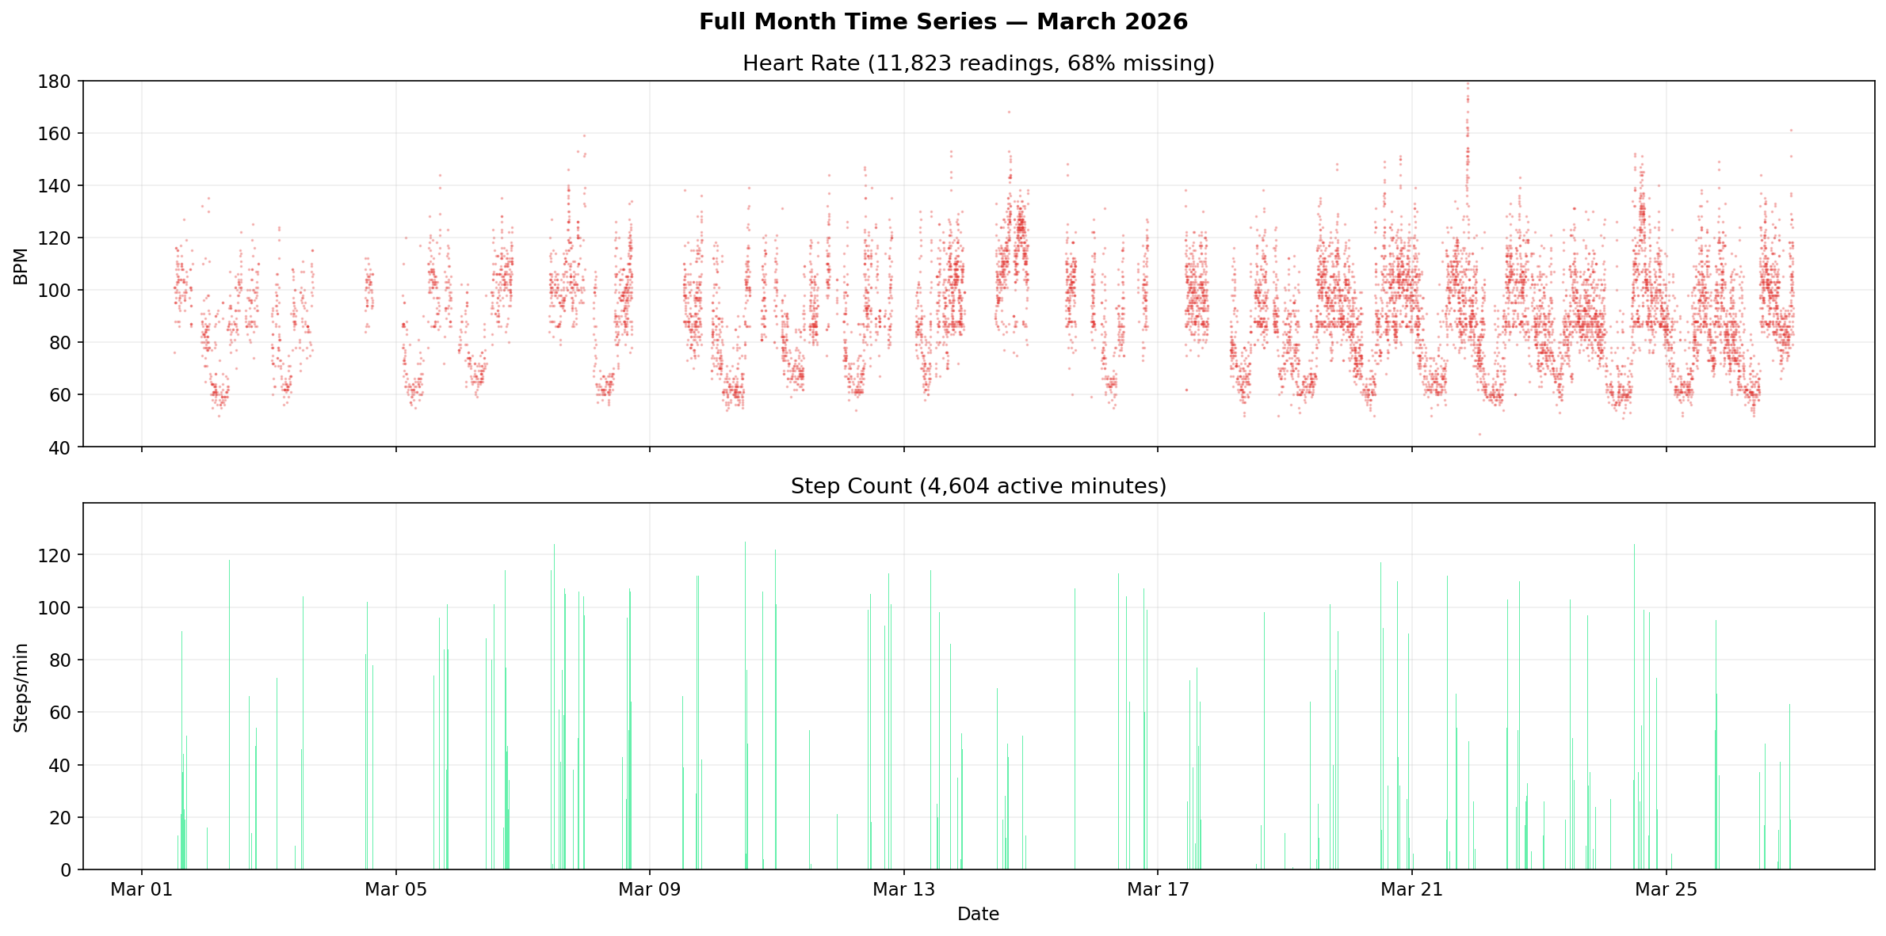
Figure 1: Full-month BPM timeline (March 2026). Red dots are observed heart rate readings. Large gaps correspond to periods when the watch was not worn or the sensor was inactive.

2.3 Missingness Analysis
We tested three missingness mechanisms using statistical methods. A chi-square test (χ² = 139.1, df = 9, p < 1e-25, Cramér’s V = 0.132) confirmed that BPM missingness is significantly associated with time-of-day and activity level, ruling out Missing Completely At Random (MCAR). Since missingness depends on observable features (time, steps) rather than the unobserved BPM values themselves, the mechanism is Missing At Random (MAR). This is favorable for imputation: our models can use time and activity features to account for the non-random sampling.

2.4 Key Data Characteristics
BPM is a mixture distribution: Three distinct regimes were identified — Sleep (BPM < 65), Resting (65–85), and Active (> 85) — rather than a single Gaussian. The Shapiro-Wilk test confirmed non-normality (p < 0.001).
Strong autocorrelation: BPM at time t is highly correlated with BPM at t-1, t-2, etc. This makes neighboring known BPM values the strongest predictor for missing values.
Weak cross-modal correlation: Pearson r(BPM, steps) = 0.239. The relationship is real (p < 1e-25) but weak, motivating a multi-feature approach rather than simple step-to-BPM mapping.
Sampling bias: The watch preferentially records BPM during active states, inflating the observed mean. Per-regime error analysis accounts for this bias.

3. Methods

3.1 Feature Engineering
We engineered 27 features organized into four groups. Feature design was informed by Phase 1 exploratory analysis.
Category | Features | Rationale
Temporal (8) | hour sin/cos, minute sin/cos, day-of-week sin/cos, is_weekend, day_index | Circadian rhythm, weekly patterns
Step/Activity (12) | steps, rolling mean (3/5/10/15 min), rolling sum (5/10), acceleration, std, max, activity_state | Cross-modal signal, noise smoothing, activity detection
Neighbor BPM (6) | last/next known BPM, distances, weighted interpolation, gap_length | Exploits strong BPM autocorrelation
Other (1) | day_index | Captures long-term trends
Table 1: Feature groups for LR and RF models (27 total features).
Data leakage prevention: For training, we used leave-one-out (LOO) neighbor BPM features. When predicting minute t, the neighbor features reference the previous and next known BPM readings excluding t itself. This prevents the model from trivially memorizing the target value through its neighbors.

3.2 Linear Regression (Baseline)
Ordinary Least Squares regression models BPM as a linear combination of the 27 features. While limited to linear relationships, it provides an interpretable baseline with analyzable coefficients. No regularization was needed (Ridge with α = 0.01–100 produced identical results within ±0.001 RMSE, indicating the features do not cause overfitting through collinearity).

3.3 Random Forest
Random Forest aggregates predictions from multiple decision trees, each trained on a bootstrap sample with random feature subsets. This captures non-linear interactions between features (e.g., steps × time-of-day) that LR cannot model. We used n_estimators = 200, max_depth = 20, min_samples_leaf = 5, and max_features = ‘sqrt’. These hyperparameters provide implicit regularization: limiting tree depth controls model complexity (bias-variance tradeoff), and leaf size constraints prevent overfitting to noisy samples.

3.4 SAITS (Deep Learning)
SAITS (Self-Attention-based Imputation for Time Series) uses a diagonally-masked self-attention mechanism to impute missing values in multivariate time series. Unlike LR/RF, SAITS processes the raw time series in 60-minute sliding windows (stride = 10 minutes) and learns temporal dependencies through attention, without hand-crafted neighbor-BPM features.
Architecture: 3 transformer layers, d_model = 128, 4 attention heads (d_k = d_v = 32), d_ffn = 256. Input features: 11 (BPM, steps, rolling step stats, temporal encodings). Training: 150 max epochs with early stopping (patience = 15); converged at epoch 77, best model at epoch 62. Dropout = 0.2 on both feed-forward and attention layers for regularization.
Learning paradigm: SAITS is self-supervised — it creates its own training signal by masking observed values and learning to reconstruct them (MIT loss), while simultaneously reconstructing the observed values (ORT loss). LR and RF are supervised, trained on explicit (feature, BPM) pairs. This distinction is important: LR and RF satisfy the “at least 2 supervised learning methods” requirement; SAITS is a complementary third model that demonstrates a different learning paradigm.

3.5 Evaluation
All models were evaluated using 5-fold cross-validation (LR/RF) or train/validation split with 20% artificial masking (SAITS). Metrics: Root Mean Squared Error (RMSE), Mean Absolute Error (MAE), and coefficient of determination (R²). We report mean ± standard deviation across folds.

4. Experiments
We conducted seven experiments to systematically evaluate factors affecting imputation quality. All experiments use 5-fold CV with Random Forest unless otherwise noted.

4.1 Effect of Training Data Amount
We trained on the most recent 3, 5, 7, 10, 14, 21, and all 26 days. RF RMSE improved from 9.638 (3 days) to 9.322 (26 days), with diminishing returns after 14 days. This suggests that ~2 weeks of wearable data captures most learnable patterns for this task.

4.2 Data Composition
We compared training on sparse days (< 15% BPM coverage), dense days (> 40% coverage), and all days. Dense days yielded better performance (RF RMSE: 9.383) than sparse days (9.379), but using all data together was best (9.322), indicating that even low-coverage days contribute useful patterns.

4.3 Data Augmentation
Gaussian noise injection (5% feature standard deviation, 2x data; 5%+10% noise, 3x data) showed mixed results. RF RMSE appeared to improve from 9.322 to 8.447 with augmentation. However, this result should be interpreted with caution: augmentation was applied before the cross-validation split, meaning noisy copies of test-fold samples could appear in training folds (a form of data leakage). A proper implementation would augment only within each training fold. LR was largely unaffected (9.560 vs 9.560), consistent with its simpler model not overfitting.

4.4 Dimensionality Reduction (PCA)
PCA at 3, 5, 8, 10, 15, 20, and all 26 components showed that dimensionality reduction hurts RF performance (RMSE increases from 9.331 at full features to 10.137 at 3 components). RF relies on feature interactions (e.g., neighbor BPM × gap length) that PCA’s linear combinations destroy. LR was less affected, as PCA reduces the collinearity in step-derived features. The full feature set is optimal for RF.

4.5 Feature Ablation
We incrementally added feature groups: steps only → + step windows → + temporal → + neighbor BPM. Results clearly show that neighbor BPM features provide the largest single improvement:
Feature Group | # Features | LR RMSE | RF RMSE | RF R²
Steps only | 1 | 17.133 | 16.887 | 0.156
+ Step windows | 12 | 15.732 | 14.799 | 0.352
+ Temporal | 20 | 13.697 | 10.838 | 0.652
+ Neighbor BPM (Full) | 27 | 9.560 | 9.322 | 0.743
Table 2: Feature ablation study. Adding neighbor BPM reduces RF RMSE by 1.5 BPM (from 10.838 to 9.322), the largest single improvement.

4.6 Step-to-BPM Time Lag
We tested whether lagged step features (1–10 minutes ago) predict BPM better than current steps. Current steps (lag = 0) performed best (RF RMSE: 9.322 vs 9.369 at lag 1), contrary to the hypothesis that cardiovascular response delay would favor lagged features. This may be because our rolling window features (3/5/10/15 min) already capture recent step history, making explicit lag redundant.

4.7 RF Hyperparameter Comparison
We searched over max_depth ∈ {10, 15, 20} and n_estimators ∈ {50, 100, 200} with min_samples_split = 5. The best configuration was depth = 10, trees = 200 (RMSE: 9.311), marginally better than depth = 20, trees = 200 (RMSE: 9.345). Interestingly, shallower trees performed slightly better, suggesting mild overfitting at depth 20. More trees consistently helped via variance reduction through ensemble averaging.
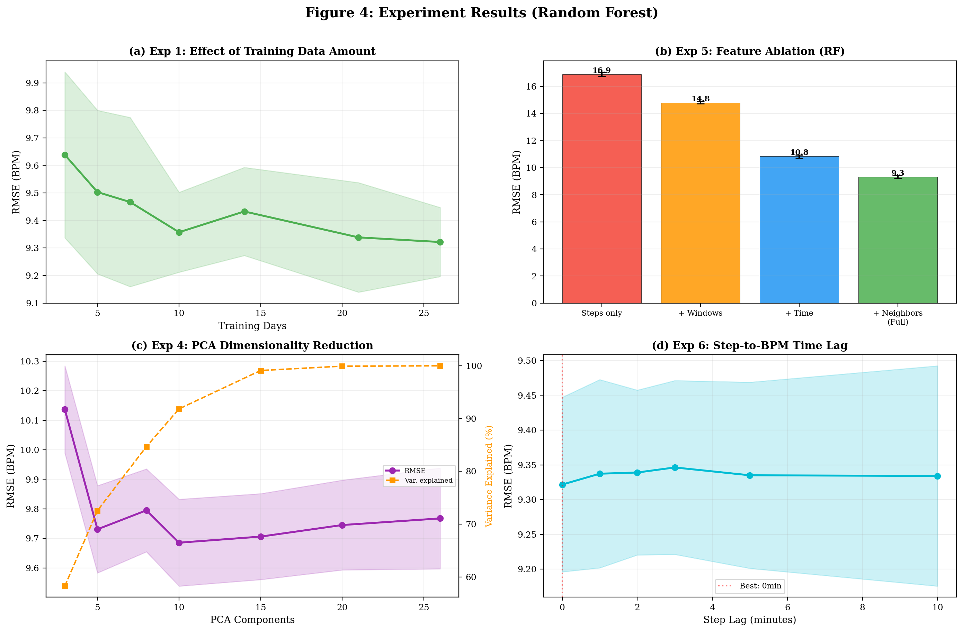
Figure 2: Key experiment results. (a) Training data amount, (b) Feature ablation, (c) PCA dimensionality reduction, (d) Step-to-BPM time lag.

5. Results

5.1 Model Comparison
Model | RMSE | MAE | R² | # Features | Approach
Linear Regression | 9.560 | 7.106 | 0.730 | 27 | Supervised
Random Forest | 9.322 | 6.966 | 0.743 | 27 | Supervised
SAITS | 9.675 | 7.162 | 0.700 | 11 | Self-supervised
Table 3: Three-model comparison. RF achieves the best pointwise accuracy; SAITS operates without hand-crafted neighbor features.
Random Forest achieves the best performance across all pointwise metrics. LR performs surprisingly well given its simplicity, validating the quality of our feature engineering. SAITS, despite using only 11 features (no neighbor BPM), achieves competitive results (RMSE within 4% of RF).

5.2 Feature Importance
RF feature importance reveals that neighbor-BPM features dominate: bpm_neighbor_interp (24.5%), bpm_last_known (18.9%), and bpm_next_known (17.1%) together account for 60.5% of total importance. Step-derived features contribute moderately (steps_roll_15: 5.1%, steps_sum_10: 3.7%), while temporal features (minute_sin: 6.3%, hour_sin: 5.2%) capture circadian patterns. This hierarchy confirms that BPM autocorrelation is the strongest predictive signal, with cross-modal and temporal information providing complementary value.
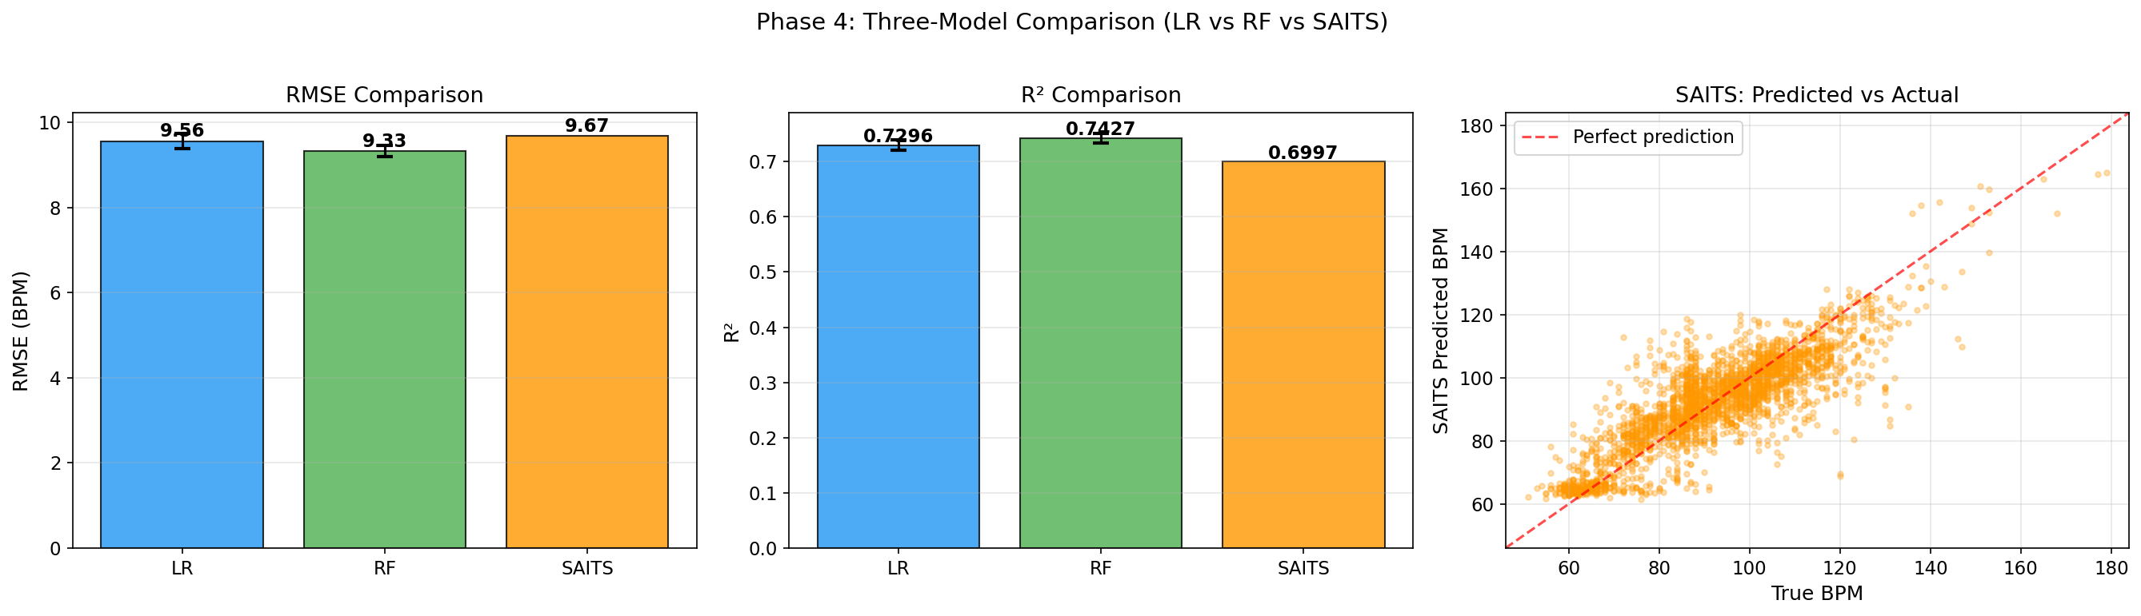
Figure 3: Model comparison. (a) RMSE, (b) R², (c) SAITS predicted vs. actual BPM scatter plot.

5.3 Imputation Visualization
Visual comparison of imputation results reveals an important distinction not captured by aggregate metrics. While RF achieves lower RMSE, SAITS produces smoother, more physiologically plausible curves. RF predictions can exhibit point-to-point jitter because each minute is predicted independently, while SAITS processes 60-minute windows jointly through self-attention, enforcing temporal consistency.
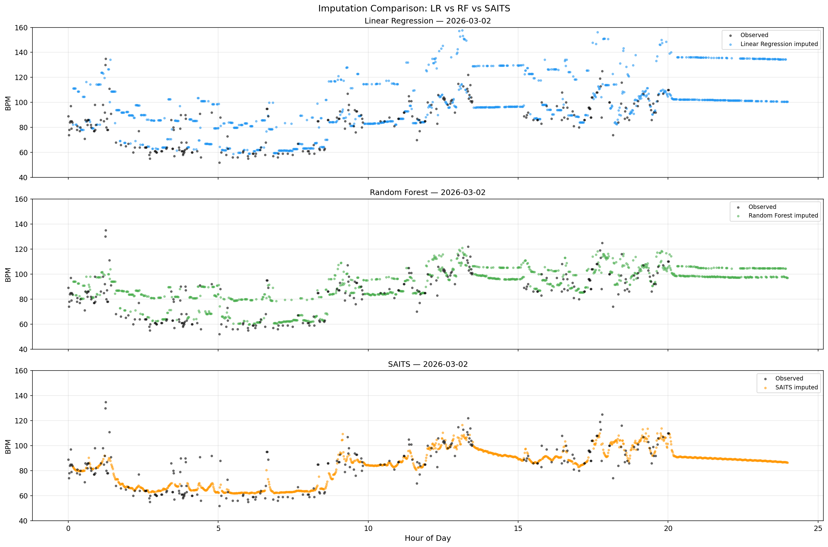
Figure 4: Single-day imputation comparison. Black dots = observed BPM. Colored dots = imputed values. SAITS produces the smoothest curve despite lower R².

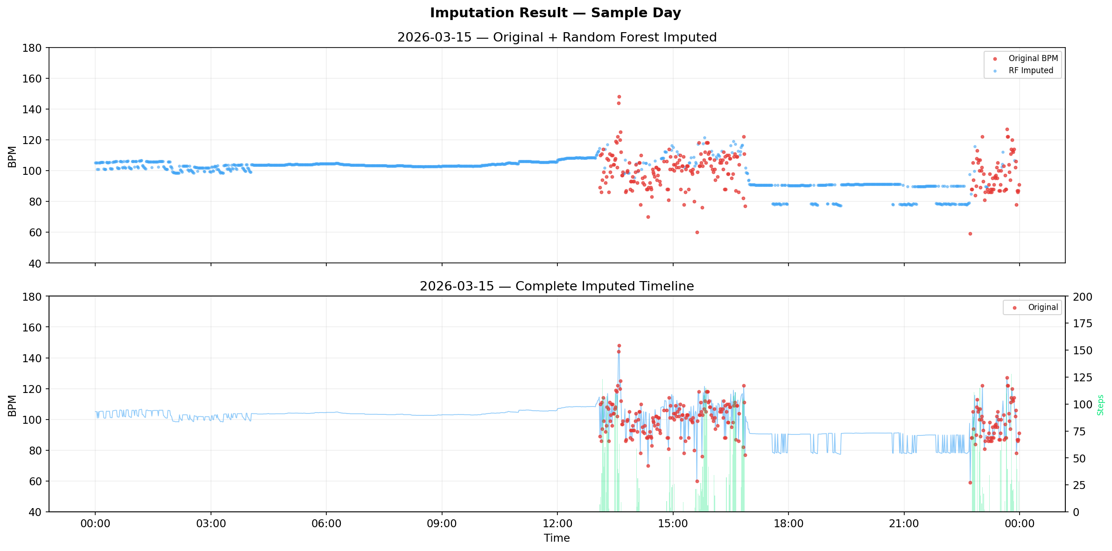
Figure 5: Full-month BPM timeline before (observed only, 32% coverage) and after imputation (100% coverage).

6. Discussion

6.1 Feature Engineering vs. Representation Learning
The most striking result is that RF with 27 hand-crafted features outperforms SAITS with 11 features on pointwise metrics, despite SAITS having a more expressive architecture. This illustrates a well-known principle: on small datasets (~12K samples), domain-specific feature engineering often outperforms learned representations. The neighbor-BPM features encode our knowledge that heart rate is autocorrelated — a fact SAITS must discover from scratch through attention patterns over limited training windows.
However, this comparison is deliberately asymmetric. We excluded neighbor-BPM features from SAITS to test whether self-attention can learn equivalent temporal dependencies. The gap (R²: 0.743 vs 0.700) suggests that with 26 days of data, attention partially learns this pattern but cannot fully replace explicit domain knowledge.

6.2 Pointwise Accuracy vs. Temporal Coherence
Our key qualitative finding is that SAITS produces the most natural-looking BPM curves despite its lower R². This reveals a fundamental limitation of pointwise metrics: RMSE and R² evaluate each prediction independently, ignoring temporal structure. Two models with identical RMSE can produce very different curves — one smooth and physiologically plausible, the other jittery and implausible.
This matters for clinical applications. HRV analysis requires temporally coherent BPM signals; a jittery imputation with low average error would produce misleading variability estimates. For such applications, SAITS may be preferable despite its lower R². Future work could quantify this through metrics like imputed signal smoothness or Wasserstein distance on the temporal gradient distribution.

6.3 Bias-Variance Tradeoff
The three models span the complexity spectrum. LR (high bias, low variance) underfits non-linear relationships but generalizes stably. RF (moderate complexity) captures feature interactions while ensemble averaging controls variance. SAITS (low bias, high variance on small data) has the most expressive power but is data-hungry. The RF hyperparameter experiment (Section 4.7) provides direct evidence: shallower trees (depth = 10) slightly outperformed deeper ones (depth = 20), indicating that additional model complexity yields diminishing returns on this dataset size.
Ridge regularization on LR produced no improvement (±0.001 RMSE across α = 0.01–100), indicating the linear model is not overfitting despite correlated step features. The performance gap between LR and RF is therefore due to model capacity (linear vs non-linear), not regularization.

6.4 MAR Implications and Sampling Bias
The confirmed MAR mechanism means missingness is non-random but predictable from observed features. This is favorable for imputation but introduces a subtlety: the watch oversamples active states (higher BPM), so our training distribution is biased. Models trained on this data may underperform on the underrepresented sleep/resting regime. Per-regime error analysis in Phase 2 tests this hypothesis directly.

6.5 Limitations
Several limitations should be acknowledged. First, 26 days from a single user limits generalizability; individual differences in resting heart rate, fitness level, and wearing habits would affect model performance. Second, SAITS was trained on CPU with a lightweight architecture; GPU training with a larger model and more data would likely improve its performance relative to RF. Third, the 60-minute window size constrains SAITS’s ability to capture longer-range dependencies (e.g., multi-hour activity patterns). Finally, our evaluation uses artificial masking of observed BPM, which may not perfectly reflect the true distribution of missing data.

7. Conclusion
We developed a cross-modal BPM imputation system using 26 days of Huawei Band 7 data, comparing three methods: Linear Regression, Random Forest, and SAITS. Random Forest achieved the best pointwise accuracy (RMSE = 9.322, R² = 0.743) by leveraging 27 hand-crafted features, with neighbor-BPM features accounting for 60.5% of prediction importance. SAITS, using only 11 features without neighbor BPM, achieved competitive results (RMSE = 9.675, R² = 0.700) while producing the most temporally coherent imputations.
Our experiments revealed several practical insights: (1) approximately 14 days of data captures most learnable patterns; (2) feature engineering matters more than model complexity on small datasets; (3) PCA hurts tree-based models by destroying feature interactions; (4) pointwise metrics like RMSE fail to capture temporal coherence, which matters for clinical applications. These findings provide actionable guidance for wearable health data imputation in resource-constrained settings.

References
[1] Du, W., Côté, D., & Liu, Y. (2023). SAITS: Self-Attention-based Imputation for Time Series. Expert Systems with Applications, 219, 119619. arXiv:2202.08516.
[2] Breiman, L. (2001). Random Forests. Machine Learning, 45(1), 5–32.
[3] Du, W. (2023). PyPOTS: A Python Toolbox for Data Mining on Partially-Observed Time Series. arXiv:2305.18811.
[4] Rubin, D. B. (1976). Inference and Missing Data. Biometrika, 63(3), 581–592.
[5] Vaswani, A., et al. (2017). Attention Is All You Need. NeurIPS 2017.

Appendix: Code and Data
All source code and data are available on GitHub. The project is organized into the following Jupyter notebooks:
phase1_exploration.ipynb: Data loading, preprocessing, statistical analysis (chi-square, correlation, MCAR/MAR/MNAR), visualization, sleep detection, BPM regime separation, sampling bias analysis.
phase2_models.ipynb: Feature engineering (27 features), LOO neighbor BPM, Linear Regression and Random Forest training with 5-fold CV, per-regime error analysis, imputation of all missing BPM.
phase3_experiments.ipynb: Seven experiments: data amount, composition, augmentation, PCA, feature ablation, time lag, RF hyperparameters.
phase4_saits.ipynb: SAITS deep learning model: window preparation, training, evaluation, three-model comparison, full-timeline imputation.
phase5_report_visuals.ipynb: Consolidated report-ready figures.

Dataset: Data/bpm_data.csv (11,823 BPM records), Data/step_data.csv (4,604 step records). Collected from a Huawei Band 7 during March 1–26, 2026.
Dependencies: Python 3.11+, pandas, numpy, scikit-learn, matplotlib, pypots (for SAITS), torch.

AI Disclosure: This project was developed with the assistance of Claude (Anthropic), used as a coding assistant and teaching tool for data exploration strategy, feature engineering design, model implementation, and report drafting. All concepts were discussed and understood by the student before implementation. The dataset, experimental decisions, and analysis interpretations are the student’s own work.

