CHAPTER I

THE PROBLEM AND ITS BACKGROUND
Chapter I sets out the background of the problem, the statement of the problem, the significance of the study, the scope and delimitation, and the definition of key terms for IMPACT. It provides the policy and practice context behind the system and states the study’s objective and questions.

Introduction
Philippine higher education runs quality assurance at two levels. At the external level, accrediting agencies and networks evaluate institutions against sector standards: the National Network of Quality Assurance Agencies (NNQAA), Federation of Accrediting Agencies of the Philippines (FAAP), AACCUP, PAASCU, and PACUCOA. At the internal level, the Commission on Higher Education (CHED) positions internal quality assurance (IQA) as the starting point for quality within outcomes-based education, program typology, and the Institutional Sustainability Assessment (ISA), the national self-evaluation instrument covering five key result areas and an ICT indicator (Commission on Higher Education, 2012; World Bank Group, 2023). Monitoring connects the two levels: CHED’s Office of Institutional Quality Assurance and Governance (OIQAG) monitors quality management in higher education institutions (HEIs), maintains a quality assurance database linked to its Management Information System (MIS), and reviews quality monitoring reports (CHED, n.d.-a).
Internal monitoring is the daily layer beneath policy: the routines institutions use to collect evidence, check conformity, and drive improvement. Philippine studies document QMS practices, internal audit, and monitoring-and-evaluation tools inside that layer (Calairo, 2025; Grate-Paltiguera & Gabion, 2026; Roque & Ulanday-Lozano, 2024). Coordinators work inside a documentation culture that expects auditable records.
The second strand is the supervision of student internships. Under the Student Internship Program in the Philippines (SIPP) framework of CHED Memorandum Order (CMO) No. 104, s. 2017, HEIs and hosts must monitor, document, and evaluate student performance during placement (Cabalbag & Ontiveros, 2024; Castro, 2024; Del Rosario & Dela Cruz, 2021). Internship monitoring runs throughout placement, follows individual students, and spans external hosts, so developers have built systems in response. Documented responses include a lean-management-based internship MIS (Del Rosario & Dela Cruz, 2021); a web-based MIS with online submission, grade computation, and feedback at Cagayan State University-Aparri Campus (Cabalbag & Ontiveros, 2024); a mobile system with global positioning system (GPS) clock-in/clock-out (Castro, 2024); and an Android-and-web OJT system using quick response (QR) code attendance, one-time password (OTP) validation, and artificial intelligence (AI)-assisted reports (Atenin et al., 2026). The pandemic reshaped supervision: a Philippine mixed-methods study treated online internships as situated, bounded, and inclusive learning across 129 evaluations, 11 key informant interviews, and 110 reflection papers (Opiniano, 2024). This internship and OJT strand is the problem the present study addresses.
Research on both strands has moved from policy handbooks to prototypes evaluated with ISO/IEC 25010 and technology acceptance models (Cabalbag & Ontiveros, 2024; Castro, 2024; Key informants’ perception on records digitization, 2025). Supervision runs on manual logbooks and paper-based Daily Time Records that researchers call time-consuming and inconsistent (Atenin et al., 2026; Cabalbag & Ontiveros, 2024; Castro, 2024; Del Rosario & Dela Cruz, 2021). Documented systems cover parts of the workflow: attendance verification, report submission, grade computation, feedback loops, traceable documentation. Supervision stays dispersed across those parts. This study will develop and evaluate a web-based prototype that consolidates them.
National mandates form a sequence that starts in 2012, when CHED’s companion handbook to CMO No. 46, s. 2012 codified outcomes-based education and program typology, introduced the ISA framework, and declared internal quality assurance the starting point for quality in every HEI (Commission on Higher Education, 2012). Infrastructure mandates followed: HEMIS under CMO No. 45, s. 2016 (CHED RO11, 2024), the Enrollment Data Collection System (EDCS) (CHED, n.d.-b), and Higher Education Institution Data Analytics (HEIDA), version 2 (CHED, 2024). Together they form a national monitoring stack.
Published evaluations set IMPACT’s benchmark. Del Rosario and Dela Cruz (2021) reported an overall ISO/IEC 25010 mean of 4.32 for a lean-management internship MIS at Laguna State Polytechnic University; Cabalbag and Ontiveros (2024) evaluated their web-based MIS-OJT with ISO standards and the Technology Acceptance Model; Castro (2024) combined GPS location, clock in/out, and parent-agency linkage and evaluated the system with ISO/IEC 25010 (n = 30); and Atenin et al. (2026) reported the cluster’s highest mean (M = 4.83, overall ISO/IEC 25010) for QR attendance, OTP validation, and AI-assisted report generation.
The quality assurance strand shows the same progression. Rodriguez et al. (2018) established the TQM paradigm for Philippine higher education; Roque and Ulanday-Lozano (2024), in an embedded mixed-method design, documented Region XII QMS practices; Calairo (2025), in a mixed-method multi-case design, developed an IQA model for two private universities, mapping SWOT findings onto the ten AQAF IQA principles and naming monitoring-and-evaluation tools the key instrument; Dando and Santillan (2025) integrated PQA criteria with ISO 9001:2015 PDCA at Camarines Norte State College for audit efficiency; Grate-Paltiguera and Gabion (2026) surveyed 160 QM coordinators and internal quality auditors across seven Western Visayas SUCs, reporting ISO 9001:2015 implementation (M = 4.59) and effectiveness (M = 4.40); and SUC stakeholders assessed the first web-based digitized-records accreditation platform using ISO/IEC 25010 and thematic analysis (Key informants’ perception on records digitization, 2025).
A 2023 World Bank assessment characterized the QA landscape, the ISA self-evaluation structure, and Philippine HEIs’ digital maturity (World Bank Group, 2023). In July 2026, CHED and ASEAN partners convened more than 200 SUC leaders at Marikina Polytechnic College for the first workshop on universities’ IQA implementation using the AUN-QA IQA Management Toolkit v1.3; the country counts 2,364 HEIs serving approximately 5.5 million students (Marikina Polytechnic College, 2026). National data systems, accreditation platforms, IQA toolkits, and internship tracking applications advance in parallel while internship supervision rests on manual, dispersed records. The mismatch sets the context for a consolidated monitoring platform.
That platform is IMPACT, the web-based on-the-job training monitoring portal developed in this study for student interns and their OJT coordinators, subtitled IMPACT: A Web-Based Monitoring Platform for Student Internship Programs. IMPACT is a website built with React 19, TypeScript, Vite, and Tailwind CSS v4 and tested with Vitest and React Testing Library. Role-based login separates student and admin (OJT Coordinator) accounts using Bulacan State University identifiers: BU-2021-10045 and @student.bulsu.edu.ph (students), admin@bulsu.edu.ph (coordinators).
IMPACT consolidates the records that internship supervision used to scatter: a social feed, explore page, and student profile; attendance against 486 required hours with a progress bar; a daily journal, portfolio, and photos; assignments; reports moving through Draft → Submitted → Under Review → Approved / Needs Revision; and notifications, announcements, and settings. Coordinators get an admin dashboard showing total interns, online / do not disturb / offline counts, “Completed” and “Nearing Target” flags, and per-intern completed-hours percentages, plus a student monitoring view with progress percentages. The prototype runs on mock records: Maria Santos, BS Information Technology 4th year, Junior Web Developer Intern at TechVentures Philippines Inc., June 5 to August 30, 2025 (312 of 486 hours completed). The study will develop and evaluate IMPACT on two measures: acceptability under the Technology Acceptance Model (perceived usefulness, perceived ease of use, attitude toward using, behavioral intention to use) and quality under the nine ISO/IEC 25010 characteristics.

Statement of the Problem
Student internships remain a required component of Philippine higher education programs. Supervision of those placements continues to run on manual logbooks, paper-based Daily Time Records, and signed accomplishment arrangements, which researchers describe as time-consuming, prone to data inconsistency, and difficult to coordinate across interns, coordinators, and host training establishments (Atenin et al., 2026; Cabalbag & Ontiveros, 2024; Castro, 2024; Del Rosario & Dela Cruz, 2021). Under the Student Internship Program in the Philippines (SIPP) framework of CHED Memorandum Order (CMO) No. 104, s. 2017, HEIs and their host training establishments must monitor, document, and evaluate student performance during placement (as referenced in Cabalbag & Ontiveros, 2024; Castro, 2024; Del Rosario & Dela Cruz, 2021). Philippine systems in the literature answer with online submission and grade computation, GPS clock-in and clock-out, and QR-code attendance with one-time password (OTP) validation (Atenin et al., 2026; Cabalbag & Ontiveros, 2024; Castro, 2024). Intern supervision continues to spread across off-campus hosts, and the documented systems leave attendance, documentation, and coordinator oversight in separate places.
This study therefore will develop and evaluate IMPACT to serve as a usable, reliable monitoring and documentation platform for student interns, addressing the following specific questions:
- How can IMPACT be developed as a web-based monitoring website that incorporates core functionalities to support the supervision and documentation of student interns, specifically through:
- 1.1 role-based access for student interns and OJT coordinators,
- 1.2 attendance logging with rendered-hours tracking against required internship hours,
- 1.3 daily journal entries, photo documentation, and portfolio records,
- 1.4 assignment distribution and report submission with coordinator review and feedback,
- 1.5 a coordinator-facing dashboard for monitoring intern progress and presence status, and
- 1.6 in-platform announcements, notifications, and a social feed that sustain intern engagement during deployment?
- How can a progress-monitoring component for IMPACT be developed to support internship supervision by computing and surfacing the following indicators:
- 2.1 rendered-hours completion relative to required internship hours,
- 2.2 per-intern progress percentages with completion status flags (completed, nearing target),
- 2.3 report-submission workflow states (draft, submitted, under review, approved, needs revision), and
- 2.4 intern presence status (online, do not disturb, offline)?
- How acceptable is IMPACT under the Technology Acceptance Model (TAM), considering:
- 3.1 Perceived Usefulness,
- 3.2 Perceived Ease of Use,
- 3.3 Attitude Toward Using, and
- 3.4 Behavioral Intention to Use?
- How well does IMPACT meet ISO/IEC 25010 quality requirements, considering:
- 4.1 Functional Suitability,
- 4.2 Performance Efficiency,
- 4.3 Compatibility,
- 4.4 Interaction Capability,
- 4.5 Reliability,
- 4.6 Security,
- 4.7 Maintainability,
- 4.8 Flexibility, and
- 4.9 Safety?
- Is there a significant difference between the assessments of student interns and expert evaluators on:
- 5.1 the acceptability of IMPACT in terms of perceived usefulness, perceived ease of use, attitude toward using, and behavioral intention to use, and
- 5.2 the quality of IMPACT in terms of functional suitability, performance efficiency, compatibility, interaction capability, reliability, security, maintainability, flexibility, and safety?
To answer the fifth question, this study tests the following hypotheses:
H₀: There is no significant difference in the assessments of student interns and expert evaluators on the acceptability of IMPACT in terms of perceived usefulness, perceived ease of use, attitude toward using, and behavioral intention to use.
H₀: There is no significant difference in the assessments of student interns and expert evaluators on the quality of IMPACT in terms of functional suitability, performance efficiency, compatibility, interaction capability, reliability, security, maintainability, flexibility, and safety.

Significance of the Study
This study will benefit the following parties:
Student interns. IMPACT gives interns one platform to log attendance, document rendered hours, keep a daily journal, build a portfolio with photos, and submit reports through a review workflow, replacing dispersed logbooks and paper-based Daily Time Records (Atenin et al., 2026; Cabalbag & Ontiveros, 2024; Castro, 2024; Del Rosario & Dela Cruz, 2021).
OJT coordinators and faculty supervisors. The dashboard and student monitoring view let supervisors track presence status, per-intern rendered-hours percentages, and completed or nearing-target flags, and review reports for revision. The scope grounds functional requirements against documented deployments: GPS clock-in, QR-plus-OTP validation, grade computation (Atenin et al., 2026; Cabalbag & Ontiveros, 2024; Castro, 2024).
College administrators and quality-assurance personnel. IMPACT consolidates attendance, hours, journals, portfolios, and reports into auditable documentation aligned with SIPP expectations and IQA reporting routines; documented IQA instruments and monitoring-and-evaluation tools inform evidence-based selection of monitoring arrangements (Calairo, 2025; Dando & Santillan, 2025). Quality-assurance personnel, CHED, OIQAG, and accrediting agencies gain a consolidated picture of internship documentation readiness alongside ISA self-evaluation, HEMIS-linked data flows, and accreditation record digitization (CHED, n.d.-a; CHED RO11, 2024; Key informants’ perception on records digitization, 2025).
State universities and colleges and other HEIs. The prototype offers a reference implementation institutions can adapt for local use, alongside reported ISO 9001:2015 results across Western Visayas SUCs and toolkit-oriented IQA adoption among more than 200 SUC leaders (Grate-Paltiguera & Gabion, 2026; Marikina Polytechnic College, 2026).
Faculty researchers, graduate students, and future researchers. The study will contribute a reference prototype and evaluation instrument (TAM acceptability items and ISO/IEC 25010 quality items), with methodological patterns that reduce duplication and clarify thin outcome evidence (Roque & Ulanday-Lozano, 2024; World Bank Group, 2023).

Scope and Delimitation
This development study sets the following parameters.
The study will cover the design, development, and evaluation of IMPACT, a web-based monitoring platform for student interns and OJT coordinators. Functional scope: (a) role-based access for student interns and OJT coordinators; (b) attendance logging and rendered-hours tracking against required internship hours; (c) daily journal entries, photo documentation, and portfolio records; (d) assignment distribution and report submission with coordinator review and feedback; (e) a coordinator-facing dashboard and student monitoring view for intern progress and presence status; and (f) in-platform announcements, notifications, and a social feed. Evaluation will cover acceptability under the Technology Acceptance Model (perceived usefulness, perceived ease of use, attitude toward using, behavioral intention to use) and quality under the nine ISO/IEC 25010 characteristics: Functional Suitability, Performance Efficiency, Compatibility, Interaction Capability, Reliability, Security, Maintainability, Flexibility, and Safety. The locale is Bulacan State University, Malolos, Bulacan, with evaluation respondents specified in Chapter III. National policy documents and CHED information systems (HEMIS, EDCS, HEIDA, OIQAG mandates) supply governance context and fall outside the evaluation.
The prototype runs on a demonstration dataset of mock records, with no live back end and no real student personal data. The study will exclude production deployment; integration with third-party host-company systems; biometric, GPS, or QR-code hardware attendance; grade transmittal to the registrar; and payroll or human-resource functions. The related-studies background covers the literature gathered for this study, and the findings will apply to the evaluated prototype and its respondents. This study will not judge CHED policy nor re-assess the documented systems cited here, and it will reproduce reported means without recomputing them.

Definition of Terms
The study defines key terms operationally as follows.
CMO (CHED Memorandum Order). Refers to the formal issuance through which CHED sets policy for HEIs; the CMOs governing this study are No. 46, s. 2012 (typology, outcomes-based education, ISA), No. 45, s. 2016 (HEMIS data collection), and No. 104, s. 2017 (SIPP) (Commission on Higher Education, 2012; CHED RO11, 2024).
Continuous Quality Improvement (CQI). Refers to the improvement loop in which monitoring and audit findings turn into corrective and preventive action through the PDCA cycle and, in one case, integration with PQA criteria (Dando & Santillan, 2025).
External Quality Assurance (EQA). Refers to the out-of-institution evaluation that agencies and networks such as NNQAA, FAAP, AACCUP, PAASCU, and PACUCOA perform, consuming the evidence internal monitoring produces (World Bank Group, 2023).
HEMIS, EDCS, and HEIDA. Refers to CHED’s national information infrastructure: HEMIS is the centralized mandate requiring annual institutional data reporting under CMO No. 45, s. 2016, as documented for SY 2024-2025 (CHED RO11, 2024); EDCS centralizes real-time enrollment reporting (CHED, n.d.-b); HEIDA is the version 2 analytics portal with offline and mobile data collection (CHED, 2024).
IMPACT. Refers to the web-based prototype to be developed in this study, which consolidates attendance and rendered-hours tracking, journaling, portfolio and photo documentation, report submission and review, assignment tracking, and coordinator-facing progress monitoring for student interns.
Institutional Sustainability Assessment (ISA). Refers to CHED’s national self-evaluation instrument in which HEIs assess five key result areas with an embedded ICT indicator (World Bank Group, 2023; Commission on Higher Education, 2012).
Internal monitoring. Refers to the recurring, institution-run process of collecting evidence on defined indicators, checking conformity with internal standards, and feeding results into reporting cycles (Calairo, 2025; Roque & Ulanday-Lozano, 2024). It spans IQA routines (performance monitoring, data quality management, internal audit) and intern/OJT routines (attendance, documentation, trainee evaluation). IMPACT supports both sets of routines.
Internal Quality Assurance (IQA). Refers to the institution-level system of planning, implementing, evaluating, and improving quality, which CHED’s framework treats as the starting point for quality and structures around outcomes-based education, typology, and self-evaluation (Commission on Higher Education, 2012). IQA is the documentation context for IMPACT’s coordinator-facing records.
ISO 9001:2015 and ISO/IEC 25010. Refers to two standards: Philippine HEIs and their internal quality auditors apply the former to manage quality (Dando & Santillan, 2025; Grate-Paltiguera & Gabion, 2026); this study will use the latter, the software product quality standard, to evaluate IMPACT, and researchers report it for most of the systems cited here (Atenin et al., 2026; Castro, 2024; Del Rosario & Dela Cruz, 2021).
On-the-Job Training (OJT) and internship. Refers to the off-campus, work-immersion component of Philippine higher education programs in which a host training establishment places students under the SIPP framework of CMO No. 104, s. 2017, which, as referenced in the literature, requires HEIs and hosts to monitor, document, and evaluate student performance (Cabalbag & Ontiveros, 2024; Castro, 2024). Both labels describe IMPACT’s primary problem domain: person-level supervision of these placements.
Quality Management System (QMS) and internal quality audit. Refers to the documented organizational framework an HEI uses to manage quality processes; QM coordinators and internal quality auditors carry out its verification component, the internal quality audit, under ISO 9001:2015 (Grate-Paltiguera & Gabion, 2026; Roque & Ulanday-Lozano, 2024). Note: “IQA” may mean internal quality audit; this document uses it for internal quality assurance.

CHAPTER II

REVIEW OF RELATED LITERATURE AND STUDIES
IMPACT, the web-based OJT monitoring portal developed in this study, draws on three bodies of work for its design, development, and evaluation: the documentation and continuous-improvement duties that internal quality assurance imposes on Philippine HEIs, the attendance, journal, report, and coordination features already present in Philippine OJT systems, and the evaluation instruments used in comparable deployments, namely the Technology Acceptance Model (TAM) and ISO/IEC 25010. The chapter reviews theories, literature, and studies under five themes, then offers a synthesis, a gap analysis restated as design requirements, a conceptual framework, and hypotheses.

Related Theories
The theoretical backbone of IMPACT’s design is the continuous quality improvement cycle. Rodriguez et al.’s (2018) total quality management (TQM) paradigm for higher education in the Philippines remains the seminal local articulation of continuous improvement, customer orientation, and fact-based decision-making for Philippine HEIs (Rodriguez et al., 2018). The Commission on Higher Education’s Handbook on Typology, Outcomes-Based Education, and Institutional Sustainability Assessment (Commission on Higher Education [CHED], 2012) translates that paradigm into an institutional instrument, a plan–implement–assess–transform quality assurance cycle that defines QA maturity along four observable dimensions: institutionalization, documentation, extent of implementation, and quality outcomes (CHED, 2012). Monitoring works as a plan–do–check–act loop whose observable unit is documented evidence of corrective action, so IMPACT records attendance and hours, journal entries, portfolio artifacts, and report states on one dashboard.
Supervision rests on a separate frame. Opiniano’s (2024) study of pandemic-induced online internships in a journalism school theorizes them as situated, bounded, and inclusive learning through situated learning theory, boundary theories, and inclusive education (Opiniano, 2024). Situated and boundary learning treats internship competence as acquired in a community of practice spanning the boundary between the HEI and its partner agency. IMPACT must render that boundary visible and verifiable. Because the internship happens off-campus, IMPACT sustains engagement and documentation through announcements, notifications, and a social feed, alongside journal and photo records.
A third theory supplies the evaluative lens. Cabalbag and Ontiveros (2024) evaluate a management information system for tracking OJT trainees through four technology acceptance constructs (perceived usefulness, perceived ease of use, attitude toward using, and behavioral intention to use), applied alongside ISO standards (Cabalbag & Ontiveros, 2024). The same constructs structure IMPACT’s acceptability evaluation, third research question, and first hypothesis pair.

Related Literature
IMPACT’s documentary requirements come from three sources: CHED policy architecture, national information infrastructure, and the quality-management frameworks that give monitoring its procedural form.

Policy and Infrastructure Foundations of Internal Monitoring in Philippine HEIs
The conceptual anchor is the Commission on Higher Education’s Handbook on Typology, Outcomes-Based Education, and Institutional Sustainability Assessment (Commission on Higher Education [CHED], 2012), companion to CMO No. 46, s. 2012. The handbook fuses outcomes-based education with typology-based quality assurance and prescribes a plan–implement–assess–transform cycle. It specifies the Institutional Sustainability Assessment (ISA) along five key result areas and defines internal QA maturity along four dimensions: institutionalization, documentation, extent of implementation, and quality outcomes (CHED, 2012). An abstract obligation turns into observable states, and IMPACT exploits those states.
Two dimensions explain why Philippine monitoring converged on records and data systems: documentation and implementation extent. The World Bank’s Digital Transformation of Philippine Higher Education (World Bank Group, 2023) places that convergence inside the country’s external quality assurance (EQA) architecture: CHED-recognized accrediting bodies (NNQAA, AACCUP, ALCUCOA), FAAP agencies (PAASCU, PACUCOA, ACSCU-ACI), and the ISA’s self-evaluation. Identifying ICT use as a core quality indicator, the report presents a digital maturity survey showing uneven sector capacity (World Bank Group, 2023).
At the regulator’s level, monitoring runs through CHED’s Office of Institutional Quality Assurance and Governance (OIQAG), which maintains a QA database linked to CHED’s Management Information System (Commission on Higher Education, n.d.-a). Data collection runs through the Higher Education Management Information System (HEMIS); CMO 45, s. 2016 mandates its annual collection for SY 2024–2025, and institutions discharge that collection through institutional forms (CHED RO11, 2024); the Enrollment Data Collection System (EDCS) handles real-time validated enrollment submissions (Commission on Higher Education, n.d.-b); and the Higher Education Institution Data Analytics (HEIDA) portal adds analytics capacity (Commission on Higher Education, 2024). IMPACT mirrors this at intern level.
CHED has also built policy capacity. In July 2026, CHED and ASEAN partners convened more than 200 state university and college (SUC) leaders, 231 in all, for the first workshop on universities’ IQA implementation utilizing the AUN-QA IQA Management Toolkit v1.3 (Marikina Polytechnic College, 2026). The same account frames the scale of the task: 2,364 HEIs serving approximately 5.5 million students (Marikina Polytechnic College, 2026). ASEAN benchmarking has regionalized QA monitoring alongside CHED’s national compliance regime.

Quality-Management Frameworks, Standards, and the Seminal TQM Paradigm
Management paradigms give monitoring its internal logic. Rodriguez et al.’s (2018) TQM paradigm remains the local reference point for continuous improvement, customer orientation, and fact-based decision-making in Philippine HEIs. Later ISO- and audit-centered studies inherit its vocabulary: measurement, feedback loops, improvement (Rodriguez et al., 2018). Two operative frameworks set the standard for internal monitoring: ISO 9001:2015’s plan–do–check–act (PDCA) architecture and CHED’s AQAF-based self-assessment. CHED’s outcomes-based, typology-based, data-driven QA regime governs monitoring from outside (CHED, 2012; World Bank Group, 2023); standards requiring documented corrective action govern it from within.

Related Studies

Local Studies
All studies reviewed here are Philippine-based.

Policy and Infrastructure Foundations: Documented Implementation
Implementation evidence takes the form of operational records: the HEMIS annual data collection cycle for SY 2024–2025 with its institutional forms and regional orientations (CHED RO11, 2024); the HEIDA portal’s second release, adding historical, API-accessible analytics and offline/mobile collection (Commission on Higher Education, 2024); and EDCS’s real-time validated enrollment tracking (Commission on Higher Education, n.d.-b). The July 2026 AUN-QA toolkit workshop enrolled 231 SUC leaders in a structured IQA exercise on eight building blocks (Marikina Polytechnic College, 2026). The infrastructure runs in real time with validation, yet no source reports outcome data on HEI-level behavior.

Internal Quality Assurance, ISO 9001:2015, and Internal Audit Practice
The densest strand covers internal QA and audit. Calairo (2025) used a mixed-method multi-case design across two Lasallian private universities. The study reports AQAF’s ten principles at advanced levels, applies SWOT analysis and monitoring tools as IQA instruments, and proposes a synthesized model. Roque and Ulanday-Lozano (2024) ran an embedded mixed-method study of HEIs in Region XII. They found QMS practices “substantially-consistently applied” and recommended performance monitoring and analysis, data quality management, and benchmarking as next steps. Grate-Paltiguera and Gabion (2026) add the largest quantitative evidence. Their FY2025 survey covers 160 quality management coordinators, lead internal quality auditors, and internal quality auditors across seven Western Visayas SUCs, and reports implementation (M = 4.59) and effectiveness (M = 4.40) at high levels, challenges lower (M = 3.00), and a strong positive relationship between implementation and effectiveness. Martinez (2025) studied support service units in three Cordillera Administrative Region HEIs. Strong agreement runs across document control, internal control and management review (weighted mean 3.90), corrective and preventive action (3.83), and continuous improvement (3.83). Salgado (2025) offers a phenomenological account of ten internal quality auditors with at least three years of experience and identifies three themes: rewarding experience, accountability and compliance, and strengthening institutional efficiency. The study recommends standardized nonconformity reporting with auditor training. Dando and Santillan (2025), at Camarines Norte State College, integrated Philippine Quality Awards with the ISO 9001:2015 PDCA cycle to reduce audit redundancy. IMPACT takes that result as a documentation-first dashboard.

Digital Systems for QA, Accreditation, and OBE/CQI Monitoring
Digital systems now instrument the QA cycle. Pardiñan et al. (2025), in Education and Information Technologies, study records digitization and a web-based accreditation platform for Philippine SUCs. They evaluate it against ISO/IEC 25010 with attention to data security and remote backup and claim it as the first such platform. At program level, the Hisight system (DLSU Research Congress proceedings) offers a CQI-based OBE system for regulatory compliance on the Canvas LMS: curriculum and course management, monitoring dashboards, program assessment. It answers two problems: inability to monitor program implementation and reliance on manual term-end reports (“Hisight,” 2024). Salisi and Balahadia (2025) describe EduComply, an Agile-built progress tracker with real-time syllabus monitoring and a rule-based decision support system evaluating faculty deliverables, student performance, and student feedback; technology-oriented colleges rated it higher than non-technical colleges did. Mindoro-Mesana et al. (2022) document a five-step systems development lifecycle for an accreditation data warehouse at Romblon State University’s Romblon Campus, which consolidates AACCUP documents; the authors evaluate it against ISO/IEC 25010. Tarlac State University’s (2021) Project Monitoring, Evaluation, and Reporting System (PMERS) has run since July 2019, with an upgrade in 2021. The web-based extension monitoring system serves as online evidence for accreditation and ISO 9001:2015 audit, and CHED recognized it on its National Higher Education Day. Dashboards and status flags like these became reference points for IMPACT’s dashboard and build.
No explicit AI strand appears. The only AI functionality any study reports is AI-assisted accomplishment report generation within an OJT attendance system (Atenin et al., 2026, discussed below), and no study documents AI-enabled monitoring, audit analytics, or algorithmic governance for IQA in Philippine HEIs. The gap analysis below returns to AI.

Technology-Enabled Internship / OJT Monitoring Systems
Single-campus systems studies evaluated with ISO/IEC 25010 dominate the internship-monitoring literature. Castro (2024) reports a mobile internship monitoring system with a progress-tracking algorithm at the University of Antique–Tario Lim Memorial Campus. The system carries a digitized handbook, clock-in/clock-out, GPS location, parent and partner accounts, and agency validation, and 30 stakeholders evaluate it against ISO 25010. Atenin et al. (2026) describe OJTrack, an Android and web OJT monitoring and attendance system at NEMSU–Cantilan, built through an Agile SDLC. OJTrack uses QR-based attendance, supervisor one-time-password validation, and AI-assisted accomplishment reports. Under ISO/IEC 25010, 30 respondents rate it overall M = 4.83 (“Very Highly Acceptable”). Cabalbag and Ontiveros (2024) present a management information system for OJT trainees at Cagayan State University–Aparri Campus, developed with an input–process–output model and Agile practices. The system provides online submission, automated grade computation, a communication hub, and enhanced adviser feedback; the study evaluates it with ISO standards and the Technology Acceptance Model. Del Rosario and Dela Cruz (2022) report a web-based internship program system at Laguna State Polytechnic University. Built with Rapid Application Development and lean management across four modules, it scores ISO 25010 product quality at M = 4.32 (SD = 0.666) and reduces time and cost relative to the prior manual process. These deployments supply IMPACT’s feature requirements: attendance with hours tracking, journal-style submission, report handling with feedback, and coordinator-facing progress views. IMPACT’s two-instrument evaluation design draws on the same deployments.

Internship Supervision Quality and Outcomes
Evidence on supervision quality and learning outcomes is thinner than on system acceptability. Opiniano’s (2024) study of pandemic-induced online internships in a journalism school is the principal outcome-oriented study, drawing on 129 evaluation sheets, 11 journalist-mentor key informant interviews, and 110 intern reflection papers, and theorizing online internships as situated, bounded, and inclusive learning (situated learning theory, boundary theories, inclusive education). Elsewhere, supervision findings arrive embedded in systems studies rather than as direct measurements: Cabalbag and Ontiveros (2024) report enhanced adviser feedback as a system outcome, and Castro (2024) reports agency validation and parent linkage to strengthen supervisory accountability. No study reports a controlled or longitudinal assessment of how monitoring innovations affect intern competency attainment, placement completion, or employer satisfaction, so IMPACT’s evaluation stays bounded to acceptability and product quality.

Synthesis of the Review of Literature and Studies

Convergences
Four convergences shape IMPACT’s design and evaluation. First, a shared normative vocabulary: studies map their instruments onto interchangeable scaffolds, whether CHED’s (2012) plan–implement–assess–transform cycle, ISO 9001:2015’s PDCA cycle, or the CQI logic of OBE systems (Calairo, 2025; Dando & Santillan, 2025; Grate-Paltiguera & Gabion, 2026; Martinez, 2025). Second, methodological convergence: studies evaluate these systems with ISO/IEC 25010 instruments, and fewer add the Technology Acceptance Model, with samples near 30 respondents (Atenin et al., 2026; Cabalbag & Ontiveros, 2024; Castro, 2024; Del Rosario & Dela Cruz, 2022; Mindoro-Mesana et al., 2022; Pardiñan et al., 2025), the precedent IMPACT adopts. Third, documentation is the primary object of monitoring: accreditation records, syllabi, deliverables, attendance logs, audit nonconformities. CHED’s (2012) maturity rubric treats documentation and implementation extent as observable proxies for quality, and IMPACT’s modules rest on that premise. Fourth, decentralization: each HEI runs its monitoring while remaining accountable upward to CHED portals and accrediting bodies (Commission on Higher Education, n.d.-a, n.d.-b; CHED RO11, 2024; World Bank Group, 2023).

Contradictions and Limitations
The sharpest contradiction is high self-reported QMS ratings against persistent manual processes. Grate-Paltiguera and Gabion (2026) report implementation at M = 4.59 and effectiveness at M = 4.40; Martinez (2025) reports strong agreement across all monitored ISO clauses; Roque and Ulanday-Lozano (2024) judge QMS practices substantially-consistently applied. The same literature documents institutions that still cannot monitor program implementation and still produce manual term-end reports (“Hisight,” 2024), and Pardiñan et al. (2025) rest their case on segmented, paper-based records for accreditation. Perceived QMS strength may outrun the infrastructure sustaining it, so IMPACT uses two instrument families.
Context dependence is a second tension: Salisi and Balahadia (2025) report lower acceptance in non-technical colleges, which qualifies any claim that a well-designed platform transfers across units. Outcomes form a third: Grate-Paltiguera and Gabion (2026) measure effectiveness within the same cross-sectional instrument as implementation, while systems studies report only quality and acceptability scores, and neither demonstrates downstream outcomes such as accreditation performance, audit closure, or intern competency gain. Salgado (2025) documents auditor experiences that are rewarding yet in need of standardized reporting and training; practice stays person-dependent even where institutions have formalized documentation.

Gap Analysis
- Outcome-evidence gap. Studies report design features and acceptability or ISO/IEC 25010 quality scores (Atenin et al., 2026; Cabalbag & Ontiveros, 2024; Castro, 2024; Del Rosario & Dela Cruz, 2022; Pardiñan et al., 2025); none links them to institutional outcomes (accreditation results, nonconformity closure rates, ISA scores, or intern performance), leaving the “outcomes” dimension of CHED’s (2012) maturity rubric unaddressed.
- AI-enabled monitoring gap. Across 24 sources, the only AI functionality is AI-assisted accomplishment report generation inside an OJT system (Atenin et al., 2026); no study documents AI-supported IQA monitoring, audit analytics, or algorithmic quality governance despite the regulator’s turn to analytics-enabled portals (Commission on Higher Education, 2024).
- Strand-disjunction gap. Studies treat the two strands as separate universes: internship systems stand alone, with no account of their feed into institutional QA, accreditation dossiers, or CHED data systems (Castro, 2024; Cabalbag & Ontiveros, 2024), although PMERS shows a monitoring system can serve as accreditation and ISO audit evidence (Tarlac State University, 2021).
- Methodological and generalizability gap. Most systems studies are single-campus, developer-affiliated, and cross-sectional, with samples near n = 30 (Atenin et al., 2026; Castro, 2024), while attitudinal studies rely on common-source self-report (Grate-Paltiguera & Gabion, 2026; Martinez, 2025); multi-site, longitudinal, and independent evaluations are scarce. Exceptions: Calairo’s (2025) multi-case design and Grate-Paltiguera and Gabion’s seven-SUC coverage.
- Supervision-quality and intern-outcomes gap. Only Opiniano (2024) examines internship learning and supervision quality with rich qualitative data; no study measures how monitoring innovations affect supervisory frequency, feedback quality, completion rates, or employer-reported competencies. Studies assert supervision improvement as a feature; none measures it (Cabalbag & Ontiveros, 2024; Castro, 2024).
- Interoperability and data-quality gap. Although CHED’s QA database, HEMIS, HEIDA, and EDCS constitute a sophisticated regulator-side data architecture (Commission on Higher Education, 2024, n.d.-a, n.d.-b; CHED RO11, 2024), no study examines interoperation with it or the data-quality and validation practices Roque and Ulanday-Lozano (2024) recommend at HEI level; the policy call for data quality management lacks an implementation evidence base.
Each gap maps to an IMPACT feature or evaluation choice:
- Outcome-evidence gap → TAM and ISO/IEC 25010 evaluation, keeping claims at acceptability and product quality.
- AI-enabled monitoring gap → no AI claimed; carried forward as a limitation and recommendation.
- Strand-disjunction gap → a unified platform whose coordinator dashboard will consolidate attendance, journal, portfolio, and report states.
- Methodological and generalizability gap → two rater groups (student interns, expert evaluators) compared by t-test with weighted means and standard deviations.
- Supervision-quality and intern-outcomes gap → report submission with coordinator review and feedback, plus announcements and the social feed, all traceable.
- Interoperability and data-quality gap → a digital documentation workflow (attendance, journal, portfolio, reports) replacing manual logbooks.

Conceptual Framework
The framework is an input–process–output model for IMPACT. Inputs: (a) SIPP policy requirements under CHED Memorandum Order (CMO) No. 104, s. 2017 as referenced in the literature (Cabalbag & Ontiveros, 2024; Castro, 2024); (b) feature requirements and evaluation benchmarks from the related studies: attendance and hours, journal and reports, dashboards, ISO/IEC 25010 and TAM precedents (Atenin et al., 2026; Cabalbag & Ontiveros, 2024; Del Rosario & Dela Cruz, 2022); (c) user requirements from student interns and the OJT coordinator. Process: requirements analysis will be conducted → the IMPACT prototype will be built through iterative design and development → components will be tested (Vitest, Testing Library) → the TAM questionnaire and ISO/IEC 25010 expert checklist will be administered → ratings will be analyzed by weighted mean, standard deviation, and t-test. Outputs: the framework will yield the IMPACT prototype and its modules, acceptability and quality ratings, and design recommendations and limitations.
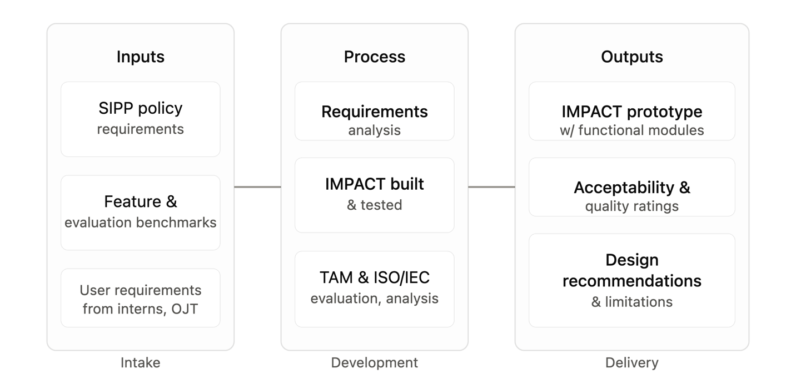

Hypotheses of the Study
This study will test the following hypotheses:
H₀: There is no significant difference in the assessments of student interns and expert evaluators on the acceptability of IMPACT in terms of perceived usefulness, perceived ease of use, attitude toward using, and behavioral intention to use.
H₀: There is no significant difference in the assessments of student interns and expert evaluators on the quality of IMPACT in terms of functional suitability, performance efficiency, compatibility, interaction capability, reliability, security, maintainability, flexibility, and safety.

CHAPTER III

RESEARCH METHODOLOGY
This chapter presents the methodology that will be used to develop and evaluate IMPACT, the web-based OJT monitoring portal developed in this study. It covers the research design and locale, the prototype’s framework and features, the development process, the evaluation (instruments, respondents, data collection, statistics), the ethical considerations, and the limitations. Together they will show how this methodology answers Chapter I’s five specific problems.

Research Design
This study will use a descriptive-developmental research design. It is developmental because the objective will be to create IMPACT, a web prototype for student interns and OJT coordinators, through iterative prototyping (requirements analysis, design, development, and testing) in a plan-do-check-act-informed cycle, each pass checked and refined. It is descriptive because the study will report, without manipulating variables, how acceptable and how high in quality evaluators judge the prototype on 10-point ratings.
The researchers will verify the prototype two ways. Automated component testing with Vitest and React Testing Library will check that each module renders and computes as specified; human evaluation through a Technology Acceptance Model (TAM) questionnaire and an ISO/IEC 25010 checklist will check acceptability and quality. The developmental strand answers Chapter I’s first two problems (developing IMPACT and its progress-monitoring component); the descriptive strand answers the third and fourth (TAM acceptability and ISO/IEC 25010 quality); the inferential strand answers the fifth, testing the H₀/H₁ hypotheses on the difference between rater groups. This design follows Philippine OJT monitoring systems built and evaluated this way (Atenin et al., 2026; Cabalbag & Ontiveros, 2024; Castro, 2024; Del Rosario & Dela Cruz, 2021).

Research Locale
The study took place at Bulacan State University, Malolos, Bulacan, in Central Luzon, Philippines. The prototype’s institutional identifiers establish the locale: student accounts use @student.bulsu.edu.ph addresses and university-style IDs such as BU-2021-10045, coordinator accounts use @bulsu.edu.ph addresses, and the interface labels its sessions “BulSU · Student Portal” and “BulSU · Admin Panel.” The university is both the requirements context (the internship program whose supervision of attendance capture, rendered-hours documentation, and coordinator oversight the prototype supports) and the setting that supplied the student interns, the OJT coordinator, and the expert evaluators. The researchers document the locale from the prototype’s identifiers and development records, not field observation; they installed no system in any university office.

System Framework and Features
IMPACT will provide two roles (student intern and admin, the OJT Coordinator). Role-based login will fix module access, as summarized below.
Table 1
Feature-Access Matrix of IMPACT by Role and Module
Module | Student Intern | OJT Coordinator (Admin)
Login | ● | ●
Feed | ● | —
Explore | ● | —
Student Profile | ● | —
Attendance | ● | ●
Journal | ● | ●
Portfolio | ● | ●
Photos | ● | ●
Reports | ● | ●
Assignments | — | ●
Admin Dashboard | — | ●
Student Monitoring | — | ●
Announcements | ● | ●
Notifications | ● | ●
Settings | ● | ●
Legend: ● = accessible; — = not in navigation.
The researchers will group the modules into three categories. Student documentation modules cover Attendance with rendered-hours tracking against the 486 required hours, Journal, Portfolio, Photos, and Reports moving through Draft → Submitted → Under Review → Approved / Needs Revision, plus Assignments. Coordinator monitoring modules cover the Admin Dashboard (total interns, Online / Do Not Disturb / Offline counts, “Completed” and “Nearing Target” flags, and per-intern completed-hours against required-hours percentages) and the Student Monitoring view of intern progress, plus report review. Engagement modules cover the Feed, Explore, Announcements, Notifications, Student Profile, and Settings.
The prototype runs in three layers: a Presentation (UI) layer of React components and page routing in App.tsx across fourteen pages; an Application layer holding role-based navigation state and view logic; and a Data layer in which data/mockData.ts serves attendance, hours, reports, assignments, and presence status.

Figure 1
System Architecture of IMPACT
[Insert system architecture diagram here]

Process of Developing the System
The researchers will build the prototype through one repeated loop: planning will fix the scope, requirements analysis will fix what the system must do, design will specify the interface and data representation, development will implement it, and testing will check the build.

Planning
Planning will fix the study’s direction and scope. Requirements will come from related Philippine internship-monitoring studies and from the Student Internship Program in the Philippines, which requires HEIs and host training establishments to monitor, document, and evaluate student performance during placement (Cabalbag & Ontiveros, 2024; Castro, 2024; Del Rosario & Dela Cruz, 2021). Reported features: attendance capture, submission and feedback on trainee documentation, centralized communication, and coordinator-facing progress views (Atenin et al., 2026; Cabalbag & Ontiveros, 2024; Castro, 2024; Del Rosario & Dela Cruz, 2021). The researchers will screen those features for feasibility at prototype scale and fix the scope to the Statement of the Problem modules: role-based access, attendance and hours tracking, journal, portfolio and photo documentation, assignments and the report-review workflow, the coordinator dashboard and student monitoring, and announcements, notifications, and the social feed. Excluded: a live back end, biometric or GPS attendance, grade transmittal, and production deployment.

Approach in Development
Development will follow an iterative prototyping cycle: requirements → user-interface design → build → feedback from users and evaluators → refine, repeated until the slice meets the requirements. Each cycle will address a bounded part of the feature list, so the prototype can be demonstrated early and corrected while changes are still inexpensive.
Figure 2
Iterative Prototyping Cycle
[Insert diagram here]
The approach suits a front-end prototype on a demo dataset: no back end to stage, no data migration, only two roles to satisfy. Each iteration costs little and returns feedback quickly, so the design meets requirements and evaluator comments without a production build.

Requirement Analysis
The researchers will derive functional requirements from the Statement of the Problem. The system shall (a) authenticate users and apply role-based access for interns and coordinators; (b) log attendance and compute rendered hours against required hours; (c) record journal entries, portfolio items, and photos; (d) distribute assignments and accept reports through the Draft → Submitted → Under Review → Approved / Needs Revision workflow with coordinator feedback; (e) compute and surface completion percentages, Completed and Nearing Target flags, report states, and presence status (Online, Do Not Disturb, Offline); and (f) deliver announcements, notifications, and a social feed.
The researchers will group non-functional requirements into four areas. Usability: navigation and tasks must be learnable without training. Security of role access: each role must reach only the modules in Table 1, with coordinator views closed to students. Responsiveness: the interface must render on desktop and narrower viewports. Reliability: hours, percentages, and flags must stay consistent for the same data.

Design
The researchers will produce a fourteen-page interface inventory: Login, Feed, Explore, Student Profile, Attendance, Journal, Portfolio, Photos, Reports, Assignments, Admin Dashboard, Student Monitoring, Announcements, Notifications, and Settings, each a sidebar component. Role-based routing will send students to the Feed and coordinators to the Admin Dashboard, showing each role only the items in Table 1. The researchers will define the data entities served to those screens: student profile (identity, placement, required and completed hours), attendance record (date, times, hours, status), rendered-hours totals, journal entry, portfolio item and photo, report with workflow status, assignment, announcement, notification, and intern presence status, all typed in the demo dataset.

Development
The researchers will implement the prototype with this stack, recorded here for reproducibility.
Technology | Purpose
React 19 | Component-based user interface and page rendering
TypeScript | Static typing for components, props, and data records
Vite | Development server and production build tooling
Tailwind CSS v4 | Utility-first styling of the interface
lucide-react | Icon set used across navigation and cards
Vitest | Test runner for the component and module suites
React Testing Library | Rendering and interaction utilities for component tests

Testing
The researchers will combine automated component tests with a manual functional walkthrough. Each module will have its own test file; testing will cover all component test files (24 files, 401 test cases): page rendering, role-based navigation after login, hours and progress computations from completed against required hours, report status counts and status-dependent displays across the workflow states, and presence display for Online, Do Not Disturb, and Offline. The researchers will run the walkthrough end to end (logging attendance, adding a journal entry, uploading photos, submitting a report, and reviewing the dashboard as coordinator) and record any deviation.

System Evaluation
The researchers will evaluate acceptability and quality: three respondent groups will complete a two-part instrument after a hands-on session, and they will analyze the ratings with descriptive and inferential statistics.

Research Instrument
Part I will be a TAM-based questionnaire covering the four constructs in the Statement of the Problem: Perceived Usefulness (how far the system helps interns and coordinators accomplish monitoring and documentation tasks), Perceived Ease of Use (how easy it is to learn and operate), Attitude Toward Using (the user’s disposition after use), and Behavioral Intention to Use (willingness to use it regularly and recommend it). Respondents will rate the statements on a 10-point scale.
Part II will be an ISO/IEC 25010 checklist covering nine quality characteristics: Functional Suitability, Performance Efficiency, Compatibility, Interaction Capability, Reliability, Security, Maintainability, Flexibility, and Safety. Expert evaluators will rate them on the same scale after hands-on use. The researchers will construct both parts, have them validated by [panel of experts: placeholder], and pilot-test them before use. Combining both instruments on one form has precedent in Philippine OJT system evaluation (Cabalbag & Ontiveros, 2024; Atenin et al., 2026).

Population and Sample
Three groups will evaluate the prototype: (1) student interns who use it, (2) the OJT coordinator/administrator who uses the coordinator modules, and (3) IT expert evaluators (faculty or practitioners) who complete the ISO/IEC 25010 checklist. The researchers will evaluate one prototype at one site, so they will draw respondents purposively from persons familiar with internship supervision or software evaluation; they will use a census wherever all eligible persons can be included.
Table 2
Summary of Evaluation Sample
Respondent group | Role in the evaluation | Sampling design | Sample size
Student interns who used the IMPACT prototype | Rated TAM acceptability | Purposive / census | [N]
OJT coordinator (administrator) | Rated coordinator modules | Census | [1]
IT expert evaluators | Rated ISO/IEC 25010 quality | Purposive | [N]

System Data Collection Procedure
The researchers will collect data in four steps. They will orient respondents and demonstrate the prototype’s screens and workflows. Each respondent will then complete hands-on tasks: a student will log an attendance entry, add a journal entry, and submit a report, while the coordinator will open the dashboard, check intern counts and presence status, and review a submitted report. Respondents will then complete the instruments individually (the TAM questionnaire for users, the ISO/IEC 25010 checklist for experts) on the same 10-point scale. The researchers will collect the forms and check them for completeness and consistent encoding.

Data Processing and Analysis
Weighted mean and standard deviation will be computed for each construct and quality characteristic: the mean summarizes the rating level, and the standard deviation describes response dispersion. Means will be interpreted against Table 3, a rubric for this study’s 10-point ratings.
Table 3
Verbal Interpretation Scale
Mean score range | Verbal interpretation
9.00 – 10.00 | Excellent
7.00 – 8.99 | Very Good
5.00 – 6.99 | Good
3.00 – 4.99 | Fair
1.00 – 2.99 | Poor
To test the H₀/H₁ hypotheses stated in Chapter I’s Statement of the Problem and in Chapter II, an independent-samples t-test at α = 0.05 will be applied to the TAM acceptability ratings and the ISO/IEC 25010 quality ratings, testing the difference between student interns and expert evaluators. Because the OJT coordinator is a single respondent, those ratings will be reported descriptively and excluded from the test.

Ethical Considerations
The study poses no risk beyond administering evaluation surveys. The researchers will obtain informed consent from every evaluator; participation will be voluntary, and respondents may withdraw without penalty. Responses will be kept anonymous, and results will be reported in aggregate.
The prototype will use demo data only: it will run on a demonstration dataset and store no real personal data of actual interns, and the researchers will create its records as mock data for the study. Should personal information ever be introduced, the Data Privacy Act of 2012 (Republic Act No. 10173) governs its collection, use, and protection. The prototype serves academic evaluation only; production deployment and official internship records are out of scope, and the limitations below bound the findings.
AI-assisted research disclosure. The researchers used AI-assisted tools for drafting this chapter and for scaffolding code during development. They verified all citations manually against the approved source list: no author, year, title, DOI, or other bibliographic detail came from model recall, and nothing appears in the reference list that was not cited.

Limitations of the Method
- Single-site locale. Requirements context and respondents come from one institution, so findings may not transfer elsewhere.
- Prototype on demo data. The system runs on a mock dataset with no live back end; behavior under real volumes (performance, concurrency, integrity) was not observed.
- Self-reported ratings. Scores come from instruments completed after a single session, so they reflect perception rather than measured usage outcomes.
- Small expert panel. ISO/IEC 25010 ratings rest on few evaluators, which constrains the stability of the quality means.
- No longitudinal outcome data. The study measures development outputs and evaluation ratings, not the system’s effect on completion rates, documentation quality, or supervision over time.

References

Araah, ¹, Cabalbag, F. C., Khadija, M., & Ontiveros, X. P. (2024). Management Information System for Tracking On-the-Job Trainees. International Journal of Arts, Sciences and Education, 5(2), 203–211. https://mail.ijase.org/index.php/ijase/article/view/352
Atenin, F. M. M. (2026). OJTrack : Android and Web-Based OJT Monitoring and Attendance System. International Journal of Multidisciplinary Research in Science, Engineering and Technology, 9(1). https://doi.org/10.15680/IJMRSET.2026.0901005
Calairo, L. R. (2025). Developing an internal quality assurance model: The case of two Philippine private universities. Philippine Education Research Journal. https://peac.org.ph/2025-1-08/
CHED (2022). Digital Transformation of Philippine Higher Education. In Digital Transformation of Philippine Higher Education. https://doi.org/10.1596/38481
CHED Region 11. (2024). Online Orientation/Workshop for the Annual Data Collection of Higher Education Management Information System ({HEMIS}) for {SY} 2024--2025. https://ro11.ched.gov.ph/2024/10/25/online-orientation-for-the-annual-data-collection-of-hemis-for-sy-2024-2025/9581/uncategorized/
Ched. (2014). Handbook on Typology , Outcome-bsed Education and Institutional Sustainability Assessment. Commission on Higher Education. http://www.ched.gov.ph/wp-content/uploads/2014/06/Handbook on Typology Outcomes.pdf
CHED. (2020). Office of Institutional Quality Assurance and Governance (OIQAG). https://ched.gov.ph/ched/official-organization-structure/office-institutional-quality-assurance-governance-oiqag/
Commission on Higher Education. (2024). Higher Education Institution Data Analytics ({HEIDA}). https://heida.ched.gov.ph/
Commission on Higher Education. (n.d.). Enrollment Data Collection System ({EDCS}). Retrieved https://edcs.ched.gov.ph/
Dando, R. P., & Santillan, J. P. (2025). Integrating Philippine Quality Awards With Iso 9001:2015 Pdca for Audit Efficiency and Improvement. Journal of Innovations in Business and Industry, 3(4), 249–258. https://doi.org/10.61552/jibi.2025.04.004
Del Rosario, M. J. N., & Dela Cruz, R. A. (2022). Internship program management information system with lean management. International Journal of Information and Education Technology, 12(1), 7–14. https://doi.org/10.18178/ijiet.2022.12.1.1580
Emma Greta M. Castro. (2024). Mobile-based Student Internship Monitoring System using Progress Tracking Algorithm. International Research Journal on Advanced Science Hub, 6(08), 204–209. https://doi.org/10.47392/irjash.2024.029
Grate-Paltiguera, S. M., & Gabion, J. G. (2026). International Organization for Standardization ({ISO}) 9001:2015 Quality Management System: Its Implementation, Effectiveness, and Challenges. International Journal of Research and Innovation in Social Science, 10(26), 3597–3610. http://ideas.repec.org/a/bcp/journl/v10y2026i26p3597-3610.html
Malabanan, O., Arellano, M. J., Cortez, C. M., Ngo, N. D., & Kawachi, R. H. (2024). {Hisight}: A Generic {CQI}-based {OBE} System for Regulatory Compliance. De La Salle University Research Congress Proceedings. https://old.dlsu.edu.ph/wp-content/uploads/pdf/conferences/research-congress-proceedings/2024/TPH-09.pdf
Marikina Polytechnic College. (2026). {CHED}, ASEAN Partners Convene Over 200 {SUC} Leaders at {MPC} for Quality Assurance Workshop. https://mpc.edu.ph/2026/07/16/ched-asean-partners-convene-over-200-suc-leaders-at-mpc-for-quality-assurance-workshop/
Martinez, J. B. (2025). Maintaining {ISO} 9001:2015 in higher education institutions in {Cordillera Administrative Region}, Philippines. Indonesian Journal of Education Research. https://cahaya-ic.com/index.php/IJoER/article/view/1739
Mindoro-Mesana, J. M., Mesana, J. P., & Mariño, L. (2023). Design and Development of Romblon State University Romblon Campus Accreditation Data Warehouse. Romblon State University Research Journal, 4(2), 17–24. https://doi.org/10.58780/rsurj.v4i2.54
Opiniano, J., Ho, A. T., & Mercado, E. M. (2026). Pandemic-induced online internships as situated, bounded, inclusive learning: a Philippine mixed methods study. Media Practice and Education, 27(2), 156–178. https://doi.org/10.1080/25741136.2024.2411644
Pardiñan, E. G., Bondad, R. M., & Mangubat, J. C. (2025). Key informants’ perception on records digitization and a web-based technology platform for accreditation of Philippine State Universities and Colleges. Education and Information Technologies, 30(8), 11127–11150. https://doi.org/10.1007/s10639-024-13256-z
Rodriguez, J., Valenzuela, M., & Ayuyao, N. (2018). TQM paradigm for higher education in the Philippines. Quality Assurance in Education, 26(1), 101–114. https://doi.org/10.1108/QAE-12-2015-0048
Roque, J., & Ulanday-Lozano, D. M. (2024). Quality Management System Practices among Higher Education Institutions in Region XII, Philippines. Journal of Interdisciplinary Perspectives, 2(12). https://doi.org/10.69569/jip.2024.0491
Salgado, M. (2025). Communicating Nonconformities in Higher Education: A Phenomenological Account of Auditors’ Experiences. Journal of Interdisciplinary Perspectives, 3(7). https://doi.org/10.69569/jip.2025.314
Salisi, G., & Balahadia, F. (2025). EduComply: A progress tracking system for compliance in teaching-learning deliverables using decision support system. International Journal of Science, Technology, Engineering & Mathematics, 5(3), 40–78. https://doi.org/10.53378/ijstem.353240
Tarlac State University. (2021). {TSU} Project Monitoring, Evaluation, and Reporting System ({PMERS}). https://coe-psp.dap.edu.ph/compendium-innovation/tsu-project-monitoring-evaluation-and-reporting-system-pmers/

Appendix A

Screenshots of the System
This appendix presents screenshots of the IMPACT prototype, the web-based OJT monitoring portal developed in this study. Each figure corresponds to a page path exercised by the component test suite: the unit tests in src/components/*.test.tsx render one test file per module, and every module listed below is covered. The first twelve figures show the student portal session; the last three show the admin (OJT coordinator) panel session. Screenshots were captured from the running development build at a 1440 × 900 viewport.

Student Portal
Figure A-1
Login page
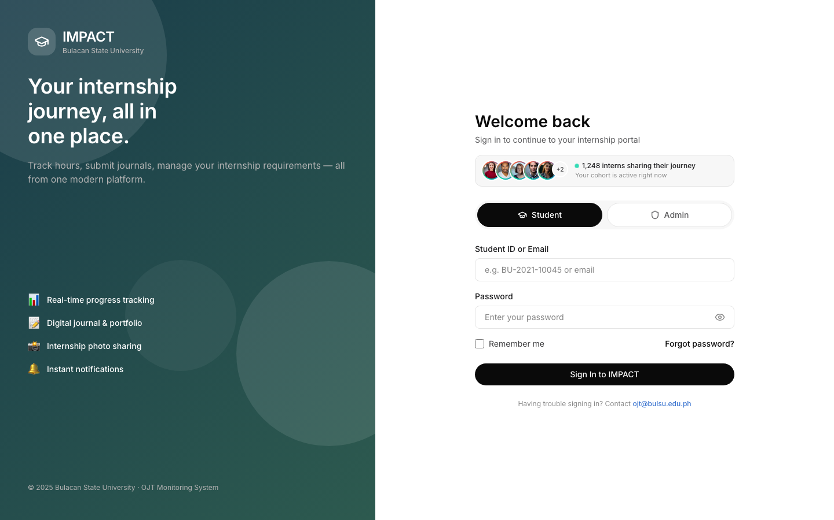
Login page of the IMPACT portal with the Student and Admin role tabs
Figure A-2
Feed
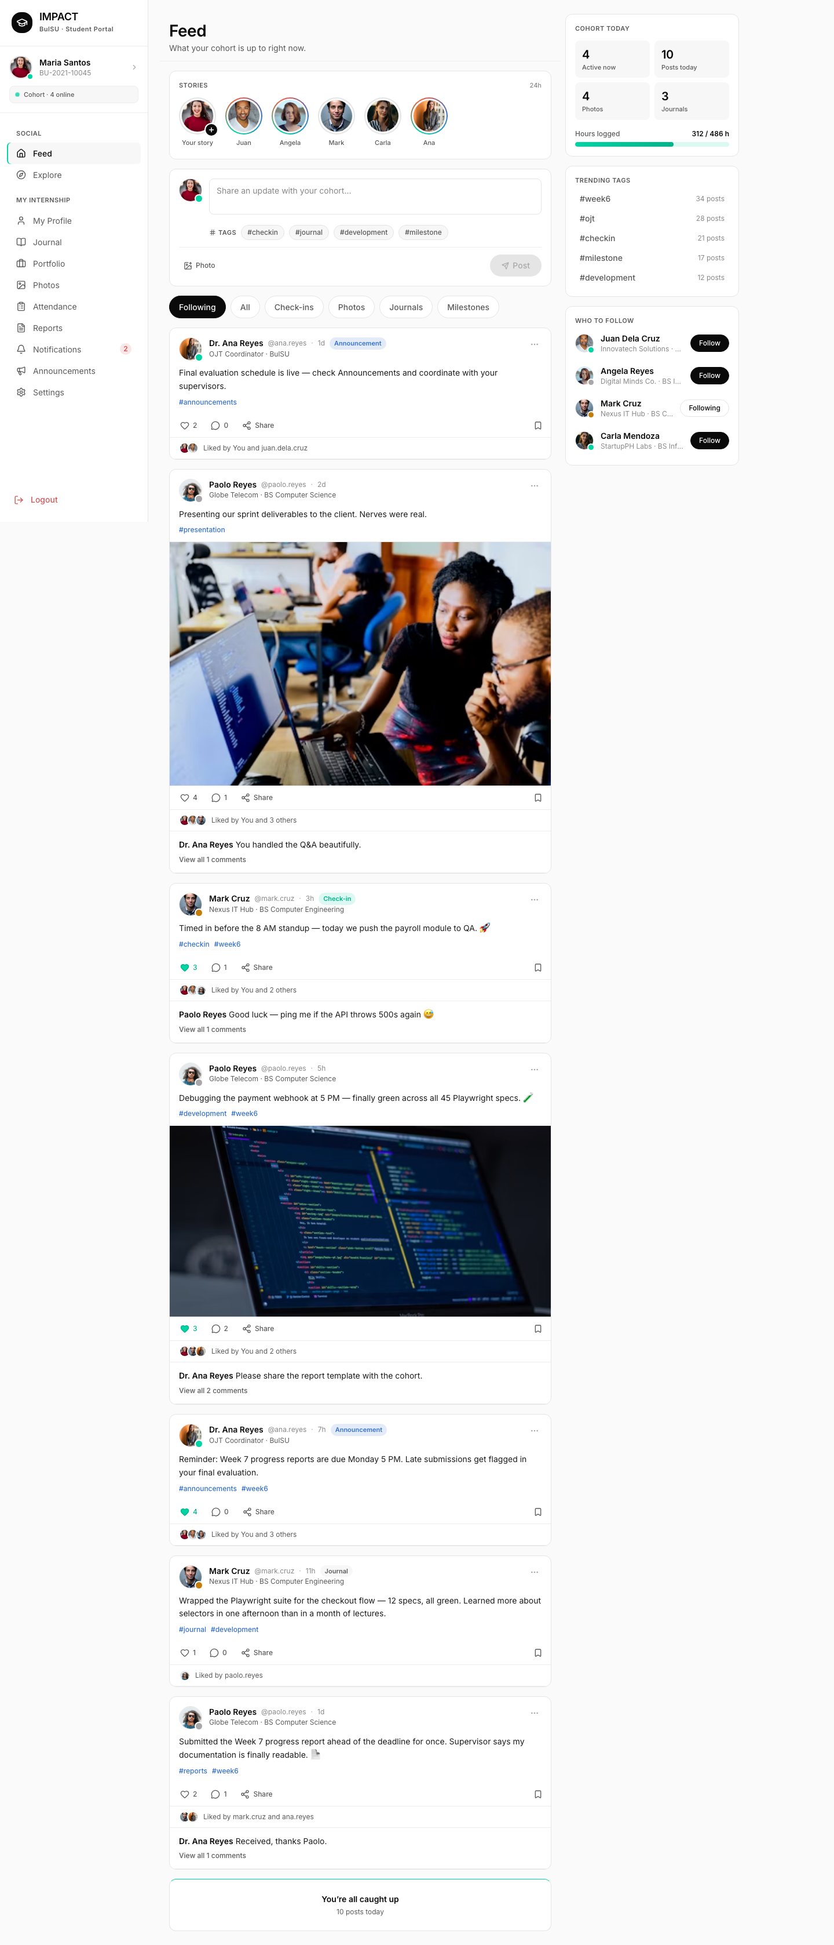
Feed page showing internship activity updates

Figure A-3
Explore

Explore page of the student portal

Figure A-4
My Profile
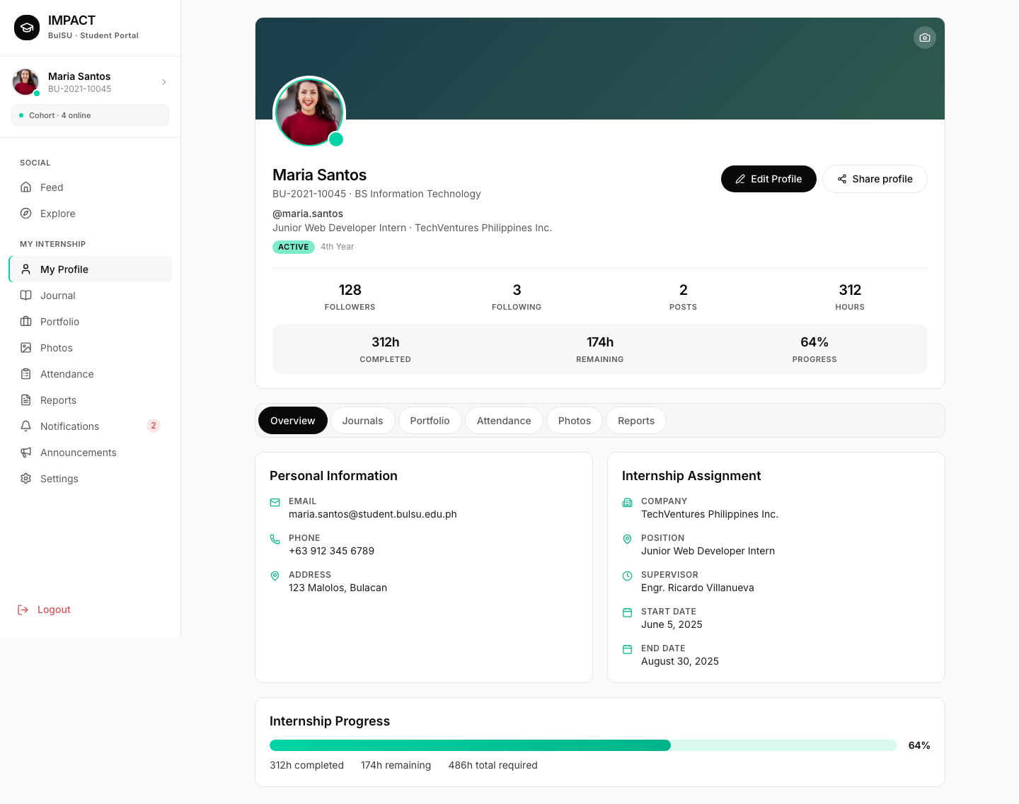
Student profile page with internship placement details

Figure A-5
Journal
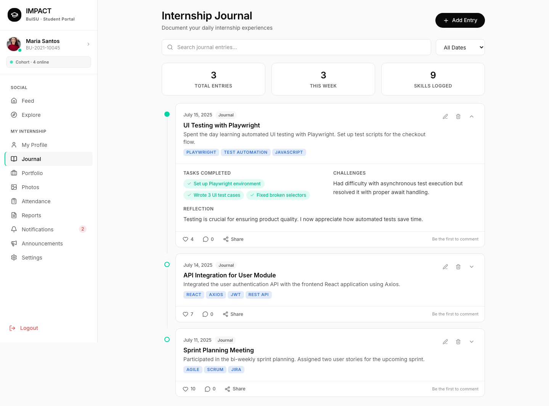
Daily journal page for internship entries

Figure A-6
Portfolio
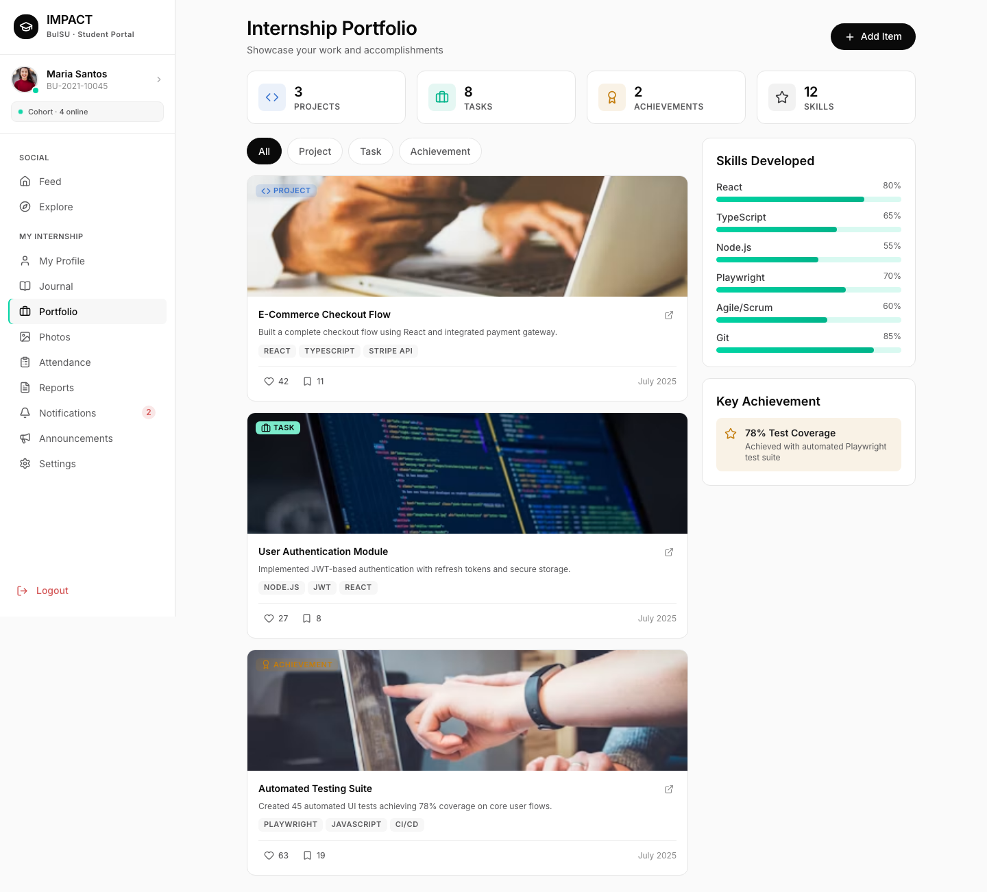
Portfolio page for internship outputs

Figure A-7
Photos

Internship photo documentation page

Figure A-8
Attendance
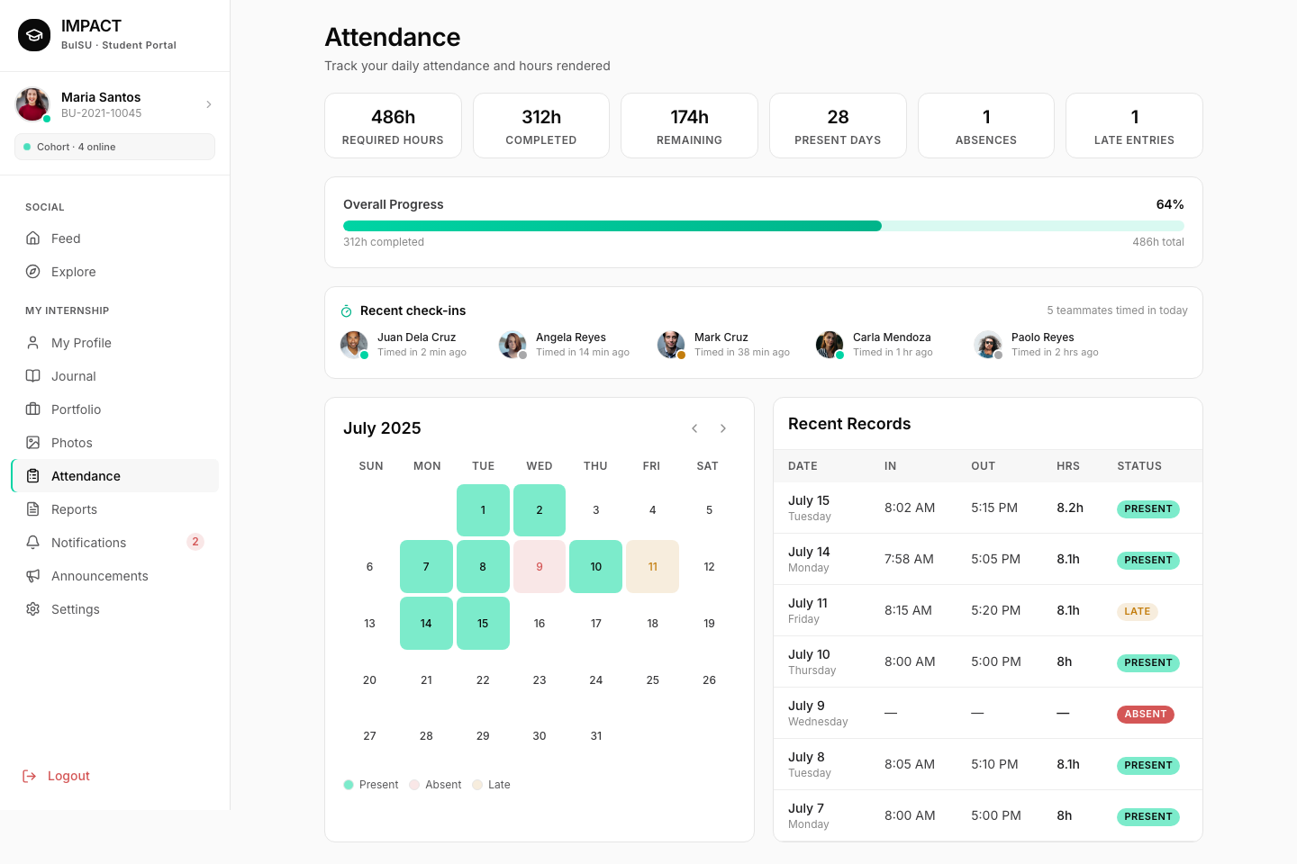
Attendance page with rendered-hours progress against required hours

Figure A-9
Reports
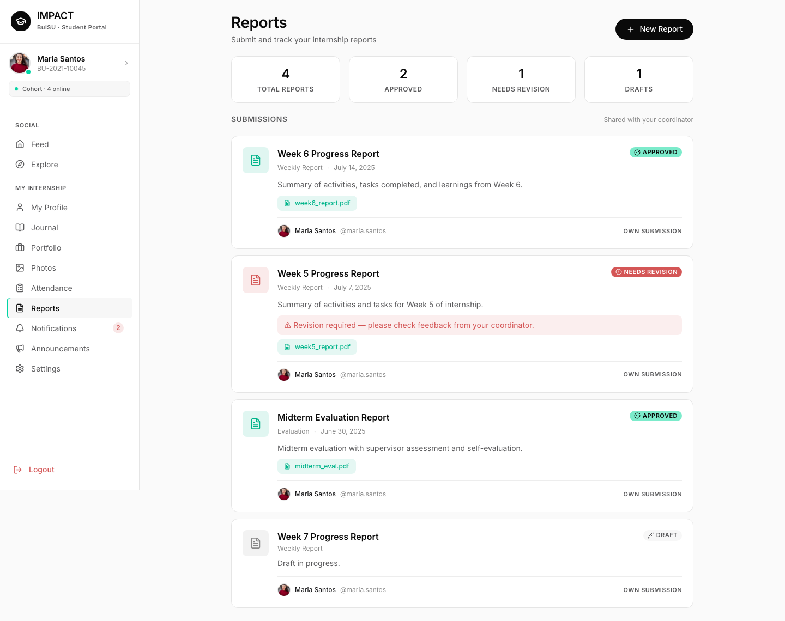
Report submission page with status summary cards

Figure A-10
Notifications
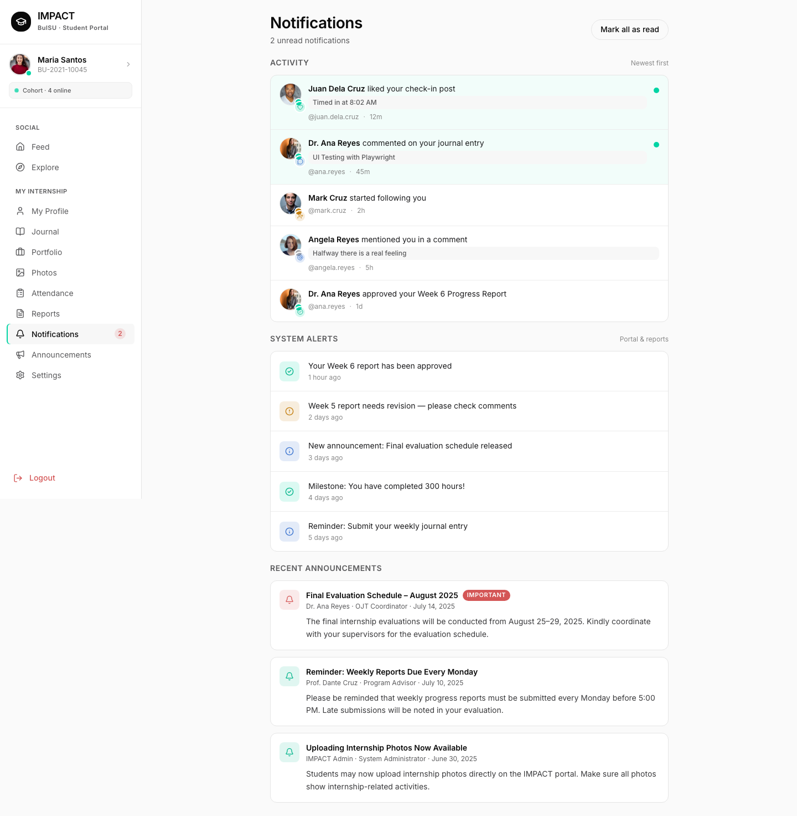
Notifications page

Figure A-11
Announcements
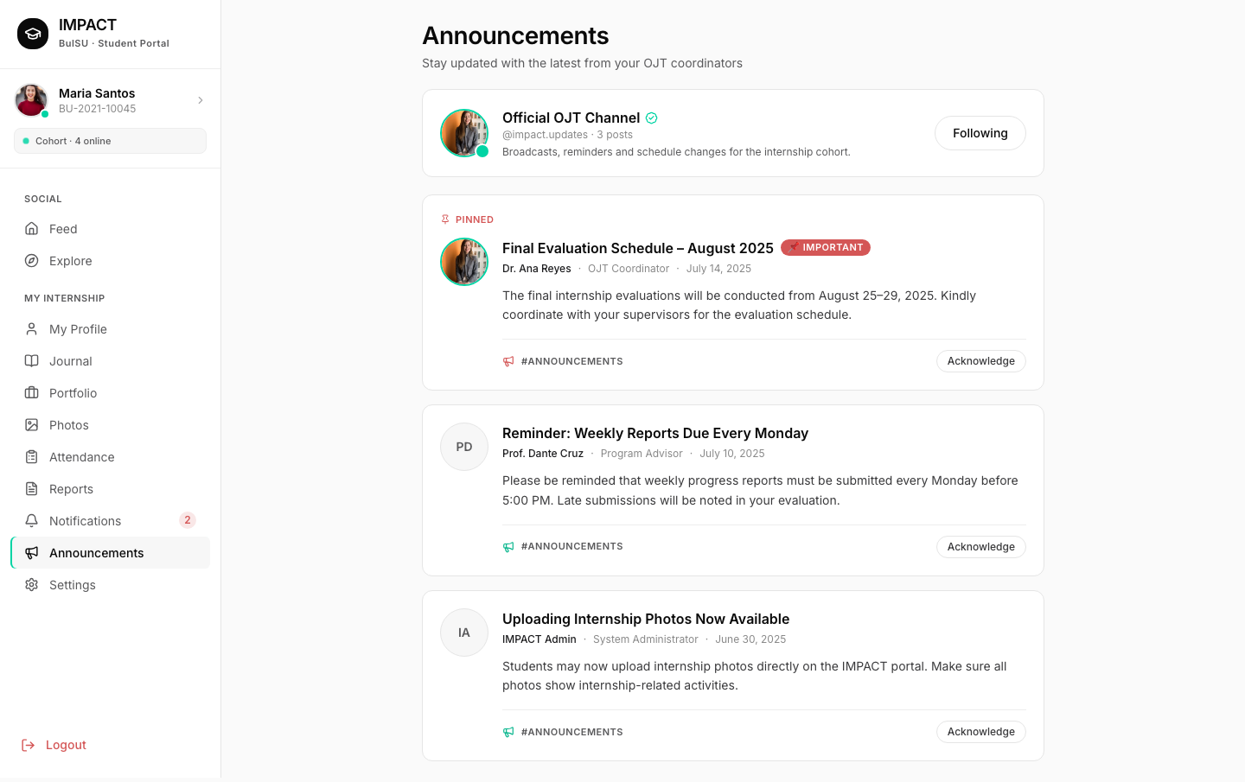
Announcements page for coordinator notices

Figure A-12
Settings
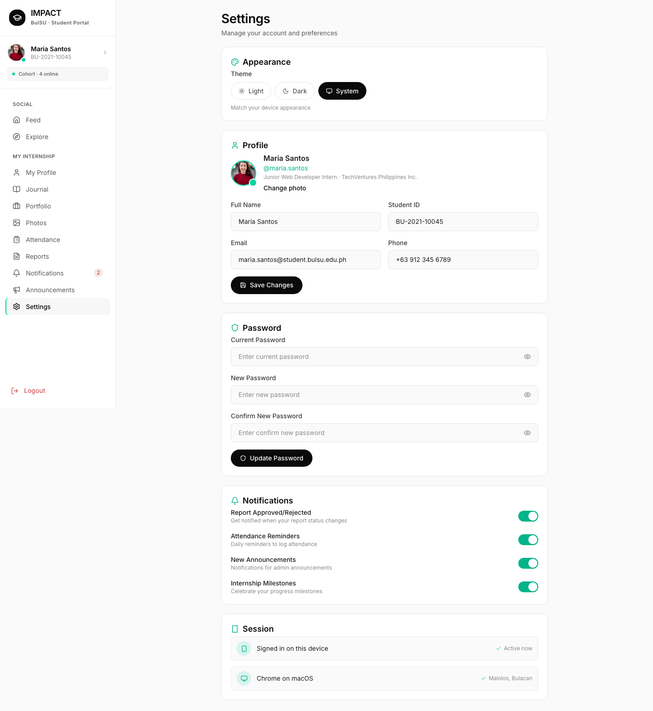
Settings page of the student portal

Admin Panel
Figure A-13
Admin Dashboard
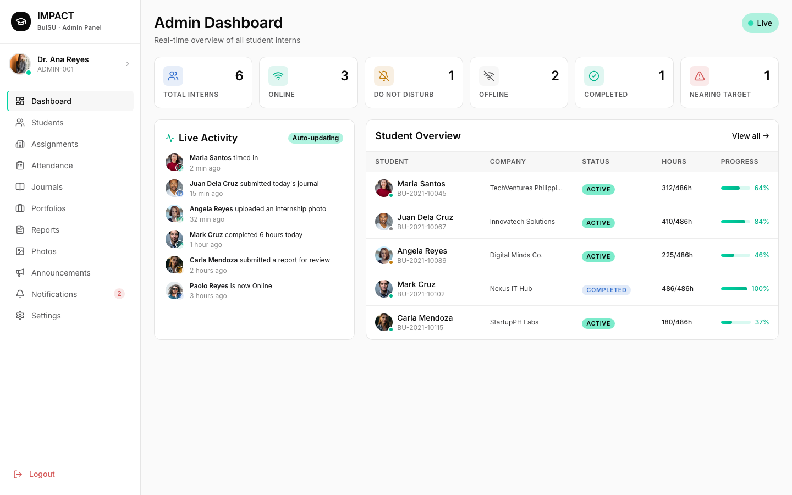
Admin dashboard with intern counts, status flags, live activity, and student overview

Figure A-14
Students monitoring
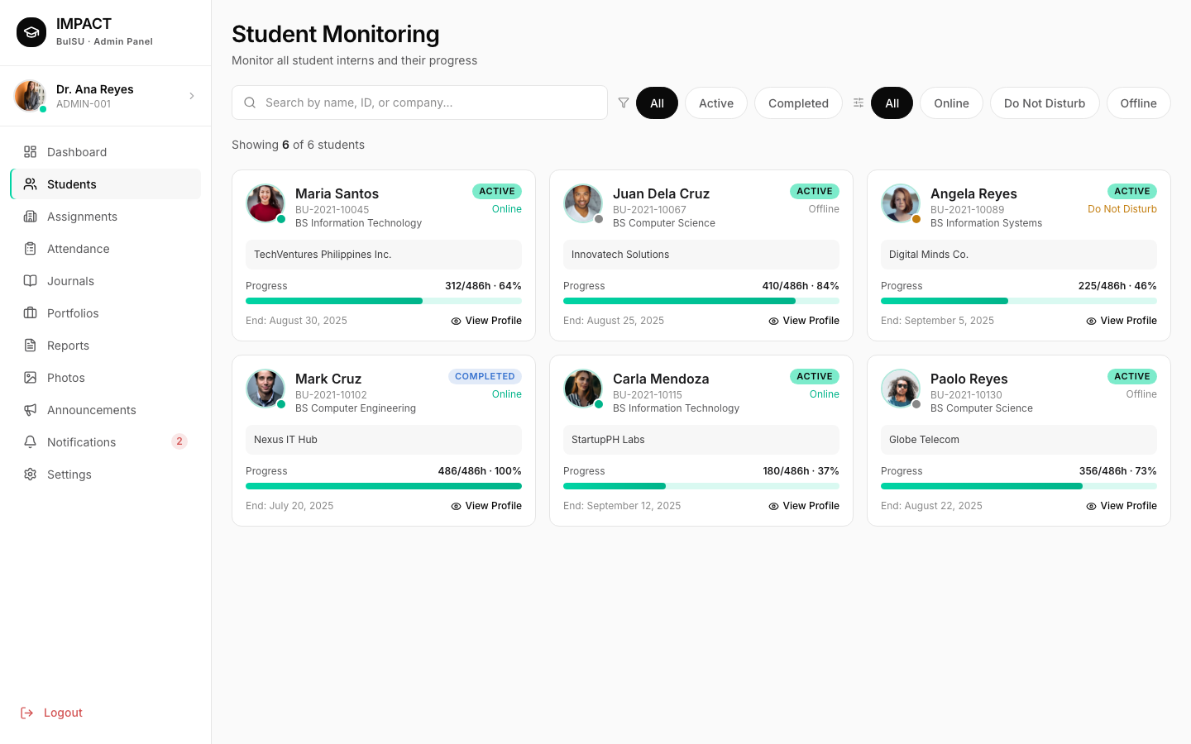
Student monitoring page listing all interns with rendered-hours progress

Figure A-15
Assignments
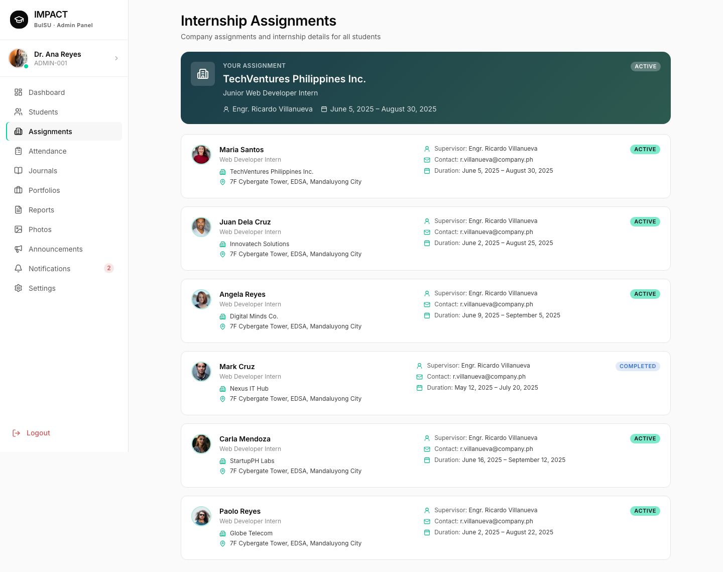
Assignments page for distributing and tracking intern tasks

