A Design and Comparative Evaluation of Hybrid Content-Based Recommendation Pipelines Integrating TF-IDF, SBERT, and Metadata Fusion

Student Researchers, BSMCS — Bulacan State University

October 2026

Table of Contents
CHAPTER I 1
THE PROBLEM AND ITS BACKGROUND 1
CHAPTER II 1
REVIEW OF RELATED LITERATURE AND STUDIES 1
CHAPTER III 1
RESEARCH METHODOLOGY 1
References 1
APPENDIX A 1
SCREENSHOTS OF THE SYSTEM 1
APPENDIX B 1
MATHEMATICAL SPECIFICATION OF THE RECOMMENDATION PIPELINES 1

CHAPTER I

THE PROBLEM AND ITS BACKGROUND
Chapter I sets out the background of the problem, the statement of the problem, the significance of the study, the scope and delimitation, and the definition of key terms for Re:Search, the hybrid content-based academic paper recommendation system developed in this study. It provides the context behind the system and states the study’s objective and questions.

Introduction
Thesis writing begins with locating related literature: researchers must find prior studies, position their work against them, and avoid duplicating completed research, and each move depends on retrieving the right papers. The volume of published research makes that a retrieval problem in its own right, and research-paper recommender systems have been built to address it (Beel et al., 2016; Bai et al., 2019). This study designs and builds a recommendation system for that setting, then evaluates its configurations against one another.
Philippine undergraduates typically find related literature by typing keywords into Google Scholar and library catalogs. Keyword retrieval works by exact term matching, and the vocabulary mismatch problem breaks it whenever authors and searchers use different words for the same idea: synonymy lets a paper on “neural networks” escape a search for “deep learning,” and polysemy lets one term pull in unrelated senses (Manning et al., 2008). Keyword search also ignores structured metadata such as publication year and venue, so a chronological search can surface dated work. Content-based research documents the same weakness: keyword profiles over-emphasize surface terms and under-use structured fields (Lops et al., 2011).
Content-based filtering offers a principled alternative: recommend items whose features resemble the query or the user’s profile (Adomavicius & Tuzhilin, 2005; Lops et al., 2011). The classical representation is TF-IDF term weighting, which measures a term’s importance within a document against its rarity across the corpus (Salton & Buckley, 1988; Manning et al., 2008). Semantic embeddings extend this by mapping sentences and paragraphs into dense vectors, so Sentence-BERT can score similarity between texts that share no surface terms (Reimers & Gurevych, 2019). Metadata adds a third signal: title, abstract, keywords, and publication year.
Each signal fails differently when used alone. Lexical matching remains blind to paraphrase, because papers on the same topic written in different vocabularies share few terms (Manning et al., 2008; Lops et al., 2011). Semantic matching captures paraphrase but can drift toward broadly related material (Reimers & Gurevych, 2019). Metadata alone cannot find conceptually related papers sharing no fields. Hybrid systems offset these weaknesses by combining signals (Burke, 2002). Yet surveys of research-paper recommenders find that most systems rely on a single representation and that few studies evaluate configurations comparatively (Beel et al., 2016; Bai et al., 2019).
This study develops Re:Search, a local academic paper repository and recommendation system for thesis writing that the interface brands “Re:Search · BulSU BSMCS.” The system stores academic papers imported from PDF or BibTeX citations, including exports from Google Scholar, and validates each record for recommendation use: title, abstract, keywords, and publication year are required. Validated records become prepared text built from Title + Abstract + Keywords. Re:Search represents prepared text two ways, as TF-IDF vectors computed with scikit-learn and as S-BERT embeddings from the all-MiniLM-L6-v2 model, and scores candidates by cosine similarity. Three signal components, TF-IDF, S-BERT, and a Metadata component scoring title, abstract, keywords, and publication year at 25 percent each, yield six fixed pipeline configurations (Table 1) and a user-customizable dial allocation. On seed-paper searches all four metadata signals are active; on free-text queries only the title signal is available, because abstract, keywords, and year are absent from the query. Search runs by free-text query or seed paper. TF-IDF and S-BERT component scores are min-max normalized before weighted combination, while metadata scores are already bounded in the 0 to 1 range and pass through unchanged; ties break by newer year, then title.
Table 1
The Six Pipeline Configurations of Re:Search
Pipeline | Signals | Weights
TF-IDF | Lexical only | 100% TF-IDF
S-BERT | Semantic only | 100% S-BERT
TF-IDF + S-BERT | Lexical + semantic | 50% / 50%
TF-IDF + Metadata | Lexical + metadata | 66.7% / 33.3%
S-BERT + Metadata | Semantic + metadata | 66.7% / 33.3%
TF-IDF + S-BERT + Metadata | Full hybrid | 40% / 40% / 20%
Comparative evaluation runs through the Arena, an instrument built into the system. Every Arena run executes all six pipelines on the same query or seed paper at a top-K of 5, 10, or 15, and reports four comparisons (Table 2): consensus ranking, pairwise agreement, the independence-weighted consensus winner, and the win tally with battle history. In the winner metric, one pipeline’s vote for a paper weighs 1 minus the Jaccard similarity of the two pipelines’ component sets, so no pipeline wins by confirmation from its own hybrids. Winning runs are logged to the battle history, and the Arena page tallies wins per pipeline, showing the champion and its streak. The local repository database held 168 paper records when this chapter was written, 146 valid for recommendation.
Table 2
Arena Comparison Measures
Measure | What it reports
Consensus ranking | Ordered by votes across pipelines, then average rank
Pairwise overlap at K | Shared papers between two pipelines’ top-K results
Mean rank gap | Mean absolute rank difference over shared papers
Independence-weighted consensus | Winner by weighted vote share, discounted for shared components
Win tally and battle history | Wins per pipeline, champion, and streak
Local prototypes rarely integrate lexical, semantic, and metadata signals, and fewer still evaluate the configurations against one another. Re:Search builds that integration, and the Arena supplies the comparison. The study will report which configurations capture consensus best and how single-signal and hybrid pipelines agree in ranking, within the Re:Search corpus and protocol. The aim is a working prototype and an evidence-based account of its configurations.

Statement of the Problem
Undergraduate thesis writing at Bulacan State University depends on related literature, yet the retrieval tools students use, keyword search in Google Scholar and library catalogs, break under vocabulary mismatch and ignore structured metadata (Manning et al., 2008). Content-based recommenders can recover relevant literature, yet single-signal approaches fail in opposite directions: lexical matching misses paraphrase, and semantic matching drifts from the topical and temporal constraints a thesis imposes (Lops et al., 2011; Reimers & Gurevych, 2019). Hybrid systems combine signals to offset these weaknesses (Burke, 2002), but comparative evidence on how configurations behave is scarce (Beel et al., 2016; Bai et al., 2019), and local prototypes integrating all three signals are rare. This study will therefore design and develop Re:Search, a hybrid content-based recommendation system for academic papers, and comparatively evaluate its six pipeline configurations, addressing the following specific questions:
- How can a hybrid content-based recommendation system for academic papers be designed and developed, specifically through:
- 1.1 prepared-text normalization of title, abstract, and keywords,
- 1.2 TF-IDF and S-BERT representations of prepared text with metadata signals,
- 1.3 six fixed-weight pipeline configurations plus a user-customizable dial allocation, and
- 1.4 query-based and seed-paper-based search?
- How can the six pipeline configurations be comparatively evaluated through the Arena, specifically through:
- 2.1 consensus ranking,
- 2.2 pairwise agreement in overlap at K and mean rank gap,
- 2.3 the independence-weighted consensus winner, and
- 2.4 win tally and battle history?
- How do hybrid configurations compare with single-signal configurations in consensus capture and ranking agreement?
To answer the third question, this study will examine the following hypotheses descriptively:
H₀: There is no difference in consensus capture between single-signal and hybrid pipeline configurations, as measured by the independence-weighted consensus winner.
H₀: There is no difference in ranking agreement between single-signal and hybrid pipeline configurations, as measured by pairwise overlap at K and mean rank gap.

Significance of the Study
This study will benefit the following parties:
Thesis students. Re:Search gives undergraduate thesis writers a local repository of academic papers and a recommendation tool that surfaces related literature beyond exact keyword matches (Manning et al., 2008; Lops et al., 2011). Arena results will show which configurations to expect to agree with the broadest set of independent signals when searching.
Faculty advisers and researchers. Faculty advisers and graduate researchers gain a documented comparison of lexical, semantic, and metadata signals on a local corpus and an instrument for explaining why different searches surface different papers.
University library and repository staff. Library and repository staff will obtain a reference design for recommendation features inside the university’s own collections, with the pipeline, weighting scheme, and evaluation protocol documented for judgment before any deployment.
System developers. Developers receive an open account of how the six configurations were built: prepared-text normalization, TF-IDF and S-BERT representations, the metadata component, weighted combination, and the Arena’s metrics (Burke, 2002; Reimers & Gurevych, 2019).
Future researchers. Future researchers will inherit the Arena as an evaluation instrument and the study’s bounded findings as a baseline, with delimitations that give later work a clear starting point for extending the corpus, adding models, or moving to human evaluation (Beel et al., 2016; Bai et al., 2019).

Scope and Delimitation
This development study sets the following parameters.
The study will cover the design, development, and comparative evaluation of Re:Search, a local academic paper repository and recommendation system. Functional scope: (a) repository import from PDF and BibTeX, including Google Scholar citations; (b) recommendation validation and prepared-text normalization; (c) TF-IDF, S-BERT, and metadata representations; (d) six fixed pipeline configurations plus a user-customizable dial allocation; (e) query-based and seed-paper-based search; and (f) the Arena evaluation instrument with consensus ranking, pairwise agreement, the independence-weighted consensus winner, and battle history. Evaluation will be system-internal: the Arena’s agreement metrics, not a human user study. The corpus will be the locally collected academic papers stored in the repository, which held 168 records when this chapter was written, 146 of them valid for recommendation. The locale is Bulacan State University, Malolos, Bulacan.
The study will exclude production deployment; collaborative filtering and user ratings; user-profile personalization; sentence-embedding models other than all-MiniLM-L6-v2; OCR for scanned PDFs, since extraction is heuristic and pdfplumber-based; and multi-node or server-class storage, since the database is SQLite on a single node. The findings will be bounded to the evaluated corpus and prototype. The study will not rank the surveyed algorithms in general.

Definition of Terms
The study defines key terms operationally as follows.
Arena. Refers to the Re:Search instrument in which all six pipelines run on the same query or seed paper and are compared on consensus ranking, pairwise agreement, and the independence-weighted consensus winner.
Battle run. Refers to one execution of the Arena with a winner, logged to the battle history the Arena page uses to tally wins, crown a champion, and show streaks.
Consensus ranking. Refers to the Arena’s paper ordering, sorted by how many pipelines ranked each paper, then by average rank.
Content-based filtering. Refers to a recommendation approach that scores items by similarity between the item’s features and a query or profile, using no other users’ ratings (Lops et al., 2011; Adomavicius & Tuzhilin, 2005); in Re:Search, the features are prepared text and metadata.
Cosine similarity. Refers to the cosine of the angle between two vectors, used by Re:Search to compare TF-IDF vectors, S-BERT embeddings, and metadata text fields (Manning et al., 2008).
Duplicate detection. Refers to the identification of multiple repository records for the same paper, a pending data-quality concern in the current corpus.
Hybrid pipeline. Refers to a pipeline configuration that combines two or three component scores by weighted sum (Burke, 2002); Re:Search defines four among its six configurations.
Independence-weighted consensus. Refers to the Arena’s winner metric, in which one pipeline’s vote for a paper weighs 1 minus the Jaccard similarity of the two pipelines’ component sets; the winner captures the largest share of available weighted consensus, ties breaking by the lower average consensus rank.
Mean rank gap. Refers to the mean absolute difference between the ranks two pipelines give to the papers both ranked.
Metadata component. Refers to the Re:Search component that scores candidates on four signals, title, abstract, keywords, and publication year, each fixed at 25 percent; missing fields contribute zero, and publication-year similarity is 1 / (1 + |Δyear|). On seed-paper searches all four signals are active; on free-text queries only the title signal is available, because abstract, keywords, and year are absent from the query.
Min-max normalization. Refers to the rescaling of component scores into the 0 to 1 range before weighted combination; metadata scores are already bounded and are not normalized.
Pairwise agreement. Refers to the comparison of two pipelines on the papers both ranked, reported as overlap at K and mean rank gap.
PDF discovery. Refers to the search for open-access candidate PDFs for a record without a stored file, drawing on sources such as Unpaywall, Crossref, Semantic Scholar, arXiv, and OpenAlex.
Prepared text. Refers to the normalized text built from Title + Abstract + Keywords that Re:Search feeds to TF-IDF and S-BERT.
Recommendation index. Refers to the repository’s stored TF-IDF vectors and S-BERT embeddings; the system tracks when repository changes make the index stale and rebuilds it.
S-BERT. Refers to Sentence-BERT, a Siamese BERT architecture that maps sentences and paragraphs to dense embeddings for similarity scoring (Reimers & Gurevych, 2019); Re:Search uses the all-MiniLM-L6-v2 model.
Seed paper. Refers to a repository paper selected as the query; the system builds the query representation from its prepared text and excludes it from the results.
TF-IDF. Refers to term frequency-inverse document frequency, a weighting scheme assigning weight by a term’s frequency within a document and its rarity across the corpus (Salton & Buckley, 1988; Manning et al., 2008). Re:Search computes TF-IDF vectors with scikit-learn.
Top-K. Refers to the K highest-ranked papers a pipeline returns; the Arena interface offers K values of 5, 10, and 15, while the backend accepts up to 25.

CHAPTER II

REVIEW OF RELATED LITERATURE AND STUDIES
The recommendation prototype developed in this study combines three retrieval signals, TF-IDF lexical matching, S-BERT semantic embeddings, and a metadata score over title, abstract, keywords, and publication year, into six fixed-weight pipeline configurations, then compares those configurations in an Arena that records consensus rankings, pairwise agreement, and an independence-weighted winner. Its design draws on four bodies of work: content-based filtering theory, the information retrieval models that give lexical and semantic matching their form, hybrid recommender design, and offline evaluation practice. This chapter reviews the theories, literature, and studies behind those bodies, offers a synthesis with a gap analysis restated as design requirements, and closes with the conceptual framework and hypotheses.

Related Theories
Content-based filtering theory supplies the study’s first principle. Lops et al. (2011) define a content-based recommender as a system that profiles items by their attributes and recommends items whose profiles match the profile of a query item or a learned user profile, with no reliance on the ratings of other users. For textual items the profile is a structured representation of the document’s content, and matching is a similarity computation over those representations (Lops et al., 2011). The prototype applies this principle directly: a paper record’s prepared text, built from title, abstract, and keywords, is the profile; the seed paper or text query is the comparison point; and cosine similarity produces the ranking.
The vector space model and term weighting give the lexical signal its theoretical form. Salton and Buckley (1988) established that single-term indexing with appropriately weighted terms retrieves at least as well as more elaborate text representations and identified the composite term frequency by inverse document frequency (tf-idf) weight as the operative baseline. Manning et al. (2008) formalize the model in the standard textbook treatment: documents and queries become vectors in a term space, term weights combine frequency with collection-level rarity, and cosine similarity ranks documents by the angle between vectors. The prototype’s TF-IDF pipeline implements exactly this model, fitting its vectorizer on the local corpus.
Distributed semantic representations extend the same vector-space idea from vocabulary to meaning. Devlin et al. (2019) showed that BERT, a deep bidirectional transformer pre-trained on masked language modeling, produces contextual representations that set new results across natural language tasks. BERT’s representations are token-level, however, and comparing whole documents with them is heavy. Reimers and Gurevych (2019) answer with Sentence-BERT (SBERT), a siamese arrangement of BERT networks that pools token representations into fixed-size sentence embeddings comparable with cosine similarity in seconds rather than hours. The prototype’s S-BERT pipeline embeds prepared text with the all-MiniLM-L6-v2 sentence-transformer and scores candidates by cosine similarity, the use case SBERT was designed for (Reimers & Gurevych, 2019).
Hybrid recommender theory explains why the study runs six configurations instead of one. Burke (2002) surveyed the hybrid space and distinguished seven hybridization designs: weighted, switching, mixed, feature combination, cascade, feature augmentation, and meta-level. The weighted design computes a recommendation as a linear combination of the scores of the component techniques and is the most direct way to fuse signals (Burke, 2002). Each of the prototype’s hybrid configurations is a weighted combination, TF-IDF plus S-BERT at equal weight, either lexical signal plus metadata at two-to-one weight, and the full three-signal mix at 40-40-20, so the study compares within Burke’s weighted family rather than across incomparable architectures.
Metadata and attribute-based similarity form the third signal’s theoretical base. Because content-based profiles are attribute vectors (Lops et al., 2011), publication metadata can participate in the same matching logic: the prototype scores title, abstract, and keyword similarity by cosine over normalized text and publication-year similarity by temporal closeness, then averages the four equal-weight terms. Two general theories frame the surrounding field. Adomavicius and Tuzhilin (2005) survey recommender systems and categorize approaches by recommendation method, input data, and context, situating content-based and hybrid methods inside the field’s larger taxonomy. Ricci et al. (2011) frame recommendation as a decision-support function that prunes large information spaces on the user’s behalf. Both frame the present study’s contribution: a comparative evaluation of recommendation pipelines, not a new recommendation algorithm.

Related Literature

Recommender Systems and the Research-Paper Domain
The recommender field matured from a collaborative-filtering origin into a family of techniques whose design and evaluation questions the present study inherits (Adomavicius & Tuzhilin, 2005; Ricci et al., 2011). Within that field, research-paper recommendation is a distinct domain with its own literature. Beel et al. (2016) reviewed more than 200 articles on research-paper recommenders and reported that content-based filtering dominated, applied by 55 percent of approaches, that TF-IDF was the most frequently used weighting scheme, and that collaborative and graph-based methods were minorities. Bai et al. (2019) surveyed the field with a similar conclusion: content-based, collaborative, graph-based, and hybrid methods coexist, and hybrid combinations recur as the natural response to any single method’s weaknesses. Together the two surveys establish the domain conventions the prototype follows: content-based signals as the core, hybrid fusion as the improvement path, and TF-IDF as the standard lexical baseline.

The Vocabulary-Mismatch Problem
Lexical retrieval fails when the query and the document say the same thing in different words. Manning et al. (2008) treat synonymy and polysemy as inherent limits of term-based matching in the vector space model, and Salton and Buckley (1988) already noted that weighting schemes cannot repair a vocabulary mismatch the representation never bridges. Dense embeddings exist to close exactly this gap: Reimers and Gurevych (2019) demonstrated that SBERT embeddings capture semantic similarity between sentences that share no words. The prototype’s two-representation design, TF-IDF for lexical overlap and S-BERT for semantic proximity, is the standard division of labor for this problem, and the Arena’s pairwise agreement statistics will quantify how far the two representations diverge on the same corpus.

Fusion and Normalization of Heterogeneous Signals
Combining signals requires handling scales that do not share units: a TF-IDF cosine, a transformer cosine, and a metadata score each live on their own distribution. Burke (2002) observed that weighted hybrids are only as sound as the score normalization underneath them. Robertson and Zaragoza (2009), in the probabilistic relevance framework, show that BM25-family models combine term-frequency and document-length evidence under principled normalization, a reminder that combination formulas deserve the same care as the signals themselves. The prototype min-max normalizes TF-IDF and S-BERT scores into the 0-1 range before weighting, while metadata scores are already bounded and pass through unchanged; its metadata formula gives each of four signals a fixed quarter weight with missing fields contributing zero, so a paper cannot inflate its score by omitting fields. Empirical hybrid studies show the same attention to fusion. Polignano et al. (2021) combine graph embeddings with contextualized word representations in a hybrid architecture and report that the learned fusion improves over single-signal baselines. Bhagavatula et al. (2018), working in content-based citation recommendation, found that adding metadata improves standard ranking metrics but favors self-citations, a warning that metadata fusion can distort ranking goals even when it lifts scores. The Arena answers that warning with an explicit rule: agreement between two pipelines counts only in proportion to the independence of their component sets, so no pipeline can be confirmed by its own hybrids.

Offline Evaluation Conventions
Recommender evaluation has settled conventions that the study adopts. Herlocker et al. (2004) review the key decisions in evaluating recommender systems, the user tasks, datasets, and the choice among prediction-quality, classification, and ranking metrics, and report empirically that accuracy metrics collapse into a few strongly correlated classes. Shani and Gunawardana (2011) structure evaluation into offline experiments, online experiments, and user studies, noting that offline evaluation with ranking metrics is the standard first gate because it requires no users and no deployed system. For retrieval models specifically, Thakur et al. (2021) built BEIR, a heterogeneous zero-shot benchmark of 18 datasets, and found that BM25 remains a robust lexical baseline while dense models vary widely across domains. These conventions justify the study’s offline design: one corpus, one query set, fixed top-k, and agreement statistics computed from logged runs rather than from user panels.

Related Studies

Local Studies
The only Philippine study in the reviewed corpus that touches this domain is a documentation system rather than a recommender. De la Cruz and Diesta (2019) implemented the LCC Thesis Citation System, an in-house library database for Lipa City Colleges that houses the bibliographic records of student and faculty research collections. The system assessed which theses were most and least cited, helped academic departments identify feasible research topics and agendas, and was evaluated after implementation to decide which factors to add to or delete from the pilot design (De la Cruz & Diesta, 2019). The study is the closest verified Philippine precedent for institutional thesis repositories, and its framing shows the gap the present study addresses: Lipa City Colleges organized records and counted citations, but no automated similarity ranking or recommendation appears in the published account. No Philippine study of a content-based or hybrid thesis recommendation system could be verified during the literature search for this chapter.

International Studies

Surveys of Paper Recommendation Systems
Kreutz and Schenkel (2022) reviewed the recent literature between January 2019 and October 2021, analyzing 65 system papers along 20 dimensions covering data sources, methods, datasets, and evaluation measures. Their classification shows the field’s texture: most systems use titles, abstracts, or keywords, most recommend single papers in response to an input paper or query, embeddings and cosine similarity appear across many approaches, and hybrid and graph-based methods dominate recent work (Kreutz & Schenkel, 2022). The survey also compiles the evaluation measures actually used, giving the study a checklist for its own reporting.

Embedding-Based Paper Recommendation and Retrieval
SPECTER, introduced by Cohan et al. (2020), pre-trains a transformer on citation-informed triplets so that document embeddings reflect inter-document relatedness, and outperforms competing baselines on the seven tasks of the SciDocs benchmark, including recommendation. Ostendorff et al. (2022) refine the idea with SciNCL, which samples contrastive training pairs from citation-graph neighborhoods rather than discrete citation links, and report state-of-the-art results on SciDocs together with sample-efficient training. Kang et al. (2024) take a different route to the same goal: TaxoIndex organizes extracted paper concepts into a taxonomy-guided semantic index and uses it to enhance dense retrievers for academic paper search, with significant gains and improved interpretability. These three studies demonstrate that transformer-based document representations are the current state of the art for paper similarity, and they are the reason the prototype pairs a classical lexical pipeline with a transformer pipeline rather than relying on either alone.

Content-Based Citation Recommendation with Metadata
Bhagavatula et al. (2018) propose a content-based method that embeds a query document, retrieves nearest neighbors, and reranks candidates with a discriminative model, outperforming prior results on PubMed and DBLP by wide margins without using metadata at all. Their secondary finding bears directly on this study: adding metadata improved standard metrics but favored self-citations, which are less useful in a citation recommendation setting (Bhagavatula et al., 2018). The present study’s metadata design internalizes that caution: metadata enters only through a fixed equal-weight formula, its share of the final score is fixed at one third or one fifth, and the Arena’s independence weighting ensures that a pipeline cannot be confirmed by its own metadata-enriched hybrids.

Hybrid Fusion of Heterogeneous Representations
Polignano et al. (2021) present the most direct empirical precedent for the study’s fusion question. Their hybrid framework generates graph embeddings and contextualized word representations separately, then learns a fused representation that improves over either signal alone (Polignano et al., 2021). The present study differs from theirs in design and purpose: the fusion weights here are fixed and transparent rather than learned, and the comparison covers a full family of two-signal and three-signal configurations, not a single fused model against its components.

Offline Evaluation of Recommenders
Herlocker et al. (2004) provide the classic treatment of evaluation design, and Shani and Gunawardana (2011) the canonical chapter on offline evaluation, both of which the study’s protocol follows: offline logs, ranking-level analysis, and agreement measures rather than single accuracy numbers. Thakur et al. (2021) add the zero-shot perspective, showing that lexical baselines remain competitive and that benchmark heterogeneity matters; the Arena applies that lesson by fixing the corpus, query, and depth across all six pipelines so that observed differences are attributable to the pipelines themselves.

Synthesis of the Review of Literature and Studies
Four convergences shape the study’s design. First, content-based signals dominate paper recommendation: the two major surveys and the recent review all report content-based filtering as the field’s core approach, with TF-IDF as its most common weighting scheme (Bai et al., 2019; Beel et al., 2016; Kreutz & Schenkel, 2022). Second, hybrid fusion is the accepted route to robustness: Burke’s (2002) taxonomy treats combination as a design space, and empirical work reports fusion gains (Polignano et al., 2021). Third, transformer-based document embeddings are the current state of the art for semantic paper matching (Cohan et al., 2020; Kang et al., 2024; Ostendorff et al., 2022). Fourth, evaluation is overwhelmingly offline and ranking-based, with agreement and ranking metrics preferred over raw prediction error (Herlocker et al., 2004; Shani & Gunawardana, 2011; Thakur et al., 2021).
The literature disagrees on which representation is best. Beel et al. (2016) report that no approach is consistently superior and that results vary by corpus; Thakur et al. (2021) find BM25 robust and dense models uneven in zero-shot settings; and Cohan et al. (2020) and Ostendorff et al. (2022) show citation-informed transformers leading on SciDocs. Each result is measured on a different benchmark, so the contradictions may be an artifact of incompatible evaluations. That is the first limitation: there is no shared benchmark across studies, and even within a study, hybrid gains are usually established against baselines borrowed from other works rather than against a controlled family of configurations on one corpus. A second limitation is that metadata fusion is rarely examined as a controlled variable: Bhagavatula et al. (2018) report its distortionary effect, and Kreutz and Schenkel (2022) list metadata use as a dimension but not a systematically varied one. A third limitation is local: the verified Philippine corpus contains no thesis or paper recommender at all, only bibliographic and citation-counting systems (De la Cruz & Diesta, 2019).

Gap Analysis
- Same-family comparison gap. No verified study compares a family of hybrid configurations that differ only in fusion weights on one corpus, one query set, and one top-k. Studies compare distinct architectures across benchmarks (Beel et al., 2016; Polignano et al., 2021).
- Weighted metadata fusion gap. Metadata is added or withheld (Bhagavatula et al., 2018) but not fused under fixed, transparent weights and compared against its unweighted counterparts.
- Agreement-quantification gap. The lexical and semantic mismatch is described theoretically (Manning et al., 2008; Reimers & Gurevych, 2019) but rarely measured as pairwise agreement between pipelines on the same corpus.
- Anti-confounding gap. No verified study prevents a hybrid from being validated by its own components, a design flaw the prototype’s independence-weighted consensus rule addresses explicitly.
- Local-evidence gap. No verified Philippine study evaluates a thesis or paper recommender (De la Cruz & Diesta, 2019).
Each gap maps to a design decision in the prototype:
- Same-family comparison gap → the Arena runs all six configurations against the same query with the same top-k and logs every run.
- Weighted metadata fusion gap → a fixed equal-weight metadata formula (0.25 × title, abstract, keywords, year; missing fields score zero) enters hybrids at fixed one-third or one-fifth shares.
- Agreement-quantification gap → the Arena reports consensus votes, average rank, pairwise overlap, and mean rank gap for every pair of pipelines.
- Anti-confounding gap → the winner metric weights each vote by one minus the Jaccard overlap of the two pipelines’ component sets, so a pipeline cannot be confirmed by its own hybrids.
- Local-evidence gap → the study will produce the first verified comparative evidence for content-based thesis recommendation in a Philippine university setting.

Conceptual Framework
The framework is an input-process-output model for the study. Inputs: (a) a paper corpus imported from PDFs and BibTeX records and validated for recommendation completeness (title, abstract, keywords, publication year); (b) a query text or seed paper; (c) six weight configurations over TF-IDF, S-BERT, and metadata signals (Burke, 2002). Process: prepared text will be normalized from title, abstract, and keywords → TF-IDF vectors and S-BERT embeddings will be generated and stored → the metadata score will be computed with the fixed equal-weight formula → the weighted score combination will rank candidates per configuration → the Arena will compare configurations by consensus ranking, pairwise agreement, and independence-weighted winner → battle runs will be logged. Outputs: the framework will yield ranked recommendation lists per pipeline, consensus and pairwise statistics, an independence-weighted winner with a win tally across runs, and design recommendations for hybrid content-based paper recommenders.
INPUTS -----------------> PROCESS ----------------------> OUTPUTS
Paper corpus Prepared text will be will yield ranked
imported from normalized; TF-IDF recommendations per
PDFs and BibTeX, vectors and S-BERT pipeline; consensus
validated for embeddings will be and pairwise
recommendation; generated; metadata statistics; an
query or seed score will be computed; independence-weighted
paper; six weight weighted scores will winner and win tally;
configurations rank candidates; Arena design recommendations
will compare the six and limitations
configurations

Hypotheses of the Study
This study will examine the following hypotheses descriptively:
H₀: There is no difference in consensus capture between single-signal and hybrid pipeline configurations, as measured by the independence-weighted consensus winner.
H₀: There is no difference in ranking agreement between single-signal and hybrid pipeline configurations, as measured by pairwise overlap at K and mean rank gap.

CHAPTER III

RESEARCH METHODOLOGY
This chapter presents the methodology used to develop and evaluate Re:Search, the hybrid content-based recommendation prototype built in this study. It covers the research design and locale, the system framework and features, the development process, the evaluation protocol (the Arena), the data collection and analysis plan, the ethical considerations, and the limitations of the method. Together these sections show how the methodology answers Chapter I’s specific problems: how the prototype will be designed and built, how its six pipeline configurations will be compared, and how that comparison will be conducted and interpreted.

Research Design
This study will use a descriptive-developmental research design. It is developmental because the objective will be to design and build Re:Search, a local academic repository and recommendation prototype, through iterative prototyping in a planning, requirements, design, development, and testing cycle, each pass checked and refined. It is descriptive and comparative because the study will report how the six fixed pipeline configurations rank papers on the same queries and seed papers, without manipulating any variable beyond the weight configurations themselves.
The developmental strand answers Chapter I’s first two problems: the design and construction of the system, and the design of the three recommendation components (TF-IDF, S-BERT, and metadata) together with their six hybrid configurations. The comparative strand answers the remaining problems: the agreement structure among the pipelines and the determination of a winner across repeated Arena runs. The study grounds this arrangement in the standard offline evaluation practice for content-based and hybrid recommenders, in which candidate generation, scoring, ranking, and agreement analysis run over a fixed corpus without a live user study (Adomavicius & Tuzhilin, 2005; Burke, 2002). Content-based recommenders profile items from their textual content and match them against the user’s interests (Lops et al., 2011); the prototype operationalizes that idea by profiling papers from their titles, abstracts, and keywords.

Research Locale
The study is conducted at Bulacan State University, Malolos, Bulacan, in Central Luzon, Philippines. The prototype is developed by Bachelor of Science in Mathematics and Computer Science (BSMCS) students, and the interface brands itself “Re:Search · BulSU BSMCS.” The corpus is drawn from publicly available academic literature collected by the researchers, and the evaluation runs locally on a single machine: the FastAPI backend, the SQLite database, and the React frontend all run on the researchers’ own computer, and no system was installed in any university office. The researchers document the locale from the prototype’s identifiers and from the development records, not from field observation.

System Framework and Features
Re:Search is a two-layer application: a FastAPI backend that owns the repository, the recommendation engine, and the Arena, and a React frontend that renders the repository, search, and evaluation pages. Table 1 summarizes the modules that make up the system and the purpose of each.
Table 1
Feature Matrix of the Re:Search Prototype
Module | Purpose
PDF import | Upload a PDF and extract metadata from it
BibTeX import | Parse a BibTeX citation into a paper record
Google Scholar import | Import a Google Scholar BibTeX entry or Scholar URL
Metadata extraction | Pull title, abstract, keywords, year, authors, and DOI
Subject classification | Assign a Subject: Category label when missing
Recommendation validation | Mark a paper valid only if title, abstract, keywords, and year are present
Prepared text | Build the normalized Title + Abstract + Keywords block
PDF discovery and attach | Find and attach open-access PDFs (Unpaywall, Crossref, Semantic Scholar, arXiv, OpenAlex)
Duplicate detection | Reject re-imports by exact DOI or title similarity at or above 0.85
TF-IDF pipeline | Lexical cosine similarity on TF-IDF vectors
S-BERT pipeline | Semantic cosine similarity on sentence embeddings
Metadata pipeline | Four-signal metadata score (title, abstract, keywords, year)
Six configurations and custom dials | Weighted combinations of the three components
Query search | Recommend from a free-text query
Seed-paper search | Recommend papers similar to a chosen paper
Arena comparison | Run all six pipelines side by side on one query or seed
Battle history | Log every Arena run; tally wins, champion, and streaks
Personal library | Save papers for later reference
PDF viewer | Read attached PDFs in the browser
Recommendation-index rebuild | Recompute vectors and embeddings after repository changes
The recommendation engine combines three components. The TF-IDF component follows Salton and Buckley’s (1988) term-weighting scheme. Its vocabulary and smoothed inverse-document frequencies are fitted once over the repository at index build, and every paper is stored as an L2-normalized term-weight vector:
V = vocabulary fitted on { text(d) : d in D }
idf(t) = ln( (1 + n) / (1 + df(t)) ) + 1 smoothed IDF
w(t,d) = tf(t,d) * idf(t) term weight
v(d) = w(d) / ||w(d)||_2 L2-normalized vector
At request time the query is vectorized with the same fitted vectorizer (never refit, so both vectors live in one vector space) and scored by cosine similarity:
s_tfidf(d) = cos( v(Q), v(d) )
= ( v(Q) · v(d) ) / ( ||v(Q)||_2 · ||v(d)||_2 )
The S-BERT component embeds the same prepared text with the sentence-transformers all-MiniLM-L6-v2 model (Reimers & Gurevych, 2019) and scores by cosine similarity between embeddings, so papers that share no surface terms can still score close:
e(d) = SBERT( text(d) ) in R^384
s_sbert(d) = cos( e(Q), e(d) )
The metadata component scores four bibliographic signals at fixed equal weights of 25 percent:
Metadata(d) = 0.25·sim(title) + 0.25·sim(abstract) + 0.25·sim(keywords) + 0.25·sim(year)
The three text fields are compared by TF-IDF cosine similarity after normalization (lowercase, punctuation stripped), and the year similarity is sim(year) = 1 / (1 + |Δyear|). A missing field contributes 0 while the fixed 0.25 weights are preserved, so a paper with only one available field cannot receive an inflated score because the others are absent. Which signals are active depends on the search mode. Seed-paper searches supply all four signals from the seed’s metadata. Free-text queries supply only the title slot, because abstract, keywords, and publication year are absent from the query, so those three terms contribute zero and the metadata component degenerates to title similarity. Metadata-inclusive pipelines therefore behave differently under the two search modes, and the Arena analysis stratifies results by query type.
The six configurations fix the component weights in Table 2. A seventh “custom” pipeline lets the user set the three dials, which the backend normalizes so the weights sum to 1.

Table 2
Pipeline Weight Configurations
Pipeline | w(tfidf) | w(sbert) | w(metadata)
tfidf | 1.0 | 0.0 | 0.0
sbert | 0.0 | 1.0 | 0.0
tfidf_sbert | 0.5 | 0.5 | 0.0
tfidf_metadata | 0.667 | 0.0 | 0.333
sbert_metadata | 0.0 | 0.667 | 0.333
tfidf_sbert_metadata | 0.4 | 0.4 | 0.2
Component scores are normalized independently before combination. TF-IDF and S-BERT raw scores are min-max normalized to [0, 1] (the degenerate all-equal case maps to 1.0), while metadata scores are already bounded in [0, 1] and pass through unchanged. The final score is
Final(d) = w_tfidf·norm_tfidf(d) + w_sbert·norm_sbert(d) + w_metadata·metadata(d)
Expanded for the six fixed configurations of Table 2, the final scores are:
S(d) = 1.000 · s'_tfidf(d) TF-IDF
S(d) = 1.000 · s'_sbert(d) S-BERT
S(d) = 0.500 · s'_tfidf(d) + 0.500 · s'_sbert(d) TF-IDF + S-BERT
S(d) = 0.667 · s'_tfidf(d) + 0.333 · s'_meta(d) TF-IDF + Metadata
S(d) = 0.667 · s'_sbert(d) + 0.333 · s'_meta(d) S-BERT + Metadata
S(d) = 0.400 · s'_tfidf(d) + 0.400 · s'_sbert(d) + 0.200 · s'_meta(d)
TF-IDF + S-BERT + Metadata
Components with zero weight are not computed at all. Results are ranked by Final(d) descending, with ties broken by newer publication year and then by title alphabetically; only papers with a score greater than 0 are returned, limited to top_k.
The similar-papers graph operationalizes recommendation for a single paper: the selected paper becomes the origin node and the top_k results of the active pipeline become its neighbors. Every pair of graph papers is joined by a blended edge weight that reuses the active pipeline’s own components, so the graph cannot disagree with the pipeline that selected its nodes:
w(a,b) = w_tfidf · cos( v_tfidf(a), v_tfidf(b) )
+ w_sbert · cos( e_sbert(a), e_sbert(b) )
+ w_meta · meta(a, b)
+ 0.15 · J( authors(a), authors(b) )
where meta(a, b) is the four-signal metadata score defined above and J is the Jaccard similarity over the papers’ author last names; the weight is clamped to [0, 1], and a missing stored vector contributes 0. Edges from the origin are always drawn; other pairs are drawn only at or above a minimum edge weight of 0.15. Dijkstra’s algorithm then computes the shortest path from the origin to every node with hop cost (1 − w), so a node’s distance and route summarize how directly the paper connects back to the selected paper. The graph also reports authors and topics shared by at least two graph papers as the local analogue of bibliographic coupling, since the repository stores no reference lists. Figure 1 shows the system architecture.
Figure 1
System Architecture of Re:Search
┌──────────────────────────────────────────────────┐
│ React + TypeScript + Vite UI │
│ Repository │ Search │ Evaluation (Arena) │
└───────────────────────┬──────────────────────────┘
│ HTTP / JSON
┌───────────────────────▼──────────────────────────┐
│ FastAPI + Uvicorn │
│ /api/papers/* /api/recommendations/* │
│ /api/evaluation/battles │
└──────────┬─────────────────────────────┬──────────┘
│ │
┌──────────▼────────────┐ ┌─────────────▼──────────┐
│ SQLAlchemy 2 + SQLite │ │ Recommendation Core │
│ papers │ │ prepared text │
│ battle_runs │ │ TF-IDF vectors │
│ index status file │ │ S-BERT embeddings │
│ │ │ metadata score │
│ │ │ Arena comparison │
└────────────────────────┘ └────────────────────────┘
The main interfaces are reproduced in Appendix A: the login page (Figure A-1), the recommendations page with pipeline selector and ranked results (Figure A-2), the repository page (Figure A-3), the upload page (Figure A-4), the My Library page (Figure A-5), and the Arena page with battle results and battle records (Figures A-6 and A-7). The complete mathematical specification of the components, the six configurations, and the similar-papers graph is given in Appendix B.

Process of Developing the System
The researchers built the prototype through one repeated loop: planning fixed the scope, requirement analysis fixed what the system must do, design specified the data model and the API surface, development implemented it, and testing checked the build.

Planning
Planning fixed the study’s direction and scope from Chapter I: a local academic repository plus a recommendation engine with three components and six weight configurations, evaluated by an in-system Arena rather than by human raters. The researchers screened the design space of content-based and hybrid recommenders (Burke, 2002; Lops et al., 2011) for feasibility at prototype scale and fixed the scope to the following: PDF, BibTeX, and Google Scholar import; metadata extraction, classification, validation, and duplicate detection; TF-IDF and S-BERT representations; the six pipelines plus custom dials; query and seed-paper search; and the Arena with battle history. Excluded from the scope are collaborative filtering, production deployment, multi-user accounts, and real authentication.

Approach in Development
Development followed an iterative prototyping cycle: requirements, design, build, test, refine, repeated until each slice met its requirements. Each cycle addressed a bounded part of the feature list, so the prototype could be demonstrated early and corrected while changes were still inexpensive. The approach suits a single-user local system: there is no deployment pipeline, no data migration, and only one machine to satisfy. Each iteration cost little and returned feedback quickly, so the design converged on working behavior without a production build.

Requirement Analysis
The researchers derived functional requirements from the Statement of the Problem. The system shall (a) import papers from PDFs, BibTeX files, and Google Scholar entries; (b) extract and normalize metadata; (c) classify papers by subject and validate them for recommendation; (d) detect and reject duplicates; (e) build prepared text and both vector representations; (f) run the six weight configurations and a normalized custom dial; (g) search by query or by seed paper; and (h) run the Arena and log every battle result.
The researchers grouped the non-functional requirements into four areas. Reproducibility: the same query, pipeline, and top_k must produce the same ranking on the same corpus. Index consistency: the recommendation index must be rebuilt after repository changes, with stale-state tracking to flag drift. Responsiveness: search and Arena runs must complete within interactive time on a local machine. Single-node operation: the entire stack runs locally without external services.

Design
The researchers designed the data model around one entity, Paper, which holds the bibliographic metadata (title, abstract, keywords, year, authors, DOI, subject category), the validity flag and missing-field notes, the prepared text, and the two stored representations: a TF-IDF vector and an S-BERT embedding. The Arena writes one battle_runs row per logged battle. The weight presets live in a single configuration module as six named pipelines plus a custom-weights builder that normalizes dial allocations to sum to 1. The API surface covers paper upload and import (POST /api/papers/upload, /api/papers/import-bibtex, /api/papers/import-url), recommendation search, index status and rebuild, the Arena (POST /api/recommendations/compare), and battle history (GET /api/evaluation/battles).

Development
The researchers implemented the prototype with the stack below, recorded here for reproducibility.
Technology | Purpose
FastAPI + Uvicorn | REST API and local server
SQLAlchemy 2 + SQLite | Persistence of papers and battle runs
scikit-learn | TF-IDF vectorization
sentence-transformers (all-MiniLM-L6-v2) | S-BERT embeddings
joblib + NumPy | Persistence of vectors and vector math
pdfplumber | PDF text extraction
YAKE | Keyword generation
requests | PDF discovery across external sources
python-multipart | File upload handling
React + TypeScript + Vite | Frontend application
Tailwind CSS + lucide-react | Styling and icons
Vitest + React Testing Library | Frontend component tests
pytest | Backend tests
The backend persists the fitted TF-IDF vectorizer and the per-paper vectors with joblib. The master rebuild script (python -m scripts.rebuild_recommendation) runs classify, validate, prepared text, TF-IDF, then S-BERT in order; a stale-state file (storage/recommendation_index_status.json) plus the POST /api/recommendations/rebuild endpoint keep the index honest after imports change the corpus.

Testing
The researchers combined automated tests with a manual functional walkthrough. Backend pytest suites (test/test_extraction.py and test/test_upload_flow.py) cover metadata extraction and the upload flow, including duplicate rejection; frontend component tests with Vitest and React Testing Library cover the pages and the pipeline math, including dial normalization. The manual walkthrough runs the full loop: import a PDF and a BibTeX entry, confirm classification and validation, rebuild the index, search by query and by seed paper, and run an Arena battle. Every deviation observed during the walkthrough was recorded and corrected before the next iteration.

System Evaluation
The study will evaluate the six pipelines with the Arena, an in-system instrument, rather than with human raters. This follows a recognized offline evaluation approach for recommender systems, in which configurations are compared on ranking behavior over a fixed corpus without user involvement (Adomavicius & Tuzhilin, 2005).

Evaluation Instrument (Arena Protocol)
The Arena runs all six pipelines on the same query or seed paper at a chosen top_k (the interface offers 5, 10, and 15) and computes four structures. First, per-pipeline ranked results show each configuration’s own top_k list. Second, a consensus ranking orders every paper any pipeline ranked by votes (the number of pipelines that included it), then by average rank, then by paper id. Third, pairwise agreement is computed for every pair of pipelines as overlap@k, the number of shared papers, plus the mean absolute rank gap over the papers both pipelines ranked. Fourth, a winner is determined by independence-weighted consensus: each paper in a pipeline’s top_k collects votes from the other pipelines, where a vote from pipeline Q weighs 1 − Jaccard(P’s component set, Q’s component set). Disjoint pipelines weigh 1.0; a two-signal hybrid weighs exactly 0.5 against a pipeline built from one of its own components, and the three-signal hybrid weighs at most 2/3 against a single-signal pipeline sharing one component, so no pipeline can win through its own hybrids re-confirming its output. The winner is the pipeline with the largest share of its maximum possible weighted consensus; ties fall to the lower average consensus rank. The winner is a measure of agreement breadth under independence weighting, not of correctness: pipelines can agree in error together, and a configuration can win by being the best average of its rivals rather than the best recommender.
Every run with a winner is logged as a battle_runs row holding the query or seed, top_k, winner pipeline, metric, value, average consensus rank, and timestamp. The Arena page tallies wins over time, showing the champion and current streaks, and the backend serves the full history through GET /api/evaluation/battles.

Data Collection
The researchers will collect data by running a planned Arena campaign of 36 runs: one free-text query and one seed paper drawn from each of the repository’s six largest subject classifications (Machine Learning, Mathematical Analysis, Mathematical Modeling, Graph Theory, Linear Algebra, and Information Retrieval), each executed at top_k values of 5, 10, and 15, for 6 × 2 × 3 = 36 runs. The queries and seed papers will be selected by the researchers to represent each class’s dominant topics, and the final selection will be recorded together with the corpus’s subject-class composition before data collection begins; each run writes a battle_runs row automatically, and the researchers will export the battle history at the end of the campaign. The evaluation corpus is the repository itself, which holds 168 papers at the time of writing, 146 of them valid for recommendation. Runs logged during development walkthroughs exercised the instrument and are excluded from the reported results: the researchers will reset the battle history before the campaign, so the win tally, champion, and streaks reflect the formal runs only.

Data Processing and Analysis
The researchers will process the battle history with descriptive statistics: vote counts and average ranks per paper in the consensus ranking, score distributions per pipeline, and win shares per pipeline (wins divided by total battles). Agreement analysis will summarize the pairwise measures, showing which configurations behave alike and which diverge, both in selection (overlap@k) and in position (mean rank gap). Winner determination applies the independence-weighted consensus rule per battle, and the tally across battles identifies the configuration with the most wins and the best average consensus rank. Table 3 summarizes the metrics and their interpretations.
Table 3
Evaluation Metrics and Interpretations
Metric | Formula | Interpretation
Consensus votes | Number of pipelines that ranked paper d | Breadth of agreement on d
Average rank | Mean of d’s ranks across its voters | How high d sits on average
Pairwise overlap@k | Number of shared papers in two top_k lists | Shared selection at k
Mean rank gap | Mean of |rank_P(d) − rank_Q(d)| over shared papers | Positional divergence between pipelines
Independence weight | 1 − Jaccard(component sets of P and Q) | Strength of cross-evidence between pipelines
Winner share | Captured weighted consensus ÷ maximum possible | Share of the strongest evidence a pipeline captured
The study will report these results descriptively; no inferential statistics will be applied, because the Arena produces system-internal agreement measures rather than human ratings drawn from a sampled population. No accept/reject language will be attached to the hypotheses; the statistics will describe observed differences within the bounds stated in the Limitations section. The Chapter I hypotheses will be assessed from the campaign’s observed statistics: win shares and average consensus ranks for consensus capture, and overlap and mean rank gap for ranking agreement. Every statistic will be computed overall and separately for the two query types (free-text runs and seed-paper runs), and per subject class where counts allow, so conclusions about metadata-inclusive pipelines are reported per query type and conclusions about lexical effects per class. The researchers will interpret the win tally and the agreement structure as evidence about which configurations agree with the widest set of independent signals, within the bounds stated in the Limitations section.

Ethical Considerations
The study uses a corpus of publicly available academic metadata and open-access documents collected by the researchers for educational research. It involves no human subjects, collects no personal data, and conducts all processing on a single local machine. All citations in this chapter come from the approved source list and were verified manually against their DOI or publisher records; no bibliographic detail was taken from model recall. AI-assisted tools were used for drafting this chapter and for scaffolding code during development, and every technical claim was checked against the running prototype, its tests, and the live database.

Limitations of the Method
- Single corpus. The evaluation runs on one local repository (168 papers, 146 valid for recommendation), so the results may not transfer to larger or differently sourced collections.
- Single semantic model. All S-BERT scores rest on one embedding model (all-MiniLM-L6-v2); other models could rank the corpus differently.
- System-internal agreement. The Arena measures agreement among pipelines, not relevance against human judgments, so it cannot certify which pipeline best serves real users. Human evaluation is deferred to future work because the study’s purpose is the controlled comparison of configurations on one corpus, not the certification of user-facing quality.
- Heuristic extraction. Metadata comes from pdfplumber text extraction without OCR, so scanned or poorly encoded PDFs degrade the corpus.
- Lexical corpus bias. TF-IDF similarity depends on shared vocabulary, so the topical spread of the corpus bounds what the lexical component can express.
- No collaborative signals. The prototype is content-based only; collaborative, popularity, or usage signals are out of scope.
- Single-node operation. SQLite and local storage bound scale and concurrency; the findings describe the prototype, not a production service.

References
Adomavicius, G., & Tuzhilin, A. (2005). Toward the next generation of recommender systems: A survey of the state-of-the-art and possible extensions. IEEE Transactions on Knowledge and Data Engineering, 17(6), 734–749. https://doi.org/10.1109/TKDE.2005.99
Burke, R. (2002). Hybrid recommender systems: Survey and experiments. User Modeling and User-Adapted Interaction, 12(4), 331–370. https://doi.org/10.1023/A:1021240730564
Lops, P., de Gemmis, M., & Semeraro, G. (2011). Content-based recommender systems: State of the art and trends. In Recommender systems handbook (pp. 73–105). Springer. https://doi.org/10.1007/978-0-387-85820-3_3
Reimers, N., & Gurevych, I. (2019). Sentence-BERT: Sentence embeddings using Siamese BERT-networks. In Proceedings of EMNLP-IJCNLP 2019 (pp. 3980–3990). https://doi.org/10.18653/v1/D19-1410
Salton, G., & Buckley, C. (1988). Term-weighting approaches in automatic text retrieval. Information Processing & Management, 24(5), 513–523. https://doi.org/10.1016/0306-4573(88)90021-0

AI-Assisted Research Disclosure
AI-assisted tools were used for drafting this chapter and for scaffolding code during development. All citations were manually verified against the approved source list; no authors, DOIs, statistics, or implementation details were fabricated, and every technical claim was checked against the repository code, its tests, and the live database. The full provenance and verification trail is kept in the file audit-trail.md.

APPENDIX A

SCREENSHOTS OF THE SYSTEM
This appendix presents screenshots of the Re:Search prototype, the academic paper repository and recommendation system developed in this study. Each figure corresponds to a page exercised by the study’s evaluation workflow: importing papers, rebuilding the recommendation index, running the six recommendation pipelines, and comparing them in the Arena. Screenshots were captured from the running development build (Vite frontend against the local FastAPI backend) at a 1440 × 900 viewport.
Figure A-1
Login page
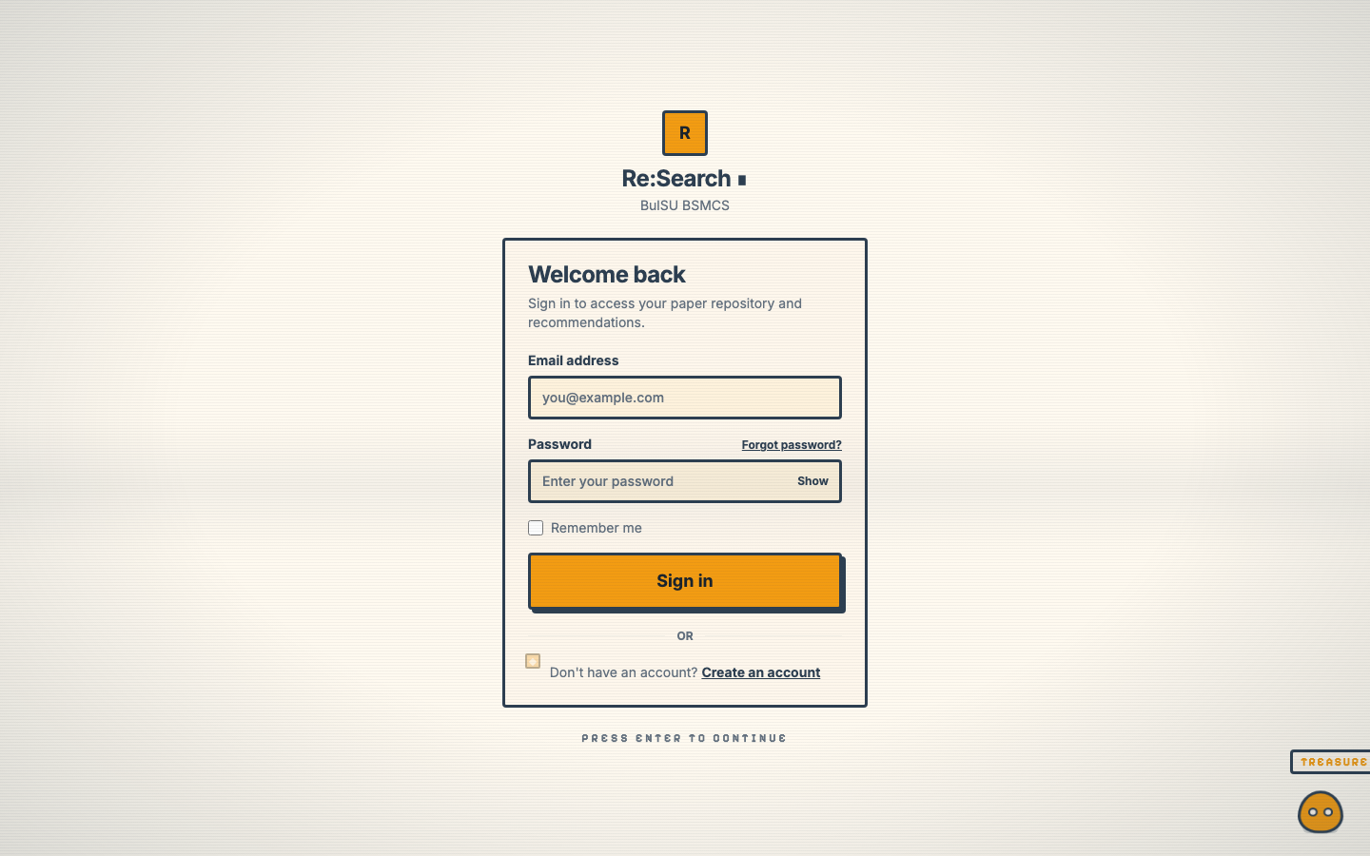
Login page of the Re:Search prototype
Figure A-2
Recommendations page
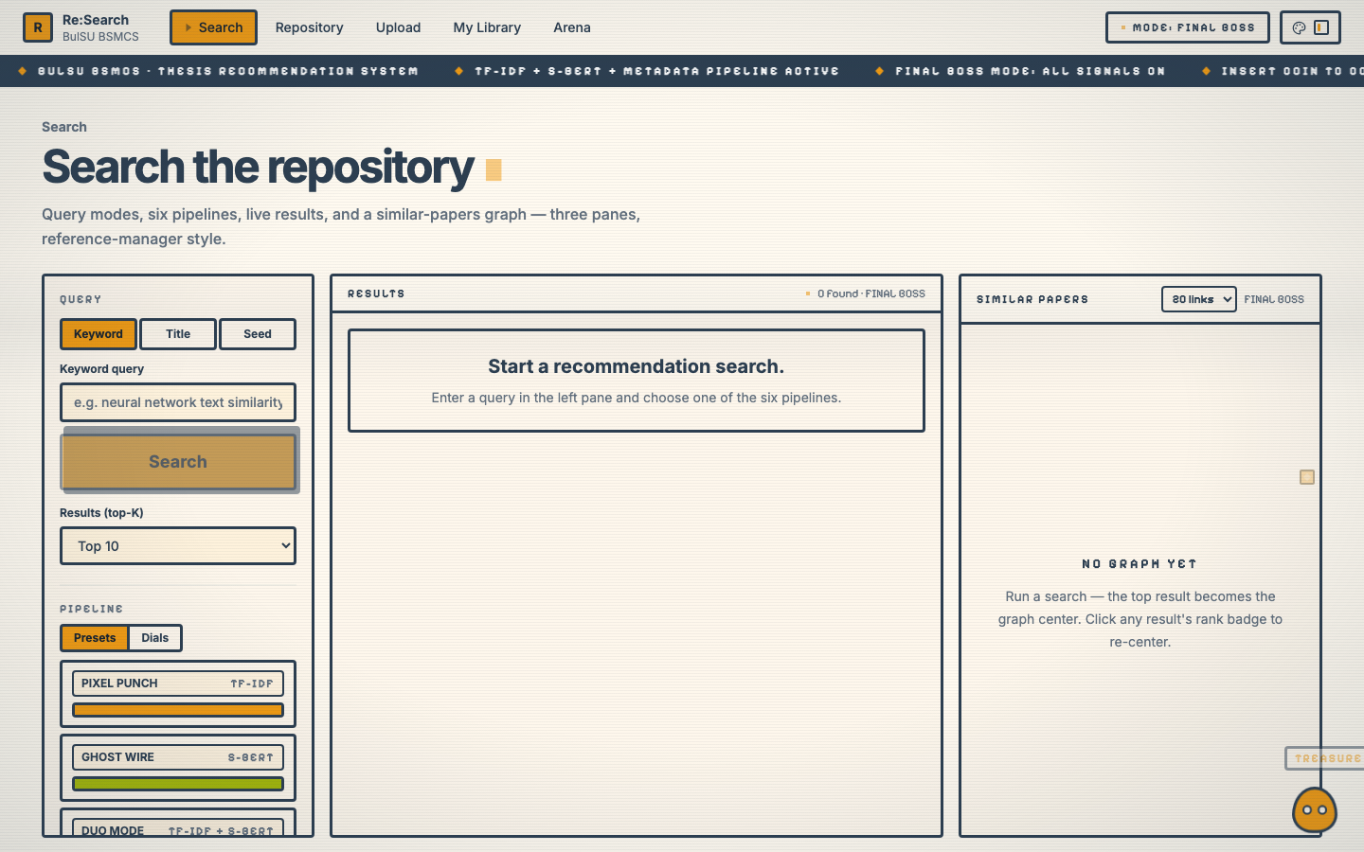
Recommendations page showing the query bar, pipeline selector, and ranked results
Figure A-3
Repository page
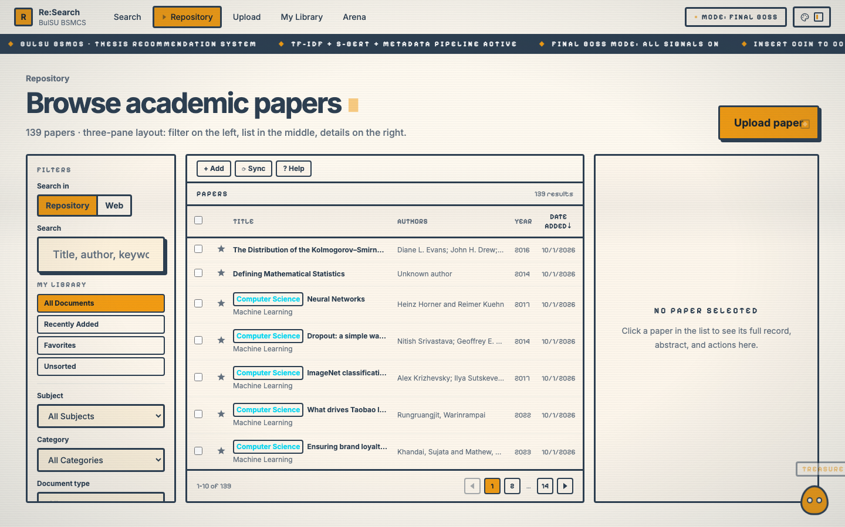
Repository page listing the stored papers with filters and sorting
Figure A-4
Upload page
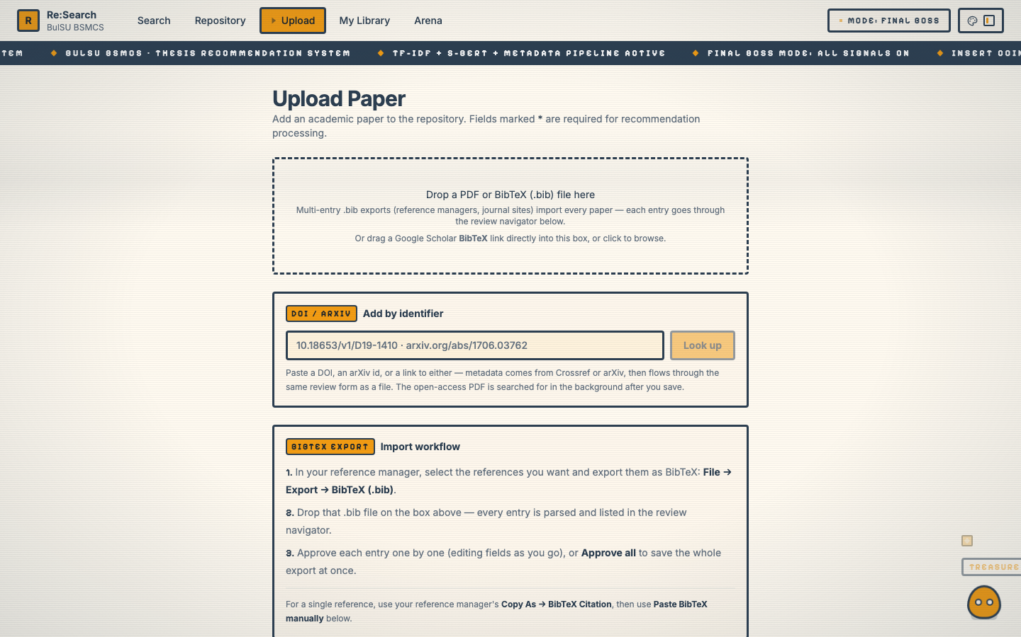
Upload page for importing papers from PDF or BibTeX with the recommendation validation checklist
Figure A-5
My Library page
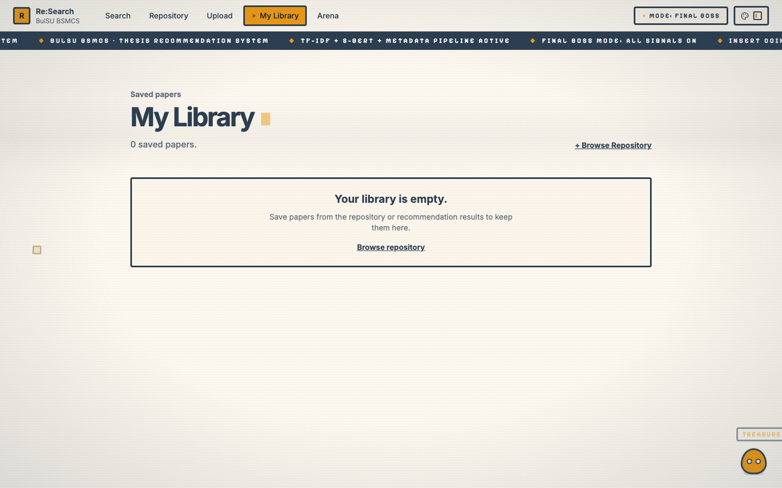
My Library page showing papers saved by the local user
Figure A-6
Arena page — pipeline battle results
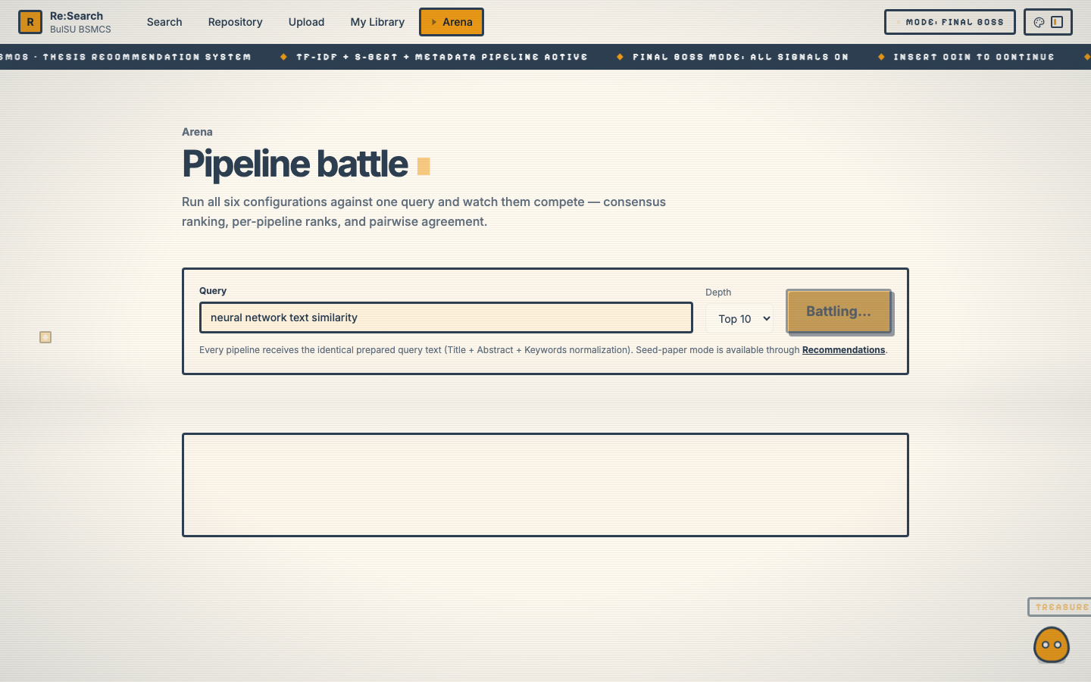
Arena page after a battle run: winner banner, score distribution by rank, consensus ranking, and pairwise agreement
Figure A-7
Arena page — battle records
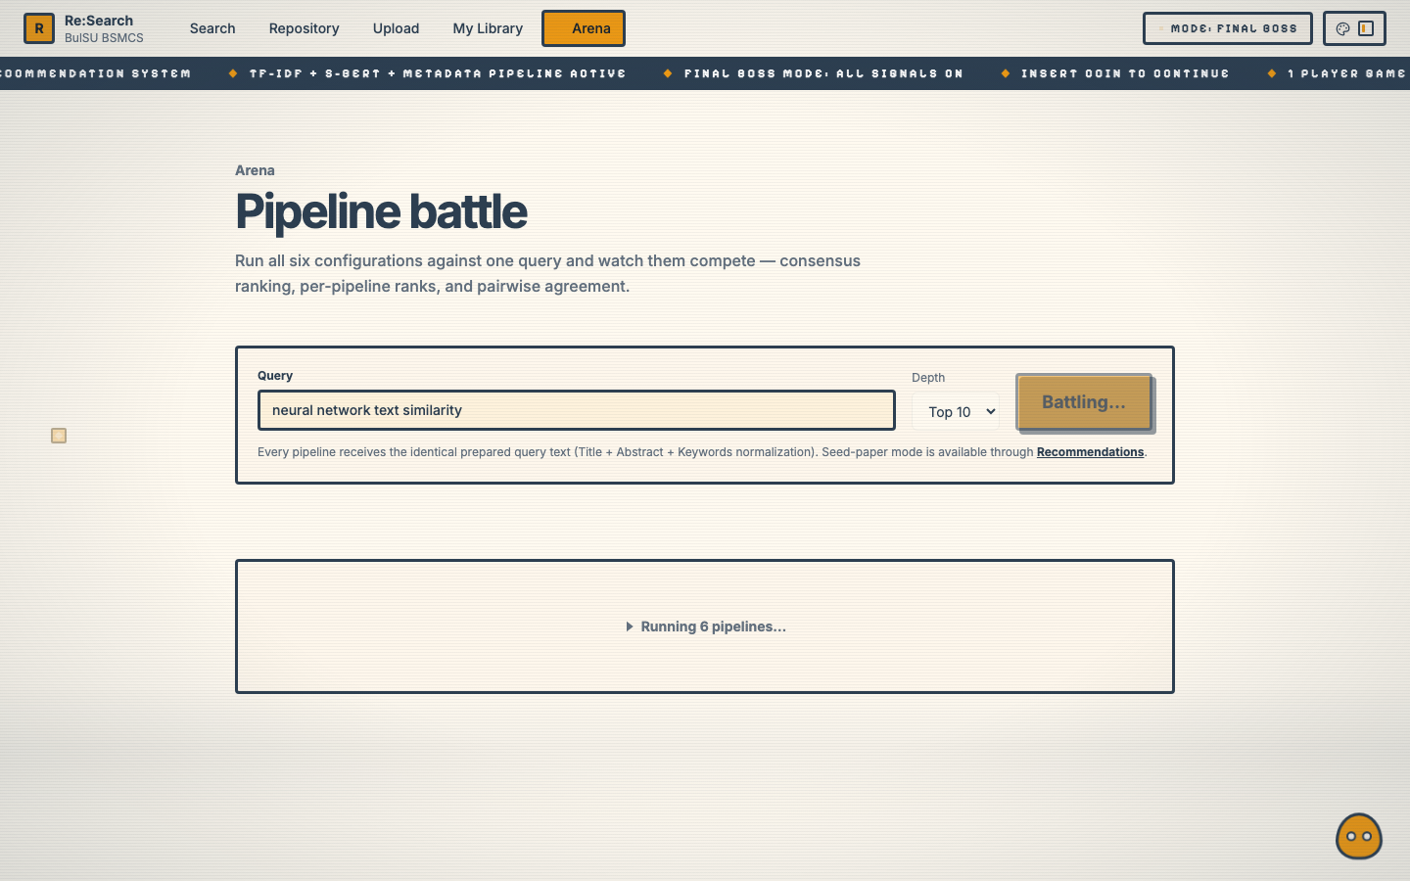
Arena page battle records section: win tally and battle history logged from previous runs

APPENDIX B

MATHEMATICAL SPECIFICATION OF THE RECOMMENDATION PIPELINES
This appendix states the mathematics the Re:Search prototype actually computes, exactly as implemented in app/services/recommendation/ (search_service.py, tfidf_pipeline.py, sbert_pipeline.py, metadata_pipeline.py, similarity.py, pipeline_config.py) and in app/services/connected_graph.py for the similar-papers graph. Sections B.1 through B.8 cover the components, the normalization rule, the six pipeline configurations, and the ranking rule; Section B.9 covers the similar-papers graph. The frontend reproduces the same formulas in its pipeline-math panel (frontend/src/data/pipelinemath.ts), so a user can watch the real numbers flow through every formula.

Notation
Q = query text, or the seed paper's prepared text
D = { d_1, ..., d_n } = candidate papers valid for
recommendation (is_valid_for_recommendation = true)
R = final ranked list, |R| = top_k
w_pipe = ( w_tfidf, w_sbert, w_meta ) = pipeline weights

B.1 Text Preparation
All components consume the same prepared text: the paper’s Title, Abstract, and Keywords, normalized by lowercasing, stripping punctuation, and collapsing whitespace runs to one space.
text(d) = normalize( Title(d) + Abstract(d) + Keywords(d) )
text(Q) = prepared query text for free-text queries
= stored prepared text for seed-paper queries

B.2 TF-IDF Component — Lexical Similarity
The vocabulary and inverse-document frequencies are fitted once per repository (index build) and never refit at request time, so the query vector and the stored vectors live in the same vector space.
Offline (index build):
V = vocabulary fitted on { text(d) : d in D }
df(t) = number of papers in D containing term t
idf(t) = ln( (1 + n) / (1 + df(t)) ) + 1 smoothed IDF
w(t,d) = tf(t,d) * idf(t) term weight
v(d) = w(d) / ||w(d)||_2 L2-normalized vector
Online (per request):
v(Q) = the fitted vectorizer applied to text(Q)
s_tfidf(d) = cos( v(Q), v(d) )
= ( v(Q) . v(d) ) / ( ||v(Q)||_2 * ||v(d)||_2 )
= 0 if either vector is the zero vector

B.3 S-BERT Component — Semantic Similarity
Prepared text is embedded with the sentence-transformers model all-MiniLM-L6-v2 (384 dimensions) and compared by cosine similarity, so papers that share no surface terms can still score close.
e(d) = SBERT( text(d) ) in R^384
e(Q) = SBERT( text(Q) )
s_sbert(d) = cos( e(Q), e(d) )
= ( e(Q) . e(d) ) / ( ||e(Q)||_2 * ||e(d)||_2 )

B.4 Metadata Component — Field-Level Similarity
The metadata component scores four bibliographic signals at fixed equal weights of 25 percent. Text fields are compared by cosine similarity between pairwise TF-IDF vectors fitted on the two texts; the publication year is compared by temporal distance. A missing field contributes 0, and the fixed weights are preserved so a paper with only one available field cannot receive an inflated score because the others are absent.
For each text field f in { title, abstract, keywords } :
s_f(d) = cos( TFIDF({ f(Q) }), TFIDF({ f(d) }) )
= 0 if the field is missing in Q or d
Publication year — temporal proximity:
s_year(d) = 1 / ( 1 + | year(Q) - year(d) | )
= 0 if either year is missing
Fixed equal signal weights (25% each):
s_meta(d) = 0.25 * s_title(d)
+ 0.25 * s_abstract(d)
+ 0.25 * s_keywords(d)
+ 0.25 * s_year(d)
s_meta(d) is clamped to [0, 1].
For free-text queries, only the title signal is active (abstract, keywords, and year are absent from the query); seed-paper queries activate all four signals.

B.5 Score Normalization
TF-IDF and S-BERT raw cosine scores are min-max normalized across all candidates before combination; metadata scores are already bounded in [0, 1] by construction and pass through unchanged. If every score is identical, the degenerate case maps every candidate to 1.0.
s'(d) = ( s(d) - min_s ) / ( max_s - min_s )
= 1.0 for every d if max_s = min_s (degenerate)
s'_meta(d) = s_meta(d) (no normalization)

B.6 The Six Pipeline Configurations
Each configuration is a weighted combination of the normalized component scores. Components with zero weight are not computed at all. Table B-1 lists the six presets with their exact formulas.
Table B-1
The Six Pipeline Configurations and Their Score Formulas
Pipeline | Weights (tfidf, sbert, meta) | Final score S(d)
TF-IDF | (1.000, 0.000, 0.000) | 1.000 · s’_tfidf(d)
S-BERT | (0.000, 1.000, 0.000) | 1.000 · s’_sbert(d)
TF-IDF + S-BERT | (0.500, 0.500, 0.000) | 0.500 · s’_tfidf(d) + 0.500 · s’_sbert(d)
TF-IDF + Metadata | (0.667, 0.000, 0.333) | 0.667 · s’_tfidf(d) + 0.333 · s’_meta(d)
S-BERT + Metadata | (0.000, 0.667, 0.333) | 0.667 · s’_sbert(d) + 0.333 · s’_meta(d)
TF-IDF + S-BERT + Metadata | (0.400, 0.400, 0.200) | 0.400 · s’_tfidf(d) + 0.400 · s’_sbert(d) + 0.200 · s’_meta(d)
A seventh “custom” pipeline lets the user set the three dials; the backend normalizes the dial values so the weights sum to 1:
w_i = dial_i / ( dial_tfidf + dial_sbert + dial_meta )

B.7 Ranking and Output
Candidates are sorted by the final score descending, with ties broken by the newer publication year first and then by title alphabetically; only papers with a score greater than 0 are returned, limited to top_k.
R = [ d in D : S(d) > 0 ], |R| = top_k

B.8 The Similar-Papers Graph
The similar-papers graph (GET /api/papers/{paper_id}/similar-graph) follows the Connected Papers model: an origin paper as the graph center, its top-k recommendations as the surrounding nodes, weighted edges between graph papers, and shortest weighted paths back to the origin. The graph always uses the selected pipeline’s own components for its edge weights, so the graph can never disagree with the pipeline that chose its node set.
Node set. The origin is the selected paper; the remaining nodes are the top_k results of running the selected pipeline (default: the full hybrid tfidf_sbert_metadata) with the selected paper as the seed.
Edge weight. For every pair of graph papers (a, b), the edge weight blends the pipeline’s raw component similarities with an author-overlap bonus:
w(a,b) = w_tfidf * cos( v_tfidf(a), v_tfidf(b) )
+ w_sbert * cos( e_sbert(a), e_sbert(b) )
+ w_meta * meta(a, b)
+ 0.15 * J( authors(a), authors(b) )
meta(a, b) = 0.25 * s_title(a, b)
+ 0.25 * s_abstract(a, b)
+ 0.25 * s_keywords(a, b)
+ 0.25 * s_year(a, b) (same formula as B.4)
J = Jaccard similarity over the papers' author last names
(lowercased); 0 if either paper has no authors
w(a,b) is clamped to [0, 1]; a missing stored vector
contributes 0.
Unlike the request-time ranking (Section B.5), the graph edges use the raw component similarities without min-max normalization, and the metadata term uses the full four-signal score of Section B.4.
Edge filtering. Every origin-to-node edge is always drawn (the origin star guarantees the graph is connected); any other pair is drawn only when its weight is at least the minimum edge weight of 0.15.
Shortest paths. Dijkstra’s algorithm runs from the origin with the hop cost of an edge defined as (1 − w), so a high-similarity edge is a short hop; ties break by the smaller paper id, which makes the output deterministic. Each similar-paper node carries the shortest weighted path back to the origin and its total length.
Shared groups. The graph reports authors shared by at least two graph papers and topics (keyword tokens and subject/category parts) shared by at least two papers. Because the repository stores no reference lists, shared topics stand in as the local analogue of bibliographic coupling; this is a deliberate substitution for the reference model’s common-reference measures, not a claim of equivalence.

