***Term Project***

**Cloud Kitchens for meal delivery**

***By*** *Ashutosh Kulkarni*

*kulkarni.ashu@northeastern.edu*

Submission Date: 31 March 2024

EMGT5220: Engineering Project Management, Spring 2024

Northeastern University

Instructor: Prof. George Kontopidis

Table of Contents

1. Purpose 3

2. Objective 3

3. Scope 3

4. Funder/Investor 3

5. Critical Success Factors 3

6. Assumptions 4

7. Technical Approach 4

8. Organization 5

9. Project Plan 6

a. Work Breakdown Structure (WBS) 6

b. Resource Plan and Responsibilities (RACI) 7

c. Financial Plan 8

d. PERT Chart 9

e. Gantt Chart 10

10. Risk Assessment 11

a. SWOT 11

b. RPN Table 11

c. Risk Assessment matrix 12

d. Mitigation Plan 12

11. Resource Allocation 13

12. Conclusion 13

13. Appendix 14

a. Mind Map 14

b. Activity Diagram 15

c. Sequence Diagram 16

d. Initial Gantt chart 17

e. Initial Resource Chart 17

14. References 18

## Purpose

The United States is a top choice for international students to pursue higher education. These students must manage their housing, maintenance, grocery, cooking, university, social life and of course their grades! All these tasks take up a considerable amount of time, especially grocery shopping and cooking. Also, several ingredients required for their local dishes are hard to find. During major assignments and exams managing time becomes difficult and usually cooking takes a back seat. In these situations, students resort to fast food or frozen meals which are not the healthiest options.

Here there is an opportunity to provide a meal service that offers the feeling of a home cooked meal at a good price.

## Objective

Rebel Foods, a traditional restaurant company wants to expand in the meal delivery business. The company will require physical sites that can be used as remote kitchens and hence the objective of the project is to set up 5 such physical sites. These sites will incorporate well designed layouts and special purpose equipment to ensure fast preparation of orders and will fulfill the orders placed on 3rd party delivery apps. The primary target customers are students, and the available menu will be catered accordingly.

## Scope

The scope of this project is to rent and build interior layout for 5 cloud kitchens. The locations of these will be decided based on market research. Further, the kitchen layout will be designed for efficient functioning and specialized cooking equipment will be sourced for automating certain processes. A compelling menu will be made as per market analysis. The pricing of the subscription and that for per meal will be fixed based on target customer. Finally, Kitchen and support staff will be hired and trained for smooth functioning.

## Funder/Investor

Rebel Foods will be the investor. This project gives the company an opportunity to venture into the meal delivery business. Considering the student population across the US, there is sizeable market, and the company will have the opportunity to secure a market position. The project requires a one-time investment and as the customer base increases, cash flow from one time and subscription customers will payback. Also, if this model works, it can be expanded and be modified to cater to a different customer base.

## Critical Success Factors

* Establishing clear communication channels between different departments (Engineering, Culinary, Operations, HR) and external contractors is essential for timely updates, decision-making to avoid misunderstandings or delays.
* Staying updated on evolving food safety regulations and operating licenses to avoid delay in project delivery.
* Successfully integrating the Restaurant Management System for streamlined order processing, inventory control, and address technical issues promptly.
* Meeting deadlines for kitchen build-out across all five locations is crucial to avoid delays in launching operations and generating revenue.

## Assumptions

* The chosen assembly line layout design can effectively handle the anticipated order volume at each location while maintaining food quality.
* Reliable contractors can be hired on time and within budget to build and equip the kitchens according to specifications.
* No significant disruptions occur in the supply chain that would impact ingredient availability.

## Technical Approach

1. **Kitchen Layout design:**

An “Assembly Line” layout will be designed for the 5 sites. Food preparation starts at one end, and the dish is finished by the time it reaches the end of the “line.”

* Ideal for limited menus and high-volume demand
* Seamless flow of ingredients from one station to the next creates kitchen efficiencies that allow for faster service.

Figure 1-Kitchen Layout

1. **Kitchen equipment selection:**

Engineering team will get input from the culinary department regarding their machinery/equipment requirements. The application engineers will decide on the equipment based on what is available in the market.

1. **Establish supporting network:**

The operation of the sites will require sourcing of ingredients and other kitchen tools. Establishing supplier relations to get best pricing is required. With 3rd party platforms, finalizing of promotion and delivery costs for the product will be crucial for revenue.

1. **Menu Design and tasting:**

Based on market research location of the 5 kitchens will be finalized. Each of the 5 kitchens being in different locations will have their own menu. Head chef is responsible for menu, recipes, and portion sizes. The olfactory expert will then finalize the dishes to be kept based on quality.

1. **Recruitment and Training:**

The 5 sites will require teams of ten each to run efficiently. The human resources department will hire these people and collaborate with the head chef in training the people to ensure smooth functioning.

1. **Restaurant Management System Software**

Software package consists of 3 modules:

* Point of Sale System: This module will accept orders from various online platforms and keep record of the sales data.
* Kitchen Display System: This module will help kitchen staff view the order details and the order pickup time immediately and prepare the order accordingly.
* Smart Inventory System: An inventory management system will enable the staff to track daily stock consumption and will prompt required material for next purchase cycle.

## Organization

The company Rebel Foods has a matrix organization. As a project manager, it is required to borrow employees from Functional Managers and hire external contractors for some aspects of the project.

* Engineering will be responsible to design kitchen layouts and decide on the required equipment for the kitchen.
* Culinary staff will be responsible for designing the menu based on location of the 5 sites and finalize the taste, packing and presentation.
* Operations will be responsible to set up networks to keep the 5 sites running.
* Human resources will have to hire and train the personnel to run these 5 kitchens.
* Software Department will be responsible to develop and implement the restaurant management software system.
* Building of the Kitchen layouts will be outsourced to civil contractors and based on market research, exact location of these kitchens will be decided after consulting with real estate agencies.

Figure 2-Organization Structure

## Project Plan

### Work Breakdown Structure (WBS)

The WBS is derived from the mind map and presented in a refined and structured format. It gives details of the tasks, their duration, responsible person, number of people required and milestones.

|  |  |  |  |  |  |  |
| --- | --- | --- | --- | --- | --- | --- |
| Work Breakdown Structure | | | | | | |
| Task ID | Task Name | Responsible Person | Duration | Dependencies | No. of People | Notes |
| 1 | **Kitchen Design** |  |  |  |  |  |
| 1a | Site Survey | Real Estate Agent | 1 week |  | 0 | Selection of 5 locations |
| 1b | Layout Design | Layout Engineers | 2 weeks | 1a | 4 |  |
| 2 | **Menu Design** |  |  |  |  |  |
| 2a | Menu Creation | Head Chef | 2 weeks |  | 4 |  |
| 2b | Finalize Dishes | Taster | 1 week | 2a | 2 |  |
| 3 | **Restaurant Management Software** |  |  |  |  |  |
| 3a | Get input from culinary staff | SWE 1, 2 | 1 week | 2b | 4 | Document recipes, ingredients, preparation time. |
| 3b | Develop Software | SWE 1, 2 | 2 weeks | 3a | 4 |  |
| 3c | Design UI/UX | SWE 1, 2 | 2 weeks | 3b | 4 |  |
| 4 | **Equipment Selection** |  |  |  |  |  |
| 4a | Scout and select kitchen equipment | Application Engineer | 1week | 1a, 2b | 2 | Based on Head chef's requirement and menu designed. |
| 5 | **Operations set-up** |  |  |  |  |  |
| 5a | Finalize material requirement | Purchaser | 1 week | 2b | 2 | Confirm quality with Head chef. |
| 5b | Set up partnerships | Purchaser | 2 weeks | 5a | 2 |  |
| 6 | **Layout Construction** |  |  |  |  |  |
| 6a | Build kitchen interior | Civil Contractor | 3 weeks | 4a | 0 |  |
| 7 | **Kitchen Set-up** |  |  |  |  |  |
| 7a | Set up Kitchen equipment | Application Engineer | 2 weeks | 6a | 2 |  |
| 7b | Deployment of Restaurant Management Software | SWE 1, 2 | 1 week | 7a | 4 | Connect Software to kitchen equipment. |
| 8 | **Staff Recruitment** |  |  |  |  |  |
| 8a | Recruit staff for sites | Recruiter | 1 week | 6a | 4 |  |
| 8b | Training | Trainer | 2 weeks | 8b | 4 |  |

Table 1-Work Breakdown Structure

### Resource Plan and Responsibilities (RACI)

The RACI gives information regarding who is responsible, accountable, consulted and informed for each task.

|  |  |  |  |  |  |
| --- | --- | --- | --- | --- | --- |
| RACI | | | | | |
| Task ID | Task Name | Responsible Person | Accountable | Consulted | Informed |
| 1 | **Kitchen Design** |  |  |  |  |
| 1a | Site Survey | Real Estate Agent | Project Manager |  |  |
| 1b | Layout Design | Layout Engineer 1, 2 | Engineering FM |  | PMO |
| 2 | **Menu Design** |  |  |  |  |
| 2a | Menu Creation | Head Chef | Culinary FM |  |  |
| 2b | Finalize Dishes | Taster | Culinary FM | Head Chef |  |
| 3 | **Restaurant Management Software** |  |  |  |  |
| 3a | Get input from culinary staff | SWE 1, 2 | Software FM | Head Chef |  |
| 3b | Develop Software | SWE 1, 2 | Software FM |  |  |
| 3c | Design UI/UX | SWE 1, 2 | Software FM |  |  |
| 4 | **Equipment Selection** |  |  |  |  |
| 4a | Scout and select kitchen equipment | Application Engineer | Engineering FM | Head Chef |  |
| 5 | **Operations set-up** |  |  |  |  |
| 5a | Finalize material requirement | Purchaser | Operations FM | Head Chef |  |
| 5b | Set up partnerships | Purchaser | Operations FM |  |  |
| 6 | **Layout Construction** |  |  |  |  |
| 6a | Build kitchen interior | Civil Contractor | Project Manager | Layout Engineer 1, 2 | PMO |
| 7 | **Kitchen Set-up** |  |  |  |  |
| 7a | Set up heavy equipment | Application Engineer |  |  |  |
| 7b | Deployment of Restaurant Management Software | SWE 1, 2 | Software FM |  | PMO |
| 8 | **Staff Recruitment** |  |  |  |  |
| 8a | Recruit staff for sites | Recruiter | HR Lead |  |  |
| 8b | Training | Trainer | HR Lead |  | PMO |

Table 2-RACI matrix

### Financial Plan

The financial plan gives the idea of the budget required every week and for the entire project. The budget format follows the timeline of the Gantt chart. The distribution of funds every week is based on the percentage of tasks done. The budget estimate is $ 5,76,150.

Figure 3-Project budget

### PERT Chart

The PERT chart helps us to map out the tasks in the project and identify the dependencies between the tasks. The chart below is an auto generated from the Gantt chart. Solving the PERT chart gives an idea of the critical path and quantify the slack for each task.

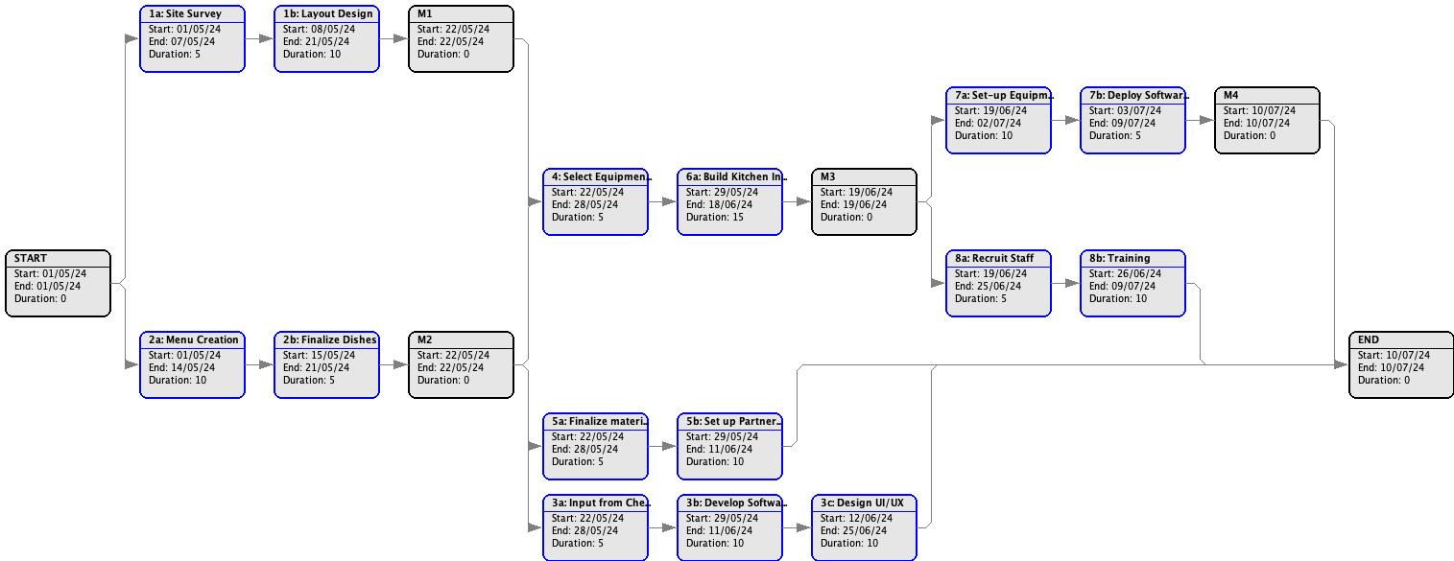

Figure 4-Auto generated PERT chart

Figure 5-Solved PERT chart

### Gantt Chart

The Gantt chart gives us an overview of the project timeline. The project will take about 10 weeks to complete. This helps us to calculate the budget required every week and estimate the total project budget.

Below is the adjusted Gantt chart after considering resource loading and balancing.

For previous Gantt Chart please refer to appendix (section 13d).

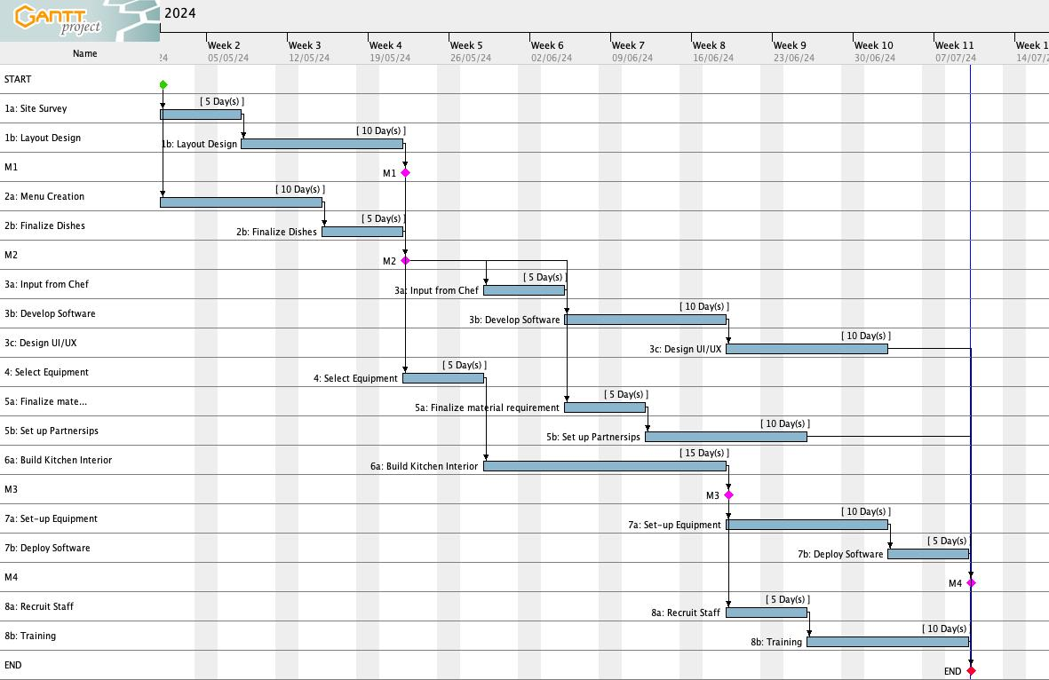

Figure 6-Final Gantt chart

## Risk Assessment

### SWOT

SWOT analysis identifies Strengths, Weaknesses, Opportunities and Threats, and helps us plan out the project and consider factors that may help or hinder its success.

Figure 7-SWOT analysis

### RPN Table

Here we calculate the risk priority number (RPN) for our weaknesses and threats. We quantify the severity, Likelihood of occurrence and Inability to detect the occurrence. RPN is the product of these three quantities.

Figure 8-RPN table

### Risk Assessment matrix

This is the visual representation of risk analysis. We place our weaknesses and threats on the map. The horizontal axis represents the severity of impact and the vertical axis is the probability of occurrence.

Figure 9-Risk assessment matrix

### Mitigation Plan

* W1: Software Deployment on sites

Thoroughly test the system during the implementation phase. - Have a backup plan for manual order processing

* W3: Effectiveness of Kitchen Layout

The effectiveness can be quantized or estimated approximated by conducting a test run.

* W4: Dependance of project timeline on contractors

Finalize detailed contracts with clear timelines and penalties for delays.

* T3: Regulatory changes in kitchen licensing

Keeping up to date with licensing norms will be beneficial to make necessary changes during the project.

* T4: Non-compliance from contractors

A thorough background check of the contractors will be beneficial.

* T1: Availability of ingredients in selected regions

Establish relationships with multiple suppliers to ensure redundancy.

## Resource Allocation

The Resource chart gives us an overview of the how resources are allocated to the given tasks. This chart helps us in identifying which resources are multitasking and whether any one is overloaded. Initially the Head Chef was overloaded due to multitasking and the workload was balanced by adjusting tasks 3a and 5a utilizing available slack.

For previous Resource loading chart please refer to appendix (section 13e).

Figure 10-Final Resource chart

## Conclusion

This project outlines the development and implementation of a cloud kitchen network for Rebel Foods, targeting international students in the US. By establishing five strategically located kitchens with optimized layouts, specialized equipment, and a compelling menu, Rebel Foods can capture a significant market share in the growing meal delivery sector. The project leverages a robust technology platform to streamline order processing, inventory control, and kitchen operations. By carefully managing risks, allocating resources effectively, and adhering to a defined timeline, Rebel Foods is well-positioned to achieve its expansion goals and provide students with a convenient and healthy meal option.

## Appendix

### Mind Map

The mind map helps us to put ideas down on paper. These ideas and their threads help us to create the Work breakdown structure and further sections.

Figure 11-Mind Map

### Activity Diagram

The following flow chart shows how an order from the customer is processed in the system.

Figure 12-Activity Diagram

### Sequence Diagram

The following diagram shows the sequence of interaction between the Customer, Restaurant Management Software and 3 departments of the Cloud Kitchen.

Figure 13-Sequence Diagram

### Initial Gantt chart

Below is the initial Gantt chart of the project timeline.

Figure 14-Initial Gantt chart

### Initial Resource Chart

As we can see, the Head Chef is overloaded to 300% due to multitasking on activities 3a (Input from Chef), 4 (Select Equipment) and 5a (Finalize material requirement). Hence, we have moved task 3a ahead by 5 days and task 5a by 10 days as they are non-critical tasks, and we have enough slack available.

Figure 15-Initial Resource chart

## References

* <https://www.oracle.com/food-beverage/cloud-kitchens/>
* <https://cloudkitchens.com/blog/commercial-kitchen-layout-ideas/>
* <https://www.touchbistro.com/blog/commercial-kitchen-layout-design-for-restaurats/>