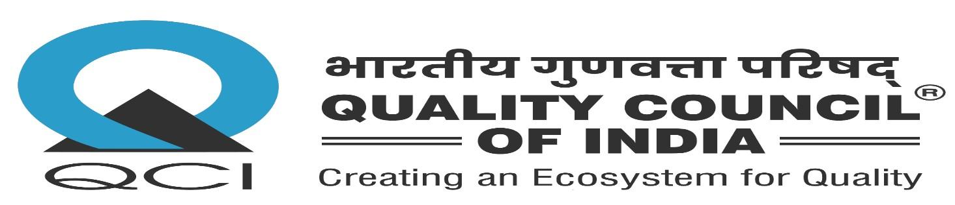
Tower J-200, World Trade Center, Nauroji Nagar, New Delhi – 110029

MEMORANDUM OF UNDERSTANDING (INTERNATIONAL)

MoU No. | {{ mou_no }}
Date | {{ mou_date }}
Between | {{ indian_party_name }} and {{ foreign_party_name }}
Foreign Party Country | {{ foreign_party_country }}

1. Purpose
{{ purpose }}
2. Areas of Cooperation
{{ areas_of_cooperation }}
3. Duration
{{ duration }}


FOR AND ON BEHALF OF {{ indian_party_name }} | FOR AND ON BEHALF OF {{ foreign_party_name }}
Name: {{ signatory_indian_name }}  Designation: {{ signatory_indian_designation }} | Name: {{ signatory_foreign_name }}  Designation: {{ signatory_foreign_designation }}

Witnesses: | Witnesses:
1. ____________________________ | 1. ____________________________
2. ____________________________ | 2. ____________________________

