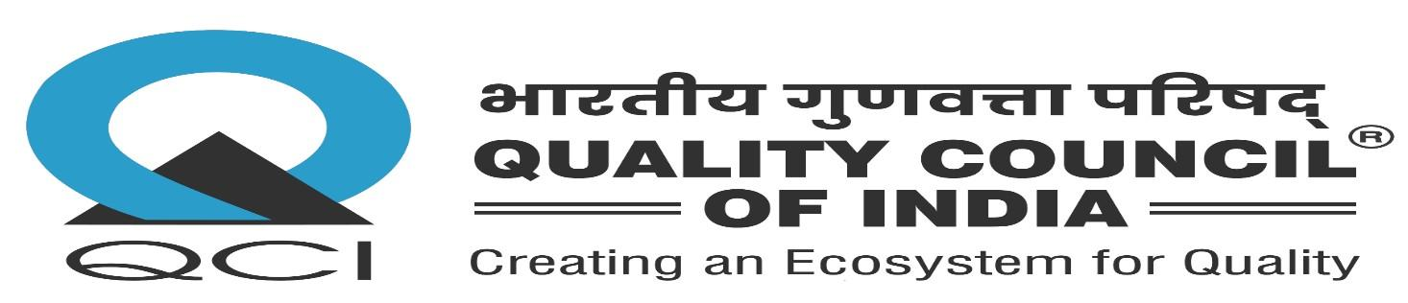
Tower J-200, World Trade Center, Nauroji Nagar, New Delhi – 110029

ANNUAL MAINTENANCE CONTRACT (AMC)

AMC No. | {{ amc_no }}
Date | {{ amc_date }}
Vendor | {{ vendor_name }}
Vendor Address | {{ vendor_address }}

1. Equipment Covered
{{ equipment_covered }}
2. AMC Period & Service Frequency
AMC period: {{ amc_period }}
Service frequency: {{ service_frequency }}
3. Response Time SLA
{{ response_time_sla }}
4. AMC Value
{{ amc_value }}


For {{ issuing_organisation }} | Received & Accepted by  For {{ vendor_name }}
Name: {{ authorized_signatory_name }}  Designation: {{ authorized_signatory_designation }} | Signature: ____________________  Name: ____________________  Date: ____________________

