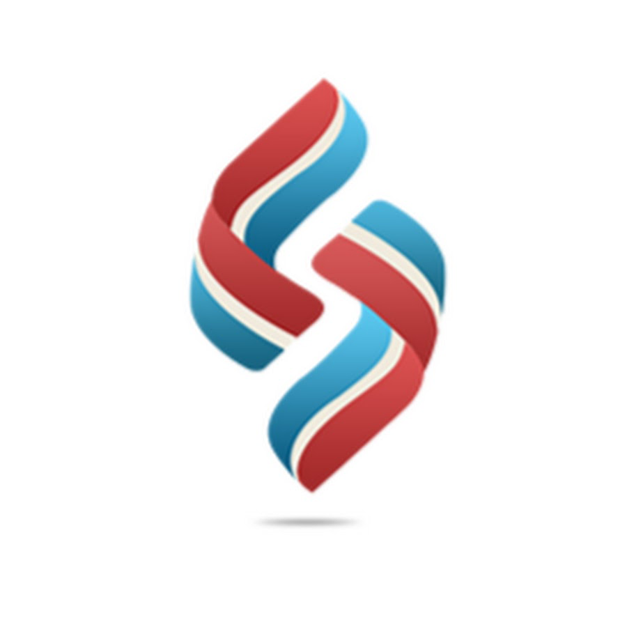

Source Soft Solutions
New Jersey, USA (HQ) · Dubai, UAE · Noida, India

TECHNICAL PROPOSAL

Proposal No. | {{ proposal_no }}
Date | {{ proposal_date }}
Client | {{ client_name }}
Project | {{ project_title }}

TABLE OF CONTENTS

[Right-click and select 'Update Field' to populate the Table of Contents]

About the Company
We at Source Soft Solutions provide AI, cloud, and data solutions to drive innovation and growth across industries. Our services focus on data modernization, analytics, and cloud infrastructure management, helping businesses unlock new possibilities with AI/ML, data insights, and scalable cloud technologies.
Empowering organizations to thrive in the digital landscape.
Headquartered in Edison, New Jersey, with an office in Dubai and our primary engineering centre in Noida, India, we run long-term maintenance and support contracts on the same platforms we engineer.
What we deliver
• Transformative Data Solutions | • Robust Cloud Services
• Advanced AI Capabilities | • Insightful Analytics
• Seamless Integration | • Custom Software Development
• Data Security & Compliance | • Training & Support

Leadership team
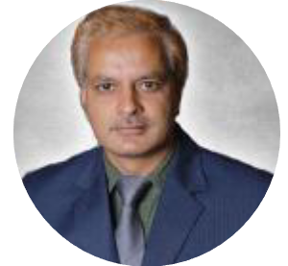 | Alok Dharayan — President  25+ years delivering engineering solutions to complex global problems. Masters, New Jersey Institute of Technology. Sets delivery governance and client accountability across Source Soft Solutions' enterprise and government engagements.

 | Vijay Konar — Chief Technology Officer  Leads all product and platform engineering at Source Soft Solutions. Deep expertise in full-stack development, AWS cloud architecture and data engineering; owns technical standards, release controls and architecture reviews.

 | Vikram Sharma — Solutions Lead  Architects client engagements end-to-end — from requirement study and solution design to transition-in and steady-state operations. Background in enterprise consulting and large-scale application maintenance programmes.

Source Soft Solutions
New Jersey, USA (HQ) · Dubai, UAE · Noida, India

TECHNICAL PROPOSAL

Proposal No. | {{ proposal_no }}
Date | {{ proposal_date }}
Client | {{ client_name }}
Project | {{ project_title }}

1. Executive Summary
{{ executive_summary }}

2. Our Understanding of the Requirement
{{ understanding }}

3. Project Objectives
{{ objectives }}

4. Requirement to Solution Compliance Matrix
{{ compliance_summary }}
[[COMPLIANCE_MATRIX]]

5. Information Architecture
{{ information_architecture }}
[[SITEMAP_DIAGRAM]]

6. Solution & Technology Architecture
{{ architecture_intro }}
[[ARCHITECTURE_DIAGRAM]]

7. Data Flow Diagram
{{ data_flow_intro }}
[[DATA_FLOW_DIAGRAM]]

8. Public Website — Modules & Features
{{ modules_intro }}
[[MODULES_TABLE]]

9. Core Platform Module
{{ core_module_intro }}
[[CORE_MODULE_FLOW]]

10. Admin CMS Portal
{{ admin_portal_intro }}
[[ADMIN_FEATURE_GRID]]
Roles
[[ADMIN_ROLES_TABLE]]

11. Enquiry & Notification Handling
{{ enquiry_intro }}
[[ENQUIRY_TABLE]]

12. Security, Hosting & Compliance
{{ security_intro }}
[[SECURITY_FLOW]]
[[SECURITY_TABLE]]

13. Multilingual, SEO & Performance
{{ seo_intro }}
[[SEO_TABLE]]

14. UI Design Concepts & Mock Screens
The concepts below illustrate the shape and structure of the public site and the admin CMS — page layout, navigation and information density — not final visual design. Final screens are confirmed with {{ client_name }} in the discovery and design phase.
[[UI_MOCKUP_HOME]]

[[UI_MOCKUP_ADMIN]]

15. Implementation Methodology & Timeline
{{ methodology }}
[[TIMELINE_DIAGRAM]]

16. Annual Maintenance & Support
{{ amc_intro }}
[[AMC_TABLE]]

17. Deliverables, Assumptions & Clarifications
{{ deliverables }}

For {{ submitted_by }}

Name: {{ signatory_name }}
Designation: {{ signatory_designation }}

