Name – Ashutosh Ardu

Regno – 20BRS1262

Challenge Test

Consider the following schema:

customer(cust_id, cust_name, cust_city)

item(item_id, item_name, price)

sale(bill_no, cust_id, item_id, qty_sold, sold_date)

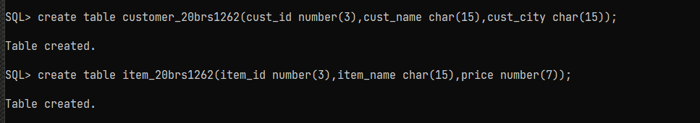



Create the above tables with necessary primary and foreign key constraints and insert appropriate records into it.

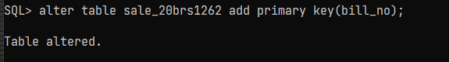

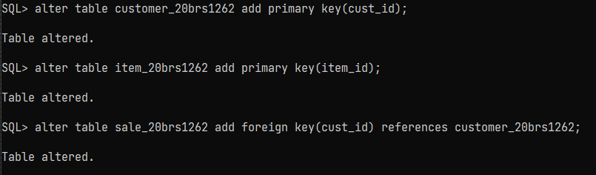

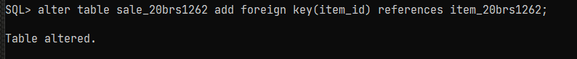

Inserting values

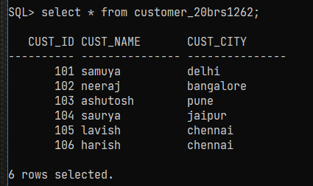

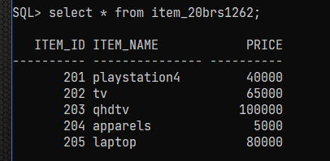

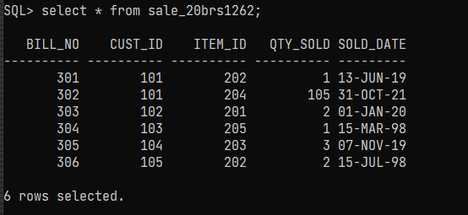

List the name of the item which was sold during the year 1998 or 2019

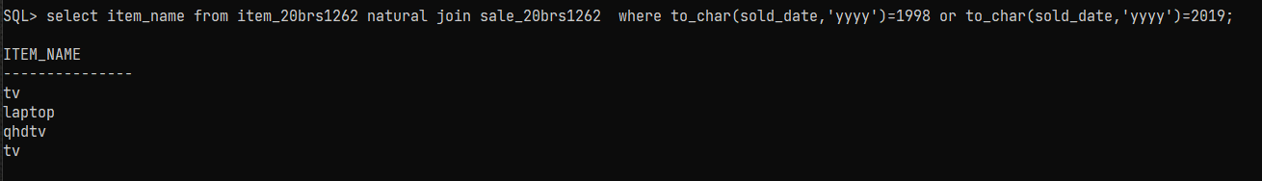

List all customers whose names starts with 'S' and ends with 'a'.

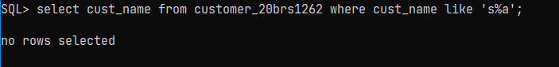

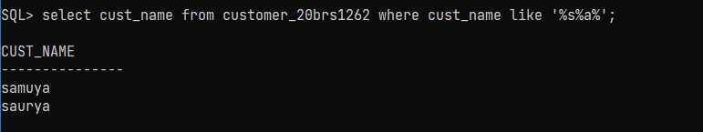

List the customer details with the sales details in descending order with respect to the quantity sold, ascending order with respect to the customer id

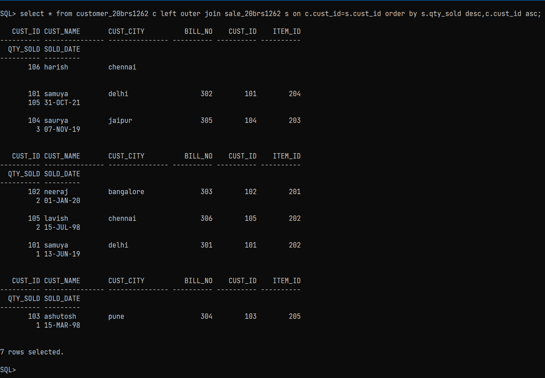

Identify the city with maximum number of customers. List all the customers’ name from that city

Max_count

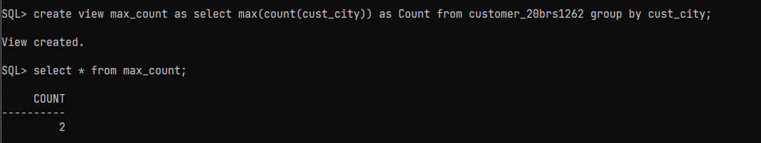

Total_count

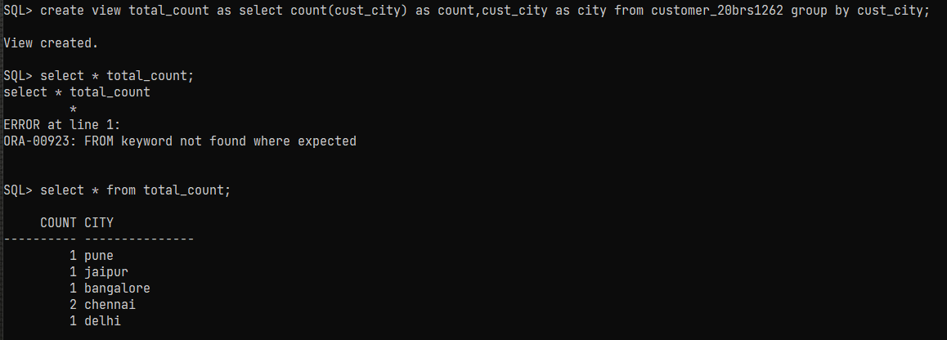

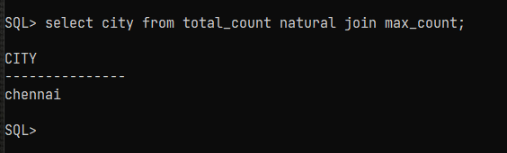

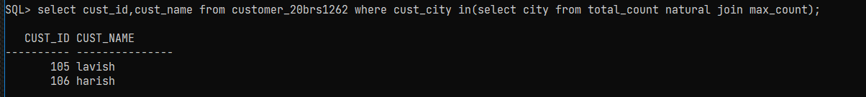

Count the customers whose purchased amount is <100

