Name : Ashutosh Ardu

Regno : 20BRS1262

DBMS FAT LAB

3)

a).Create Tables as follows by choosing appropriate data type and set the necessary primary , foreign key constraints:

Voter (VoterId, Votername, Gender, Boothid,Checkvote,age)

checkvote is 1(voted) or 0 (not voted)

Booth (Boothid, Location,BIncharge )

i)Write an SQL query to list the voters name with gender, and add a constraint to check whether their age is >18.(3)

Output

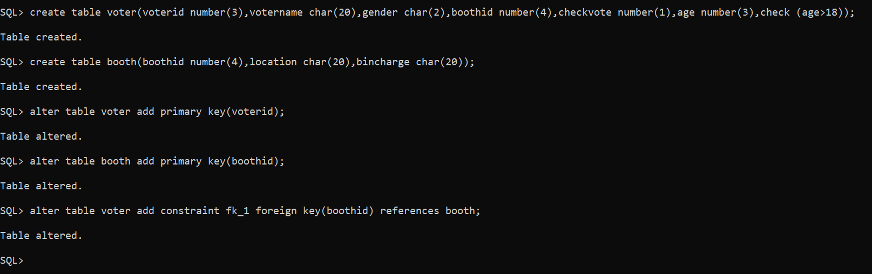

Booth

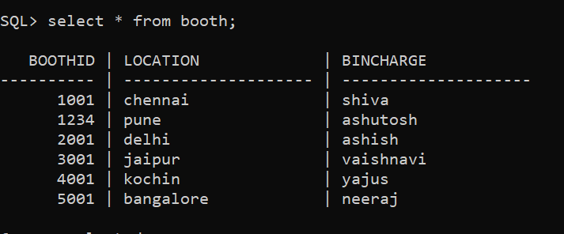

Voters

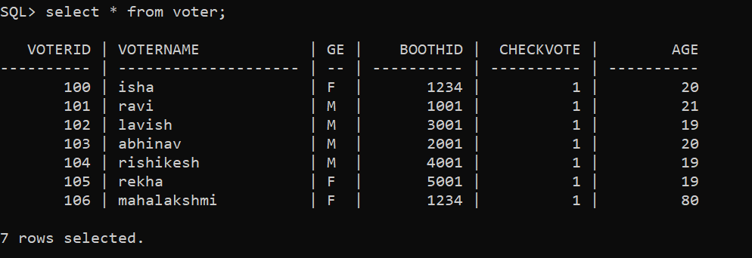

Violation of check constraint (age>18)

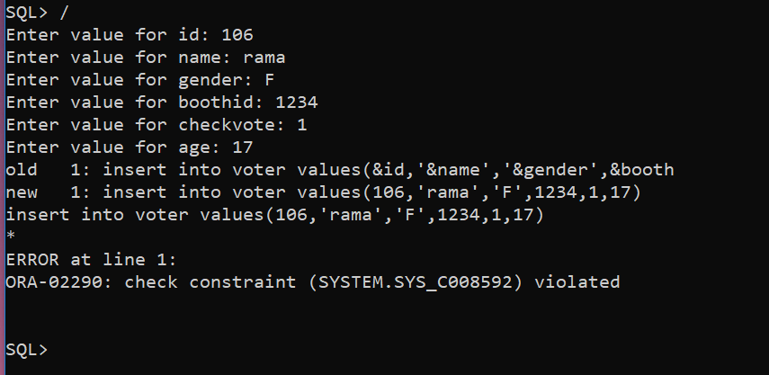

Voters

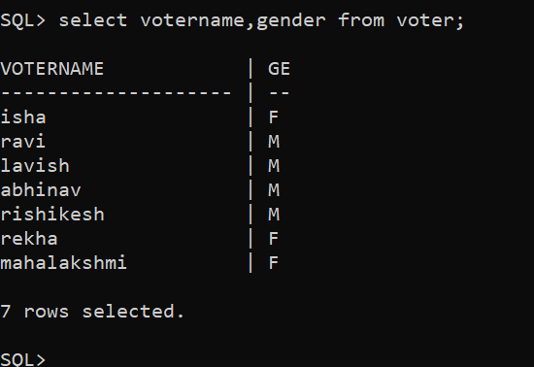

ii) Write an SQL query to fetch the no. of booths available in each location in the descending order.(3)

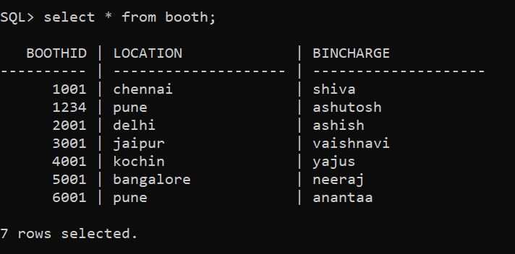

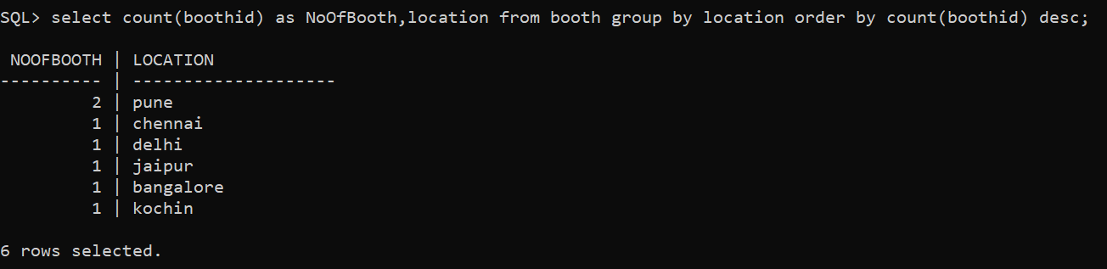

iii) (a)List the count of voters in each Booth (2 Marks)

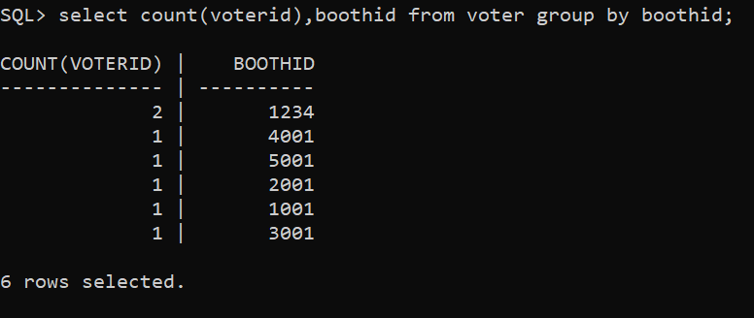

(b) List the count of Female voters those who voted in BoothID 1234 (2 Marks).

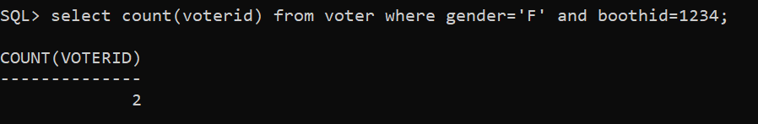

(iv)Create a view with Boothid, Location and count of voters voted and also display the details of voters those who are having age less than 30. (3)

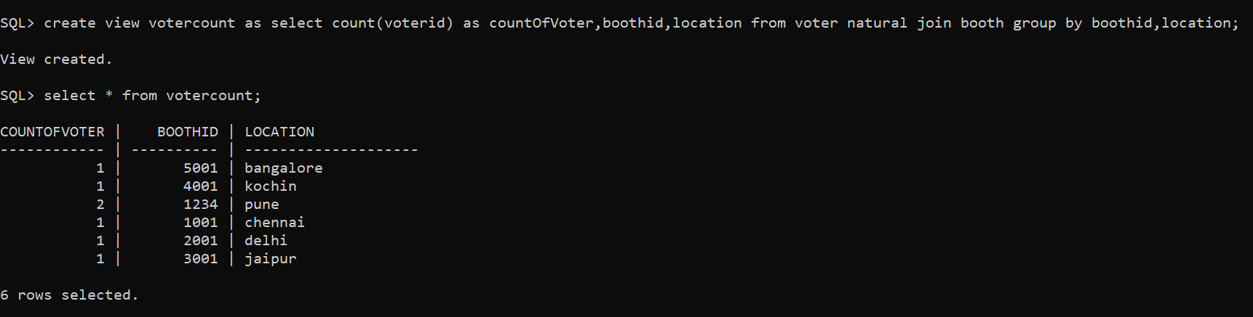

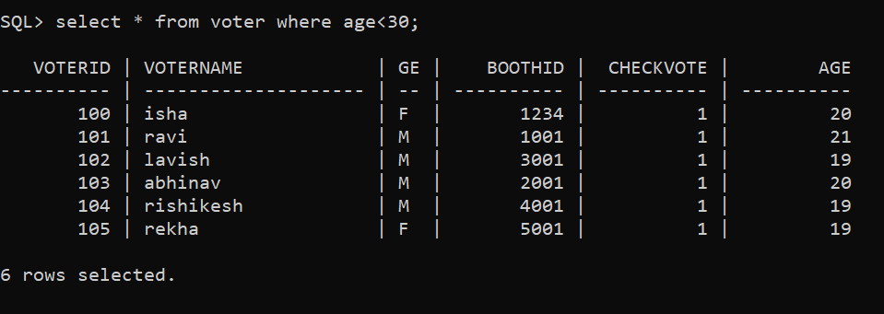

(v) Delete the details of booth which has less than 10 votes(2)

As you can see here the max number of voters at a location is 2 so if we delete the booth details where count of voters at a particular booth is less than 10 all booths will get deleted.

Hence we will go with delete the details of booth which has more than 1 votes

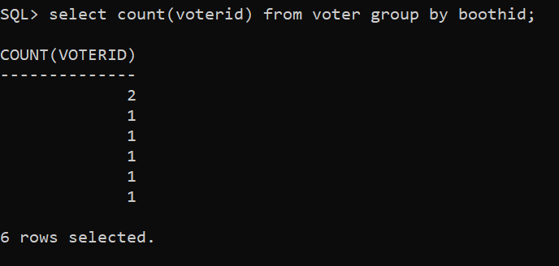

To perform deletion first we drop the foreign key fk_1 (linking boothid from booth 🡪 voter) so that sql allows us to delete records from booth table.

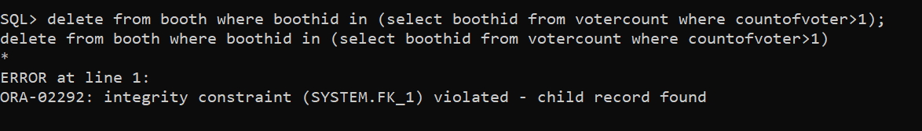

After removing the foreign constraint

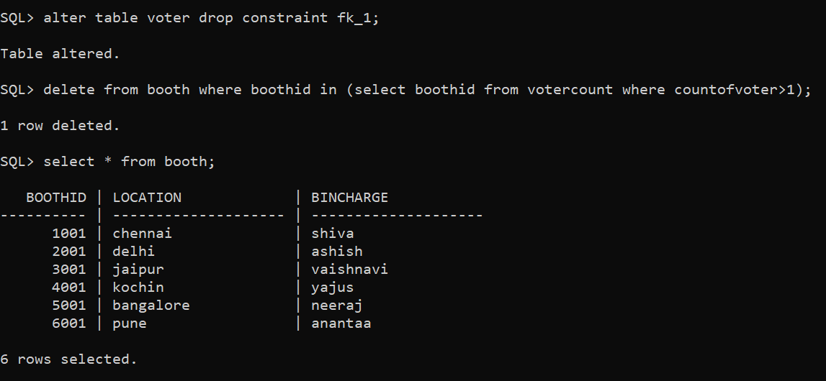

(as you can see boothid=1234 is removed as it had more than 1 voters)

b) Write an PLSQL query to print the details of all the voters those who have age more than 60. (15)

Code:

declare

  id voter.voterid%TYPE;

  name voter.votername%TYPE;

  gender voter.votername%TYPE;

  b voter.boothid%TYPE;

  chvote voter.checkvote%TYPE;

  ag voter.age%TYPE;

  cursor vot is

    select * from voter where age>60;

begin

  open vot;

  loop

  fetch vot into id,name,gender,b,chvote,ag;

  exit when vot%notfound;

  dbms_output.put_line(chr(10)||chr(9)||id||' '||name||' '||gender||' '||b||' '||chvote||' '||ag);

  end loop;

  close vot;

end;

/

Output (Age>60)

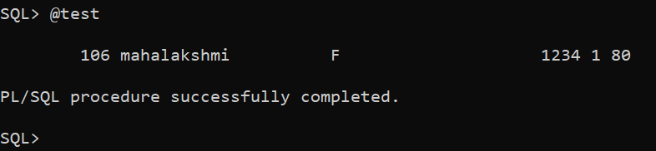

(Age>19)

