Name : Ashutosh Ardu

Regno : 20BRS1262

Model FAT LAB

Queries

Consider the company database. The schemas are

1.employee(eno,ename,dob,gender,doj ,basicpay,dno,area)

2.department(dno,dname)

3.project(pno,pname,dno)

4.workfor(eno,pno,dateworked,intime,outtime)

1.Create a table called employee with all details.

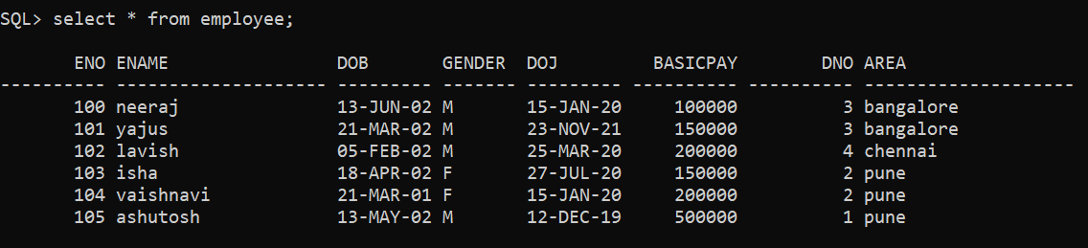

2.Display employee details who have joined in the month of July.

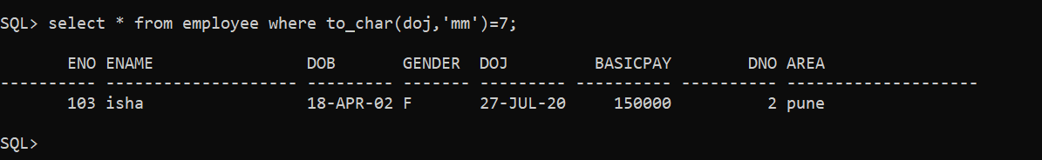

3.Display employee name who is working in marketing & finance department

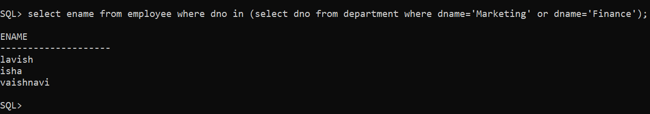

4.Display employee details whose middle name starts with 'I'.

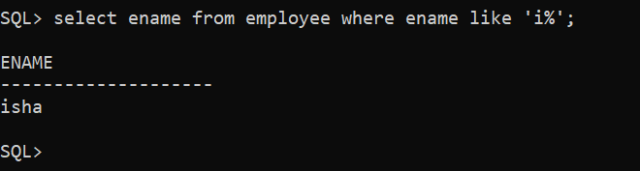

5.Display distinct area of all employee.

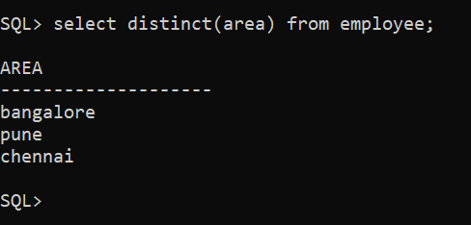

6.Display employee details whose age is in-between 30 & 35.

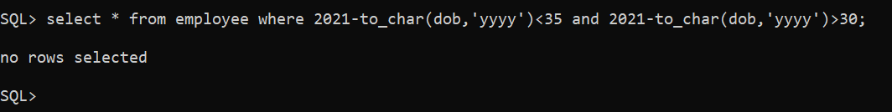

Age of each Employee

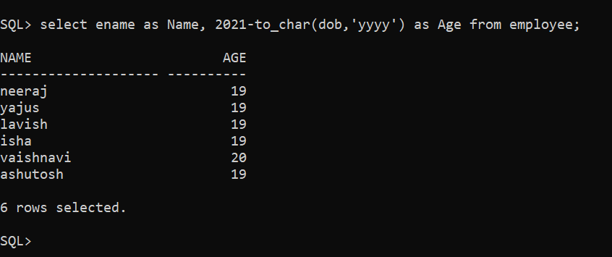

7.Give average salary of all employees.

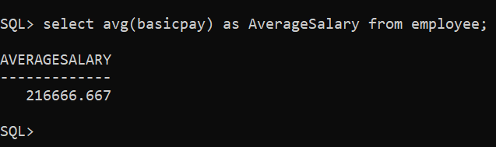

8.Count the number of employee who are working in Finance department.

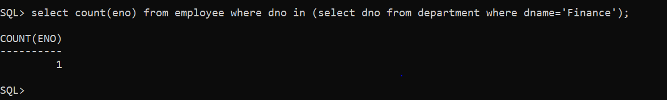

9.Delete records of employee who belong to ‘General’ department.

Initial State

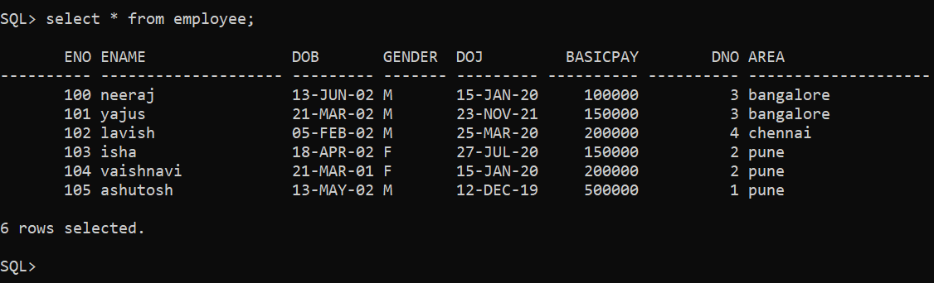

Final State

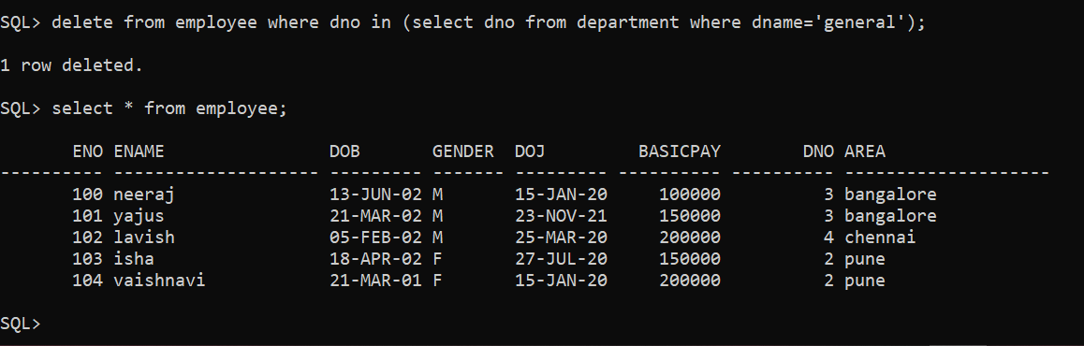

10.List the details of employees who earn a basic pay that is less than the average basic pay of every employees.

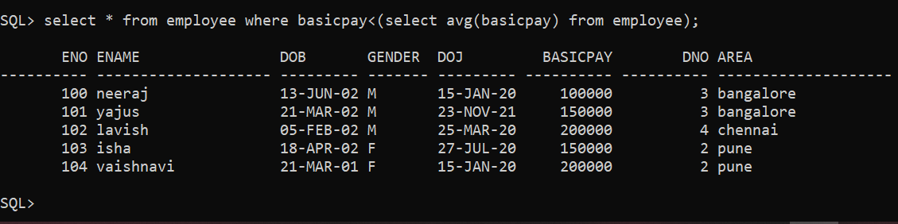

11.List the dno,no_of_employees in each department

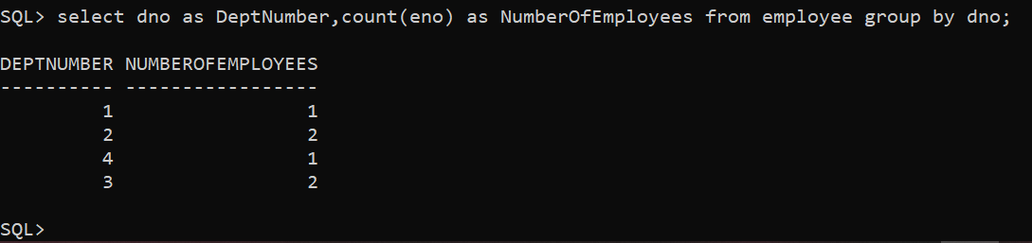

12.List the details of employees who have worked in the projects controlled by cse department

Project Schema

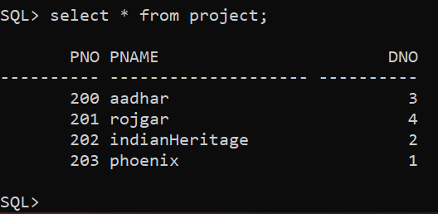

Cse Department

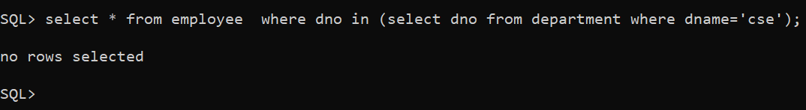

Developer Department

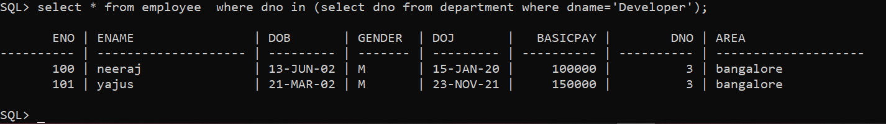

13.Write a pl/sql program to find the sum &avg basicpay of all the employees using procedures.

Code

create or replace procedure findSumAvg

is

  total number;

  average number;

begin

  select sum(basicpay),avg(basicpay) into total,average from employee;

  dbms_output.put_line(chr(10)||chr(9)||'Total Pay: '||total||' Average Pay: '||average);

end;

/

Output

