NAME – ASHUTOSH ARDU

REGNO – 20BRS1262

DBMS LAB 2

1. List the records of student relation.

SQL> select * from student_20brs1262;

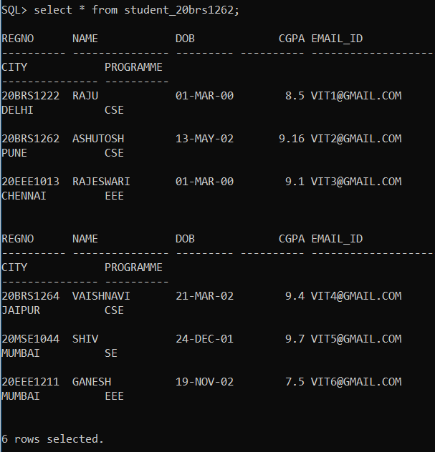

1. List all student details whose cgpa is > 8

SQL> select * from student_20brs1262 where cgpa>8;

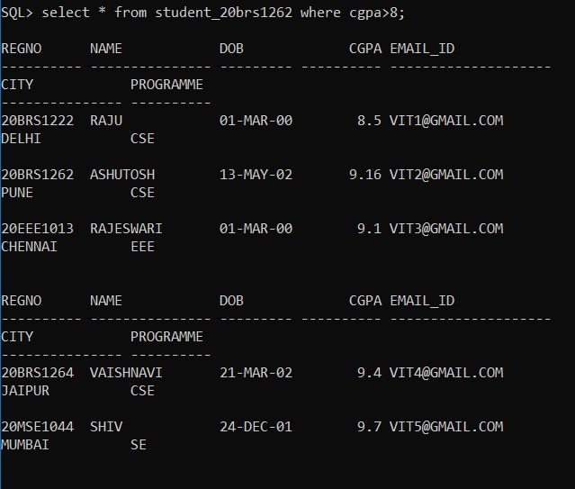

1. List the name of the student whose date of birth is ’01-march-2000’

SQL> select * from student_20brs1262 where dob='1-MAR-00';

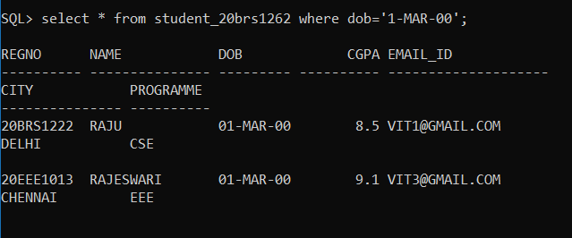

1. List the student’s details who are from Delhi and doing CSE.

SQL> select * from student_20brs1262 where city='DELHI' and programme='CSE';

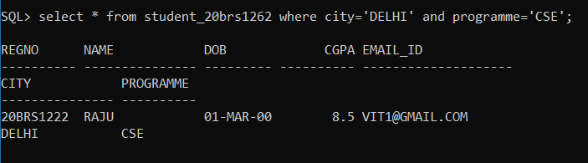

1. List the student’s details who are either from Delhi or from Chennai.

SQL> select * from student_20brs1262 where city='DELHI' or city='CHENNAI';

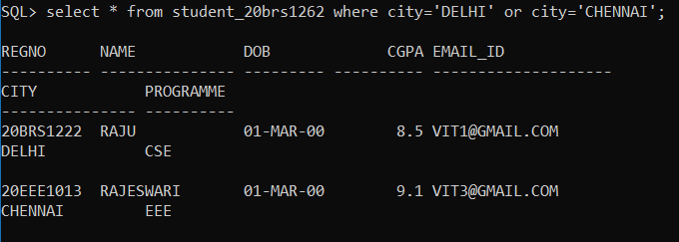

1. List the name and email id of the student who doesn’t lived in Mumbai.

SQL> select name,email_id from student_20brs1262 where city<>'MUMBAI';

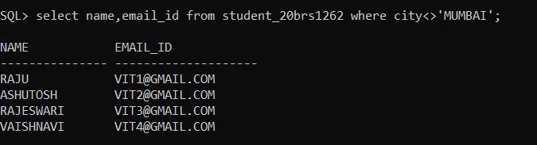

1. Sort the student details based on their dob in descending order

SQL> select * from student_20brs1262 order by dob desc;

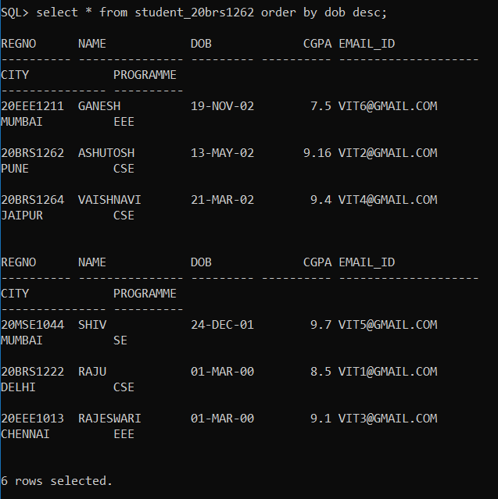

1. Sort the student details based on their name in ascending order and city in descending order.

SQL> select * from student_20brs1262 order by name asc,city desc;

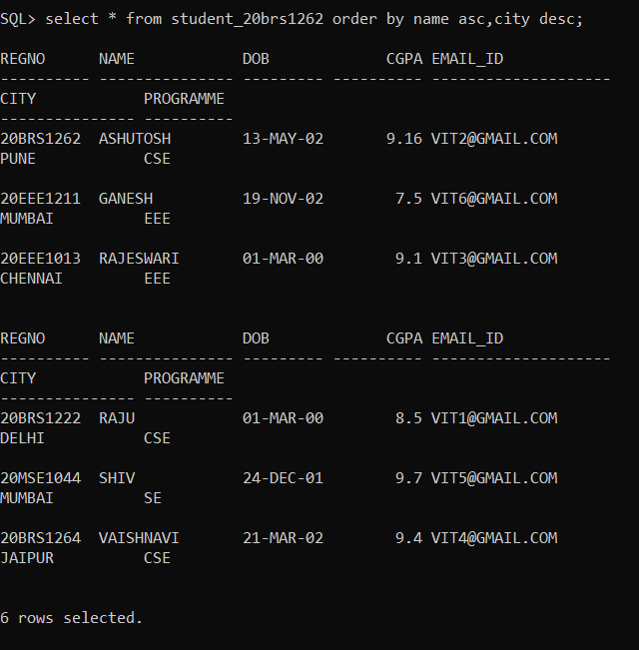

1. List the name of the students whose name starts with ‘r’ and ends with ‘i’

SQL> select * from student_20brs1262 where name like 'R%I';

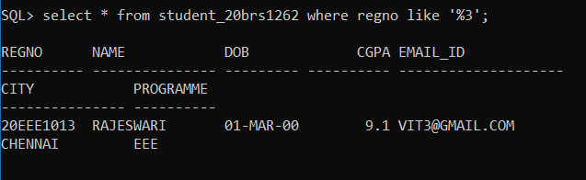

1. List the name of the students who has ‘s’ in their name

SQL> select * from student_20brs1262 where name like 'S%';

