NAME – ASHUTOSH ARDU

REGNO – 20BRS1262

DBMS LAB-1

1. Create a table for a student, with register number, date of admission, programme, name, email id, date of birth, city and cgpa as attributes.

COMMAND

create table student_20brs1262(regno varchar2(10),doa date,programme char(4),name char(15),email varchar2(20),dob date,city char(15),cgpa number(3,2))

OUTPUT

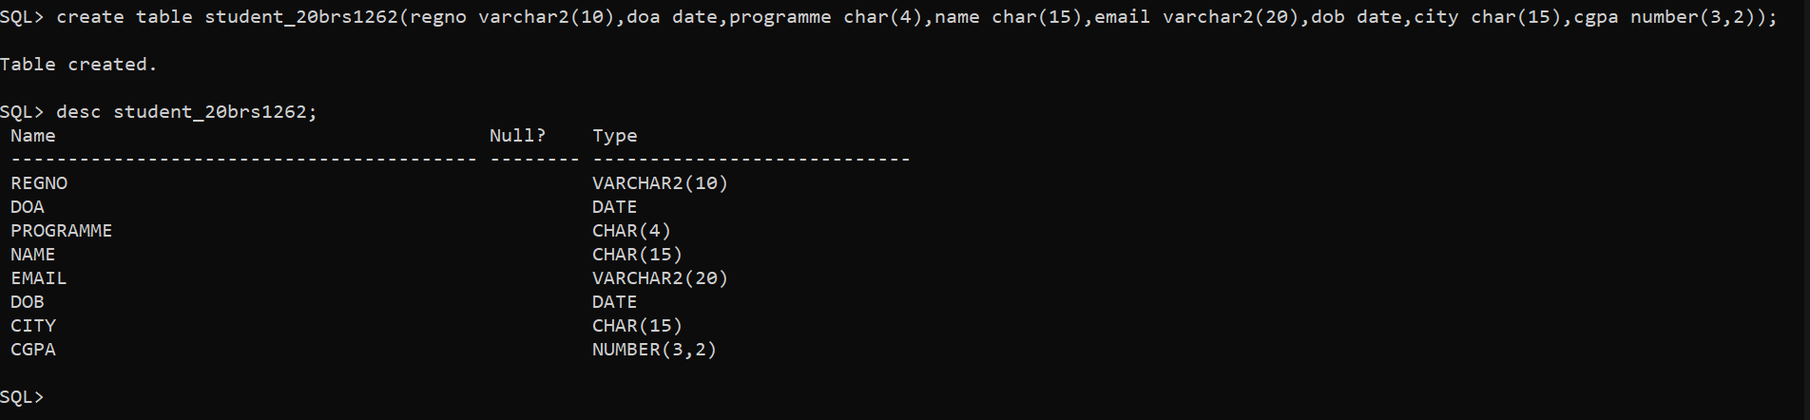

1. Add mobile number attribute to student relation and describe the structure.

COMMAND

alter table student_20brs1262 add mobile_number number(12);

OUTPUT

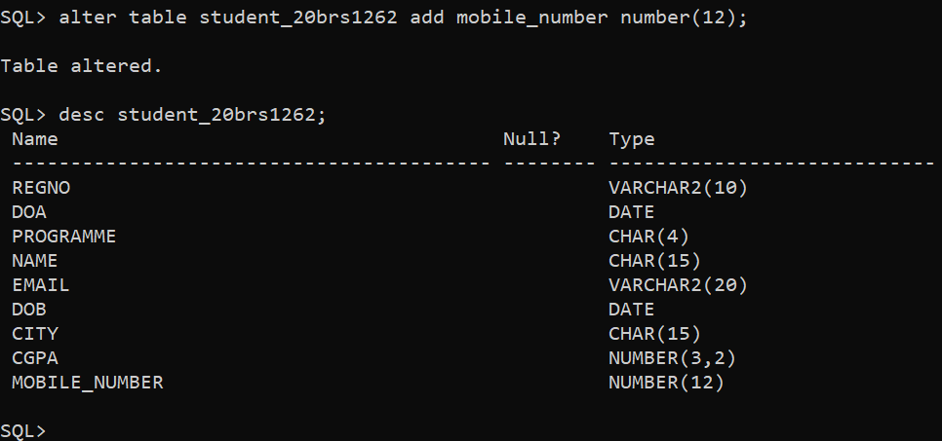

1. Change the data type of name in student relation and describe the structure.

COMMAND

alter table student_20brs1262 modify name varchar2(15);

OUTPUT

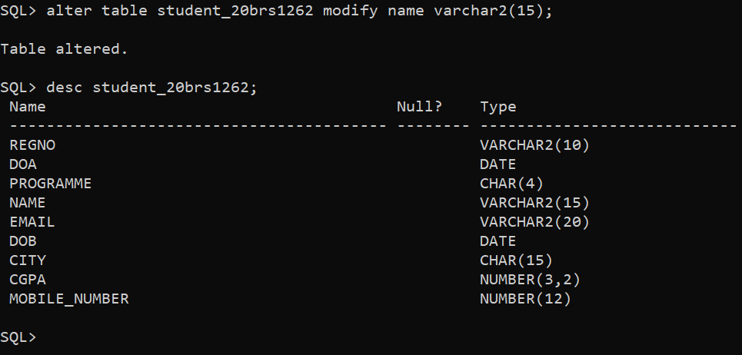

1. Change the size of any attribute and describe the structure.

COMMAND

alter table student_20brs1262 modify programme char(10);

OUTPUT

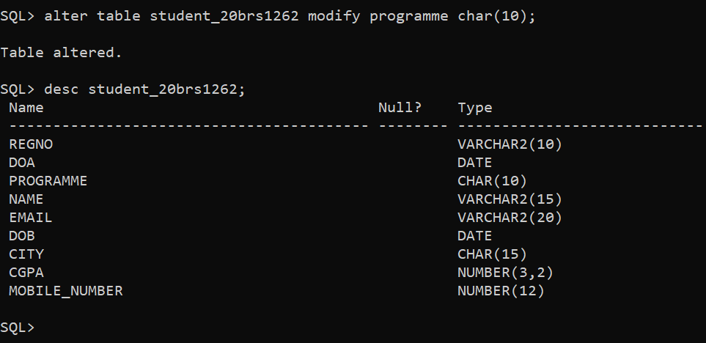

1. Rename the any of the attribute as in student relation and describe the structure

COMMAND: alter table student_20brs1262 rename column regno to reg_no;

OUTPUT

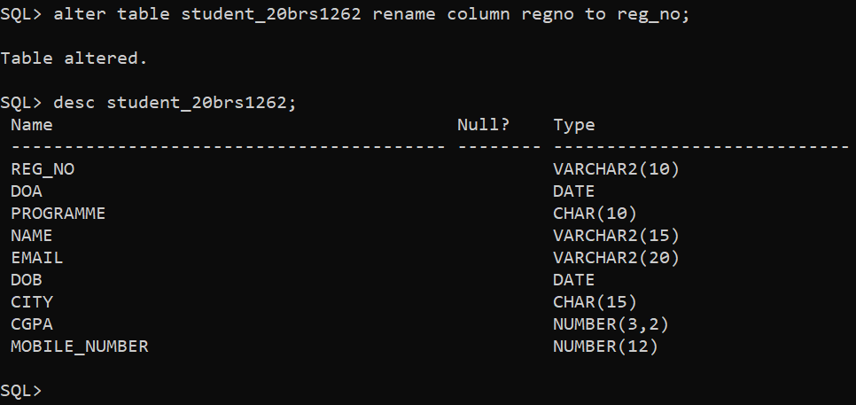

1. Insert 7 records to student relation.

COMMAND

SQL> insert into student_20brs1262 values('&reg_no','&doa','&programme','&name','&email','&dob','&city',&cgpa,&mobile_number);

Enter value for reg_no: 20brs1262

Enter value for doa: 27-sep-2020

Enter value for programme: cse

Enter value for name: Ashutosh

Enter value for email: vit62@gmail.com

Enter value for dob: 14-may-2001

Enter value for city: pune

Enter value for cgpa: 9.06

Enter value for mobile_number: 6334477123

old 1: insert into student_20brs1262 values('&reg_no','&doa','&programme','&name','&email','&dob','&city',&cgpa,&mobile_number)

new 1: insert into student_20brs1262 values('20brs1262','27-sep-2020','cse','Ashutosh','vit62@gmail.com','14-may-2001','pune',9.06,6334477123)

1 row created.

SQL> / (SO ON FOR SEVEN RECORDS)

OUTPUT

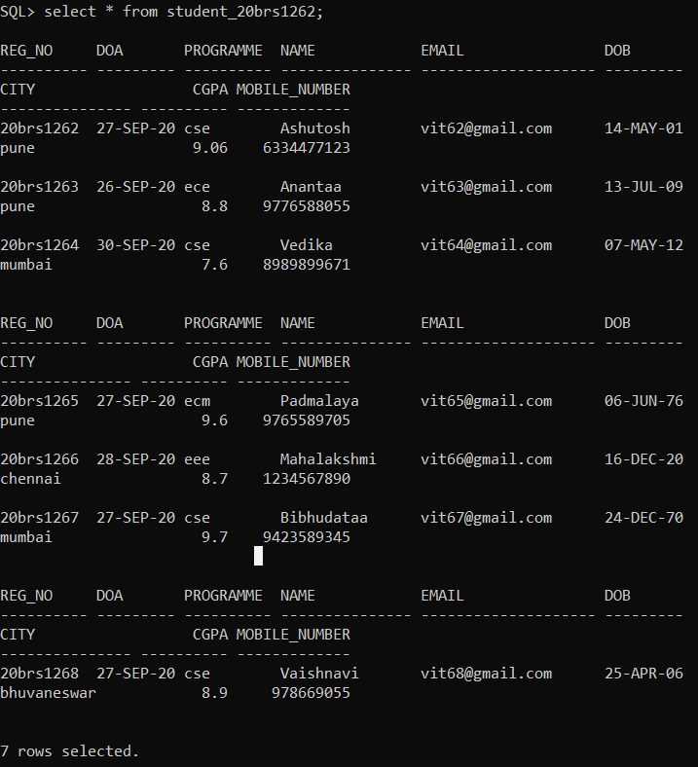

1. Copy the contents of student table and name the table as stud relation.

COMMAND

create table stud as select * from student_20brs1262;

OUTPUT

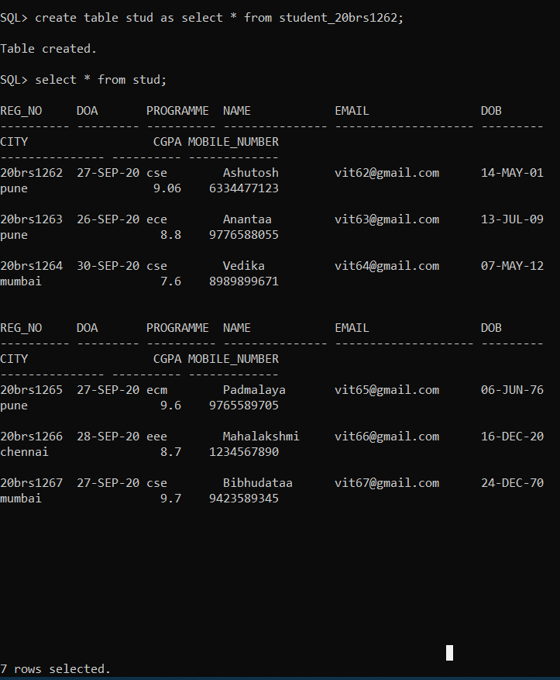

1. Delete the email id attribute from stud relation and describe the structure.

COMMAND

alter table stud drop column email;

OUTPUT

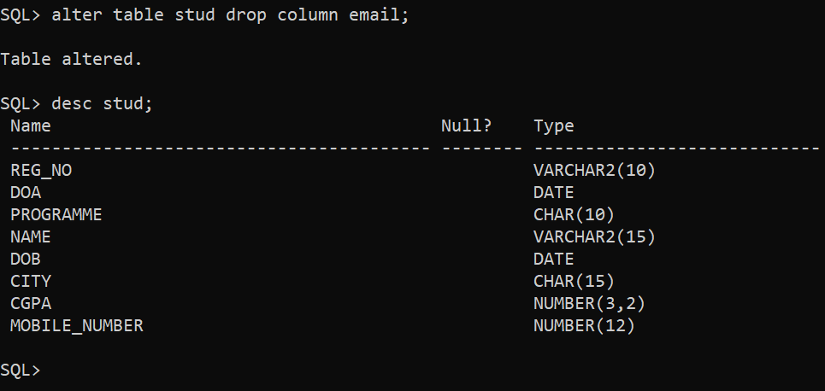

1. Display the contents of the stud relation

COMMAND

select * from stud;

OUTPUT

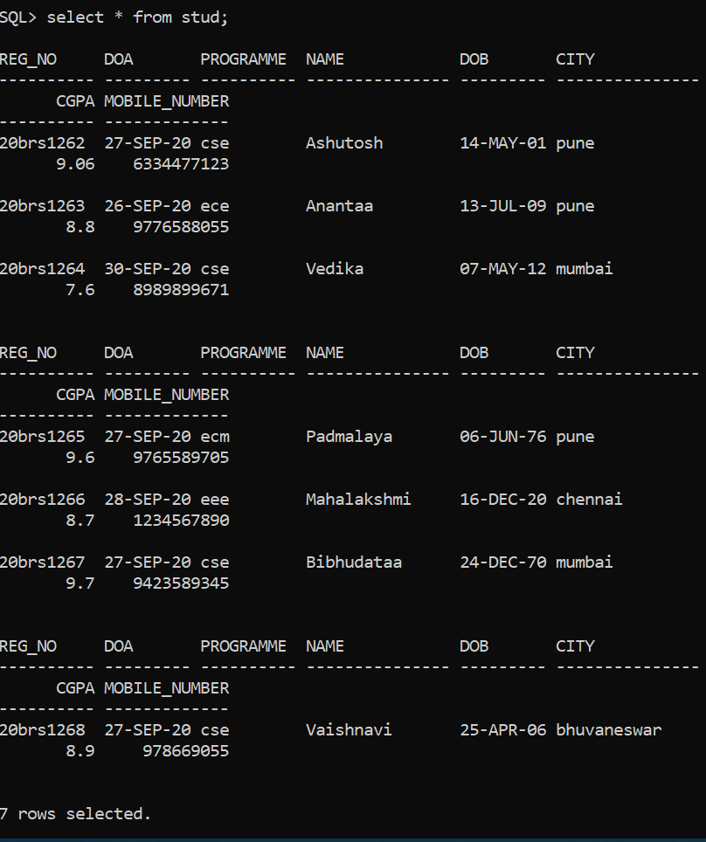

1. Rename the *stud* relation as *stu*

COMMAND

alter table stud rename to stu;

OUTPUT

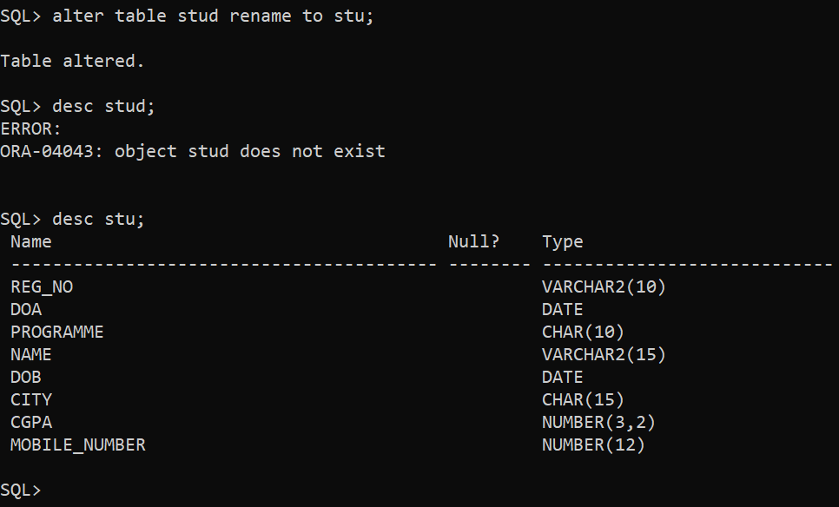

11. Delete the contents of stu relation, describe the structure and display the contents of the table

COMMAND

truncate table stu;

OUTPUT

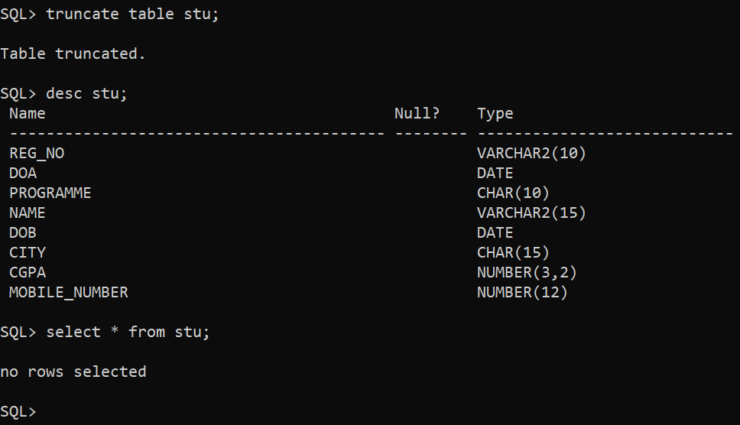

COMMAND: drop table stu;

OUTPUT

