Name : Ashutosh Ardu

Regno : 20BRS1262

DBMS LAB 10

For the already created table of student schema,

Student(regno, name, cgpa)

Course (ccode, cname, credits)

Student_course ( regno, ccode)

1. Write a PL/SQL function to update the cgpa of the student with regno 101 and use the **SQL%ROWCOUNT** attribute to determine the number of rows affected.

Code

declare

tot number;

begin

  update student set cgpa=cgpa-0.2 where regno=101;

  if sql%notfound then

    dbms_output.put_line('No Student Selected');

  elsif sql%found then

    tot:=sql%rowcount;

    dbms_output.put_line(tot||' Students Selected');

  end if;

end;

/

Output

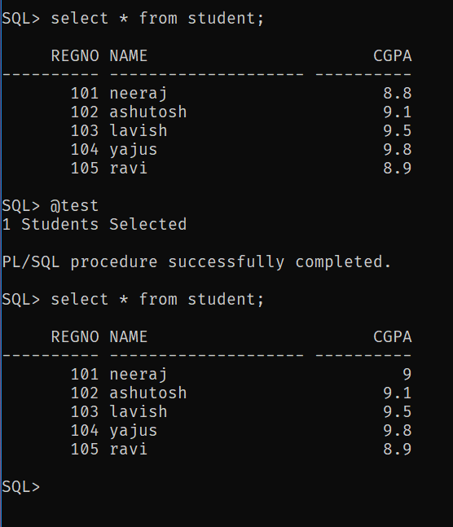

1. Write a procedure to find the maximum cgpa of all the students.

Code

create or replace procedure findMaxCgpa

is

  gpa student.cgpa%TYPE;

begin

  select max(cgpa) into gpa from student;

  dbms_output.put_line(chr(10)||chr(9)||'Max CGPS is:'||gpa);

end;

/

Output

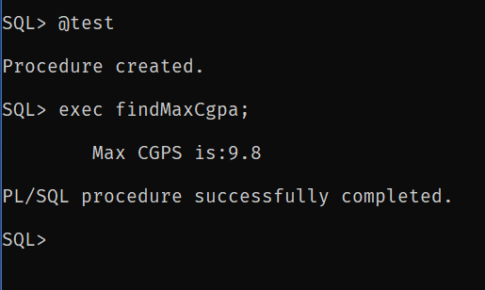

1. Insert a column named marks in student_course relation and update the column values .Use the **SQL%ROWCOUNT** attribute to determine the number of rows updated.

Code

create or replace procedure updateMarks

as

  num number:=0;

begin

update student_course set marks=89 where regno=101;

num:=num+sql%rowcount;

update student_course set marks=95 where regno=102;

num:=num+sql%rowcount;

update student_course set marks=92 where regno=103;

num:=num+sql%rowcount;

update student_course set marks=97 where regno=104;

num:=num+sql%rowcount;

update student_course set marks=80 where regno=105;

num:=num+sql%rowcount;

if sql%found then

  dbms_output.put_line('Updated: '||num||' Students');

else

  dbms_output.put_line('Nothing Updated');

end if;

end;

/

Output

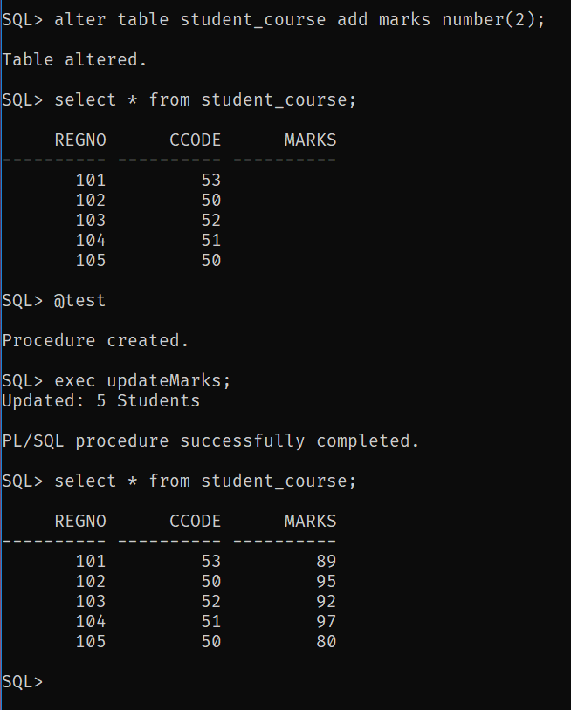

1. Write a PL/SQL program to find the name of a student with regno 105 and also check whether the record is available or not using explicit cursor.

Code

declare

  sname student.name%TYPE;

  cursor cstudent is select name from student where regno=105;

begin

  open cstudent;

  loop

  fetch cstudent into sname;

    if cstudent%notfound then

    dbms_output.put_line('Student Not found');

    EXIT;

    else

    dbms_output.put_line('Student Name: '||sname);

    end if;

  end loop;

  close cstudent;

end;

/

Output

