NAME – ASHUTOSH ARDU

REGNO – 20BRS1262

DBMS LAB 2

1. First create tables without constraints.

Code

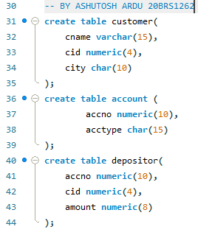

Outputs



* Customer(cname,cid,city);
* Account(accno,acctype);
* Depositor(accno,cid,amount);

1. Add the primary Key constraints (Underlined attributes are primary keys)

Code

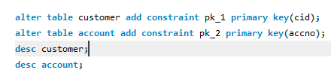

Output



Customer

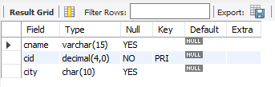

Account

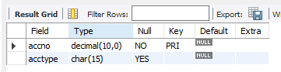

3. Add the Foreign Keys wherever it is applicable.

Code



Output



4. Make sure that the cname and acctype cannot be null.

Code



Output



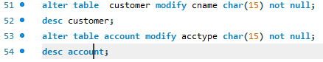



5. Ensure that the values for amount should be greater than 0.

Code



Output



6. Insert a new column ‘branchname’ in the account relation which is unique.

Code

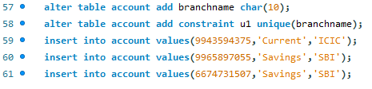

Output

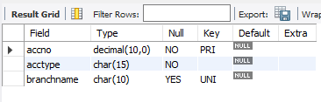



7. Drop the unique constraint for the attribute ‘branchname’

Code

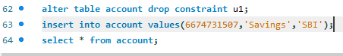

Output



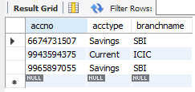

8. Set the default constraint to the attribute ‘city’ with the value ‘Delhi’.

Code

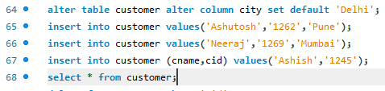

Output

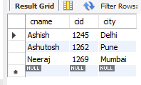

9. Show the violations of foreign key and primary key constraints with examples.

Code

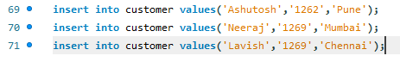

Output







(Please zoom in)

10. Drop the foreign key constraint in the Depositor relation.

Code



Output



