NAME – ASHUTOSH ARDU

REG NO – 20BRS1262

DBMS LAB – 3

* Create the following schemas and add the constraints wherever it is applicable.

Command

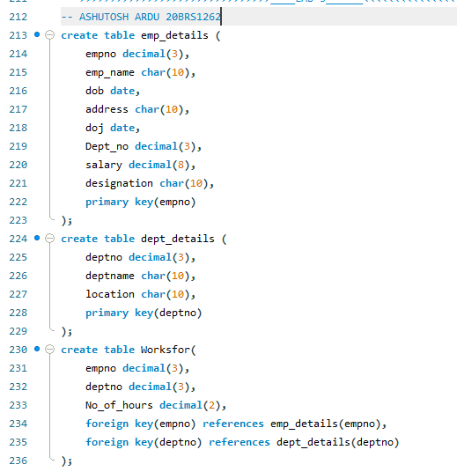

Output



* Add email id attribute to emp relation and describe the structure

Command



Output

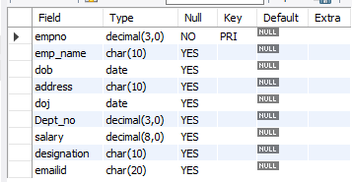

* Change the data type of emp_name in emp_details relation and describe the structure

Command



Output

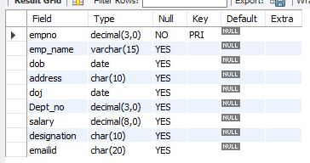

* Change the size of any attribute and describe the structure

Command



Output

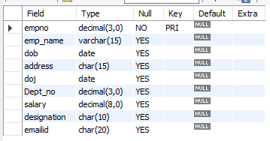

* Add phone number attribute to emp_details relation and describe the structure

Command



Output

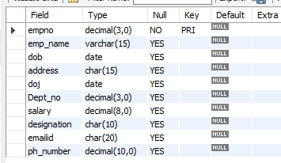

* Rename the empno attribute as Emp_id in emp_details relation and describe the structure

Command



Output

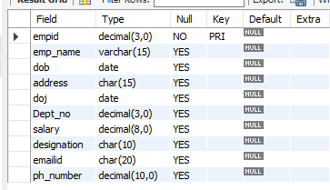

* Delete the location attribute from dep_details and describe the structure

Command



Output

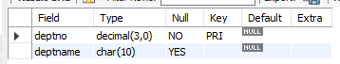

* Add Emp_id attribute to dept_details relation and describe the structure

Command



Output

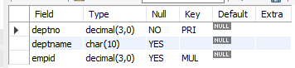

* Insert 5 records each to all the schemas

Command

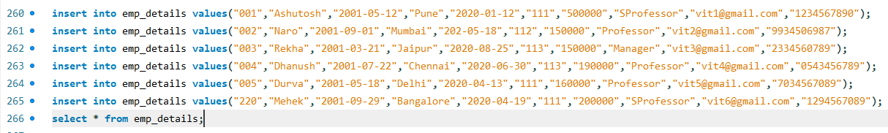

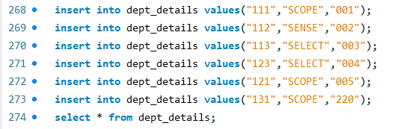

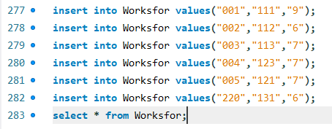

Output

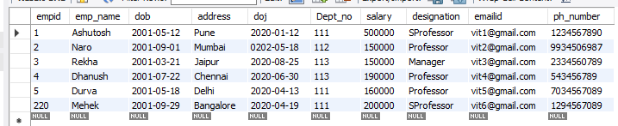

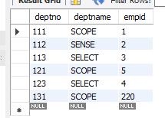

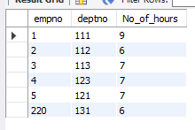

* Copy the contents of emp_details table and name the table as employee_data.

Command



Output

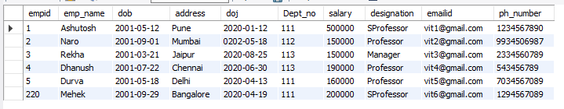

* Delete the contents of employee_data table, describe the structure and display the contents of the table

Command

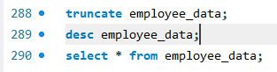

Output

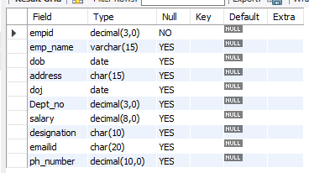

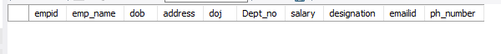

* Delete the structure of employee_data table , describe the structure and display the contents of the table

Command

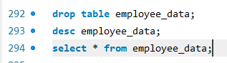

Output



Please zoom in

* List all employee details whose salary is > 10000

Command



Output

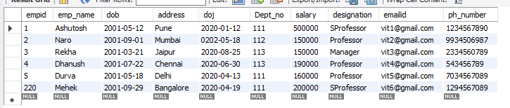

* List the name of employee whose designation is ‘Professor’

Command



Output

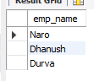

* List the employee Id and name who belongs to “SCOPE dept”

Command



Output

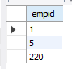

* List the name and designation of the employee who receives salary between 1 lakh and 2 lakhs

Command



Output

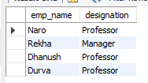

* Sort the employee details in ascending order based on the salary they receive.

Command



Output

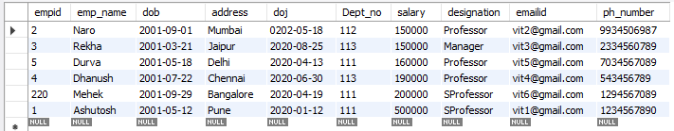

* Sort the designation of the employee by descending order and name of the employee in ascending order.

Command



Output

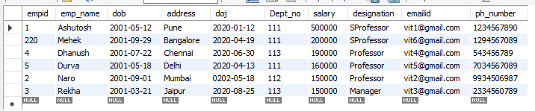

* List the name of the employee whose name starts with ‘d’.

Command



Output

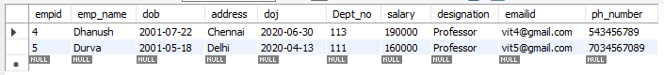

* List the dept name which has ‘E’ in it.

Command



Output

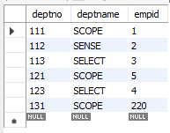

* Update the mobile number of emp_id=22090

Command



Output

