Name – Ashutosh Ardu

Regno – 20BRS1262

DBMS LAB 4

1. Insert data values for employee table.

Code

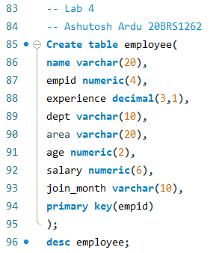

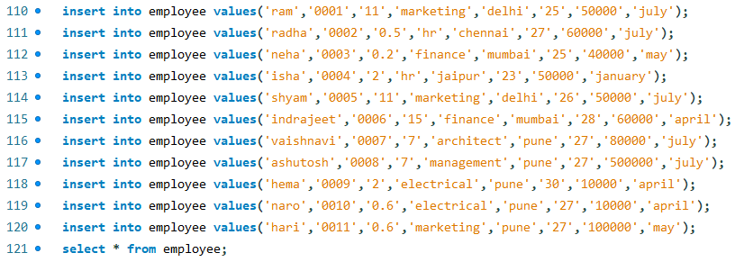

Output

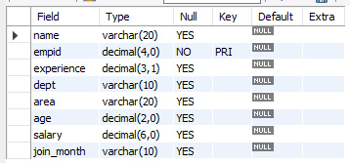

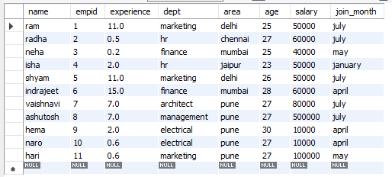

1. Display employee details who have joined in the month of July.

Code



Output

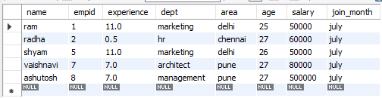

1. Display employee details having experience>10.

Code



Output

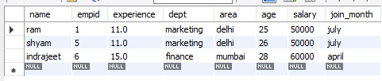

1. Display employee details having exp<1 year & belonging to marketing department

Code



Output

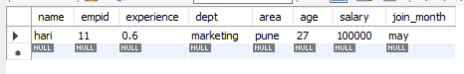

1. Display employee name who is working in marketing & finance department.

Code



Output

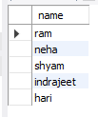

1. Display employee details whose name starts with ‘I’.

Code



Output

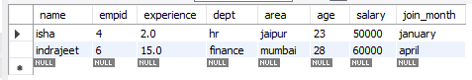

1. Add a field ‘gender’ and update the details of employee in existing table.

Code

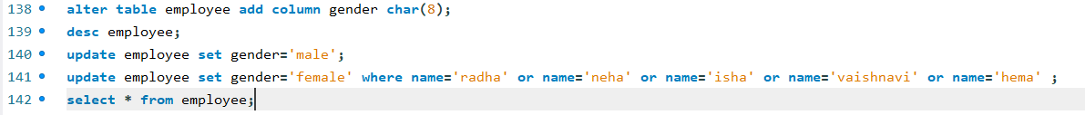

Output

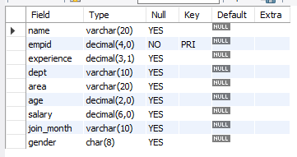

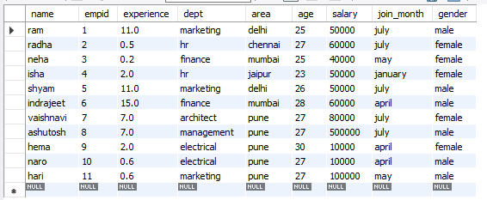

1. Change dept id of employee who is working in HR dept. Eg: If id is 151 change it to 501.

Code

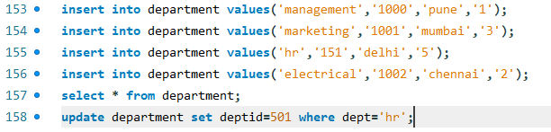

Output

Initially

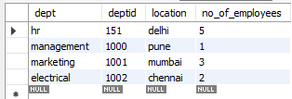

Later

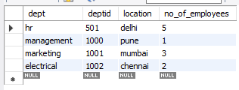

1. Display employee details whose age is in-between 30 & 35.

Code



Output

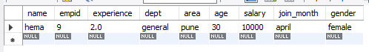

1. Delete records of employee who belong to ‘General’ department

Code



Output

Initial

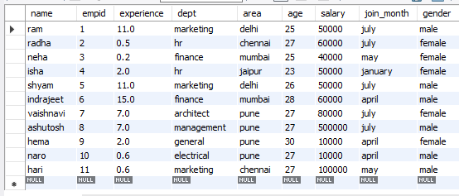

Later

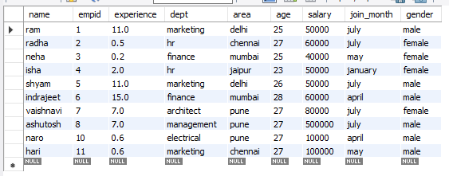

1. Create a table called department with all details

(Deptname,Dept_ID,locations,No_of_employees)

Code

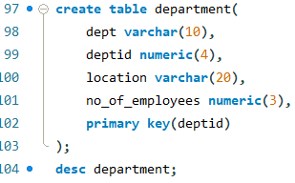

Output

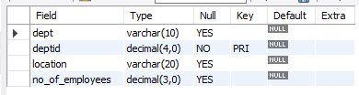

12-Create a table called project with all details

(Emp_ID, Dept_ID, location, total hours)

Code

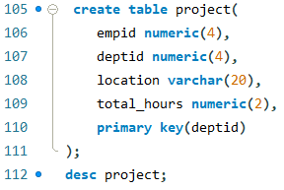

Output

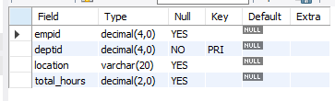

Aggregation Functions

1-Count the number of employees in Employee table

Code



Output

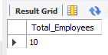

2-Calculate the average salary of all employees.

Code



Output



3-Print the highest and lowest salary of employees.

Code



Output



4-Count the number of employee who are working in Finance department.

Code



Output



5-Count the number of different cities from employee relation

Code



Output



6-Find the average salary of Finance department

Code



Output



7-Count the number of employees in Employee table

Code



Output



8-Find the number of Emp_IDs which has the salary greater than 20000

Code



Output



9-Find the number of Emp_IDs which has the salary less than 20000

Code



Output



10-Find the total salary of account department

Code



Output



11-Rename the title sum(salary) as Total in the output

Code



Output



12-List the empid and deptname with maximum salary

Code



Output

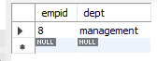

13-Display the total salary at Chennai city

Code



Output



14-Count the deptname which has more than 10k as salary

Code



Output



15-Number of departments in each area.

Code



Output

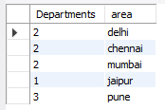

16-Display the total salary along with deptname at each location

Code



Output

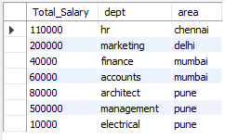

17-Find min and max salary for each location

Code



Output

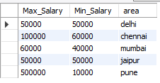

18-List the deptname with total emp_id at each area if the count is >1.

Code



Output

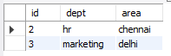

19-List the deptname with total employees if the total is >3 at each dept and the name of the dept has letter ‘e’.

Code



Output

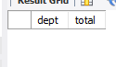

As there is only one record which satisfies such conditions not 3.

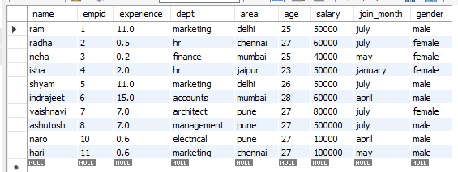

20-List the number of records at each dept with deptname.

Code



Output

