Name – Ashutosh Ardu

Regno – 20BRS1262

DBMS Lab 5

-- student(regno, sname, cgpa, school)

-- course(ccode, cname, credits)

-- faculty(empid, fname, designation, salary)

-- course_student(regno, ccode)

-- course_faculty(fid, ccode)

Commands

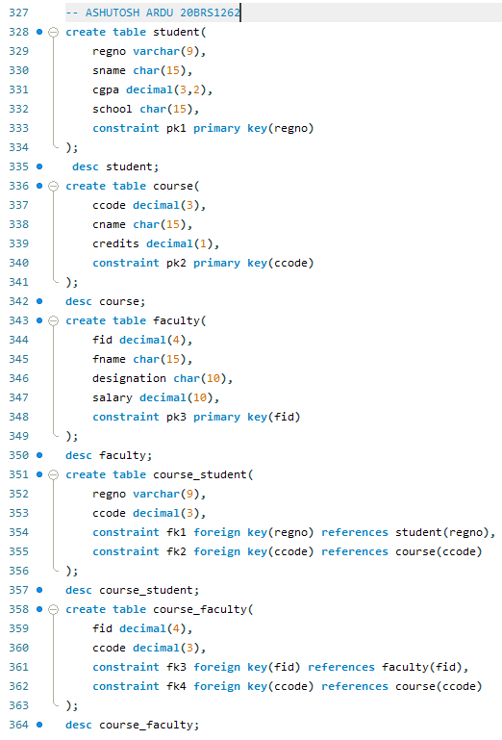

Output

Student

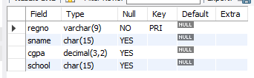

Course

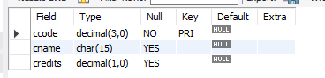

Faculty

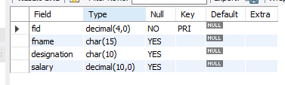

Course_Student

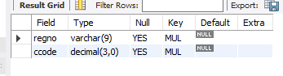

Course_Faculty

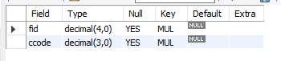

1. Add dob attribute for the student relation

Commands



Output

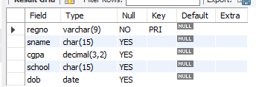

1. Update the DOB values for every record individually.

Commands

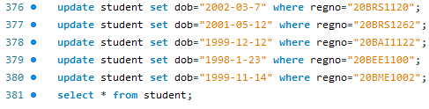

Output

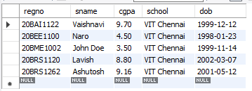

1. List the students who are not born during “Mar” of 2015

Command

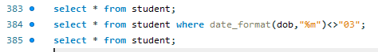

Output

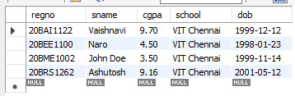

1. List the students whose age is greater than 20

Command



Output

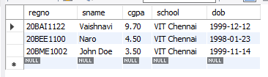

1. List the first five characters of all the students’ names

Command



Output

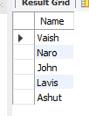

1. If a student has less than 5 cgpa, increase his cgpa by 1

Command

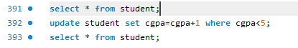

Output

Initial

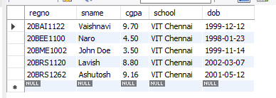

Final

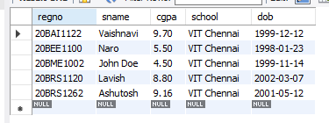

1. List the students who are not born during Jan or November

Command



Output

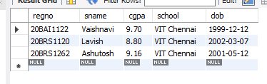

1. List the name of the faculty in capital

Command



Output

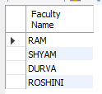

1. Find the length of each faculty name

Command



Output

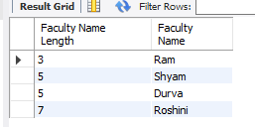

1. List the course titles which has “system” in it

Command



Output

