Name – Ashutosh Ardu

Regno – 20BRS1262

DBMS LAB 6

Consider the following relational schema. Create all the tables with the proper key constraints

Sailors(sid: integer, sname: string, rating: integer, dob: date)

Boats(bid: integer, bname: string, color: string)

Reserves(sid: integer, bid: integer, day: date)

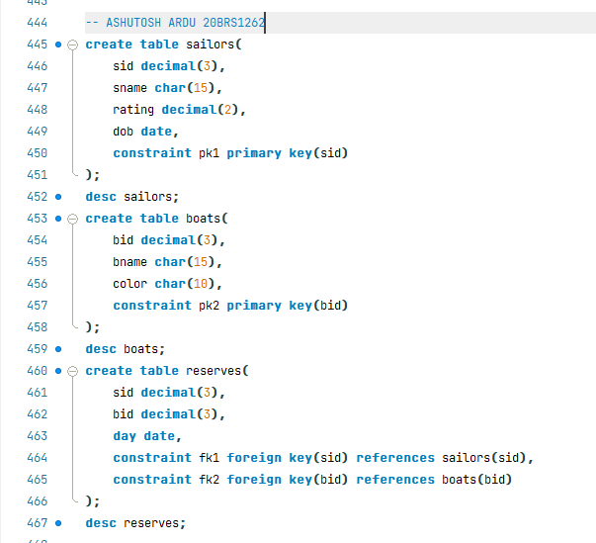

Sailors

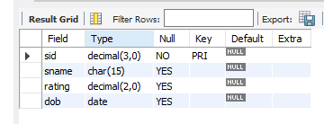

Boats

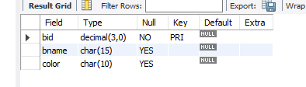

Reserves

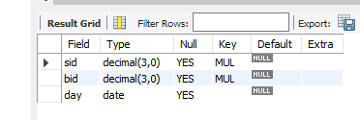

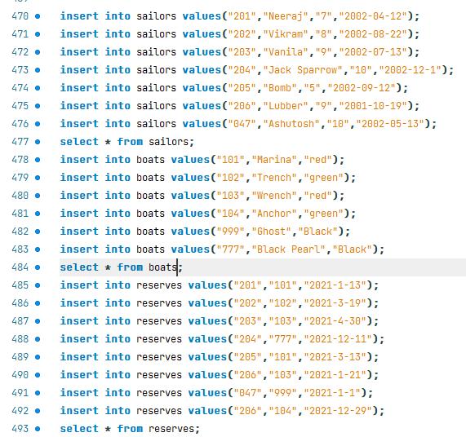

Sailors

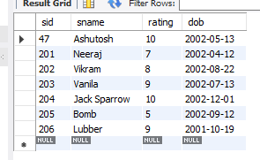

Boats

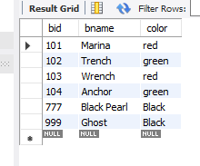

Reserves

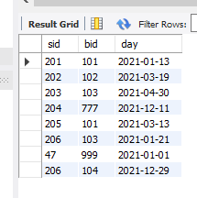

Compute the names and ratings of highly rated sailors(ratings >8)



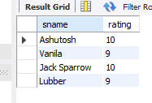

Find the names of sailors who have reserved boat 103.



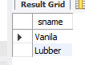

Find the colours of boats reserved by Lubber.



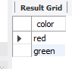

Find the names of sailors who have reserved at least one boat.



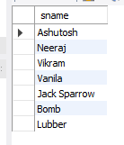

Find the names of sailors who have reserved a red or a green boat.



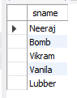

Find the names of sailors who have reserved a red and a green boat.



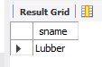

Find sailors who have reserved a red boat



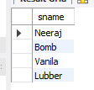

Create a view to store the sids of all sailors who have reserved red boats but not green boats.



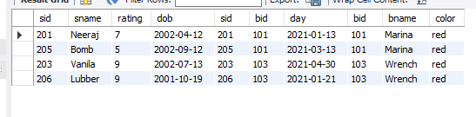

Create a view to store all sids of sailors who have a rating of 10 or have reserved boat 104.



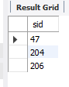

Compute the average ratings, using AVG; the sum of the ratings using SUM; and the number of sailors using count.



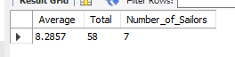

Perform all the outer join operations between sailor and reserves tables



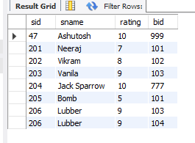

Compare the outputs of cross join and inner join operations for sailors and reserves tables



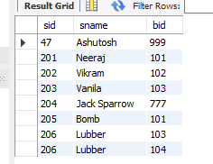



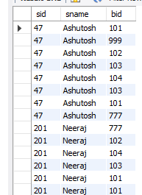

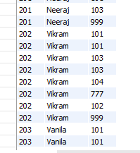

And the list goes on for 42 records (as there are 6 records in Sailor Table & 7 records in Reserves Table)more….(too much to show)

For each red boat, find the number of reservations for this boat.



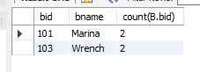

Find the dob of sailors whose name begins and ends with B and has at least three characters.





List the sailor names who are not born during “March” of 2008



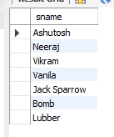

List the first two characters of all the sailors’ names



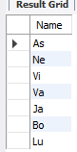

List the sailor details who are not born during December or November



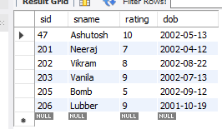

List the names of the sailors in capital letters



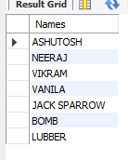

Find the length of each boat name



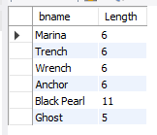

List the boat names which has “er” in it



