Name – Ashutosh Ardu

Regno – 20BRS1262

DBMS LAB 7

Consider the following banking schema

* branch(branch name, branch city, assets)
* customer (customer name, customer street, customer city)
* loan (loan number, branch name, amount)
* borrower (customer name, loan number)
* account (account number, branch name, balance)
* depositor (customer name, account number)

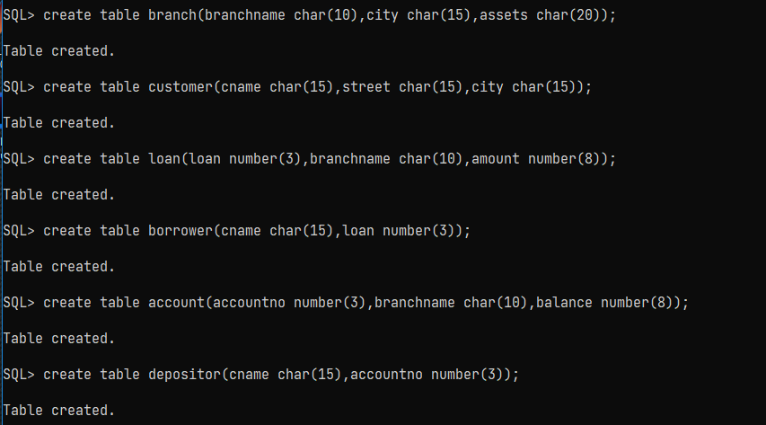

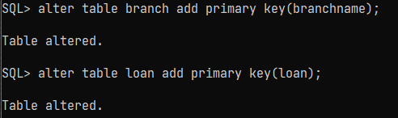

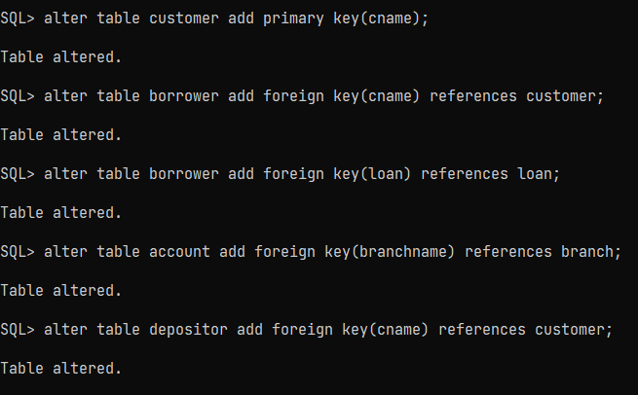

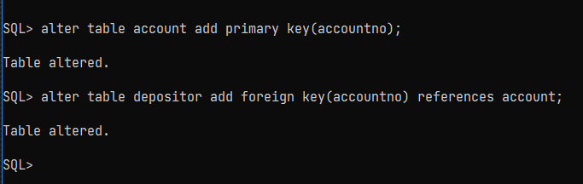

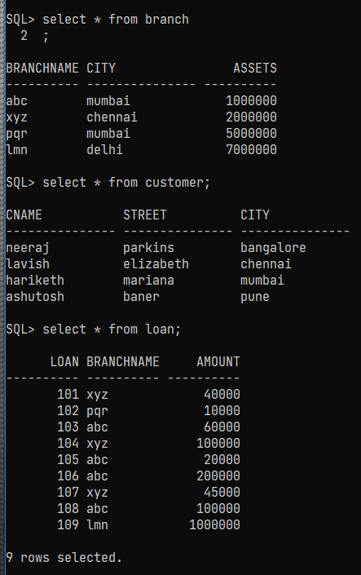

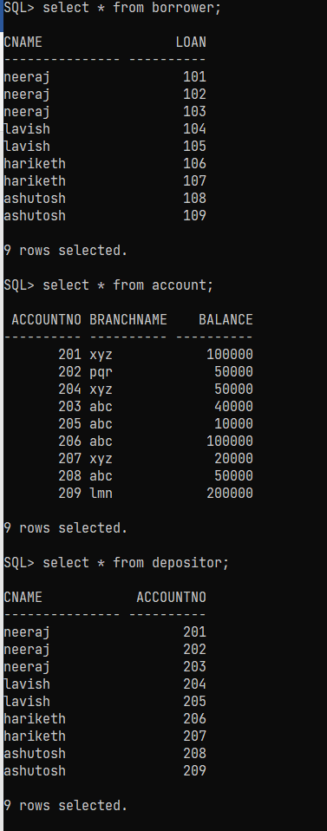

Find the names of all customer who live in city “Chennai”.

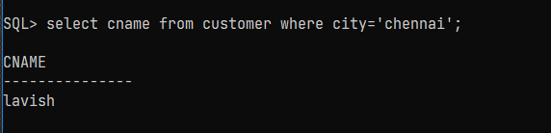

Find the names of all customer whose balance is greater than $100,000.

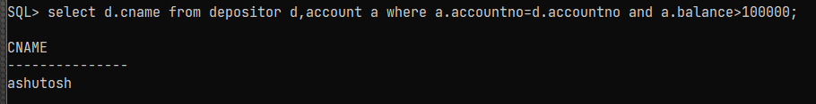

Find all loan numbers of those loans with loan amounts between $1000 to $50000.

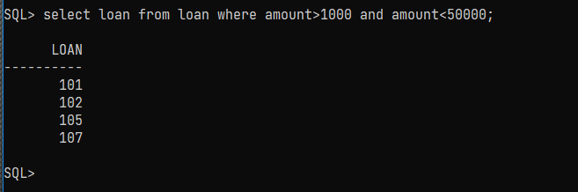

Find the names of all depositors who have an account with a value greater than $6,000 at the “PQR” branch.

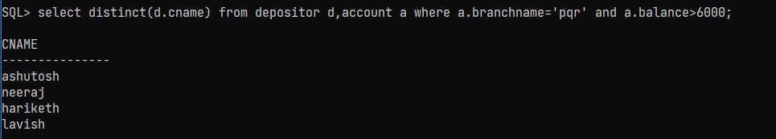

Find the names of all branches located in “Mumbai”.

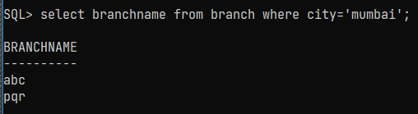

Find the names of all borrowers who have a loan in branch “ABC”.

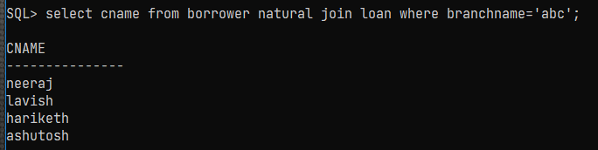

Find the average account balance at the ‘XYZ’ branch.

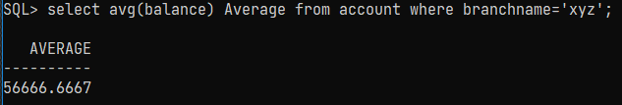

Find the average account balance at each branch.

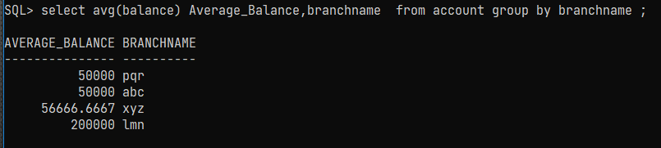

Find the number of depositors for each branch

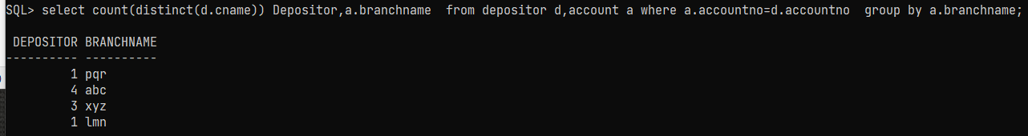

Find all loan numbers that appear in the loan relation with null values for amount.

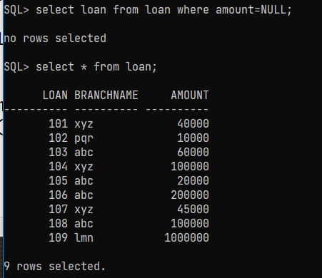

Find all customers who have both an account and loan at the “ABC” branch(use nested queries)

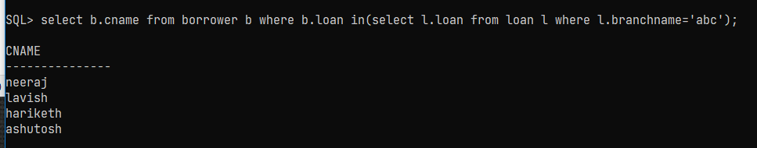

Find all customers who do have a loan at the bank but do not have an account at the bank.( use nested queries)

For ‘lmn’ bank

SQL> select distinct(cname) from borrower natural join loan where branchname='lmn' and cname not in(select distinct(cname) from depositor natural join account where branchname='lmn');

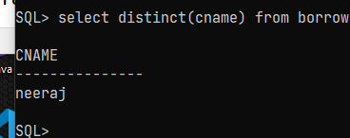

Find the names of all branches that have assets greater than those of at least one branch located in “Mumbai”.

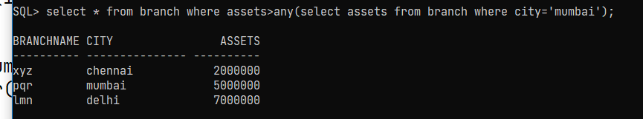

Create a view called all-customers for showing the branch names and customer names who have either an account or loan at that branch.

SQL> create view all_customers as (select b.cname,l.branchname from borrower b,loan l where b.loan=l.loan) union (select d.cname,a.branchname from depositor d,account a where a.accountno=d.accountno) order by branchname;

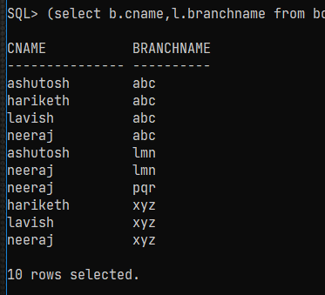

Create a view to show the sum of the amounts of all the loans at the branch

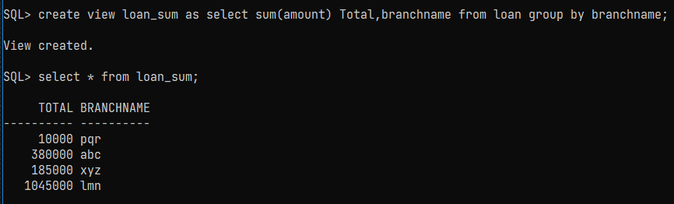

List the customers of the Chennai branch from all-customers view.

