Name : Ashutosh Ardu

Regno : 20BRS1262

DBMS LAB 8

1. Ram and Raj were playing number fun game . In this game, Ram gave three numbers (a,b,c) to Raj . Ram should find out the numbers which are divisible by third number (c) between the range of first given two numbers(a,b) and find how many numbers are there . Write a PL/SQL program for implementing the above concept using procedures

Code

Function

create or replace procedure ans (a number,b number,c number)

is

  num number := 0;

begin

  if c=0

  then

  dbms_output.put_line('Invalid Input');

  else

  for i in a..b

  loop

  if mod(i,c)=0

  then

  dbms_output.put_line(i);

  num:=num+1;

  end if;

  end loop;

  dbms_output.put_line('Total:'||num);

  end if;

end;

/

Main Code

declare

  a number := &a;

  b number := &b;

  c number := &c;

begin

  ans(a,b,c);

end;

/

Output

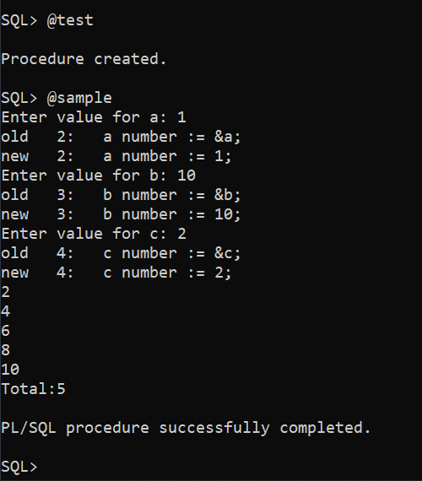

1. For the already created table of student schema,

Student(regno, name, cgpa)

Course(ccode, cname, credits)

Student_course( regno, ccode)

1. Write a PL/SQL procedure to update the cgpa of the student with regno 101

Code

create or replace procedure pro_update (x1 number,x2 number)

as

begin

  update student set cgpa=x1 where regno=x2;

  dbms_output.put_line('Updated');

end;

/

Output

Initial

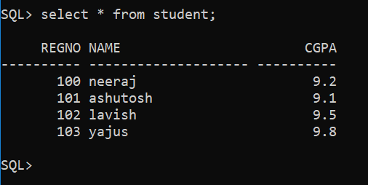

Final

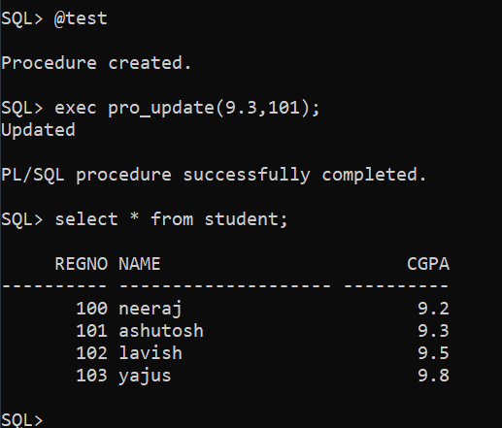

1. Write a procedure to find the maximum cgpa of all the students.

Code

create or replace procedure max_cgpa

as

  a student.cgpa%TYPE;

begin

  select max(cgpa) into a from student;

  dbms_output.put_line(chr(9)||'Max CGPS is:'||a);

end;

/

Output

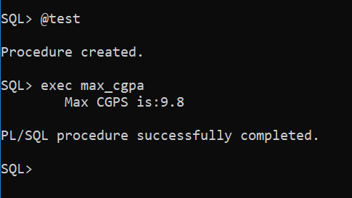

1. Insert a column named marks in student_course relation and update the column values.

Code

create or replace procedure up_marks

as

begin

  update student_course set marks=89 where regno=100;

  update student_course set marks=95 where regno=101;

  update student_course set marks=92 where regno=102;

  update student_course set marks=97 where regno=103;

  dbms_output.put_line('Updated');

end;

/

Output

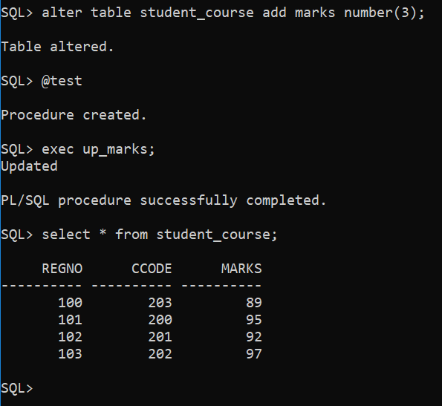

1. Get the marks of the the regno 102 and display his grade

Code

create or replace procedure get_marks (reg number)

as

  m student_course.marks%TYPE;

  grade student.cgpa%TYPE;

begin

  select cgpa into grade from student where regno=reg;

  select marks into m from student_course where regno=reg;

  dbms_output.put_line(chr(9)||'marks:'||m||' grades:'||grade);

end;

/

Output

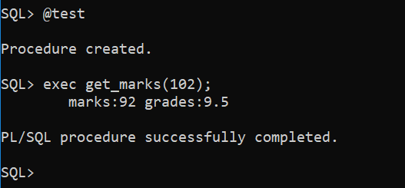

Write a procedure to perform the following concepts

Swapping of two numbers using temp variable

Code

Function

create or replace procedure ans (a in out number,b in out number)

is

  temp number;

begin

  temp:=a;

  a:=b;

  b:=temp;

end;

/

Main Code

declare

  a number := &a;

  b number := &b;

begin

  dbms_output.put_line('Before Swap a:'||a||' b:'||b);

  ans(a,b);

  dbms_output.put_line('After Swap a:'||a||' b:'||b);

end;

/

Output

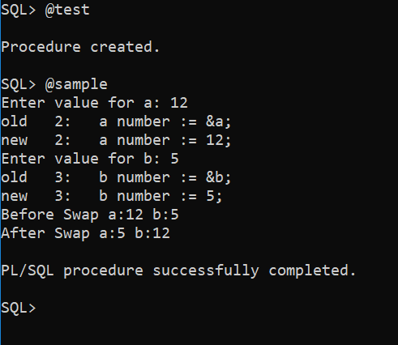

To find whether the given number is prime or not

Code

Function

create or replace procedure ans (a number)

is

  flag number := 1;

begin

  for i in 2..a/2

  loop

  if mod(a,i)=0 then

  flag:=0;

  exit;

  end if;

  end loop;

  if flag=1 then

  dbms_output.put_line(chr(10)||chr(9)||'Prime');

  else

  dbms_output.put_line(chr(10)||chr(9)||'Not a Prime');

  end if;

end;

/

Main Code

declare

  a number := &a;

begin

  ans(a);

end;

/

Output

