Name : Ashutosh Ardu

Regno : 20BRS1262

DBMS LAB 8

Write the pl/sql code for the following questions :

1. Greatest among three numbers.

Code

declare

a number;

b number;

c number;

begin

a:=&a;

b:=&b;

c:=&c;

if a>b AND a>c

then

dbms_output.put_line(chr(10)||'   A is greatest');

elsif b>a AND b>c

then

dbms_output.put_line(chr(10)||'  B is greatest');

elsif c>a and c>a

then

dbms_output.put_line(chr(9)||chr(10)||'   C is greatest');

else

dbms_output.put_line(chr(10)||'None');

end if;

end;

/

Output

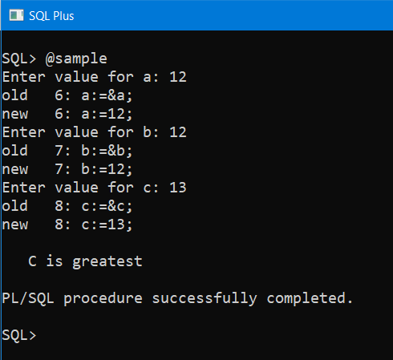

1. Factorial

Code

declare

n number;

fac number:=1;

begin

n:=&n;

for i in 1..n

loop

fac:=fac*i;

end loop;

dbms_output.put_line(chr(10)||'  factorial='||fac);

end;

/

Output

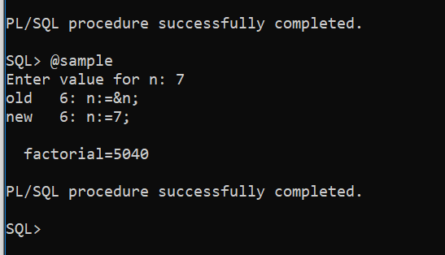

1. Fibonacci series

Code

declare

first number:=0;

second number:=1;

third number;

n number:=&n;

i number;

begin

dbms_output.put_line('Fibonacci series is:');

dbms_output.put_line(chr(9)||first);

dbms_output.put_line(chr(9)||second);

for i in 2..n

loop

third:=first+second;

first:=second;

second:=third;

dbms_output.put_line(chr(9)||(third));

end loop;

end;

/

Output

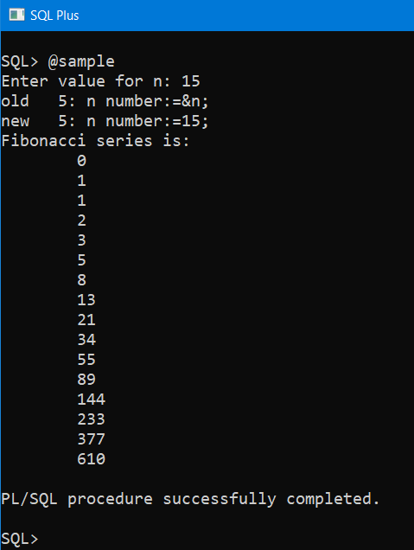

1. Armstrong number verification

Code

declare

    n number:=&n;

    s number:=0;

    r number;

    len number;

    m number;

begin

    m:=n;

    len:=length(to_char(n));

    while n>0

    loop

        r:=mod(n,10);

        s:=s+power(r,3);

        n:=trunc(n/10);

    end loop;

    if m=s

    then

        dbms_output.put_line(chr(9)||’armstrong number’);

    else

        dbms_output.put_line(chr(9)||’not armstrong number’);

    end if;

end;

/

Output

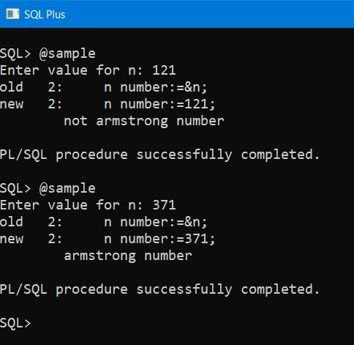

1. Calculator

Code

declare

  a number :=&a;

  b number :=&b;

  f boolean :=TRUE;

  operator varchar2(1) :='&operator';

  output number(10,4);

begin

  dbms_output.put_line(operator);

  case operator

    -- when chr(43) then

    when '+' then

      output:= a+b;

    when '-' then

      output:=a-b;

    when '/' then

      output:=(a/b);

    when '*' then

      output:=a*b;

    else

      f:=FALSE;

      dbms_output.put_line(chr(9)||'Wrong Operator');

  end case;

  if f=TRUE then

    dbms_output.put_line(chr(9)||'Your Answer '||chr(32)||output);

  end if;

  end;

/

Output

