Name : Ashutosh Ardu

Regno : 20BRS1262

DBMS LAB 9

1. Ram and Raj were playing number fun game . In this game, Ram gave three numbers (a,b,c) to Raj . Ram should find out the numbers which are divisible by third number (c) between the range of first given two numbers(a,b) and find how many numbers are there . Write a PL/SQL program for implementing the above concept using functions

Code

declare

  a number:=&a;

  b number:=&b;

  c number:=&c;

  ans number;

function chk_1 (a in number,b in number, c in number)

return number is

  ret number:=0;

begin

  if (c=0) then

    ret:=-1;

  else

    for i in a..b

    loop

      if mod(i,c)=0 then

        dbms_output.put_line(i);

        ret:=ret+1;

      end if;

    end loop;

  end if;

  return ret;

end;

begin

  ans:=chk_1(a,b,c);

  if (ans=-1) then

    dbms_output.put_line('Invalid Input');

  else

    dbms_output.put_line(‘Total: ‘||ans);

  end if;

end;

/

Output

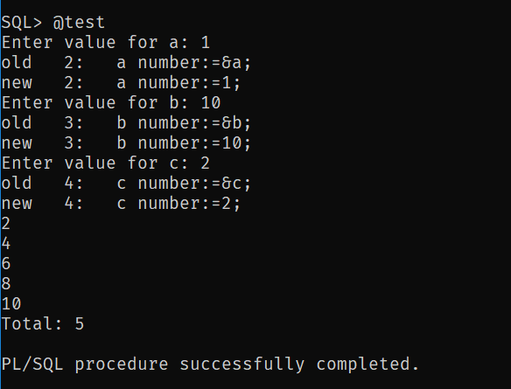

1. For the already created table of student schema,

Student(regno, name, cgpa)

Course(ccode, cname, credits)

Student_course( regno, ccode)

1. Write a PL/SQL function to update the cgpa of the student with regno 101

Code

declare

  reg number:=&reg;

  gpa number:=&gpa;

  f number;

function pro_update (x1 in out number,x2 in out number)

return number as

  ret number:=0;

begin

  update student set cgpa=x2 where regno=x1;

  return ret;

end;

begin

  f:=pro_update(reg,gpa);

  if (f=0) then

  dbms_output.put_line('Updated');

  end if;

end;

/

Output

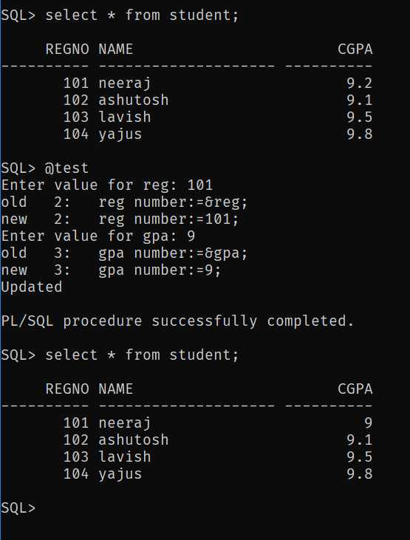

1. Write a function to find the maximum cgpa of all the students.

Code

declare

  m number;

function find_max

return number is

  a number;

begin

  select max(cgpa) into a from student;

  return a;

end;

begin

  m:=find_max();

  dbms_output.put_line('Max CGPS is: '||m);

end;

/

Output

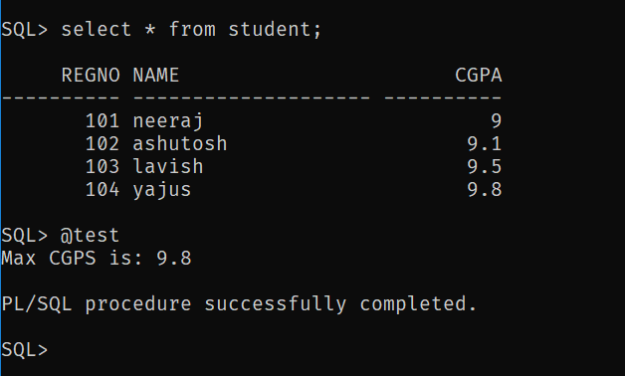

1. Insert a column named marks in student_course relation and update the column values.

Code

declare

  f number;

function add_marks

return number is

   ret number:=0;

begin

  update student_course set marks=89 where regno=101;

  update student_course set marks=95 where regno=102;

  update student_course set marks=92 where regno=103;

  update student_course set marks=97 where regno=104;

  return ret;

end;

begin

  f:=add_marks();

  if (f=0) then

    dbms_output.put_line('Updated');

  end if;

end;

/

Output

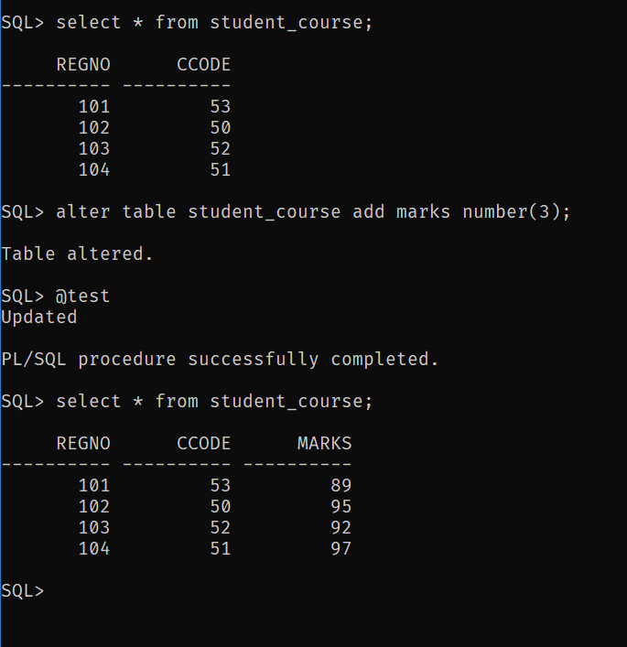

1. Get the marks of the the regno 102 and display his grade

Code

declare

  reg number:=&reg;

  m number;

  grade number;

function get_marks (reg in number)

return number is

  a number;

begin

  select marks into a from student_course where regno=reg;

  return a;

end;

function get_cgpa (reg in number)

return number is

  b number;

begin

  select cgpa into b from student where regno=reg;

  return b;

end;

begin

  m:=get_marks(reg);

  grade:=get_cgpa(reg);

    dbms_output.put_line('marks:'||m||' grades:'||grade);

end;

/

Output

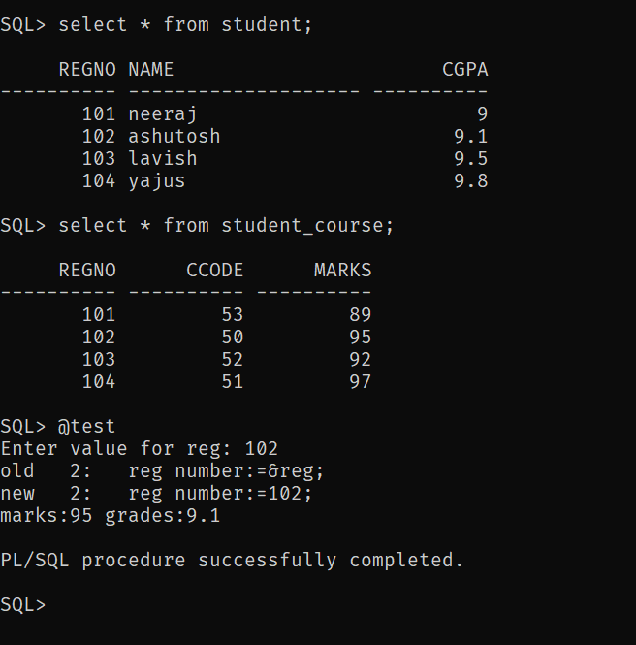

3. Write a function to perform the following concepts

i) To reverse the given number

Code

declare

  a number:=&a;

  f number;

function reverse (n in out number)

return number

is

rev number:=0;

r number;

begin

while n>0

loop

r:=mod(n,10);

rev:=(rev*10)+r;

n:=trunc(n/10);

end loop;

return rev;

end;

begin

  f:=reverse(a);

  dbms_output.put_line('Reverse : '||f);

end;

/

Output

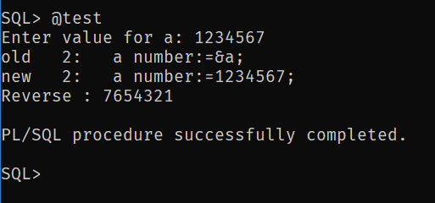

ii. To find whether the given number is odd or even

Code

declare

  a number :=&a;

  f number;

function chk_2 (n in number)

return number is

  ret number:=0;

begin

  if (mod(n,2)=0) then

    ret:=0;

  else

    ret:=1;

  end if;

  return ret;

end;

begin

  f:=chk_2(a);

  if (f=0) then

    dbms_output.put_line('Even');

  else

    dbms_output.put_line('Odd');

  end if;

end;

/

Output

