***MECE Breakdown***

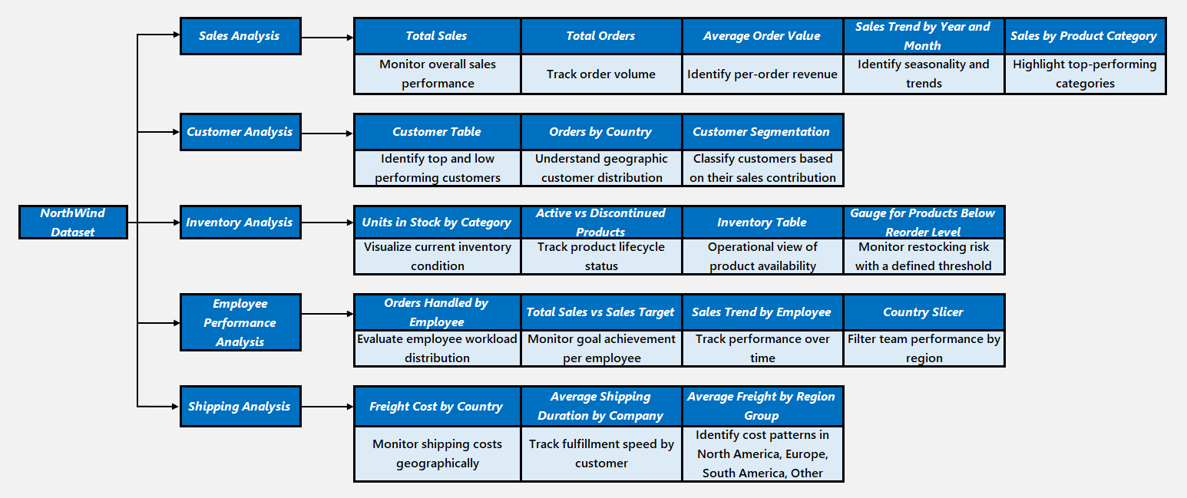

***MECE Framework Breakdown***

**I. Sales Analysis Dashboard (Revenue & Performance Monitoring)**

| **KPI/Analysis** | **Purpose** |
| --- | --- |
| **Total Sales** | Monitor overall sales performance |
| **Total Orders** | Track order volume |
| **Average Order Value** | Understand per-order revenue |
| **Sales Trend by Year & Month** | Identify seasonality and trends |
| **Sales by Product Category** | Highlight top-performing categories |

**II. Customer Segmentation Dashboard (Customer Profiling & Value Analysis)**

| **Analysis** | **Purpose** |
| --- | --- |
| **Customer Table (Details)** | Identify top and low-performing customers |
| **Orders by Country** | Understand geographic customer distribution |
| **Customer Segmentation (High/Medium/Low/No Orders)** | Classify customers based on their sales contribution |

**III. Inventory Analysis Dashboard (Stock & Supply Monitoring)**

| **Analysis** | **Purpose** |
| --- | --- |
| **Units in Stock by Category** | Visualize current inventory health |
| **Active vs Discontinued Products** | Track product lifecycle status |
| **Inventory Table (Stock, Order, Reorder Info)** | Operational view of product availability |
| **Gauge for Products Below Reorder Level** | Monitor restocking risk with a defined threshold |

**IV. Employee Performance Dashboard (Sales & Operational Efficiency)**

| **Analysis** | **Purpose** |
| --- | --- |
| **Orders Handled by Employee** | Evaluate employee workload distribution |
| **Total Sales vs Sales Target** | Monitor goal achievement per employee/team |
| **Sales Trend by Employee** | Track performance over time |
| **Country Slicer (US, UK, etc.)** | Filter team performance by region |

**V. Shipping & Order Fulfillment Dashboard (Logistics & Delivery Efficiency)**

| **Analysis** | **Purpose** |
| --- | --- |
| **Freight Cost by Country** | Monitor shipping costs geographically |
| **Average Shipping Duration by Company** | Track fulfillment speed by customer |
| **Average Freight by Region Group** | Identify cost patterns in North America, Europe, South America, Other |

**Summary of MECE Categories**

| **Business Area** | **Dashboards Covered** |
| --- | --- |
| **Sales Performance** | Sales Dashboard |
| **Customer Profiling & Segmentation** | Customer Dashboard |
| **Inventory & Supply Chain** | Inventory Dashboard |
| **Employee Productivity** | Employee Dashboard |
| **Shipping & Fulfillment** | Shipping Dashboard |