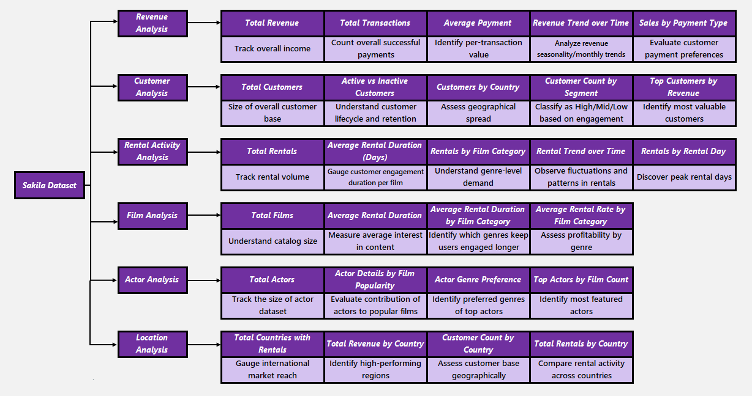***MECE Breakdown***

***MECE Framework breakdown***

**I. Revenue & Payment Analysis Dashboard**

| **Analysis** | **Purpose** |
| --- | --- |
| **Total Revenue** | **Track overall income** |
| **Total Transactions** | **Count overall successful payments** |
| **Average Payment** | **Understand per-transaction value** |
| **Revenue Trend over Time** | **Analyze revenue seasonality/monthly trends** |
| **Sales by Payment Type** | **Evaluate customer payment preferences** |

**II. Customer Analysis & Segmentation Dashboard**

| **Analysis** | **Purpose** |
| --- | --- |
| **Total Customers** | **Size of overall customer base** |
| **Active vs Inactive Customers** | **Understand customer lifecycle and retention** |
| **Customers by Country** | **Assess geographical spread** |
| **Customer Count by Segment** | **Classify as High/Mid/Low based on engagement** |
| **Top Customers by Revenue** | **Identify most valuable customers** |

**III. Rental Activity Analysis Dashboard**

| **Analysis** | **Purpose** |
| --- | --- |
| **Total Rentals** | **Track rental volume** |
| **Average Rental Duration (Days)** | **Gauge customer engagement duration per film** |
| **Rentals by Film Category** | **Understand genre-level demand** |
| **Rental Trend over Time** | **Observe fluctuations and patterns in rentals** |
| **Rentals by Rental Day** | **Discover peak rental days** |

**IV. Film & Inventory Dashboard**

| **Analysis** | **Purpose** |
| --- | --- |
| **Total Films** | **Understand catalog size** |
| **Average Rental Duration** | **Measure average interest in content** |
| **Average Rental Duration by Film Category** | **Identify which genres keep users engaged longer** |
| **Average Rental Rate by Film Category** | **Assess profitability by genre** |

**V. Actor & Content Insights Dashboard**

| **Analysis** | **Purpose** |
| --- | --- |
| **Total Actors** | **Track the size of actor dataset** |
| **Actor Details by Film Popularity** | **Evaluate contribution of actors to popular films** |
| **Actor Genre Preference** | **Identify preferred genres of top actors** |
| **Top Actors by Film Count** | **Identify most featured actors** |

**VI. Store & Location Performance Dashboard**

| **Analysis** | **Purpose** |
| --- | --- |
| **Total Countries with Rentals** | **Gauge international market reach** |
| **Total Revenue by Country** | **Identify high-performing regions** |
| **Customer Count by Country** | **Assess customer base geography** |
| **Total Rentals by Country** | **Compare rental activity across countries** |

**Summary of MECE Categories**

| **Business Area** | **Dashboards Covered** |
| --- | --- |
| **Sales Performance** | Revenue & Payment Analysis Dashboard |
| **Customer Profiling & Segmentation** | Customer Analysis & Segmentation Dashboard |
| **Rental Behaviour & Engagement** | Rental Activity Analysis Dashboard |
| **Inventory & Content Insights** | Film & Inventory Dashboard |
| **Talent & Content Contribution** | Actor & Content Insights Dashboard |
| **Market & Regional Operations** | Store & Location Performance Dashboard |