EDA Insights Report
Pokémon Machine Learning Assessment — Part 2: Feature Engineering & EDA

1. Overview
This report summarizes the exploratory data analysis (EDA) performed on the cleaned 200-Pokémon dataset, the two engineered features (total_power and is_high_power), and the four required visualizations along with their interpretation.

1.1 Engineered Features
- total_power = hp + attack + defense + special_attack + special_defense + speed
- is_high_power = 1 if total_power > median(total_power) [405.0], else 0
Resulting class balance: 105 Pokémon classified Low Power (0), 95 classified High Power (1) — a near-even split, as expected from a median-based threshold.

2. Visualizations

2.1 Attack Distribution (Histogram + KDE)
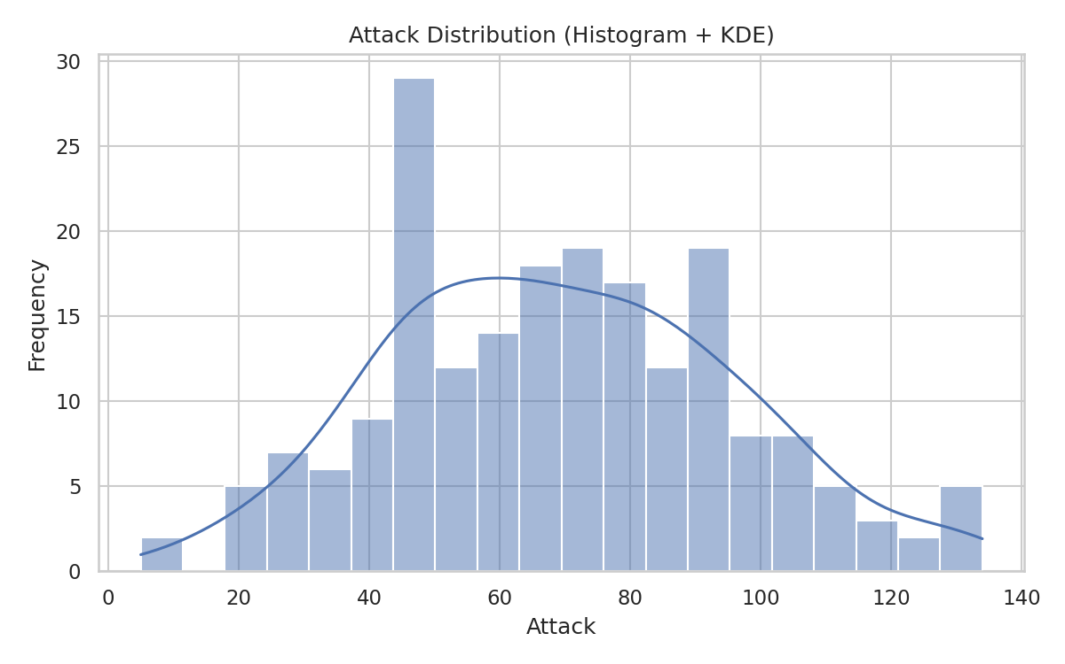
Figure 1. Distribution of the Attack stat across all 200 Pokémon, with a kernel density estimate overlay.
Attack is right-skewed, ranging from 5 to 134 (mean ≈ 69.4, median ≈ 65). Most Pokémon cluster between 45 and 90 Attack, with a long tail of high-Attack Pokémon rather than a small isolated cluster.

2.2 Correlation Heatmap
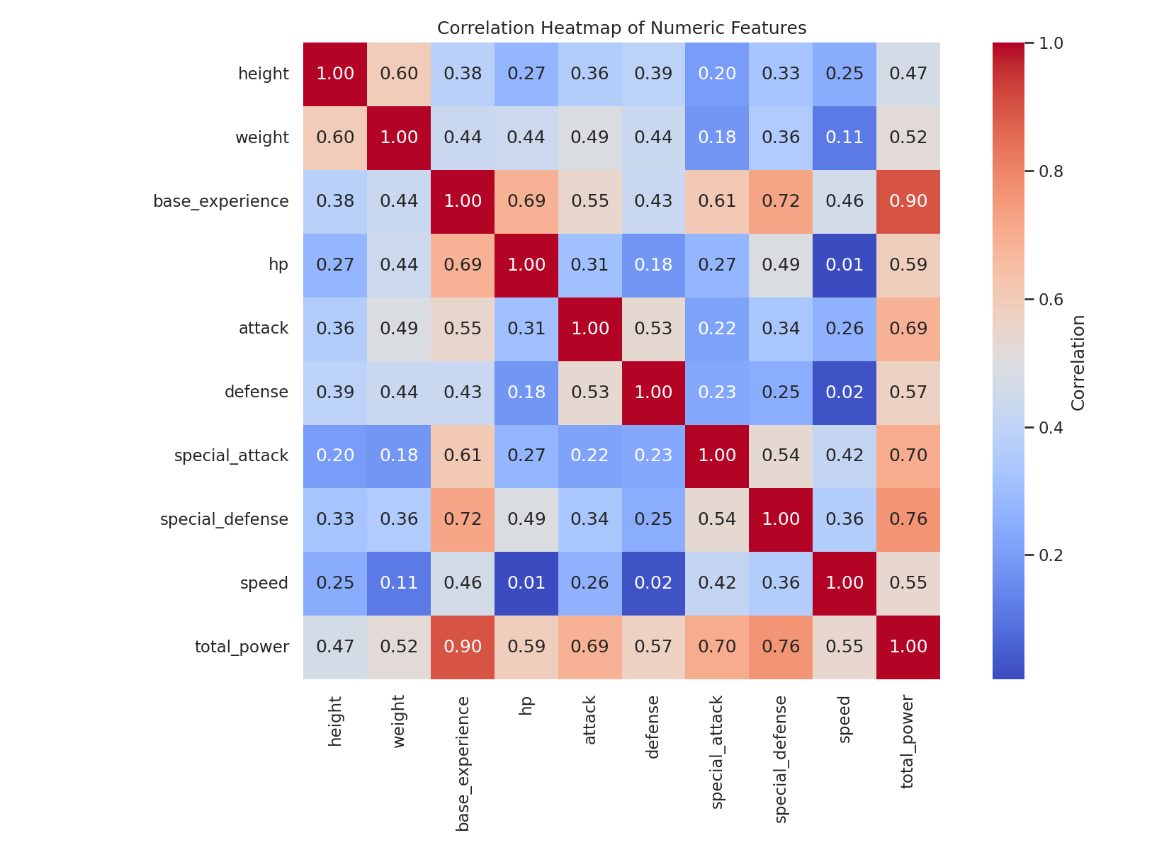
Figure 2. Pearson correlation matrix across all numeric features and total_power.
base_experience is the strongest single predictor of total_power (r ≈ 0.90), followed by special_defense (r ≈ 0.76) and special_attack (r ≈ 0.70). Speed is weakly correlated with hp (r ≈ 0.01) and defense (r ≈ 0.02), indicating these stats vary largely independently.

2.3 Pokémon Type Frequency Chart
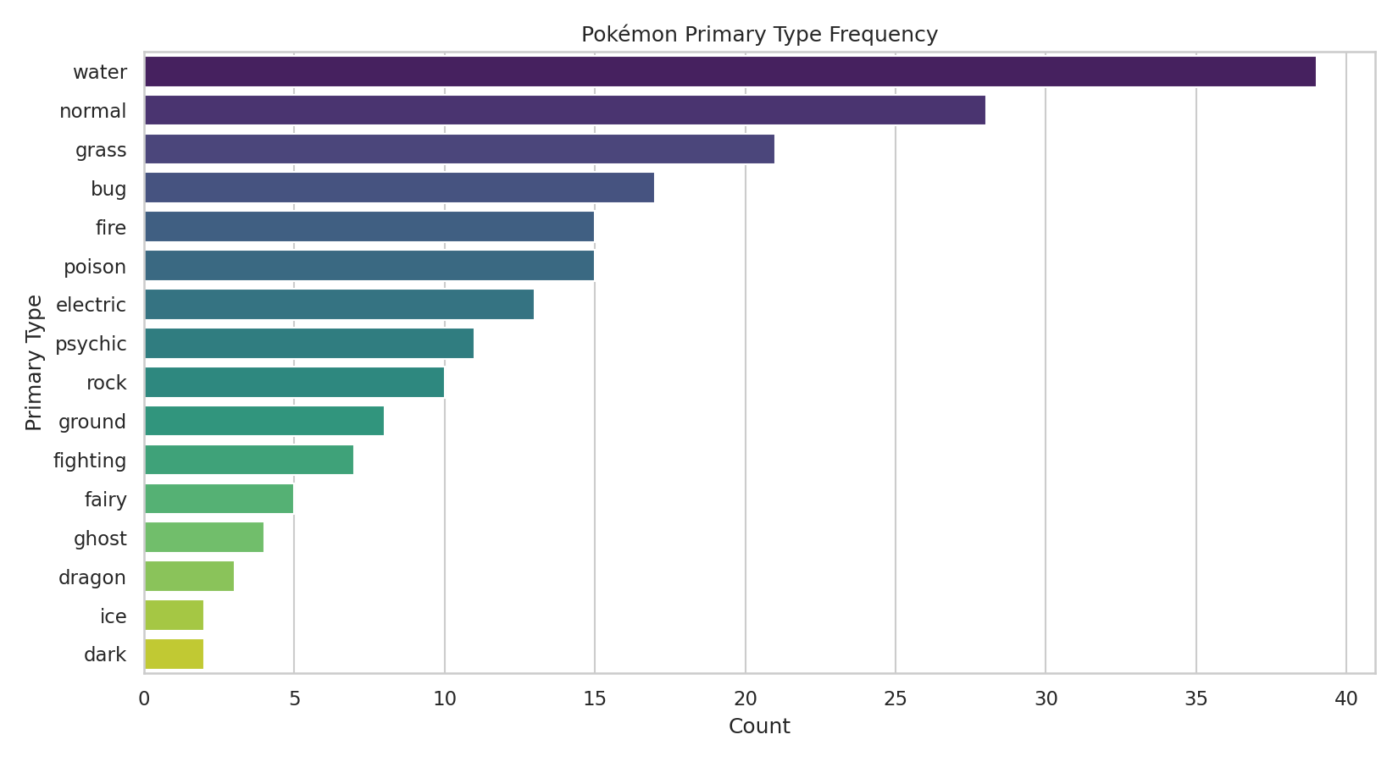
Figure 3. Count of Pokémon by primary type across the 200-record sample.
Water and Normal are the most common primary types in this Pokédex range, while types such as Ice, Fairy, and Dragon are comparatively rare — consistent with their distribution across the full Pokémon universe.

2.4 Speed vs Attack Scatter Plot
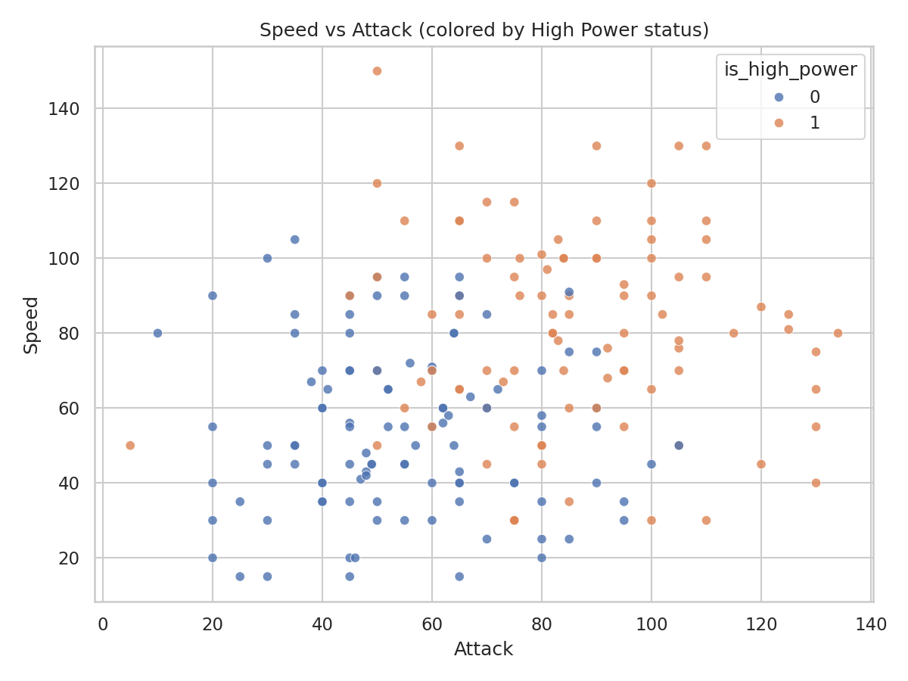
Figure 4. Speed vs Attack, colored by is_high_power classification.
High-power Pokémon (orange) skew toward the upper-right of the plot, with above-median values in both Attack and Speed, but the relationship is not strictly linear — several high-power Pokémon achieve their status via high HP/Defense/Special stats rather than raw Attack and Speed alone.

3. Required Insights

3.1 Strong Correlations
- base_experience ↔ total_power: r ≈ 0.90 (strongest)
- special_defense ↔ total_power: r ≈ 0.76
- special_attack ↔ total_power: r ≈ 0.70
- attack ↔ total_power: r ≈ 0.69

3.2 Weak Correlations
- hp ↔ speed: r ≈ 0.01 (weakest pair in the dataset)
- defense ↔ speed: r ≈ 0.02
- weight ↔ speed: r ≈ 0.11

3.3 Outliers
Using the IQR method (1.5×IQR fence) on the Attack column, no Pokémon falls outside [−8.4, 144.4] — i.e., zero statistical outliers were detected. The distribution is right-skewed with a smooth tail rather than isolated extreme points. The highest-Attack Pokémon (Dragonite: 134, Machamp/Kingler/Flareon: 130) sit naturally atop a continuous range.

3.4 Powerful Pokémon Categories
- Mewtwo (680), Dragonite (600), and Mew (600) top the total_power ranking.
- Legendary birds Articuno, Zapdos, and Moltres each score 580.
- Pseudo-legendary and fully-evolved starters (Arcanine 555, Gyarados 540, Snorlax 540) round out the top tier.
- 95 of 200 Pokémon (47.5%) are classified is_high_power = 1.

3.5 Type-Based Performance Trends
Primary Type | Avg. total_power
Ice | 517.5 (highest)
Dark | 465.0
Psychic | 461.5
Fire | 447.7
Bug | 337.1
Fairy | 334.8 (lowest)

Ice, Dark, and Psychic types average the highest total_power, largely driven by a small number of legendary representatives (Articuno, Mewtwo, Mew). Bug and Fairy types average the lowest total_power, consistent with their typical early-game / support role across the Pokémon series.

