Experiment -1:

Objective 1: add using immidiate addressing mode

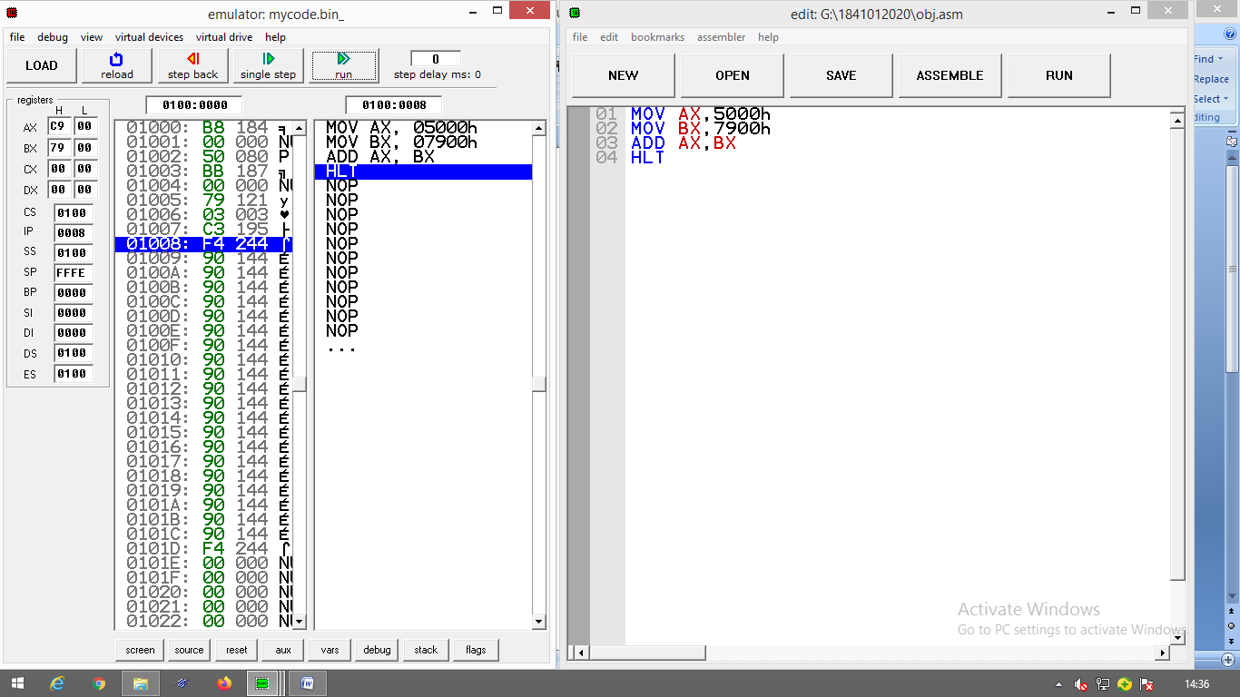

Objective 2:add using direct addressing mode

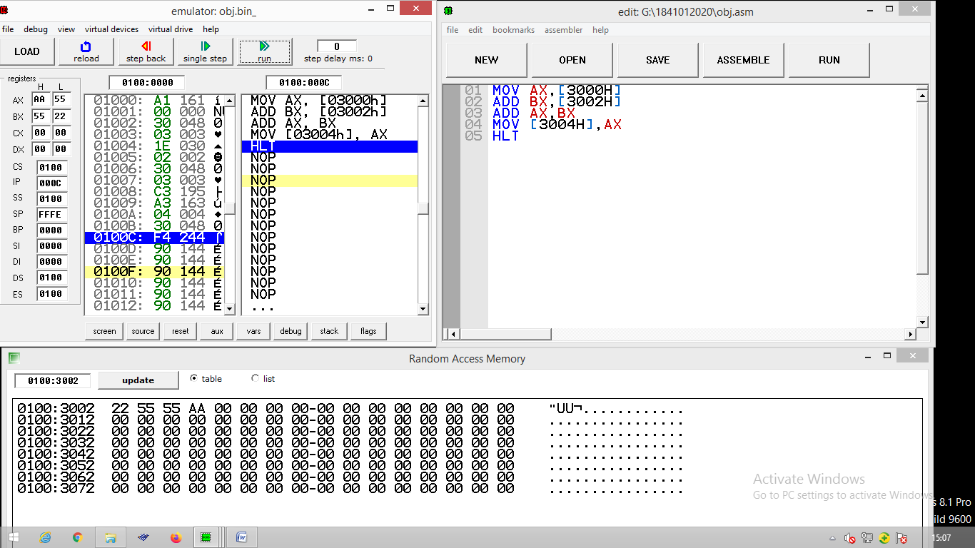

Objective 3:add using indirect addressing mode

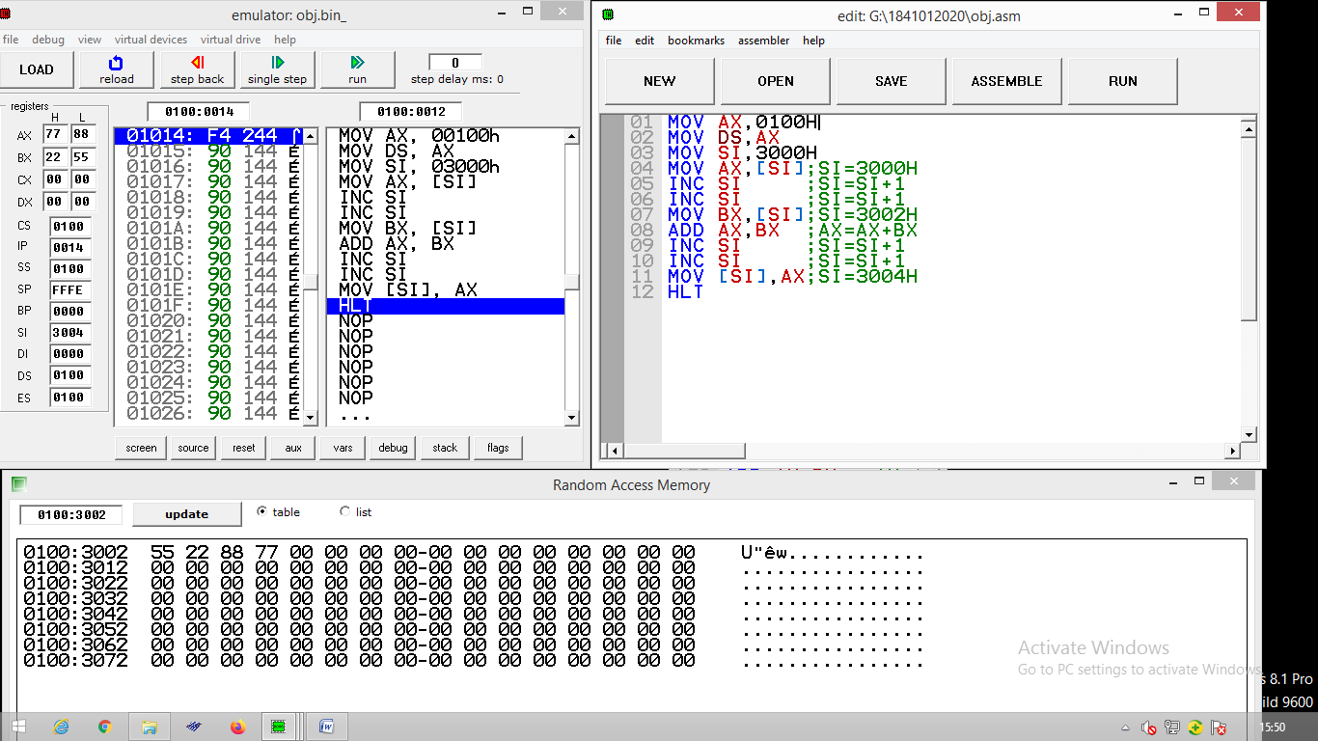

Objective 4:add using index addressing mode

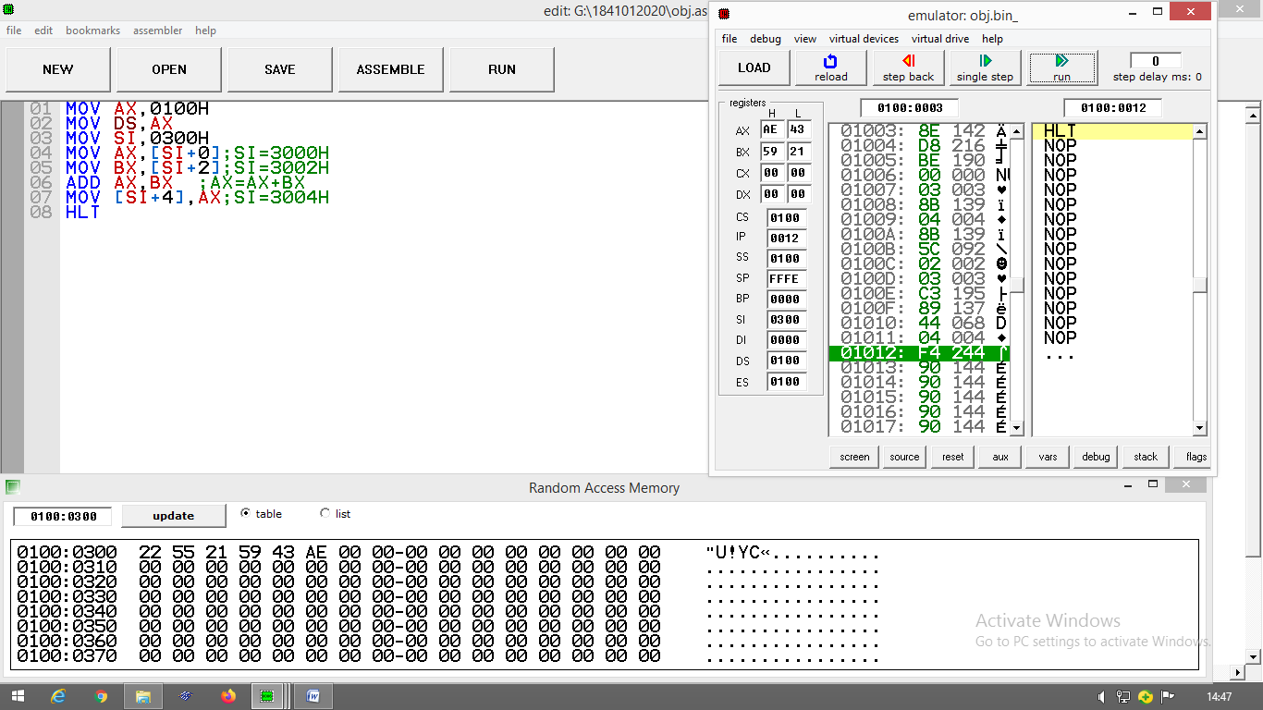

Objective 5:add using base index addressing mode

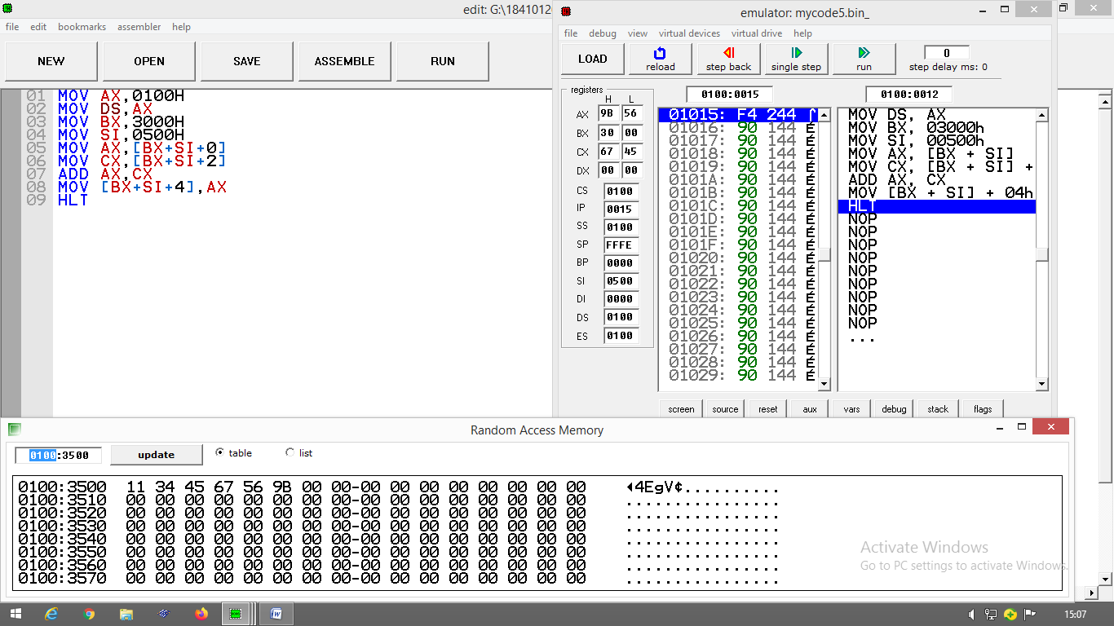

EXPERIMENT 2:

Perform all arithimatic operations

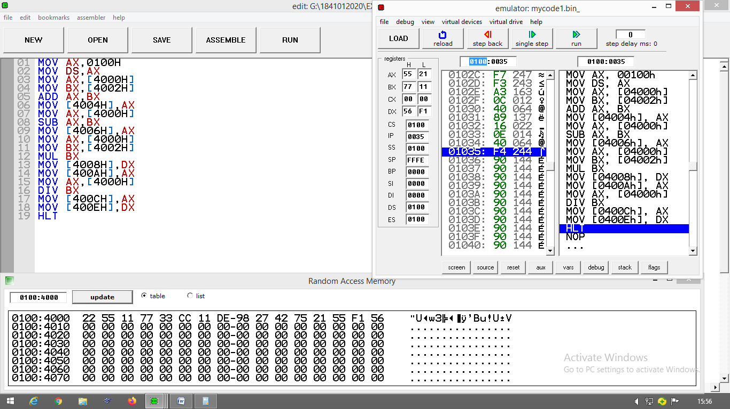

EXPERIMENT 3:

