Production Planning Detailed Scheduling

Summary

- Application Flow diagram:
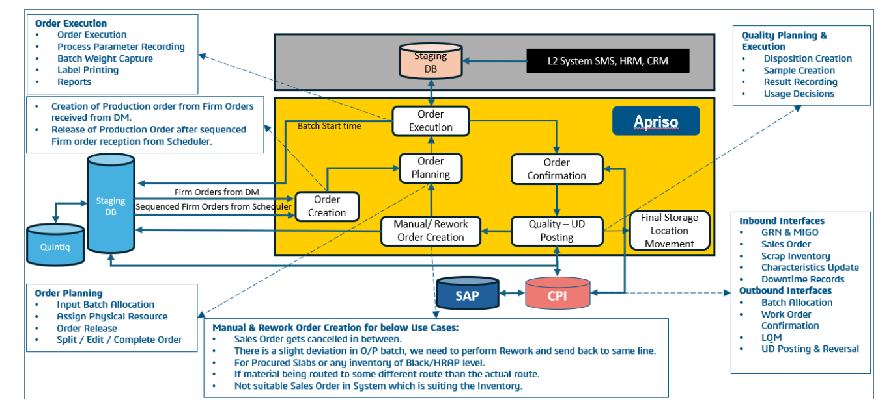

- Create → Production order is generated from
- demand/scheduler inputs.
- Plan → Batch, resources, and production sequence are assigned.
- Execute → Manufacturing process starts and shop-floor data is captured.
- Confirm → Production completion and quantities are confirmed in the system.
- Quality → Samples, results, and usage decisions are recorded.
- Store → Finished goods are moved to the final storage location.
- Update Systems → SAP, CPI, L2, and other interfaces are updated with final transaction data.

- Create → Plan → Execute → Confirm → Quality → Store → Update Systems

Apriso SAP Integration:

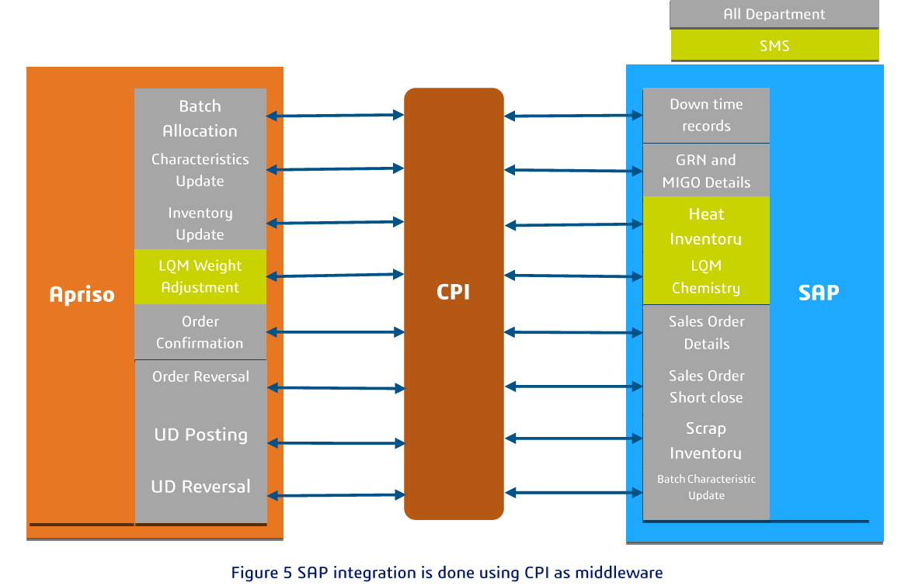

- Apriso and SAP are connected through CPI middleware.
- CPI works like a bridge that sends data between both systems.
- SAP → Apriso (Inbound): SAP sends order-related data like batch allocation, inventory, sales orders, and quality updates.
- Apriso → SAP (Outbound): Apriso sends shop-floor updates like order confirmation, order reversal, UD posting, and reversals.
- This ensures real-time data sync between ERP and manufacturing operations.
- It helps both systems stay updated with production, inventory, and quality information.

Flow in One Line
- SAP sends order data → CPI transfers → Apriso executes → Apriso sends updates back → SAP gets final status
- This is the simple communication flow between ERP and shop floor systems.

Apriso L2 Integration:

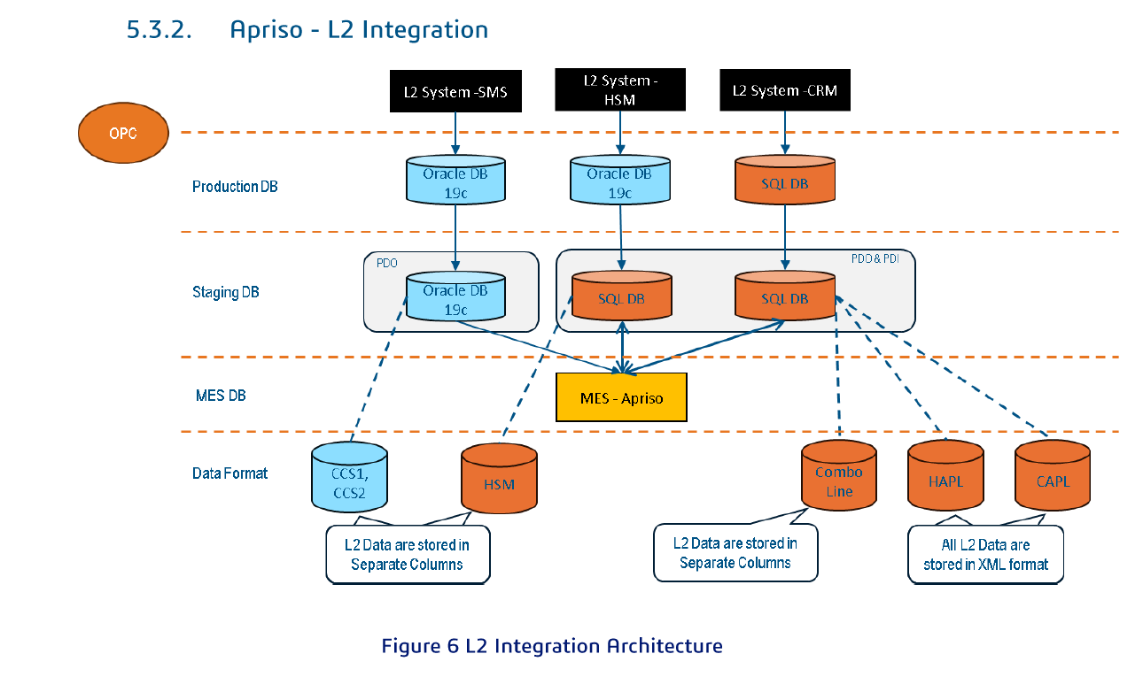

- L2 systems (SMS, HSM, CRM) generate production line data.
- This data is first stored in the Production DB.
- Then it moves to the Staging DB for processing and formatting.
- After validation, the data is sent to MES Apriso.
- Apriso uses this data for manufacturing execution and shop-floor monitoring.
- Different lines/modules like CCS, HSM, Combo Line, HAPL, and CAPL send line-specific data.
- Some data is stored in separate columns, while some is stored in XML format.
- This integration ensures real-time production data flow from L2 systems to MES.
- Flow in One Line

- L2 Systems → Production DB → Staging DB → MES Apriso → Shop Floor Monitoring & Execution

- This is basically the real-time machine/line data integration flow into Apriso.

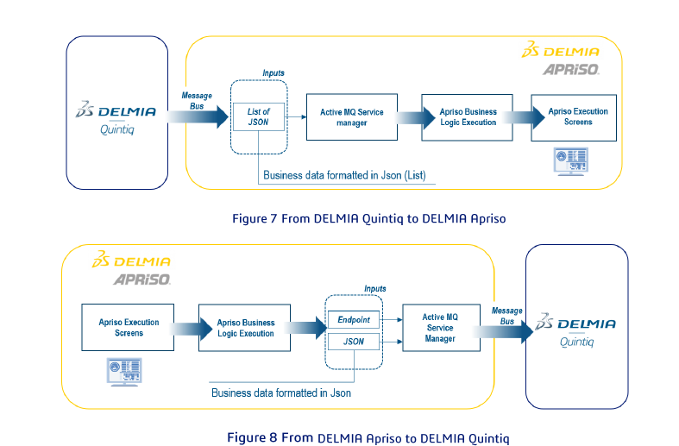
- Apriso-Quintiq:

- Quintiq sends planning/scheduling data to Apriso through a message bus.
- The data is shared in JSON list format.
- Apriso receives it through Active MQ Service Manager.
- Then business logic is executed, and the data is shown on Apriso execution screens.
- In reverse flow, Apriso sends execution updates back to Quintiq.
- Data is again converted into JSON format.
- It passes through endpoint → Active MQ → message bus.
- Quintiq receives the updated execution status for planning synchronization.
- Flow in One Line

- Quintiq Planning → Message Bus → Apriso Execution → JSON Update → Quintiq Sync

- Apriso-Quintiq Integration Flow:

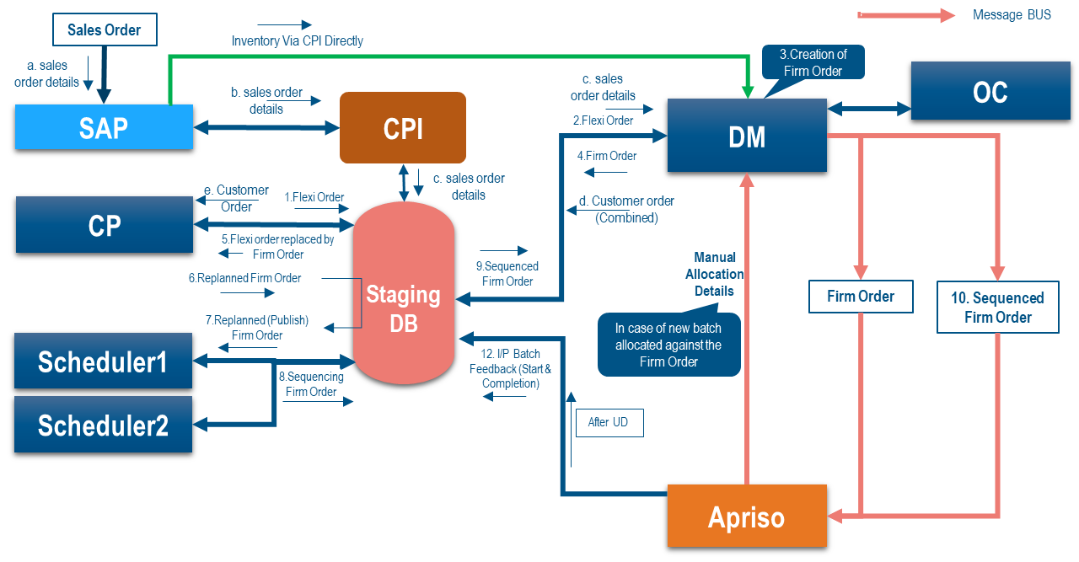

- Sales order starts in SAP with customer order details.
- Order details are sent through CPI and Staging DB.
- DM creates the flexi order and converts it into a firm order.
- Firm orders are shared with OC and schedulers.
- Schedulers generate the sequenced firm order.
- The sequenced order is stored in Staging DB.
- Apriso receives the sequenced firm order for production execution.
- During execution, batch feedback, start, and completion status are sent back.
- If needed, manual batch allocation can be done for new firm orders.
- After UD (usage decision), the final production status is updated.
- Flow in One Line

- SAP Sales Order → CPI/Staging → DM Firm Order → Scheduler Sequence → Apriso Execution → Feedback Update

