A Project Synopsis on

# OBJECT DETECTION AND ALARMING SYSTEM

**Submitted By-**

**Mr. Ashutosh Shailendra Jarag (24)**

**Mr. Aditya Kishor Khadake (30)**

**Mr. Aniket Santosh Mali (34)**

**Mr. Vinay Vijay Naik (43)**

Under the guidance of

**Mr. Rajesh D. Gade**

(Assistant Professor)



**Department of Computer Science and Engineering**

**(Data Science)**

**Dr. D. Y. Patil Pratisthan’s College of Engineering,**

**Kolhapur**

## Introduction

In this project, we focus on developing a collision detection system using the HC-SR04 ultrasonic sensor and a Raspberry Pi microcomputer. The HC-SR04 sensor is renowned for its accuracy in measuring distances using ultrasonic waves, while the Raspberry Pi serves as a versatile platform capable of executing complex tasks and interfacing with various hardware components.

Our collision detection system aims to provide real-time monitoring of distances between objects and the sensor, with the objective of triggering an alarm when an object approaches dangerously close. The system's functionality relies on the interplay between the HC-SR04 sensor, which continuously measures distances, and the Raspberry Pi, which processes this data and activates the alarm when necessary.

Key components of the project include the HC-SR04 ultrasonic sensor, Raspberry Pi microcomputer, and the Python programming language, which is utilized for coding the system's functionalities. By leveraging these components, we aim to demonstrate the feasibility of using affordable hardware and open-source software for developing practical IoT solutions, particularly in the realm of collision detection.

## Literature Survey/ Review of Existing System

Prior research in collision detection systems has explored various methodologies and technologies to address safety concerns in dynamic environments. Studies have highlighted the effectiveness of ultrasonic sensors, such as the HC-SR04, in providing accurate distance measurements for collision avoidance applications. Additionally, research has demonstrated the versatility of Raspberry Pi as a platform for interfacing with sensors and executing collision detection algorithms.

Several projects have implemented similar collision detection systems using ultrasonic sensors and microcomputers. These projects typically employ Python as the programming language for interfacing with the hardware components and processing sensor data. Furthermore, literature in the field emphasizes the importance of real-time monitoring and timely response mechanisms to mitigate collision risks effectively. Overall, the existing body of research provides valuable insights into the design considerations, implementation challenges, and performance evaluations of collision detection systems using ultrasonic sensors and microcomputers. By building upon this prior work, our project aims to contribute to the advancement of collision avoidance technology, particularly in the context of IoT applications.

## Problem Specification/ Proposed System

Our project aims to develop a collision detection system utilizing the HC-SR04 ultrasonic sensor interfaced with a Raspberry Pi microcomputer. The system will be designed to monitor distances between objects and the sensor in real-time, with the objective of triggering an alarm when an object approaches dangerously close.

Hardware Setup: We will assemble the HC-SR04 ultrasonic sensor with the Raspberry Pi microcomputer according to the manufacturer's specifications. This setup will enable communication between the sensor and the Raspberry Pi, facilitating distance measurement capabilities.

Software Development: Using the Python programming language, we will develop the software components necessary for the collision detection system. This includes coding algorithms to interface with the HC-SR04 sensor, process distance measurements, and activate an alarm when predefined thresholds are exceeded.

Testing and Validation: We will conduct rigorous testing to ensure the functionality and reliability of the collision detection system. This will involve testing the system's response to various object distances and velocities to validate its effectiveness in detecting potential collisions.

By following these steps, we aim to develop a robust and efficient collision detection system that demonstrates the capabilities of IoT technologies in addressing safety challenges in real-world scenarios.

## Hardware/ Software Requirements

* Hardware requirements:

1. The Raspbian Operating System
2. Python Interpreter
3. An Integrated Development Environment (IDE) like Thonny.

* Software requirements:

1. Raspberry Pi 4B
2. HC-SR04 Ultrasonic Sensor
3. Electronic Buzzer
4. Breadboard
5. Jumper Cables.

**System Design and Implementation DFD**

## LEVEL 0

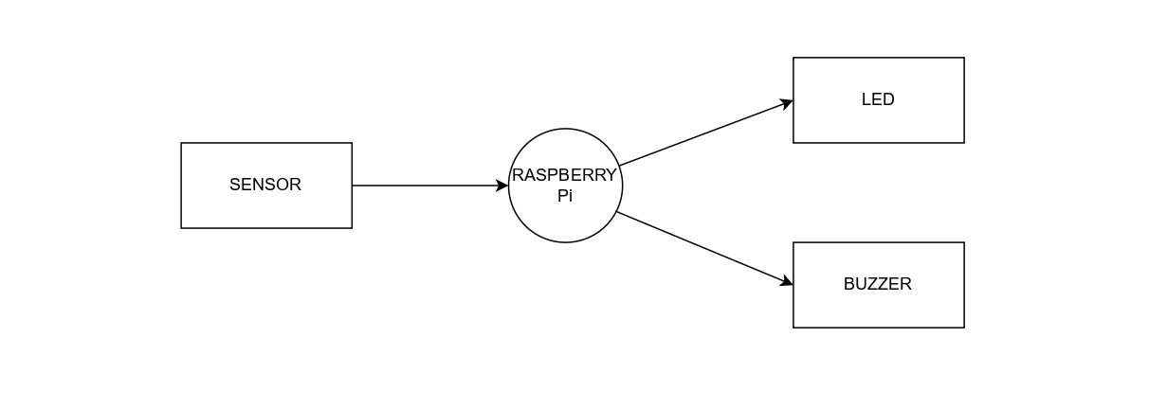

## LEVEL 1

## References / Bibliography

**Books**

* + Raspberry Pi Cookbook: Software and Hardware Problems and Solutions" by Simon Monk
  + Building Internet of Things with the Raspberry Pi" by Marco Schwartz and Olivier Englert
  + Python Crash Course: A Hands-On, Project-Based Introduction to Programming" by Eric Matthes

**Links**

* <https://projects.raspberrypi.org/en/projects/physical-computing/1>
* <https://www.w3schools.com/python/>
* <https://projects.raspberrypi.org/en/projects/raspberry-pi-getting-started/2>