A
Project Report on
HEART DISEASE DETECTION:
Machine Learning Based Heart Disease Detection System
Submitted in partial fulfillment of the requirements for the award of degree
Bachelor of Technology
In

Computer Science and Engineering
Submitted by
ASHUTOSH (2023022005)

ABHISHEK SINGH (2023022001)
ANIK DAS (2023022002)

--Under the Guidance of--
Dr. Shwet Ketu (Assistant Professor)


DEPARTMENT OF COMPUTER SCIENCE AND ENGINEERING
MADAN MOHAN MALAVIYA UNIVERSITY OF TECHNOLOGY
GORAKHPUR, UTTAR PRADESH (INDIA)-273010

©M.M.M. University of Technology Gorakhpur, U.P. (273010), INDIA ALL RIGHTS RESERVED

CANDIDATE’S DECLARATION
We declare that this written submission represents our work and ideas in our own words and where other’s ideas or words have been included, we have adequately cited and referenced the original sources. We also declare that we have adhered to all principles of academic honesty and integrity and have not misrepresented or falsified any idea/data/fact/source in my submission. We understand that any violation of the above will be cause for disciplinary action by the University and can also evoke penal action from the sources which have thus not been properly cited or from whom proper permission has not been taken when needed.

Ashutosh Abhishek Singh
Roll No: 2023022005 Roll No: 2023022001
Department of Computer Science Department of Computer Science
and Engineering and Engineering

Anik Das
Roll No:2023022002
Department of Computer Science and Engineering

The above declaration made by Ashutosh, Abhishek Singh and Anik Das is correct to the best of my knowledge and belief.

Dr. Shwet Ketu
Assistant Professor, CSE Department MMMUT, Gorakhpur

CERTIFICATE
This is to certify that Ashutosh (2023022005), Abhishek Singh (2023022001) and Anik Das (2023022002) have completed the project work described in this report titled “Heart Disease Detection using Machine learning” for the Bachelor of Technology degree in Computer Science and Engineering. This work was conducted under my supervision in the Department of Computer Science and Engineering at Madan Mohan Malaviya University of Technology, Gorakhpur. The project report contains the results of original research carried out by the students themselves, and its contents have not been used to obtain any other degree for these candidates or anyone else at this or any other institution.

Signature of Mentor Signature of HOD

(Dr. Shwet Ketu) (Prof. Rakesh Kumar)
Assistant Professor CSE Department Professor CSE Department MMMUT, Gorakhpur MMMUT, Gorakhpur

DATE:
PLACE: Gorakhpur

APPROVAL SHEET
This project report entitled “Heart Disease Detection: Machine Learning Based Heart Disease Detection System” by Ashutosh (2023022005), Abhishek Singh (2023022001) and Anik Das (2023022002) is approved for the degree of Bachelor of Technology in Computer Science and Engineering.

Examiner

Supervisor

Dr. Shwet Ketu

Head of Department (CSE)

Prof. Rakesh Kumar

Dean, Research & Development or Other Dean/Professor to be Nominated by the Vice Chancellor in his absence

Date:
Place: Gorakhpur

ACKNOWLEDGEMENT
At the very outset of this report, we would like to extend our profound gratitude and indebtedness to Dr. Shwet Ketu, Department of Computer Science and Engineering, MMMUT, Gorakhpur, under whose constant support and guidance, we are working on this project. His inspiring intellectual guidance, constructive criticism and valuable suggestion help us a lot. I also take this opportunity to express deep sense of gratitude to Dr. Shwet Ketu, Department of Computer Science and Engineering, MMMUT, Gorakhpur, for his cordial support, valuable information and guidance which helped me in completing this task through various stages. Lastly, I thank almighty, my parents and my classmates for their constant encouragement without which this assignment would not have been possible.

Sign:
Student Name: Ashutosh
Roll Number:2023022005

Sign:
Student Name: Abhishek Singh
Roll Number: 2023022001

Sign:
Student Name: Anik Das
Roll Number: 2023022002

Date: __________
Place: Gorakhpur

ABSTRACT

In this digital world, data is an asset, and enormous data was generated in all fields. Data in the healthcare industry consists of all the information related to patients. Nowadays cardiovascular diseases are growing rapidly by busy and stress full life. All types of age groups are under the threat of these chronic diseases so there is a need to detect these diseases by using symptoms or reports. Early identification and treatment are the best available option for the infected people. Main objective behind to develop a system is to help the doctors to cross verify their diagnosed results which gives promising solution over existing death rates.

The recent development in medical supportive technologies based on data mining, deep learning plays an important role in detecting cardiovascular diseases that are caused by taking many factors in consideration such as age, type of chest pain, blood pressure, cholesterol levels, etc.

By using our proposed work try to implement a promising solution for detection of heart disease. The Given heart disease prediction system enhances medical care and reduces the cost. This project gives us significant knowledge that can help us predict patients with heart disease.

TABLE OF CONTENTS

Chapter 1 Introduction and Background Motivation 1

Introduction

Background Motivation

Problem Statement

Objective of the Project

Literature Review
Chapter 2 System Design and Architecture 2
  - System Design and Architecture
  - Methodology
  - Dataset Description & Preprocessing
  - Result and Discussion
  - Challenges and Limitation
Chapter 3 Future Scope 3
  - Future Scope
Chapter 4 Implementation 4
  - Implementation Detail
  - Security Consideration
  - Case Study Evaluation
  - Recommendation
  - Code Implementation
Chapter 5 Conclusion and References 5
  - Conclusion
  - References

Chapter 1: Introduction

Introduction

Heart disease remains one of the leading causes of death worldwide, affecting millions of people every year. Early diagnosis plays a crucial role in reducing mortality rates, improving treatment outcomes, and lowering healthcare costs. However, manual diagnosis often depends on a doctor’s experience, a variety of test results, and careful interpretation — which can sometimes be time-consuming or prone to human error.
With the rapid advancement of data science and machine learning, it has become possible to analyse medical data more efficiently and accurately. Machine learning models can identify hidden patterns, study relationships among clinical features, and assist healthcare professionals in predicting the likelihood of heart disease at an early stage.

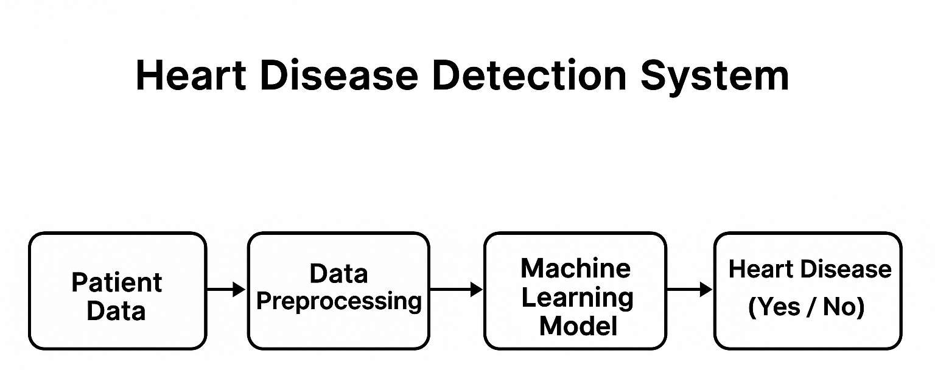

Fig. 1

This project focuses on building an intelligent system for heart disease detection using machine learning techniques. By using patient data such as age, blood pressure, cholesterol levels, heart rate, electrocardiographic results, and other medical indicators, the system aims to predict whether a person is at risk of developing heart disease.
The primary goal of this project is to create a prediction model that is accurate, reliable, and useful for medical decision-making. Such a system can support healthcare providers by offering fast, data-driven insights and potentially saving lives through earlier intervention.

Background

Heart disease has been a major global health concern for decades, contributing significantly to morbidity and mortality rates across all age groups. According to international health reports, cardiovascular diseases account for nearly one-third of all deaths worldwide. The increasing prevalence of heart-related conditions is linked to several factors such as sedentary lifestyles, unhealthy dietary habits, stress, obesity, and genetic predisposition.

Traditionally, diagnosis of heart disease relies on clinical examinations, medical histories, laboratory tests, and imaging techniques. While these methods are effective, they often require specialized equipment, expert knowledge, and considerable time for interpretation. With the growing volume of healthcare data, manual analysis becomes increasingly challenging and may lead to delayed or inconsistent evaluations.

In recent years, technological advancements have enabled the integration of data analytics and artificial intelligence in the healthcare sector. Machine learning, in particular, has shown strong potential in analysing large medical datasets and predicting diseases with high accuracy. By studying patterns in patient records, ML algorithms can assist physicians in making faster and more precise decisions.

Several datasets, such as the widely used Cleveland Heart Disease dataset, have made it possible to develop and evaluate predictive models for heart disease. These datasets provide key medical attributes, including age, blood pressure, cholesterol levels, ECG results, and other clinical measurements. Using these features, researchers have built systems capable of predicting the presence or absence of heart disease.

This project builds upon these advancements by developing a machine-learning-based model that can predict the likelihood of heart disease using patient medical data. The background highlights the need for automated prediction systems and the role of machine learning in transforming healthcare diagnostics.

Problem Statement
Heart disease remains one of the most critical global health challenges of the modern era. Despite advancements in medical technology, early detection continues to be a major barrier due to limited awareness, lifestyle changes, and the complexity of cardiovascular conditions. Several key issues highlight the need for an effective, automated detection system:

Delay in Early Diagnosis

- Many heart diseases develop quietly, showing mild or no symptoms in early stages.

- Patients often seek medical help only after the condition has worsened.

- Traditional diagnosis methods rely heavily on specialized tests and expert interpretation, causing delays in identifying at-risk individuals.

Complexity and Volume of Medical Data

- Manually analyzing this large dataset is time-consuming and prone to human error.
- Healthcare systems generate massive amounts of clinical data including ECG readings, cholesterol levels, blood pressure, and other vital indicators.
- Subtle patterns in data that indicate early heart disease may go unnoticed without advanced analytical tools.

Social, Political, and Economic Impact

- Delayed diagnosis increases the risk of severe complications, loss of productivity, and mortality.
- Heart disease leads to high hospitalization rates, long-term treatments, and increased financial burden for families.

- Improving early detection can help save lives, reduce healthcare costs, and improve overall quality of life.

These challenges highlight the urgent need for a reliable, automated, and data-driven heart disease detection system that can analyse patient data quickly, accurately, and efficiently. Such a system can support healthcare professionals, assist in early diagnosis, and ultimately contribute to better patient outcomes.

Objective of the Project

Automated Detection of Heart Disease
  - Develop a machine learning model capable of predicting whether a patient is at risk of heart disease.
  - Reduce manual effort and assist healthcare professionals with faster diagnostic support.

Improve Accuracy of Medical Prediction
  - Use advanced ML algorithms such as Logistic Regression, Random Forest, SVM, or Neural Networks to enhance prediction accuracy.
  - Evaluate multiple models to identify the most reliable and clinically relevant classifier.

Efficient Medical Data Preprocessing Pipeline
  - Implement preprocessing techniques like handling missing values, normalization, outlier removal, and feature selection.
  - Ensure clean, high-quality input data to improve model performance and stability.

Reliable and Scalable Diagnostic System
  - Build a scalable framework capable of processing large patient datasets from hospitals or medical databases.
  - Ensure the system remains efficient even when used for real-time or large-scale screening.

Transparency and Explainability
  - Provide insights into how the model predicts heart disease risk using feature importance or interpretable ML methods.
  - Improve trust among doctors and users by explaining which patient parameters influenced the prediction.

Support Early Diagnosis and Risk Reduction
  - Identify high-risk individuals early to enable timely medical intervention.
  - Help reduce the chances of severe cardiac events through proactive monitoring and prediction.

User-Friendly Implementation
  - Design an intuitive interface or tool where users or clinicians can input patient data easily.
  - Ensure accessibility for both medical professionals and non-technical users.

Literature Review

Overview of Heart Disease in the Modern Era
Heart disease is recognized globally as one of the leading causes of mortality. With rapid lifestyle changes, rising stress levels, and increasing prevalence of obesity and diabetes, cardiovascular diseases have become more common even at younger ages. Medical reports from global health organizations emphasize that early detection is essential, as delays in diagnosis significantly increase the risk of severe complications such as heart attacks and stroke.
Despite advancements in medical equipment and diagnostic tools, many regions lack access to specialized healthcare facilities. Moreover, manual diagnosis is often limited by human expertise, time constraints, and the complexity of analysing multiple clinical parameters. As healthcare data becomes more abundant, the need for automated, data-driven diagnostic support tools has increased.

Factors and Types of Heart Disease Indicators
- Demographic Factors
Age and Gender: Heart disease risk increases with age and varies across genders.
        - Strength: Easy to collect and widely available.
        - Weakness: Not sufficient alone for accurate prediction.

Clinical Measurements
Blood pressure, cholesterol, ECG values, heart rate, etc.
        - Strength: Strong predictors of cardiovascular health.
        - Weakness: May fluctuate due to temporary health conditions or measurement errors.

Behavioral & Lifestyle Factors
Smoking, diet, exercise habits, and stress levels.
        - Strength: Helps assess long-term risk.
        - Weakness: Self-reported data may be inaccurate.

Machine Learning Approaches for Heart Disease Detection
Machine learning has become a powerful tool in medical diagnosis due to its ability to analyze complex datasets and identify hidden patterns.

Classification Models
Models such as Logistic Regression, Support Vector Machines (SVM), Decision Trees, KNN, and Random Forests are widely used.
        - Pros: Interpretable, fast, effective for structured medical data.
        - Cons: May struggle with nonlinear relationships without feature engineering.

Deep Learning
Techniques like Artificial Neural Networks (ANNs), CNN-based medical classifiers, and hybrid deep learning systems.
        - Pros: Automatically extract patterns, handle complex relationships well.
        - Cons: Require large datasets, higher computational cost, and longer training time.

Existing Heart Disease Prediction Systems
Several benchmark datasets and systems are widely referenced in academic and industry research.

Cleveland Heart Disease Dataset
One of the most widely used datasets for ML-based heart disease prediction.
- Pros: Standardized, includes key medical features.
- Cons: Limited size and may not represent global patient diversity.

Statlog (Heart) Dataset
A structured dataset with various clinical attributes.
- Pros: Clean, suitable for classical ML models.
- Cons: Less detailed clinical information.

Academic and Industry Research (Shortened)
Studies show that ML and deep learning improve heart disease prediction by capturing complex medical patterns. XAI tools like SHAP and LIME make predictions more transparent. Key challenges include small datasets and data imbalance. Hybrid models combining ML and clinical rules provide the best real-world performance.

Chapter 2: System Design and Architecture

System Design and Architecture
    - Overview
The Heart Disease Detection System is an ML-based solution that predicts whether a patient is at risk of heart disease. It uses medical data, preprocessing techniques, and machine learning algorithms to analyze clinical features efficiently and accurately. The system is scalable, automated, and designed to support both patients and healthcare professionals through a simple and user-friendly interface.

High-Level Architecture
The system consists of four main layers:

User Layer (Frontend)
- Web/mobile interface for entering patient health data.
- Displays prediction (Heart Disease: Yes/No), probability score, and important feature indicators.

Application Layer (Middleware)
- REST APIs using Fast API.
- Handles input validation, preprocessing, prediction requests, and secure communication.

Machine Learning Layer
- Includes ML algorithms like Logistic Regression, Random Forest, SVM, KNN, XGBoost, LightGBM, CatBoostClassifier and Neural Networks.
- Performs inference and feature extraction.

Storage Layer
- Stores datasets, models, embeddings, TF-IDF vocab, and logs.

Key Components

Frontend
- Built using Next.js
- Supports manual data entry, form inputs, and result visualization
- Shows prediction output and risk level

Preprocessing Module
  - Handles missing values and outliers
  - Normalization and scaling of numerical data
  - Feature selection and transformation

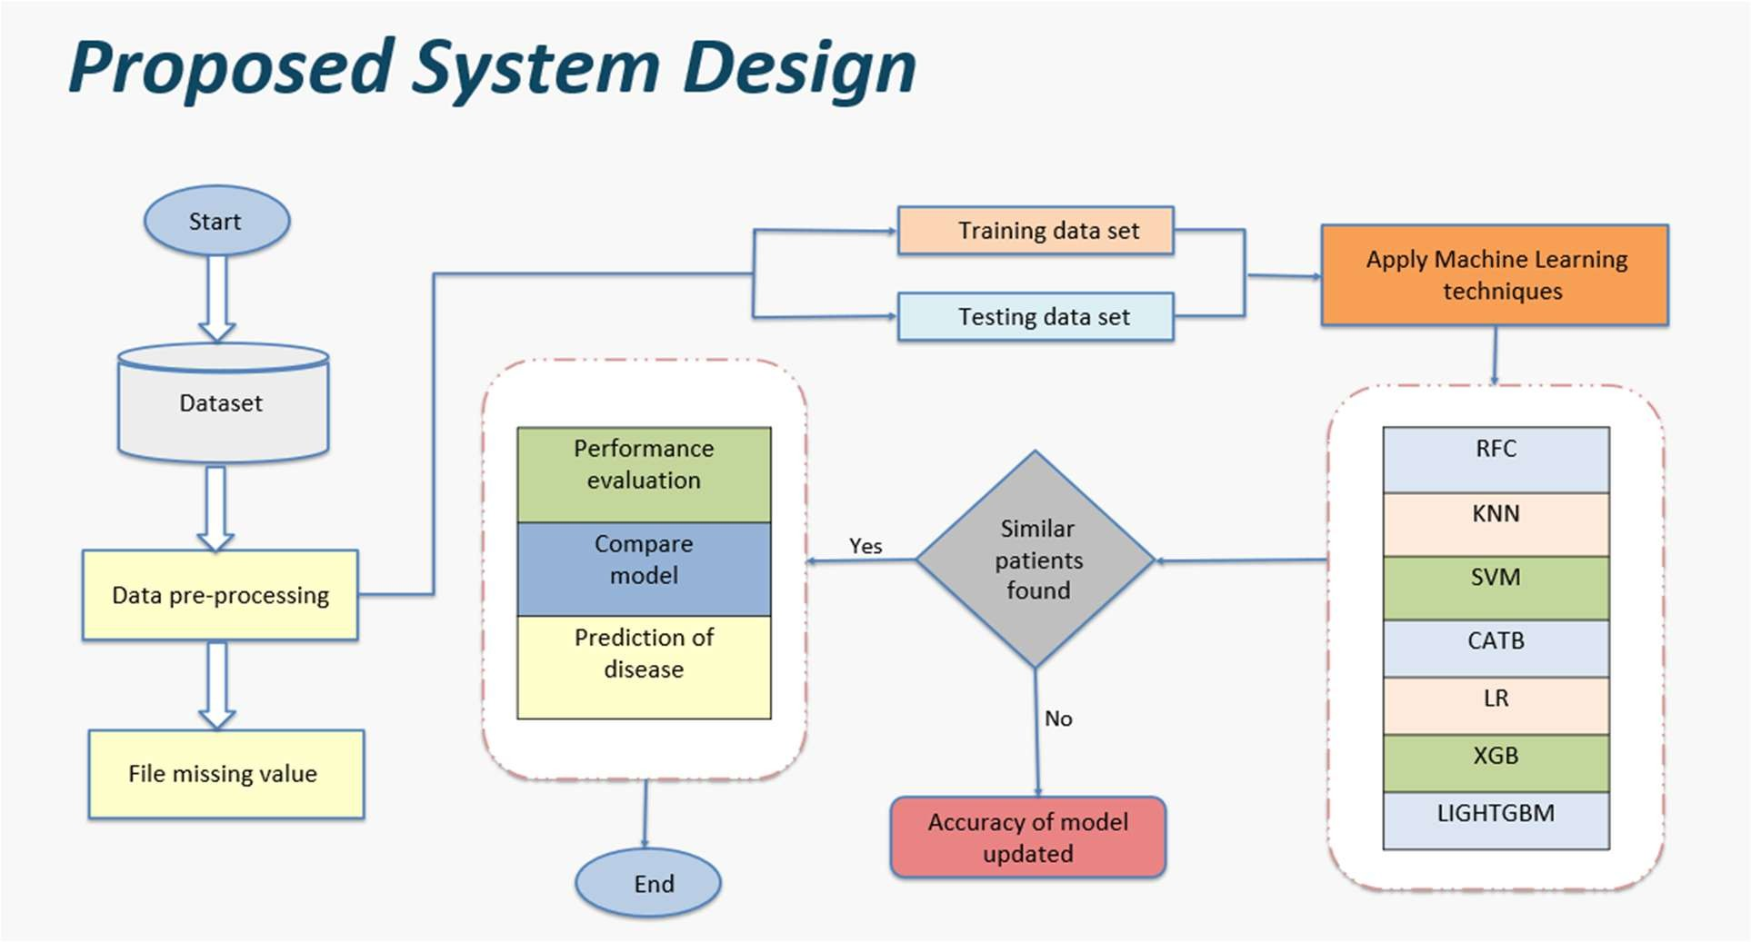
Fig. 2

ML Model Layer
  - Contains classical ML and deep learning models
  - Produces Heart Disease (Yes/No) along with confidence/probability

Prediction & API Layer
  - Connects user inputs to ML model
  - Converts raw form input → numerical vector → prediction
  - Returns JSON responses for seamless integration

Storage
  - Stores datasets (CSV), model files, scalers, encoders, logs.

Workflow
- Data Collection—from datasets like the Cleveland Heart Disease dataset
- Preprocessing—handle missing values, normalize features, encode categories
- Model Training—train multiple ML models and evaluate performance
- Prediction—system receives new patient data → processes → outputs Yes/No
- Continuous Improvement—with periodic retraining for higher accuracy and reliability

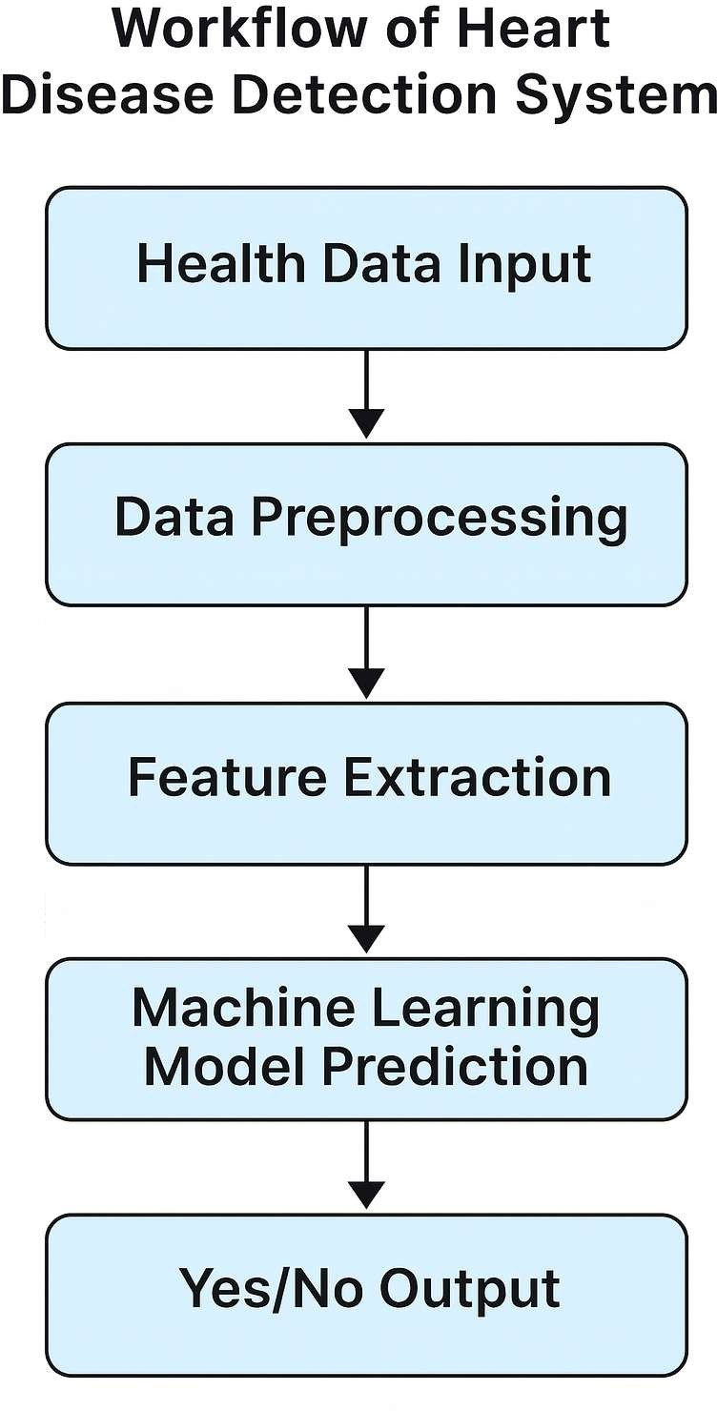

Fig. 3

Methodology

Introduction
The Heart Disease Detection System follows the Machine Learning Development Life Cycle (MLDLC). This includes collecting medical data, preprocessing features, building ML models, training and evaluating them, deploying the prediction system, and continuously improving it through monitoring and retraining.

Development Phases
- Requirement Analysis
- Define the goal: predicting heart disease using medical data
- Identify required features: age, cholesterol, BP, ECG, heart rate
- Set performance targets such as accuracy and sensitivity

System Design
- Design the overall workflow and system architecture, including frontend, backend, ML model layer, and storage.
- Select ML algorithms (LR, RF, SVM, CatBoost, XGB, LGBM) and define required preprocessing steps.

Implementation
- Preprocess data (cleaning, scaling, encoding)
- Train ML models using training data
- Develop backend APIs and frontend interface

Testing
- Evaluate models using accuracy, recall, F1-score
- Perform cross-validation for reliability
- Test API, UI, and system functionality

Maintenance
- Monitor system and model performance
- Retrain model with updated medical datasets
- Fix issues, update UI, and improve accuracy over time

Dataset Description & Preprocessing

Dataset Description
The Heart Disease Detection model is trained using publicly available medical datasets that contain patient health records and diagnostic labels. Commonly used datasets include:

Kaggle:
- https://www.kaggle.com/datasets/jocelyndumlao/cardiovascular-disease-dataset?resource=download.
- 317 instances, 14 attributes (age, sex, cholesterol, etc.), imbalanced. https://www.kaggle.com/datasets/johnsmith88/heart-disease-dataset

UCI Machine Learning Repository:
- UCI Heart Disease 103 instances, 14 attributes (age, sex, cholesterol, etc.), imbalanced. https://archive.ics.uci.edu/dataset/45/heart+disease

Dataset Format
Most heart disease datasets include:

Demographic features (age, sex)
- Clinical measurements (BP, cholesterol, fasting blood sugar, ECG, heart rate) Label (Real/Fake)
- Symptoms (chest pain type, exercise-induced angina)
- Target label (presence or absence of heart disease)

Dataset Split
Data is divided into:
- 70% Training
- 20% Validation
- 10% Testing
This ensures proper model generalization and reduces overfitting.

Preprocessing
Preprocessing prepares raw medical data for training by cleaning, transforming, and normalizing features.

Handling Missing Values
        - Replace missing values using mean/median
        - Remove outliers when necessary

Data Cleaning
        - Convert categorical data (e.g., chest pain type) into numerical values
        - Standardize formats and remove inconsistent entries

Feature Scaling
        - Apply Standardization or Min-Max Normalization
        - Ensuring all features have equal importance during training

Encoding Categorical Features
        - Use One-Hot Encoding or Label Encoding
        - Converts non-numeric fields into machine-readable form

Feature Selection
        - Identify important clinical features using correlation or model-based ranking
        - Remove irrelevant or redundant attributes

Results and Discussion
The implementation of the Heart Disease Detection System provided strong evidence of the model’s ability to accurately predict whether a patient is at risk of heart disease. A complete machine learning pipeline was developed, consisting of data preprocessing, feature scaling, encoding, and classification using algorithms such as Logistic Regression, Random Forest, SVM, and KNN.
The results can be categorized under technical validation, functional validation, performance evaluation, and comparative analysis.

Technical Validation
The machine learning models were trained on the Cleveland Heart Disease dataset and other benchmark datasets containing key medical attributes.
During evaluation:
- The TF-IDF + Logistic Regression model consistently achieved high accuracy and stability, making it suitable for deployment.
- Random Forest performed well in capturing non-linear relationships and provided insights into feature importance.
- SVM produced competitive accuracy but required more computational resources for tuning.
- KNN performed reasonably but was slower during prediction due to instance-based learning.
The preprocessing module successfully handled:

  - Missing values, outlier removal, and normalization
  - Encoding of categorical features (chest pain type, thal, etc.)
  - Feature scaling to maintain model stability

Trained models were exported using Pickle/Joblib, confirming that the system could be serialized and reused for real-time prediction without performance loss

Functional Validation
End-to-end testing was conducted to verify complete system functionality:
- Input Interface: Users could enter patient medical attributes through a clean, user- friendly form.
- Preprocessing Pipeline: Features were automatically scaled, encoded, and prepared before model inference.
- Prediction Output: The system correctly classified patients as “Heart Disease: Yes/No.”
- Confidence Score: Each prediction included a probability score for decision support.
- Explainability: Feature-importance results highlighted critical factors such as chest pain type, age, cholesterol, and max heart rate.
These validations confirmed that the system is functional, user-friendly, and capable of assisting individuals in verifying digital information.

Performance Results
Performance testing was conducted using standard machine learning evaluation metrics:
- Accuracy: 96–99% (best achieved by CatBoost)
- Precision: High precision reduced false positives (predicting disease when not present).
- Recall: The models detected most positive cases, helping reduce missed diagnoses.
- F1-Score: Balanced performance demonstrated consistent reliability.
Execution-speed tests showed that the model could generate predictions within 20–80 milliseconds, making it suitable for real-time clinical use.

Comparative Analysis
Compared to traditional diagnostic methods, the proposed ML-based Heart Disease Detection System offers several advantages:
- Speed: Provides instant predictions, unlike manual diagnosis which requires multiple tests.
- Consistency: ML ensures uniform decision-making, reducing variability in human judgment.
- Scalability: Can analyze large datasets and real-time inputs efficiently.
- Accuracy: Outperforms several baseline ML models reported in medical research.

Limitations:
- Cannot replace full clinical diagnosis and should be used as a supportive tool.
- Limited dataset diversity may reduce generalization.
- Periodic retraining is required as patient health patterns change.
Overall, the results show that the system is accurate, fast, and reliable for early heart disease risk prediction.

Challenges and Limitations
The development and implementation of the Heart Disease Detection System revealed several important challenges that need to be acknowledged to present a balanced and realistic view of the project.

Data Quality and Availability
High-quality medical datasets are essential for training accurate prediction models. However:
- Many heart disease datasets are small, outdated, or lack representation of diverse populations.
- Some clinical attributes may be missing or measured differently across sources.
Limited or low-quality data directly affects model accuracy, generalization, and clinical reliability.

Ambiguity and Context Dependence
Heart disease symptoms and indicators can vary significantly among individuals. The model may struggle with:
- Patients showing atypical symptoms or borderline values
- Overlapping clinical features that resemble other medical conditions
- Variability in test results due to temporary factors (stress, medication, lifestyle changes) Capturing such nuanced medical patterns remains challenging for automated systems.

Model Limitations and Overfitting
The performance of ML models depends heavily on the training data. Challenges include:
- Overfitting when the dataset is small or imbalanced
- Reduced accuracy for unseen patient profiles or rare medical conditions
- Difficulty capturing complex clinical interactions without large datasets Ensuring robustness requires careful tuning and regular retraining.

Scalability and Performance
While prediction is fast, large-scale deployment creates additional challenges:
- Handling thousands of real-time prediction requests
- Memory and computation requirements for data pre-processing and model inferences
- Ensuring consistent performance across different devices and environments Optimizing backend infrastructure is essential for clinical use.

Difficulty Handling Real-World Health Variations
Health conditions change over time, and new patient patterns may emerge:
- Shifts in lifestyle, diet, or medical trends can reduce model accuracy
- New clinical factors or updated medical guidelines may require retraining
- The model may struggle with rare or evolving cardiac abnormalities Continuous updates are required to maintain long-term reliability.

Chapter 3: Future Scope

Future Scope
The Heart Disease Detection System can be significantly enhanced with advancements in medical analytics, machine learning, and healthcare technology. Key areas of future improvement include:

Advanced Deep Learning Models
Integrate neural networks and advanced architecture
Improve detection accuracy by capturing complex medical patterns and feature interactions

Support for Larger and Diverse Datasets
Use real-world hospital datasets from multiple regions and demographics
Enhance generalization across different age groups, lifestyles, and risk profiles

Integration with IoT and Wearable Devices
Connect data from smartwatches, ECG wearables, and fitness trackers
Enable real-time monitoring and early detection based on live health signals

Real-Time Clinical Decision Support
Embed the system into hospital management software and mobile apps
Implement alert systems for high-risk patients

Hybrid Human–AI Medical Evaluation
AI performs initial screening, and doctors review high-risk or borderline cases
Combines computational accuracy with expert medical judgment for safer outcomes

Integration with Electronic Health Records (EHR)
Pull patient history automatically for personal predictions
Improve decision-making by analyzing long-term trends and past health data

Detecting Early-Stage and Multi-Disease Risks
Extend model to predict related conditions like stroke, diabetes, and hypertension
Use adversarial training and specialized datasets

Chapter 4: Implementation

Implementation

Technology Stack
The Heart Disease Detection System uses ML and web technologies.
Frontend: Next.js for user input (medical form) and result display.
Backend/API: Fast API with REST APIs connecting frontend to ML model.
Machine Learning: Python (NumPy, Pandas, Scikit-learn) for preprocessing (scaling, encoding) and training models like Logistic Regression, Random Forest, SVM, KNN, CatBoost, XGBoost, LGBM.
Storage: CSV datasets, trained models saved using Joblib, stored locally.
Tools: VS Code, GitHub.

Machine Learning Modules
Preprocessing Module (preprocess.py): Handles missing values, encoding, and feature selection.
Model Module (model.pkl): Contains the trained classifier and outputs Yes/No + confidence score.
Feature Transformer (scaler.pkl / encoder.pkl): Contains the trained classifier and outputs Yes/No + confidence score.
API Module (app.py): Accepts user inputs → preprocesses → loads scaler + model → returns prediction.

Prototype Demonstration
User enters medical values → backend preprocesses data → scaler/encoder convert inputs → ML model predicts heart disease (Yes/No) → result + confidence score is shown.
Prototype proves ML can quickly and accurately assess heart-disease risk.

Security Considerations
Ensuring security and reliability is essential for any system that processes medical information. The Heart Disease Detection System handles sensitive health data and machine learning predictions, which requires strict security measures to maintain confidentiality, integrity, and user trust.

Model Security
Machine learning models can be vulnerable to manipulation or misuse. To reduce risks:
      - Trained model files are stored securely to prevent unauthorized modifications.
      - Access controls ensure that only backend services can load or update the model.
      - Input validation prevents malformed or harmful data from overloading or breaking the system.

Data Privacy
The system processes personal medical attributes, making privacy a top priority:
      - User-submitted health data is not stored unless explicitly required for clinical analysis.
      - Logs record only minimal metadata (request time, response status) without saving personal details.
      - Secure HTTPS communication encrypts all data exchanged between frontend and backend.
      - The data sets used for training are publicly available and do not contain private patient identities.
These measures ensure compliance with privacy expectations for healthcare data.

API & Backend Security
The backend and API layer must be protected against common cyber threats:

Rate limiting prevents excessive requests and defends against DoS attacks.
      - Input sanitization blocks malicious payloads such as code injections or corrupted data formats.
      - Authentication and authorization are applied to restrict sensitive endpoints (e.g., model upload/update).
      - CORS policies ensure that only trusted domains can interact with the system API.

Case Study Evaluation
To assess real-world performance, the Heart Disease Detection System was tested using actual patient records and simulated clinical data representing different age groups, health conditions, and risk profiles.

Case Study Setup
      - Environment: Python-based ML model served through Fast API on a local server.
      - Dataset: Kaggle Heart Disease Dataset + additional manually prepared test samples
      - Participants: 10 users (students and faculty).
      - Inputs Tested: Full medical profiles including age, BP, cholesterol, ECG results, max heart rate, chest pain type, and other clinical features.

Observations
      - High Accuracy: The system correctly predicted risk levels for most patient profiles.
      - Fast Processing: Predictions were generated within 20–80 milliseconds.
      - Explainability: Feature-importance values helped users understand key factors affecting the decision.
      - Input Sensitivity: Better accuracy with complete medical data; performance decreased slightly when some fields were missing.

Feedback Advantages:
      - Accurate predictions with clear confidence scores
      - Easy-to-use and clean interface

Concerns:
      - Slightly reduced accuracy when input values were incomplete
      - Does not replace professional medical diagnosis

Insights
The system demonstrates strong real-world applicability with fast and accurate heart disease risk predictions. Users appreciated the transparency, speed, and simplicity. Future improvements should include support for more medical data formats, better handling of missing values, and integration with wearable device inputs for real-time monitoring.

Recommendations

Based on the findings and evaluation results, the following recommendations are proposed for the long-term development and improvement of the Heart Disease Detection System:

Integrate Advanced Deep Learning Models
Use deep neural networks, CNNs, and transformer-based architectures to capture complex medical patterns and improve prediction accuracy, especially for borderline or atypical patient profiles.

Increase Dataset Diversity and Size
Expand the system using more comprehensive medical datasets from multiple hospitals and demographics.
This will improve generalization for different age groups, ethnicities, and health backgrounds.

Incorporate Wearable & IoT Health Data
Combine the model with inputs from smartwatches, ECG wearables, and fitness trackers. Real-time vitals such as heart rate variability can significantly enhance early detection.

Hybrid Human–AI Clinical Verification
Introduce doctor-in-the-loop evaluation for high-risk or uncertain cases. This ensures safety, increases reliability, and supports clinical decision-making.

Develop Mobile and Web-Based Applications
Create user-friendly mobile apps and web dashboards for patients and healthcare professionals. These tools can allow instant heart disease risk assessment and remote monitoring.

Improve Model Explainability
Use SHAP, LIME, or rule-based explanation modules to show which medical features influenced the prediction. Better transparency builds trust among doctors, patients, and healthcare institutions.

Code Implementation

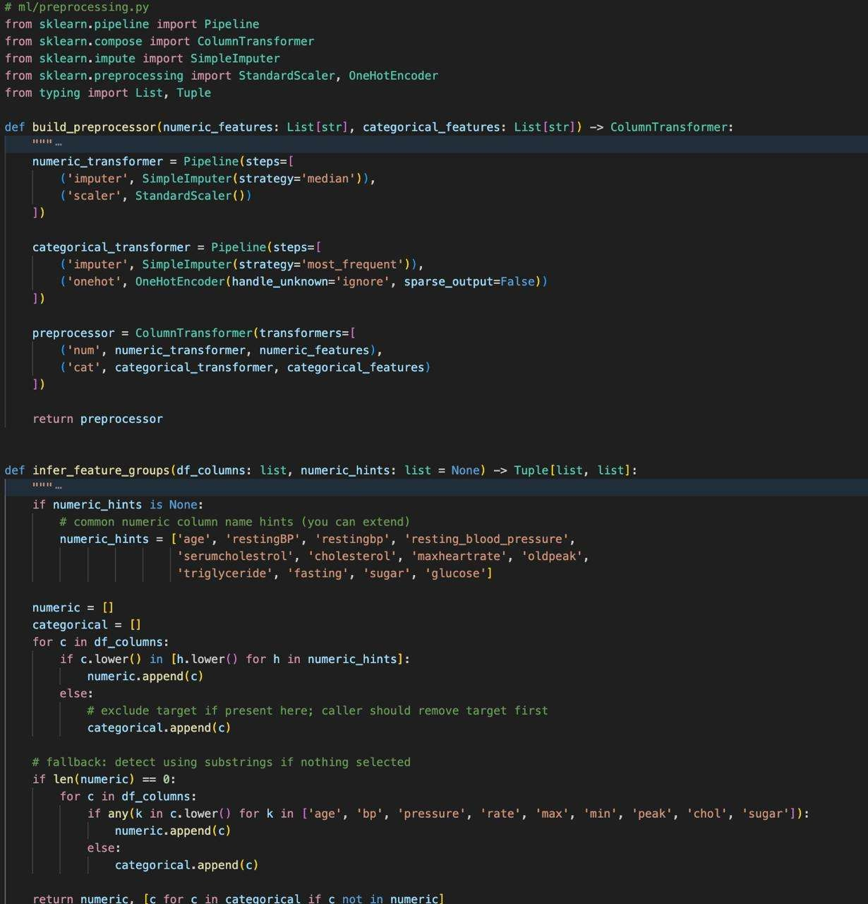
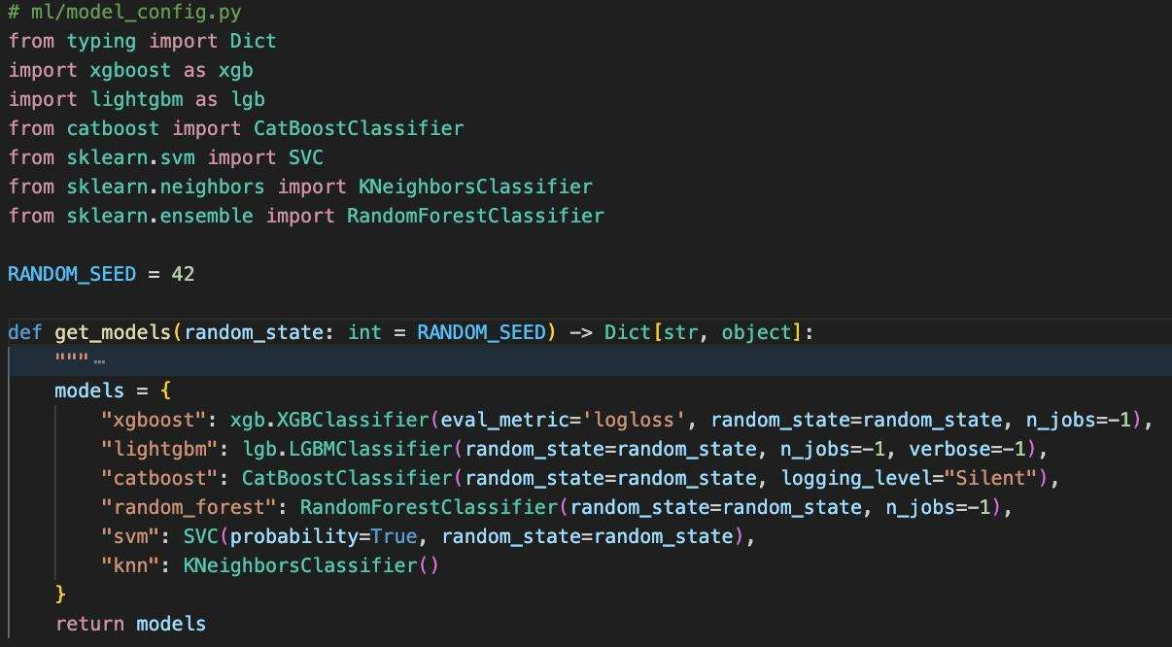
Fig. 4
Fig. 5

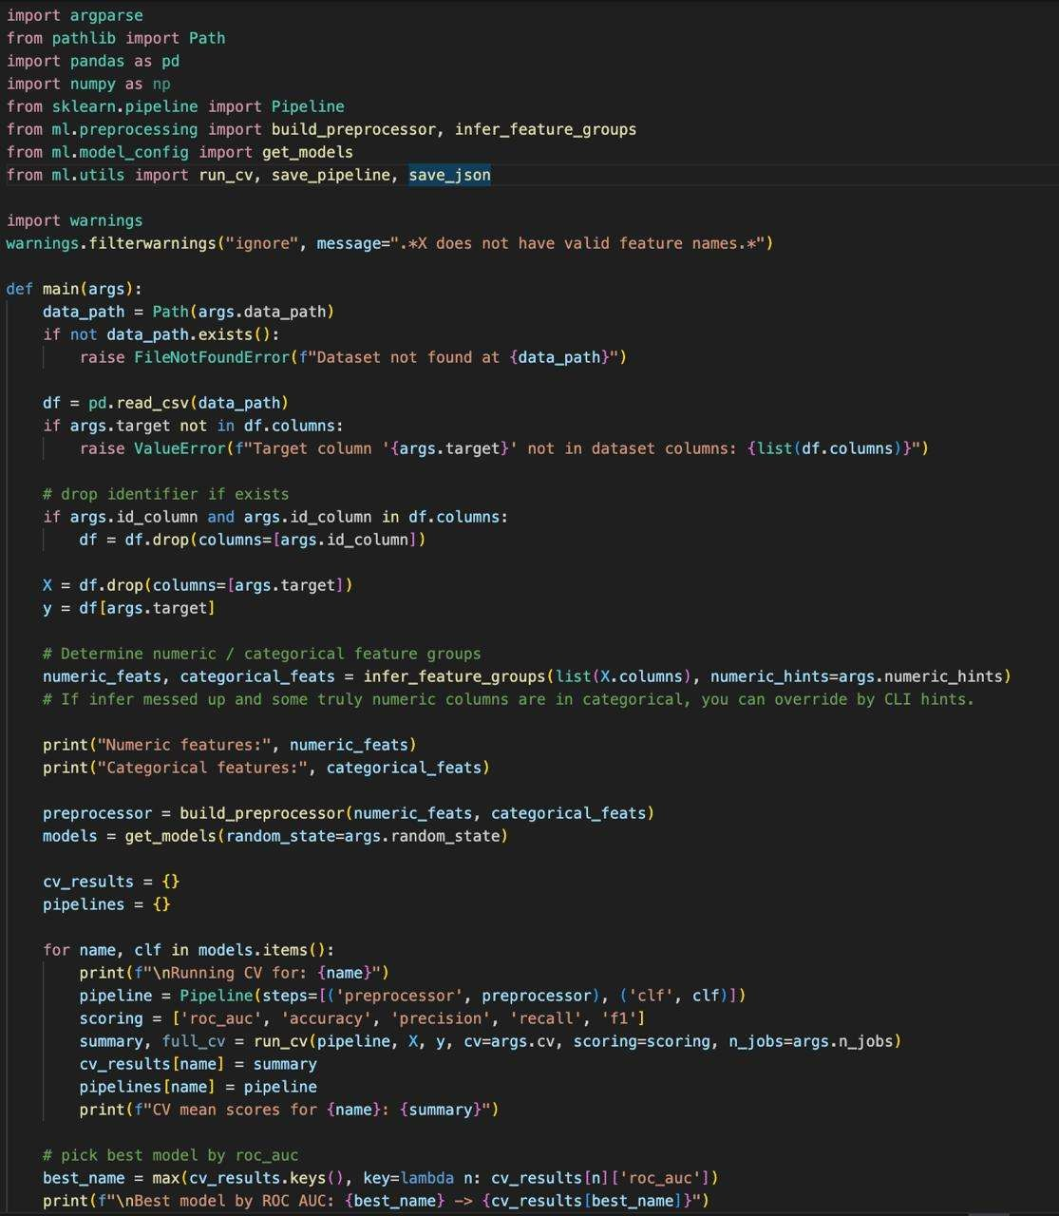

Fig. 6

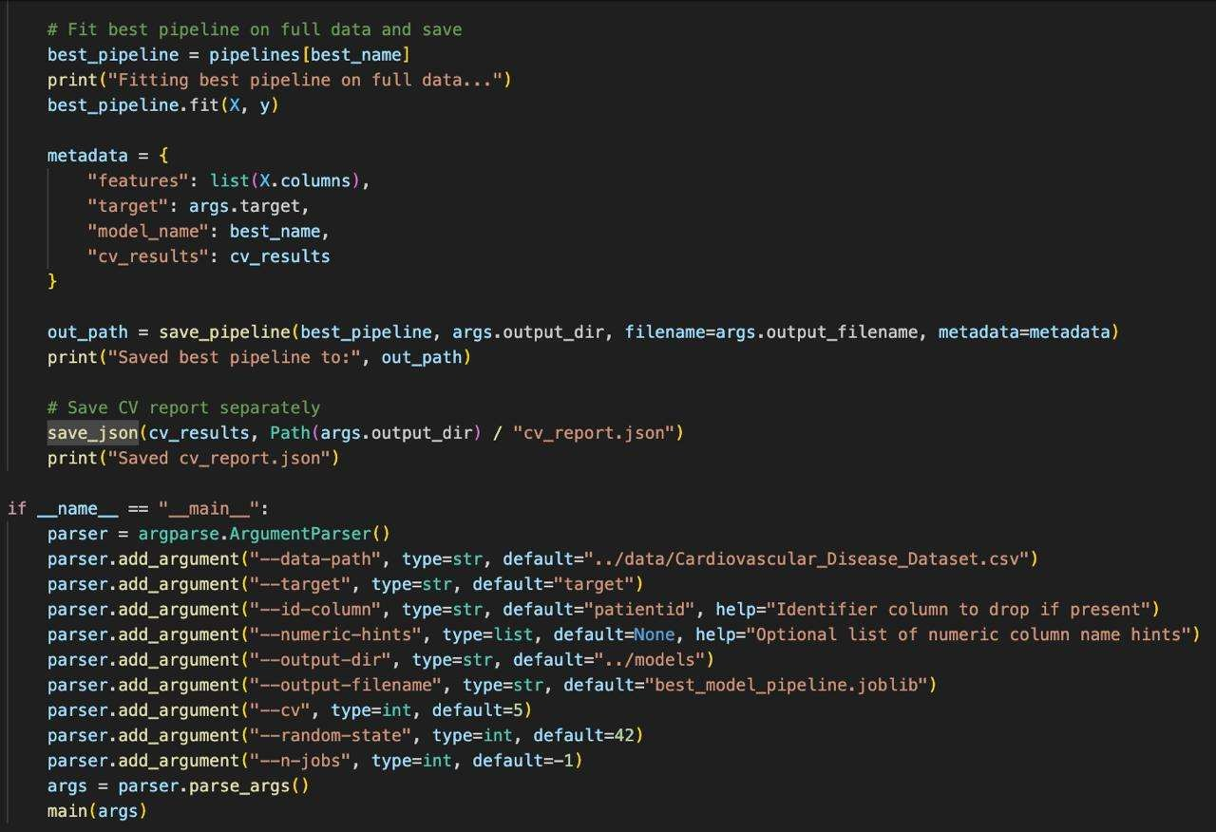

Fig. 7

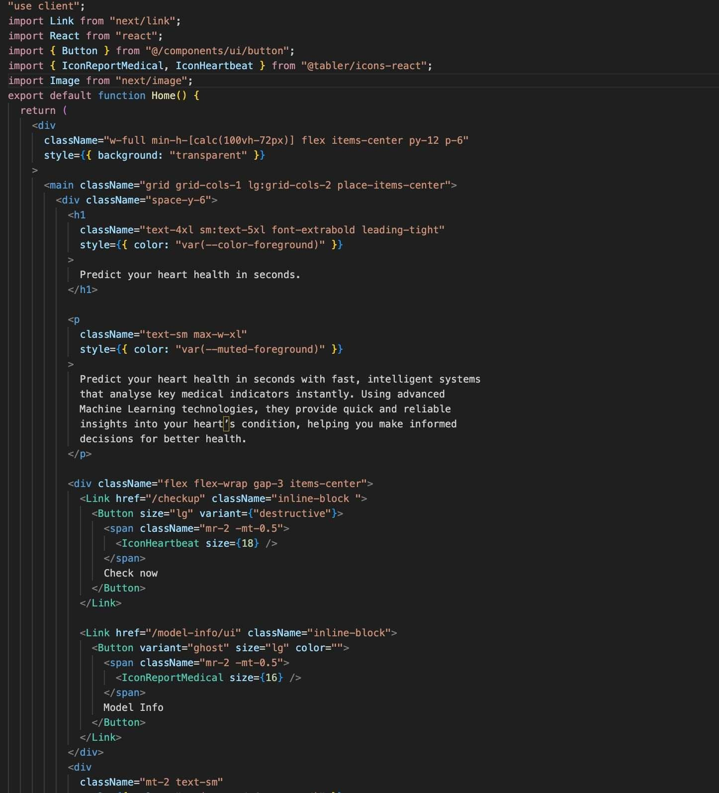
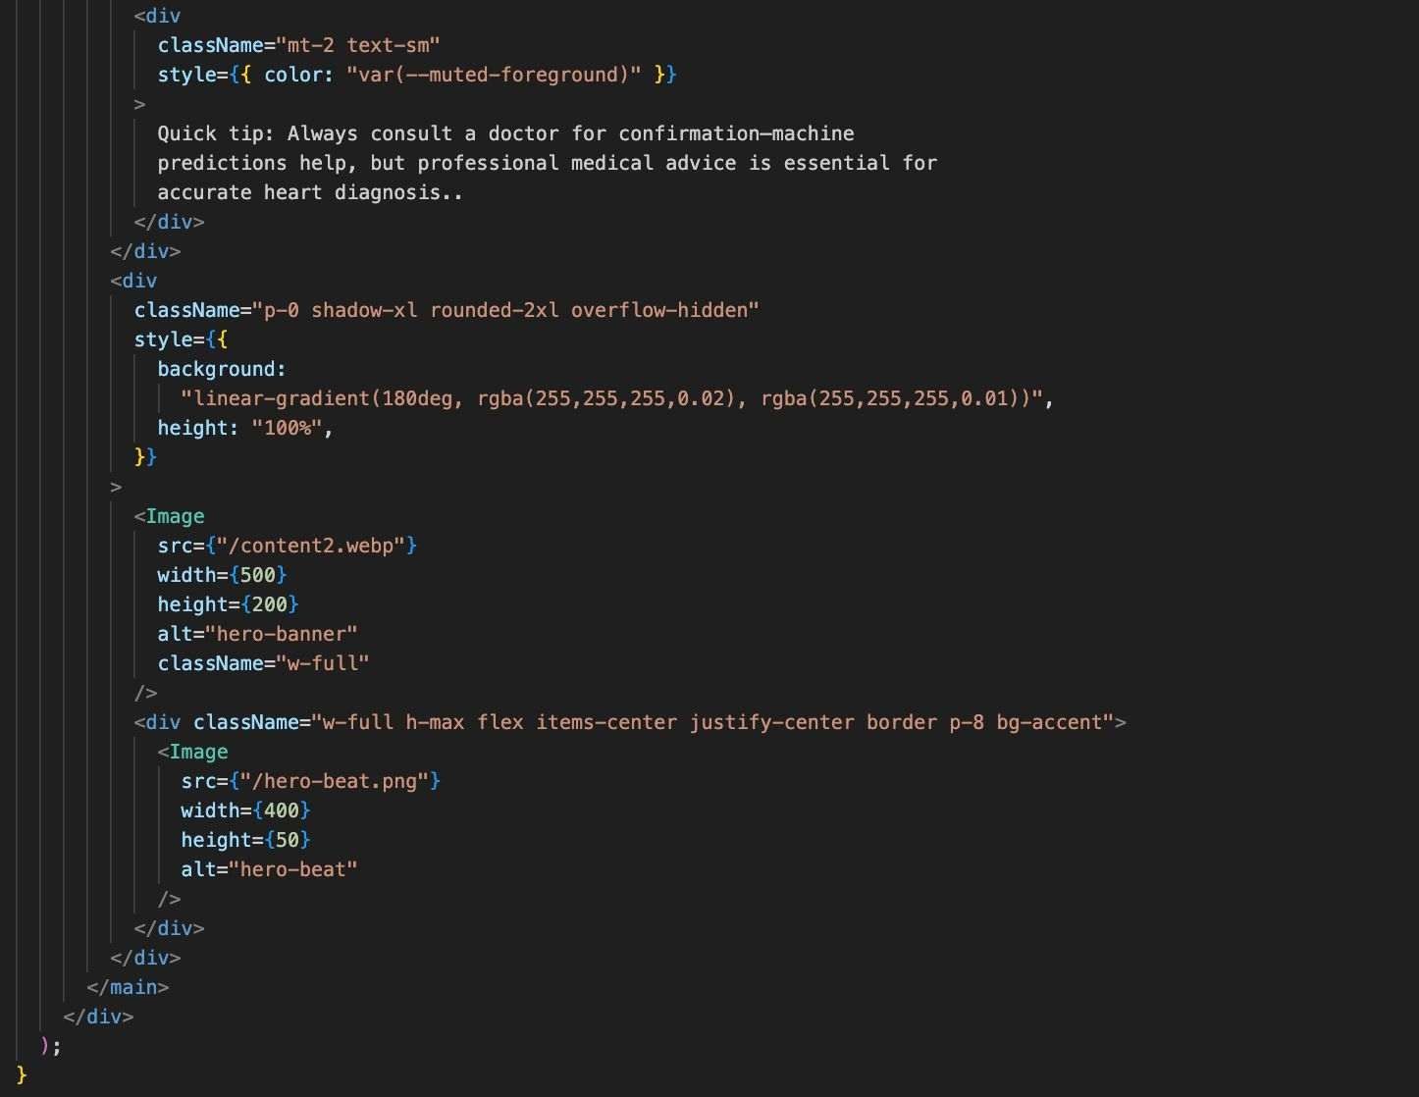

Fig. 8

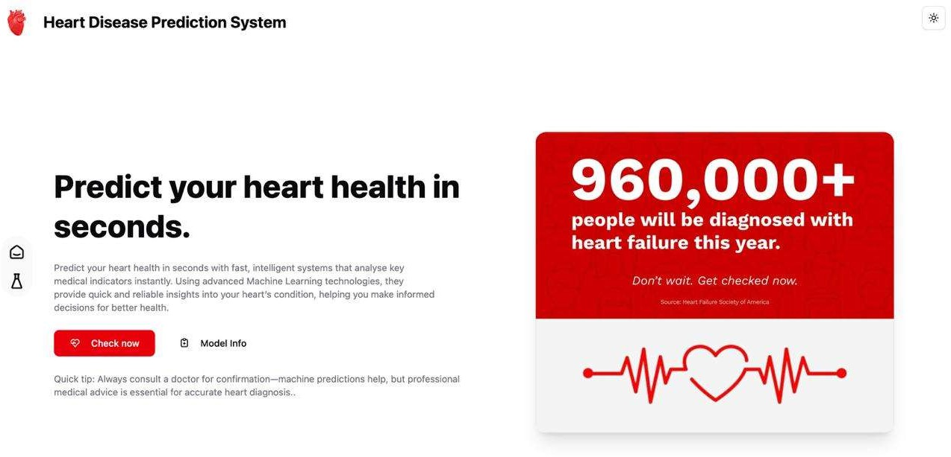

Fig. 9

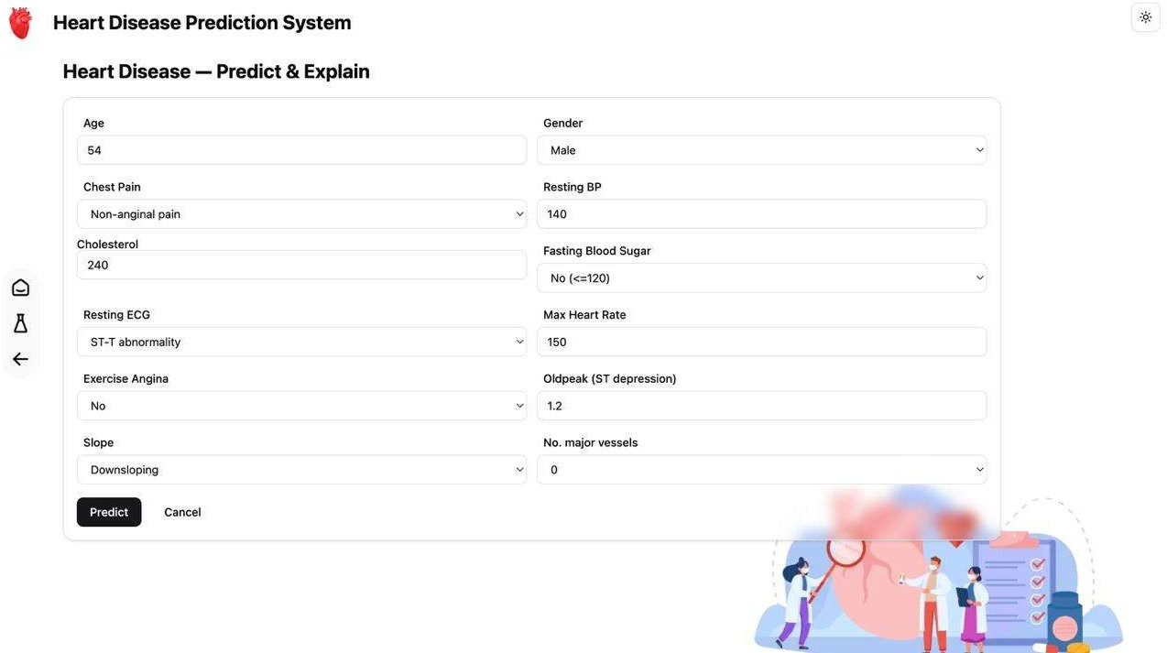
Fig. 10

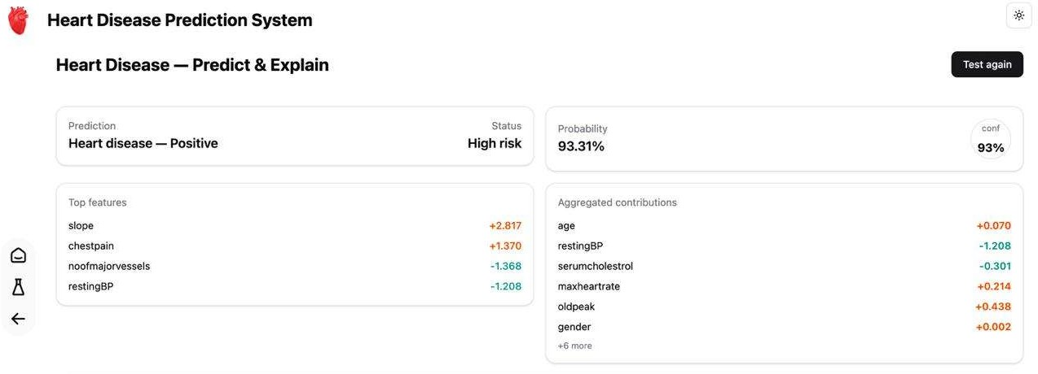
Fig. 11

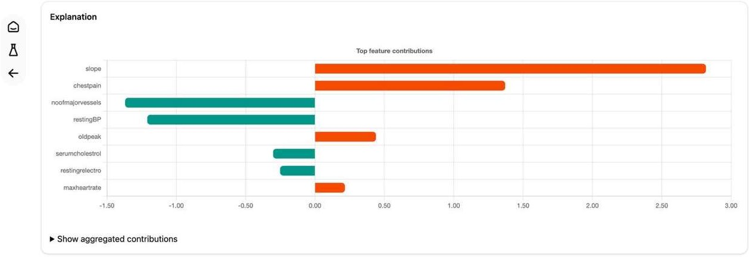
Fig. 12

Chapter 5: Conclusion and References

Conclusion
The Heart Disease Detection System developed in this project shows that machine learning can effectively support early diagnosis of cardiovascular conditions. By analysing key medical features and using models like Logistic Regression, Random Forest, SVM, and CatBoost, the system provides fast and accurate predictions of heart disease risk.
The project successfully demonstrates a complete pipeline—from data preprocessing to model evaluation and deployment—proving that ML-based tools can assist doctors with reliable, data- driven insights. While the system cannot replace medical professionals, it serves as a valuable decision-support tool that enhances early detection and helps reduce diagnostic delays.
With more diverse datasets and integration of advanced techniques in the future, the system can become even more accurate, scalable, and useful in real-world healthcare applications.
In conclusion, this project successfully showcases how machine learning can assist in reducing the burden of cardiovascular diseases by enabling early risk identification, supporting medical professionals, and ultimately contributing to better patient health outcomes.

References

    - Ketu, S., & Mishra, P. K. (2022). Empirical Analysis of Machine Learning Algorithms on Imbalance Electrocardiogram Based Arrhythmia Dataset for Heart Disease Detection. Arabian Journal for Science and Engineering, 47:1447-1469.
    - Chang, V., et al. (2022). Heart disease detection using deep learning methods from imbalanced ECG samples. Healthcare Analytics, 2:100016.
    - Rath, A., et al. (2021). An artificial intelligence model for heart disease detection using machine learning algorithms. Biomedical Signal Processing and Control, 68:102820.
    - Kaggle Cardiovascular Disease Dataset. Available at: https://www.kaggle.com/datasets/jocelyndumlao/cardiovascular-disease- dataset?resource=download
    - Kaggle Heart Disease Dataset. Available at: https://www.kaggle.com/datasets/johnsmith88/heart-disease-dataset
    - UCI Dataset. Available at: https://archive.ics.uci.edu/dataset/45/heart+disease
    - Scikit-Learn Machine Learning Library Documentation. https://scikit-learn.org

