ML Ops Report

Name : Ashutosh Gupta

Roll : M23CSE009

# Boston Housing Price Prediction

## Overview

The objective of this experiment is to predict housing prices using the **Boston Housing Dataset**. Two machine learning models were trained and evaluated:

1. **Linear Regression**
2. **Random Forest Regressor**

Both models were evaluated based on their **Mean Squared Error (MSE)**. The experiment was tracked using **MLflow** to log model parameters, metrics, and models.

## Dataset Overview

**Dataset Name**: Boston Housing Dataset

**Features**:

* The dataset consists of 13 features, including:
  + crim: per capita crime rate by town
  + zn: proportion of residential land zoned for lots over 25,000 sq. ft.
  + indus: proportion of non-retail business acres per town
  + chas: Charles River dummy variable (1 if tract bounds river; 0 otherwise)
  + nox: nitric oxides concentration (parts per 10 million)
  + rm: average number of rooms per dwelling
  + age: proportion of owner-occupied units built prior to 1940
  + dis: weighted distances to five Boston employment centers
  + rad: index of accessibility to radial highways
  + lstat: percentage of lower-status population
* **Target Variable**:
  + medv: median value of owner-occupied homes in $1000s.

## Models and Evaluation

## 1. Linear Regression

* **Mean Squared Error (MSE)**: 24.29
* **Model Summary**: Linear Regression is a simple model that assumes a linear relationship between the features and the target variable. Despite its simplicity, it produced a reasonable MSE for this dataset.

### Key Result:

* MSE of 24.29 indicates that on average, the squared differences between the predicted and actual house prices are around 24.29 thousand dollars.

.

## 2. Random Forest Regressor

* **Mean Squared Error (MSE)**: 8.18
* **Model Summary**: Random Forest is an ensemble method that uses multiple decision trees to improve prediction performance. This model significantly outperformed Linear Regression with a much lower MSE.

### Key Result:

* MSE of 8.18 indicates a better fit for this dataset compared to Linear Regression. The lower MSE means that Random Forest has more accurate predictions.

Summary of Results

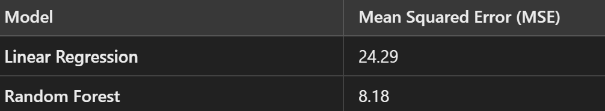

* The **Random Forest** model performed significantly better than the **Linear Regression** model in terms of prediction accuracy, as indicated by the much lower MSE.
* Both models were logged in **MLflow** for future reference, comparison, and reproducibility. However, future improvements can include logging the model signature and input example for both models.

## MLflow Artifacts

### Random forest

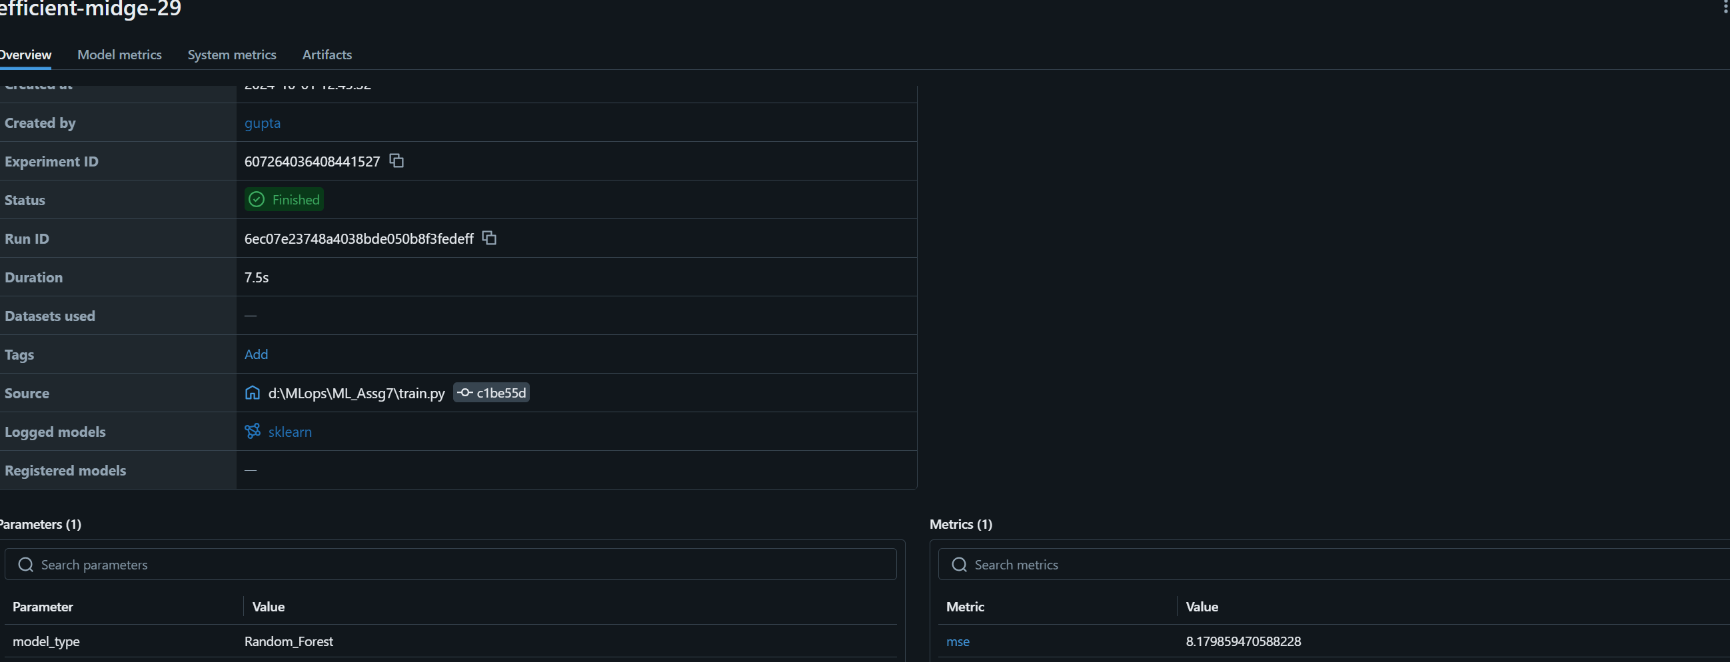

### Linear Regression

