**JOB-A-THON**

**Forecast Green Energy**

**Problem Statement:**

In order to achieve this objective, the government of Green Energy would like to use Data Science to understand the total energy demand of the country in the near future. This will help the government to build the infrastructure and technologies to achieve 95% of the total energy capacity via renewable energy.

They have captured the estimated total energy demand from the past 12 years on an hourly basis. Now, the government of Green Energy is looking for a data scientist to understand the data and forecast the total energy demand for the next 3 years based on past trends.

**Objective**  
  
Your task at hand is to build a machine learning/deep learning approach to forecast the total energy demand on an hourly basis for the next 3 years based on past trends.

**Dataset**  
  
You are provided with total energy demand on an hourly basis for the past 9 years from March 2008 to Dec 2018 in the training set. You need to forecast the total energy demand on an hourly basis for the next 3 years from 2019 to 2021 in the test set.

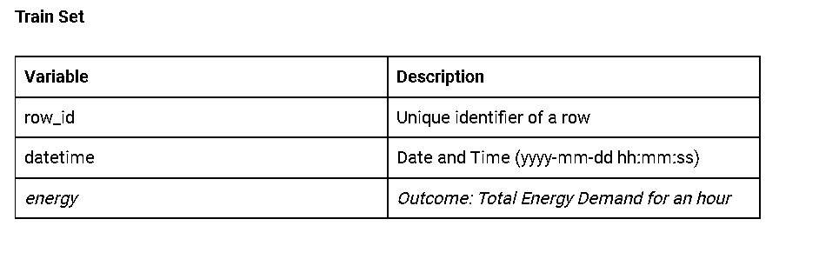

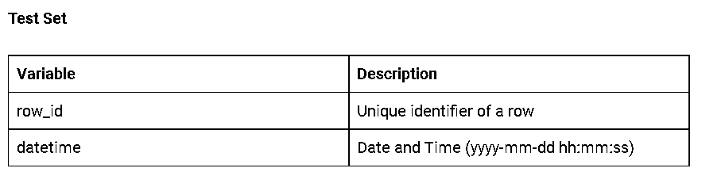

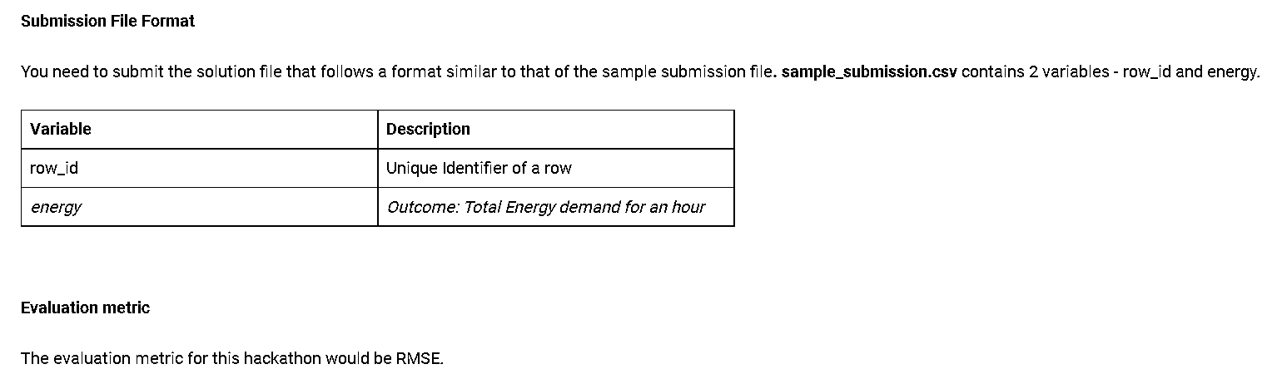

**Approach:**

First of all it is a time series dataset so there are only two column are given one is date and time column and another is energy which we have to predict. First what I did was that clearing the data so the datetime series is not in datetime so I converted and made it as index and did eda on it as time series data a applied ARIMA and SARIMAX on it but RMSE score is too high , SO I leave that.

**MACHINE LEARNING MODEL USE**:

* First I convert date time feature to different feature and did one hot encoding on month column and all necessary Eda and Feature engineering part.
* I try with Random forest , XGBOOST , GradientBoostingRegressor and CatBoostRegressor and GradientBoosting is giving me least rmse score.

**DEEP LEARNING :**

Finally I use ANN with 3 Hidden layer with relu activation function which is given by more accurate result then other so , finally I am going with ANN .