Experiment no.-1

Aim:-

To study the different components of a system.

Components:-

Monitor, keyboard, mouse, processor, Motherboard, Hard disk, CD drive, SMPS, RAM and ROM

Observation:-

**Monitor:**

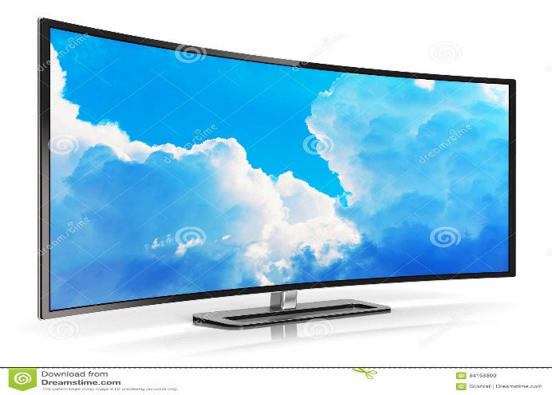

* **A computer monitor** is an [output device](https://en.wikipedia.org/wiki/Output_device) that displays information in pictorial or text form.
* A monitor usually comprises a [visual display](https://en.wikipedia.org/wiki/Electronic_visual_display), [some circuitry](https://en.wikipedia.org/wiki/Electronic_circuit), a casing, and a [power supply](https://en.wikipedia.org/wiki/Power_supply).
* Modern computer monitors are easily interchangeable with conventional television sets and vice versa.
* Native Resolution. Unlike CRT monitors, LCD monitors display information well at only the resolution they are designed for, which is known as the native resolution.
* Using Monitor user can get the visual information about the tasks and processes

**KeyBoard:**

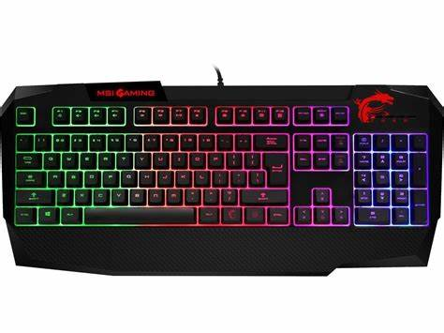

* A keyboard is one of the primary input devices that allows users to input text into a computer or any other electronic machinery
* It is a peripheral device that is the most basic way for the user to communicate with a computer.
* It consists of multiple buttons, which create numbers, symbols, and letters, and special keys.
* Like the Windows and Alt key, including performing other functions.
* The design of the keyboard comes from the typewriter keyboards, and numbers and letters are arranged on the keyboard in that way, which helps to type quickly.

**MOUSE:**

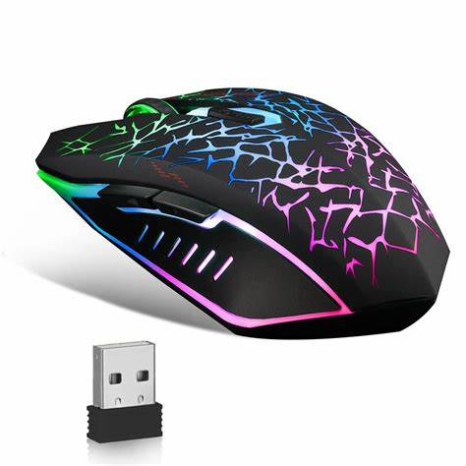

* A mouse is a small hardware input device used by hand.
* It controls the movement of the cursor on the computer screen and allows users to move and select folders, text, files, and icons on a computer.
* It is an object, which needs to put on a hard-flat surface to use.
* When the users move the mouse, the cursor moves in the same direction on the display screen.
* The name mouse is derived from its size as it is a small, corded, and elliptical shape device that looks a bit like a mouse.

**Processor:**

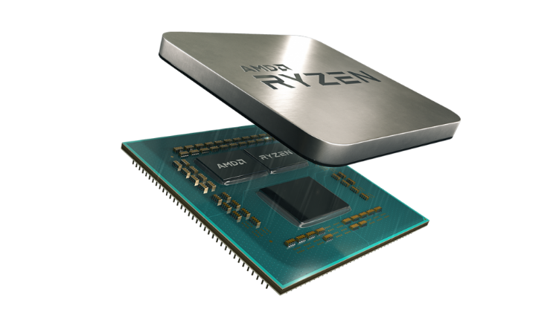

* It fetches information from the main memory and sends it to CPU for processing.
* Now a day's processors are designed with multi-cores.
* The speed of CPU is measured either in GHz (Gegahertz) or in MHz (Migahertz), where Hertz is a unit of frequency.
* All new generation processors support parallel processing due to multithreading.
* A processor should support memory modules of different types like DDR1, DDR2 and DDR3 and it should be compatible.

**Motherboard:**

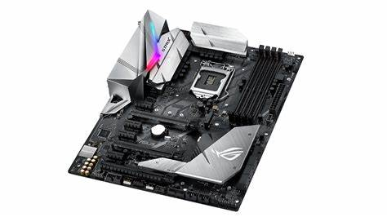

* A motherboard is the primary board and foundation of a computer
* On Apple computers, it is called a **logic board**.
* The CPU, memory RAM expansion slots, [ROM](https://www.javatpoint.com/rom), USB ports, and PCI slots are attached to the motherboard in the computer.
* It provides connectivity between the [RAM](https://www.javatpoint.com/ram), CPU, and all other hardware components.
* Also, it contains controllers for devices such as a keyboard, mouse, hard drive, and DVD drive.

**NICs:**

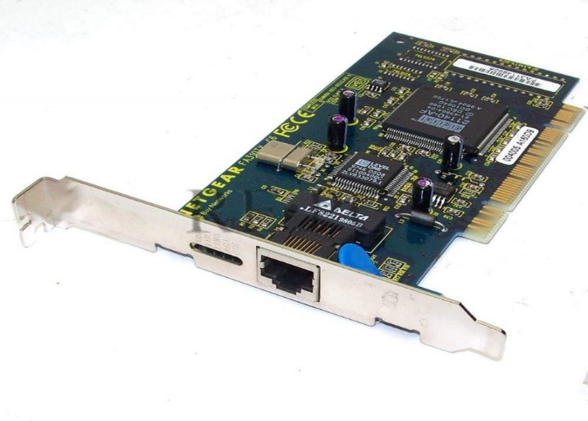

* NIC is additionally called as Ethernet or physical or network card.
* NIC is one of the major and imperative components to associate a gadget to the network.
* NIC is one of the major and imperative components to associate a gadget to the network.
* Each gadget that must be associated with a network must have a network interface card.
* Even the switches comprise of NIC in arrange to associate to the systems.

**Hard Disk:**

* 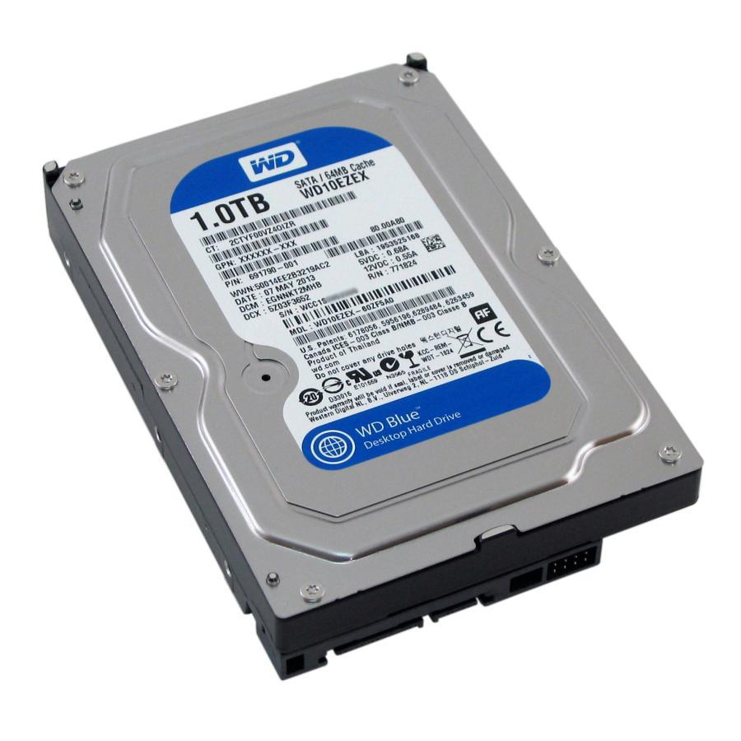
* The hard disk provides a large storage capacity. The capacity of a personal computer hard disk is from 160 GB to 2TB and more.
* It is much faster than the floppy disk.
* It is the primary media for storing data and programs.
* It is more reliable than a floppy disk.
* Data stored on the hard disk is safer than the floppy disk.

**CD Drive:**

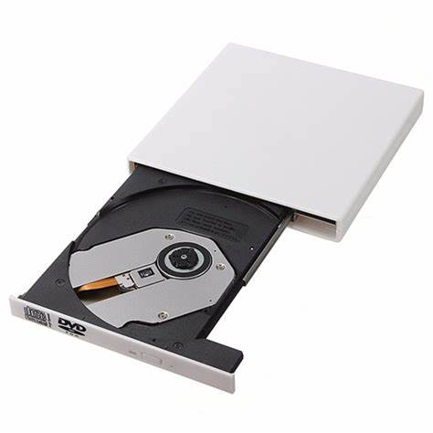

* Also called a *CD-ROM player, it is*a [device](https://www.webopedia.com/definitions/device/) that can [read](https://www.webopedia.com/definitions/read/) information from a [CD-ROM](https://www.webopedia.com/definitions/cd-rom/).
* CD-ROM drives can be either internal, in which case they fit in a [bay](https://www.webopedia.com/definitions/bay/), or external, in which case they generally connect to the [computer’s](https://www.webopedia.com/definitions/computer/) [SCSI](https://www.webopedia.com/definitions/scsi/) interface or [parallel port](https://www.webopedia.com/definitions/parallel-port/).
* Parallel CD-ROM players are easier to install, but they have several disadvantages: They’re somewhat more expensive than internal players,
* They use up the parallel port which means that you can’t use that [port](https://www.webopedia.com/definitions/port/) for another device such as a [printer](https://www.webopedia.com/definitions/printer/).
* The parallel port itself may not be fast enough to handle all the [data](https://www.webopedia.com/definitions/data/) pouring through it.

**SMPS:**

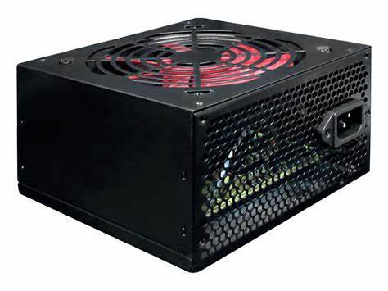

* The power supply is continuous.
* The circuitry is simple.
* These are reliable systems.
* This system dynamically responds to load changes.
* The circuit resistances are changed to regulate the output voltage.

**RAM:**

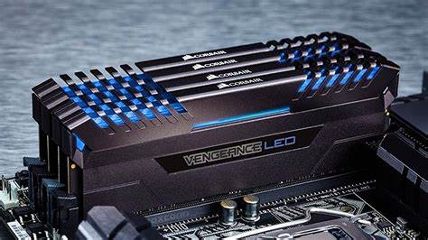

* Long life
* No need to refresh
* Faster
* Used as cache memory
* Large size
* Expensive
* High power consumption

**ROM:**

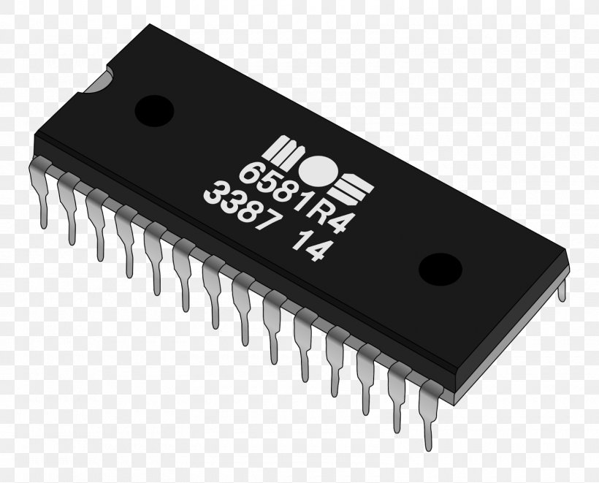

* Non-volatile in nature
* Cannot be accidentally changed
* Cheaper than RAMs
* Easy to test
* More reliable than RAMs
* Static and do not require refreshing