34. Process

30. 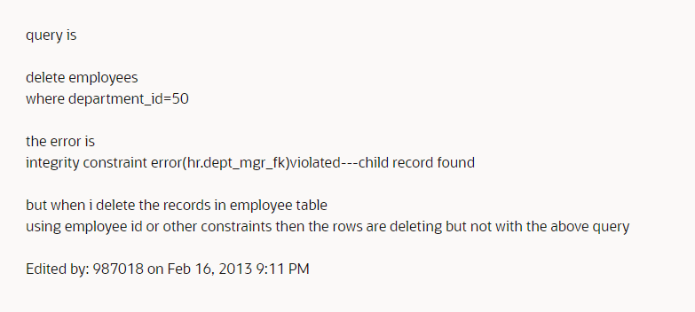

36.

31. Procedural & functional