Curriculum Vitae

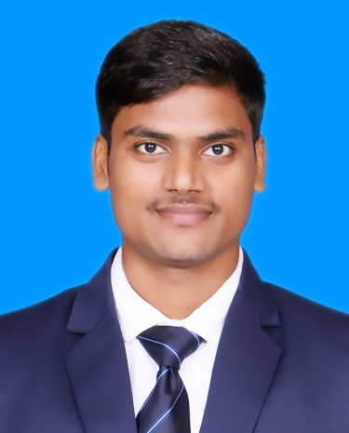

**Name**: Ashutosh Kumar Maurya

**Mob:** 6387530250

**Email:** [ashumaurya2511@gmail.com](mailto:ashumaurya2511@gmail.com)

**LinkedIn Id:**

www.linkedin.com/in/ashutoshmaurya21/

**GitHub Id:** https://github.com/Ashutosh2272

# Career Objective

To serve in an organization where my knowledge and skill scan be utilized for the growth of the organization.

# Education Qualification

|  |  |  |  |  |
| --- | --- | --- | --- | --- |
| **Standard** | **Board/University** | **School/College Name** | **Year of Passing** | **Division& Percentage** |
| B.C.A. | State University | PSIT College of Higher Education, Knapur Uttar Pradesh | 2026 | 7.87 CGPA |
| Intermediate | UP Board | S S U P S Inter College, Ramgarh Sonbhadra | 2019 | 57.60% |
| High School | UP Board | S S U P S Inter College, Ramgarh Sonbhadra | 2017 | 76.33% |

**Professional Certification**

* Certified in **“Problem Solving Through Programming In C”** by **NPTEL Swayam.**
* Certified in **“HTML5”** by **Infosys Springboard.**
* Certified in **“CSS3”** by **Infosys Springboard.**
* Certified in **“JavaScript”** by **Infosys Springboard.**
* Certified in **“Twitter Bootstrap”** by **Infosys Springboard.**
* Certified in **“Introduction to Python”** by **Infosys Springboard.**
* Certified in **“C/C++ and DSA using C++”** by **MySirGPremium.com.**

**Project**

* StudySync Using HTML, CSS & JavaScript
* Professional Portfolio Using HTML, CSS & JavaScript
* E-Commerce Website Using HTML, CSS & JavaScript
* Tourism Website Using HTML, CSS & JavaScript
* Digital Clock Using HTML, CSS & JavaScript
* Netflix Clone Using HTML, CSS & JavaScript

# Seminar/Conference/Workshop/Webinar

* Joined International Conference -2024 at PSIT College of higher Education.

# Awards & Achievements

# 400+ Questions solve on LeetCode, GeeksforGeeks.

|  |  |
| --- | --- |
| **Soft Skills** | **Technical Skills** |
| * Effective Communication * Teamwork * Adaptability * Problem-Solving * Time Management * Work ethics * Creativity | * **Programming Languages:** JavaScript (ES6+), HTML5, CSS3, Python, C/C++ * **Frontend Development:** React.js, Bootstrap, Tailwind CSS * **Backend Development:** Node.js, Express.js * **Database Management:** MongoDB, MySQL,ORACAL * **Version Control:** Git, GitHub * **Tools & Platforms:** Visual Studio Code * **Other Skills:** Data Structures & Algorithms (DSA), Object-Oriented Programming (OOP), Operating System, Fundamental of Computer, Internet Technology and Web Development (ITWD) |

# Co-curricular Activities

# I participated in many Quizzes and achieved certificates in myGov Quizzes platform.

# Hobbies& Interests

# Problem Solving

# Playing Chess & Kabaddi

# Traveling

# Reading Books

# Learning New Technologies

**Personal Details**

**Father’s Name:** Jogendra Kumar Singh

**Address:** Vill- Gheval Post- Shivpur Ramgarh Sonbhadra Uttar Pradesh.

**DOB:** 25/11/2001

**Gender:** Male

**Marital Status:** Single

**Language Known:** Hindi & English

# Declaration

I hereby declare that the information furnished above is true to the best of my knowledge and belief.

**Place:** Kanpur **Signature**

**Date:** **(** Ashutosh Maurya **)**