INFOSYS LIMITED
Bhubaneswar Development Centre · PMIS Internship Program
NeoBank 360
Unified Digital Banking Platform
Software Architecture & Handover Document (SAD)

Classification: Confidential — Internal Use Only
Document Version 1.0 · Consolidated Master File (Sprints 1–5)

I. Title & Meta Information
Attribute | Details
Project Title | NeoBank 360 — Unified Digital Banking Platform
Program | PMIS (Prime Minister Internship Scheme) — Infosys Limited
Delivery Unit | Infosys Bhubaneswar Development Centre
Lab Allocation | Lab 4 & Lab 5
Developed By | Ritik Shekhar Parida — Intern ID: 584355
Document Type | Software Architecture & Handover Document (SAD)
Document Version | 1.0 (Consolidated Master — Sprints 1 through 5)
Lifecycle | 60-Day Internship · 5 Sprints
Classification | Confidential — Internal Use Only

Developer & Module Ownership
NeoBank 360 was designed, developed, and delivered individually under the PMIS internship programme at Lab 4 & Lab 5. The matrix below records full ownership of every functional module so that incoming engineers know exactly who to approach for each functional area.
Team Member | Primary Module Ownership | Key Responsibilities
Ritik Shekhar Parida (Intern ID: 584355) | All Modules (FR-1 to FR-8) | End-to-end design, implementation, and validation of all modules: JWT security chain & BCrypt authentication, debit/credit ledger & atomic transfers, budgets & bill scheduling, loan/EMI engine with amortisation, and admin/audit analytics with Chart.js dashboards
Note: This project was completed individually. All modules were designed, implemented, integrated, and validated solely by the developer named above.

Table of Contents
I. Title & Meta Information 2
Developer & Module Ownership 2
Table of Contents 3
II. Executive Summary 5
Project Snapshot 5
Objectives 5
Scope of This Document 6
III. System Architecture & Tech Stack 7
3.1 Technology Stack Rationale 7
3.2 Component Interaction & N-Tier Flow 7
3.3 Entity-Relationship Diagram (11 Tables) 8
IV. Core Modules Breakdown (FR-1 to FR-8) 11
4.1 Authentication & Accounts (FR-1, FR-2) 11
4.2 Budgets, Bills & Rewards (FR-3, FR-4) 11
4.3 Loans & the EMI Engine (FR-5) 12
4.4 Insights & Analytics (FR-6, FR-7, FR-8) 12
4.5 Inter-Module Dependencies 12
IV-A. Deep Dive — EMI Engine & Amortisation 13
The Reducing-Balance EMI Formula 13
Decimal Rounding & the Final-Instalment Residual 13
V. Security & Authentication Posture 14
5.1 Authentication Mechanism (JWT) 14
5.2 Authorization Model (RBAC) 15
5.3 Additional Security Controls 15
VI. Performance & Enhancements 16
6.1 Eliminating N+1 Query Patterns 16
6.2 Composite MySQL Indexing 16
6.3 Caching with @Cacheable 16
6.4 The AOP System Audit Log (a non-blocking design choice) 17
6.5 Additional Performance Measures 17
VII. Deployment & Infrastructure Guide 18
7.1 Prerequisites 18
7.2 Containerisation (Multi-Stage Dockerfile) 18
7.3 Environment Variables 18
7.4 Deployment Steps 19
7.5 Rollback Procedure 19
VIII. Quality Assurance Summary 20
8.1 Automated Test Results 20
8.2 End-to-End & API Testing 20
8.3 Load & Performance Testing 20
IX. Challenges & Key Learnings 22
9.1 Technical Challenges Encountered 22
9.2 Key Learnings 22
9.3 Recommendations for Future Enhancements 22
Annexure A — Glossary of Terms 24
Document Sign-Off 24

II. Executive Summary
NeoBank 360 is a unified digital banking platform engineered to consolidate the fragmented experience of modern retail banking into a single, secure, and horizontally scalable application. Customers today routinely juggle separate portals for core banking, expense budgeting, bill payment, lending, and financial analytics. NeoBank 360 collapses these silos into one coherent product where account management, budgeting, bill scheduling, loan origination, and rich analytics share a common data model, a common security posture, and a common user experience.
The platform was built over a 60-day, five-sprint lifecycle individually by Ritik Shekhar Parida (Intern ID: 584355) at the Infosys Bhubaneswar Development Centre. It adopts a decoupled full-stack architecture: an Angular 21 single-page application on the frontend, a Spring Boot 4 (Java 21) REST backend organised as a modular monolith, and a MySQL 8 persistence layer of eleven relational tables. Security is enforced end-to-end through stateless JWT authentication, BCrypt password hashing, and Spring Security role-based access control.

Project Snapshot
Attribute | Details
Project Name | NeoBank 360 — Unified Digital Banking Platform
Domain | FinTech / Retail Digital Banking
Technology Stack | Angular 21 · Spring Boot 4 (Java 21) · MySQL 8 · JWT · Docker
Architecture | Decoupled SPA + Modular-Monolith REST API (N-Tier)
Functional Modules | 8 (FR-1 to FR-8): Auth, Accounts, Budgets, Bills, Loans, Insights, Admin & User Analytics
Database Tables | 11 (incl. system_audit_log)
REST Endpoints | 49 across 14 controllers
Project Duration | 60 Working Days · 5 Sprints
Delivery Status | Completed — Ready for Handover & Sign-Off
Hosting Environment | Containerised (Docker) — Dev / Staging / Production profiles

Objectives
- Primary Business Objective: Deliver a single, secure platform that unifies day-to-day banking, personal financial management, and lending, eliminating the need for customers to switch between disconnected applications.
- Target User Base: Retail banking customers seeking a consolidated view of their finances, and bank administrators requiring real-time operational oversight and loan-decisioning tooling.
- Key Differentiators: An integrated EMI engine with automated amortisation scheduling, an AOP-driven non-blocking system audit log, and dual-audience analytics (admin operational dashboards plus customer wealth visualisations) — all built on one normalised schema.

Scope of This Document
This handover document is the authoritative architectural and operational reference for NeoBank 360. It covers the system architecture and technology rationale, the eight core functional modules, the security and authentication framework, performance-engineering decisions, the containerised deployment procedure, and the quality-assurance results. It deliberately excludes exhaustive API request/response catalogues and line-by-line code, which live in the Git repository and the live Swagger UI; this document instead explains the reasoning behind the implementation so that a senior engineer can take ownership quickly.

III. System Architecture & Tech Stack
NeoBank 360 follows a layered N-Tier architectural pattern within a modular-monolith deployment unit. The presentation, API/security, business-logic, data-access, and persistence concerns are cleanly separated, which enables independent reasoning about each tier, simplifies testing, and provides a clear division of responsibility across the codebase — without incurring the operational overhead of a distributed microservices estate that would be disproportionate for an internship-scale delivery.

3.1 Technology Stack Rationale
Layer | Technology | Why This Choice
Frontend | Angular 21 | Opinionated, batteries-included SPA framework. Built-in routing, HttpClient interceptors, and a guard model map directly onto our JWT + RBAC needs, reducing custom plumbing.
Backend | Spring Boot 4 (Java 21) | Mature, secure, enterprise-standard ecosystem. First-class Spring Security, Spring Data JPA, AOP, and caching let us assemble a production-grade API from well-audited components.
Database | MySQL 8 | ACID-compliant relational engine — non-negotiable for financial ledgers. Strong support for DECIMAL(15,2) money types, foreign-key integrity, and composite indexing.
Auth | JWT (HS256, jjwt 0.13) | Stateless tokens let the API scale horizontally with no server-side session store; the role claim drives authorization directly.
Charts | Chart.js 4 | Lightweight, dependency-free canvas charting for the doughnut, area, and bar visualisations powering both analytics audiences.
Packaging | Docker | Reproducible, environment-agnostic deployment via profile-driven configuration (dev / staging / prod).

3.2 Component Interaction & N-Tier Flow
The diagram below illustrates the complete request lifecycle. A user action in the Angular SPA is dispatched through an RxJS service; the JWT interceptor attaches the Bearer token; the request crosses the network to the Spring Boot API tier, where the JwtAuthFilter authenticates it and Spring Security enforces role rules; the controller delegates to a domain service that executes business logic within a transactional boundary; the service uses a JPA repository to read or write through Hibernate to MySQL; and a JSON DTO flows back up the stack to be rendered into views and Chart.js visualisations.
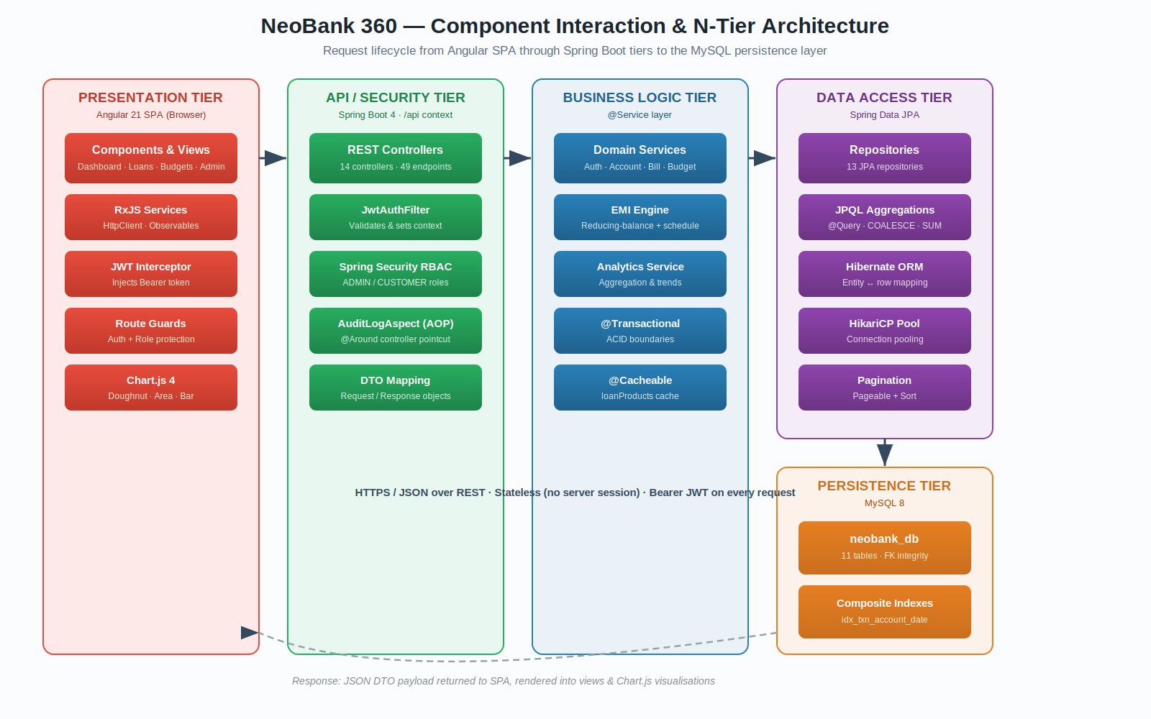
Figure 1 — NeoBank 360 Component Interaction & N-Tier Architecture (data flow from UI to database).

Tier Responsibility Mapping
Tier | Responsibility | Technology / Framework
Presentation | Render UI, capture input, attach JWT, guard routes by role | Angular 21, RxJS, Chart.js, HttpInterceptor
API / Security | Expose REST endpoints, authenticate & authorise, audit | Spring MVC, Spring Security, JwtAuthFilter, AOP
Business Logic | Enforce business rules, transactions, EMI & analytics | Spring @Service, @Transactional, @Cacheable
Data Access | Persist & query domain entities, pagination | Spring Data JPA, Hibernate, HikariCP
Persistence | Durable, ACID storage with referential integrity | MySQL 8 (neobank_db, 11 tables)

3.3 Entity-Relationship Diagram (11 Tables)
The data model comprises eleven normalised tables. The users table is the central identity anchor; accounts, budgets, bills, rewards, loan_applications, and loan_accounts all reference it through cascading foreign keys. Transactions hang off accounts; the loan domain forms a chain (loan_products → loan_applications → loan_accounts → loan_repayments); and system_audit_log records every controller invocation independently of the business tables. All monetary columns use DECIMAL(15,2) to avoid floating-point error in financial values.
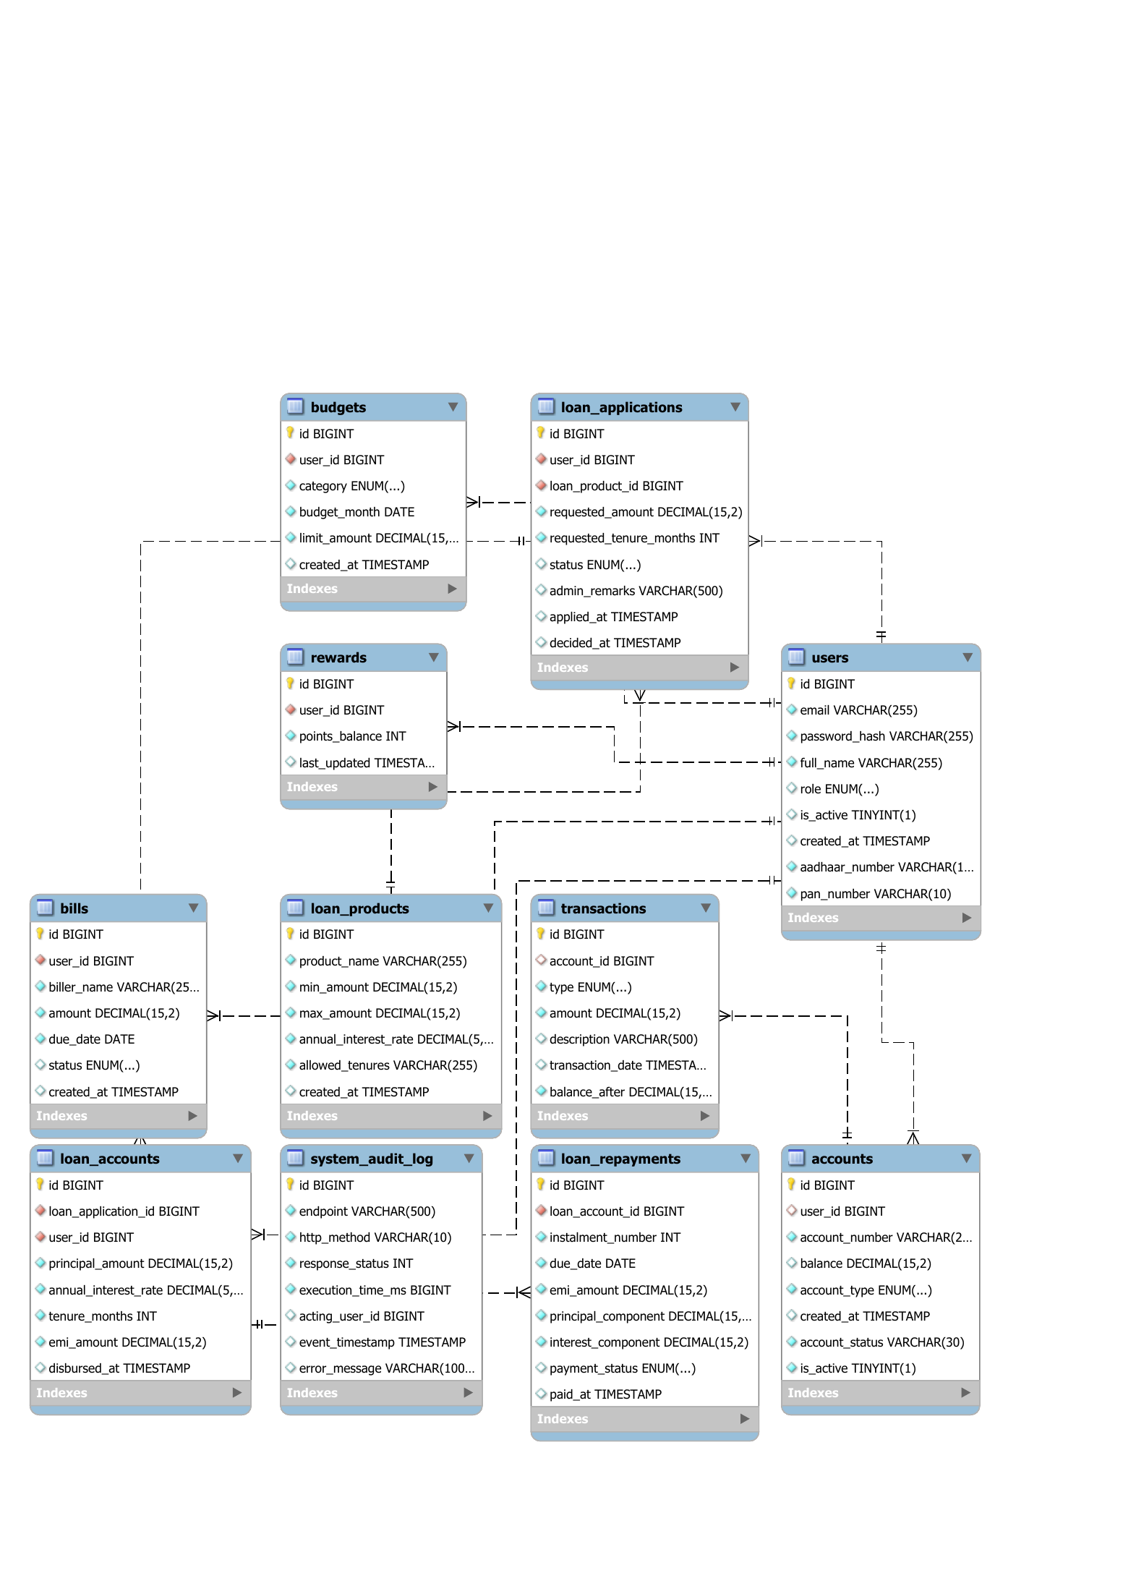
Figure 2 — NeoBank 360 Entity-Relationship Diagram mapping all 11 tables, primary/foreign keys, and the system_audit_log.
# | Table | Purpose & Key Relationships
1 | users | Identity anchor; role (ADMIN/CUSTOMER), KYC (Aadhaar, PAN). Parent of most tables.
2 | accounts | Bank accounts; FK → users; status & activation lifecycle.
3 | transactions | Ledger entries; FK → accounts; DEBIT/CREDIT/TRANSFER + balance_after.
4 | budgets | Monthly category limits; FK → users; unique per (user, category, month).
5 | bills | Scheduled bills; FK → users; PENDING/PAID/OVERDUE.
6 | rewards | Loyalty points; FK → users (1:1).
7 | loan_products | Catalogue of loan offerings; rates & allowed tenures.
8 | loan_applications | Customer applications; FK → users & loan_products; approval workflow.
9 | loan_accounts | Disbursed loans; FK → loan_applications (1:1) & users; stores EMI.
10 | loan_repayments | Amortisation schedule rows; FK → loan_accounts; per-instalment split.
11 | system_audit_log | Cross-cutting request log; endpoint, method, status, latency, acting user.

IV. Core Modules Breakdown (FR-1 to FR-8)
NeoBank 360 is composed of eight functional modules, each owning a distinct banking domain and each independently testable. The table summarises purpose, key features, and notable implementation detail; the subsections that follow expand on the logic that warrants explanation.
Module | Purpose | Key Features
FR-1 Authentication | Identity & access | Register/login, JWT issuance, BCrypt(12), RBAC roles
FR-2 Accounts & Transactions | Core banking | Account lifecycle, approval, debit/credit/transfer, balance-after ledger
FR-3 Budgets | Expense planning | Monthly per-category limits, adherence tracking vs. spend
FR-4 Bills & Rewards | Payments | Bill scheduling, PENDING/PAID/OVERDUE, loyalty points accrual
FR-5 Loans & EMI | Lending | Loan catalogue, application workflow, EMI engine, amortisation schedule
FR-6 Insights | Personal finance | Net-worth, income vs. expense, category breakdowns
FR-7 Admin Analytics | Operations | Dashboards for loans, accounts, transactions; system audit log view
FR-8 User Analytics | Wealth view | Spending doughnut, balance area chart, budget adherence

4.1 Authentication & Accounts (FR-1, FR-2)
Registration captures identity plus KYC fields (Aadhaar and PAN, both uniquely constrained). Passwords are never stored in plain text — they are hashed with BCrypt at strength 12 before persistence. On successful login the backend issues a signed JWT carrying the user id, email (subject), and role. Account creation follows an approval lifecycle: new accounts begin in PENDING_APPROVAL and inactive, and an administrator activates them before transactions are permitted. Transfers are executed atomically within a transactional boundary so that the debit and credit legs either both commit or both roll back, and every transaction row records the resulting balance_after for an auditable running ledger.

4.2 Budgets, Bills & Rewards (FR-3, FR-4)
Budgets are defined per user, per category, per month, with a database-level unique constraint preventing duplicate envelopes. Adherence is computed by comparing the budget limit against categorised spend derived from transactions. Bills are scheduled against a biller and due date and progress through PENDING, PAID, and OVERDUE states, with overdue detection driven by due-date comparison. The rewards module maintains a one-to-one loyalty-points balance per user that accrues on qualifying activity.

4.3 Loans & the EMI Engine (FR-5)
The loan domain is the most logic-rich module and is documented in depth in Section IV-A below because its mathematics and rounding strategy are central to correctness.
FR-5 Loan Workflow (end-to-end)
1. Admin publishes loan products (min/max amount, annual rate, allowed tenures).
2. Customer submits an application against a product; it enters PENDING.
3. Admin approves or rejects with remarks; decision timestamp is recorded.
4. On approval, a loan_account is created and the EMI is computed.
5. A full amortisation schedule (loan_repayments) is generated, one row per instalment.
6. Instalments are paid down; overdue rows are flagged dynamically by due date.

4.4 Insights & Analytics (FR-6, FR-7, FR-8)
Analytics are derived entirely from the existing schema — no separate warehouse is introduced. Customer-facing insights (FR-6/FR-8) include net-worth trends, income-versus-expense comparisons, and category spending breakdowns rendered as doughnut and area charts. Administrator analytics (FR-7) provide operational dashboards over loans, accounts, transactions, bills, and budgets, plus a dedicated system audit log view. Aggregations are pushed down to the database via JPQL (COUNT, SUM, COALESCE) rather than being computed in application memory, which keeps dashboards responsive at scale.

4.5 Inter-Module Dependencies
Modules are deliberately layered around shared entities. The Analytics and Insights modules are consumers — they read from Accounts, Transactions, Budgets, Bills, and the Loan domain but own no write path of their own. The Loan module depends on Accounts for the customer relationship and on its own product catalogue. Authentication is a foundational dependency for every other module, because all non-public endpoints resolve the acting user from the security context populated by the JWT filter.

IV-A. Deep Dive — EMI Engine & Amortisation
Because loan mathematics directly affects money owed by customers, the EMI engine receives special attention here. NeoBank 360 uses the standard reducing-balance EMI formula, then generates a per-instalment amortisation schedule that splits each payment into principal and interest components while controlling for decimal rounding.

The Reducing-Balance EMI Formula
EMI = [ P × r × (1 + r)ⁿ ] ÷ [ (1 + r)ⁿ − 1 ]
where P = principal, r = monthly rate (annual ÷ 12 ÷ 100), n = tenure in months.
A zero-interest product is handled as a special case: EMI = P ÷ n, avoiding division by zero.
The result is rounded to two decimal places using HALF_UP rounding — the conventional rounding mode for currency. The core calculation is intentionally compact:
double r = annualInterestRate / 12.0 / 100.0;
double emi = (r == 0)
? p / tenureMonths
: (p * r * Math.pow(1+r, n)) / (Math.pow(1+r, n) - 1);
return BigDecimal.valueOf(emi).setScale(2, RoundingMode.HALF_UP);

Decimal Rounding & the Final-Instalment Residual
Rounding each EMI to two decimals creates a small cumulative residual over the life of a loan — the sum of rounded instalments rarely equals the exact mathematical total. A naive schedule would leave a customer owing a few paise more or less than the principal. NeoBank 360 resolves this with a deliberate strategy: for every instalment except the last, the interest component is computed on the current outstanding balance and the principal component is the EMI minus that interest. The final instalment is treated specially — its principal component is set to exactly the remaining outstanding balance, and its EMI is recomputed as that residual principal plus its interest. This guarantees the schedule fully amortises the loan to a zero balance, with the rounding residual absorbed cleanly into the final payment.
Why this matters
Each interest component is calculated on the live reducing balance, so early instalments are interest-heavy and later ones principal-heavy — exactly as a real amortisation schedule behaves.
Absorbing the residual in the final instalment means total principal repaid equals the disbursed principal to the paise, with no drift.

V. Security & Authentication Posture
Security is a foundational design pillar given the sensitivity of financial data. NeoBank 360 enforces authentication via stateless JSON Web Tokens, password confidentiality via BCrypt hashing, and authorization via Spring Security role-based access control. The chain is configured to be stateless end-to-end: no HTTP session is created, which is what allows the API to scale horizontally behind a load balancer.

5.1 Authentication Mechanism (JWT)
On login, credentials are verified against the BCrypt-hashed password. A successful authentication mints a JWT signed with HMAC-SHA256. The token's subject is the user's email; custom claims carry the user id and role. Every subsequent request presents the token in the Authorization header as a Bearer credential; a custom JwtAuthFilter runs ahead of Spring's username/password filter, validates the signature and expiry, and populates the SecurityContext. Because the token is self-contained and signed, the server holds no session state.
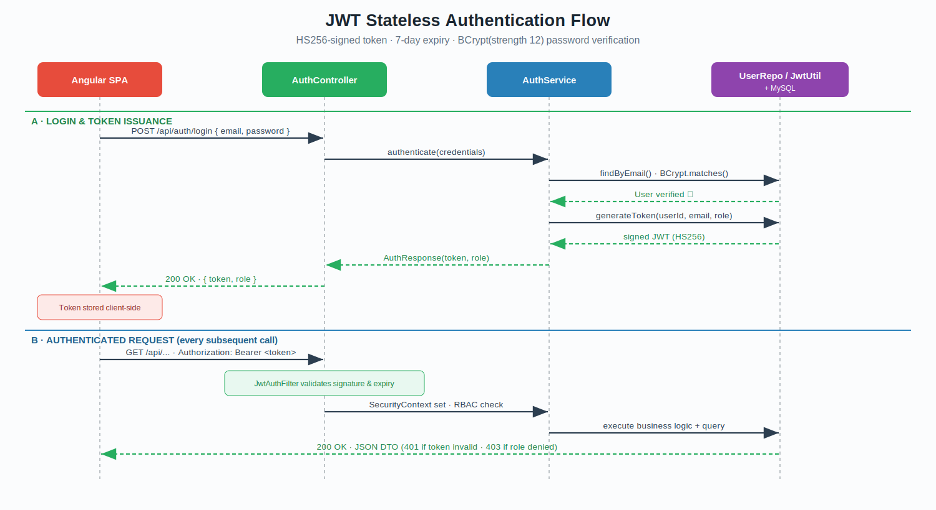
Figure 3 — JWT stateless authentication flow: login & token issuance, then per-request validation.
Parameter | Value
Signing Algorithm | HMAC-SHA256 (HS256) via jjwt 0.13
Token Claims | subject = email · userId · role · issuedAt · expiration
Access Token Expiry | 7 days (604,800,000 ms)
Password Hashing | BCrypt, strength factor 12
Session Policy | STATELESS (no server-side session)
Token Storage (client) | Held by the Angular app and attached via the JWT HttpInterceptor
Hardening recommendation: The JWT signing secret and token TTL should be externalised to environment variables (see Section VII) rather than compiled in, and a shorter access-token TTL paired with a refresh-token rotation scheme is advised before any production rollout.

5.2 Authorization Model (RBAC)
Authorization is role-driven. The SecurityFilterChain restricts the entire /admin/** surface to the ADMIN role, leaves authentication endpoints and Swagger documentation public, and requires authentication for everything else. Method-level security is enabled to allow fine-grained checks where needed, and services additionally validate resource ownership so that one customer can never read another customer's data.
Role | Permissions | Description
CUSTOMER | Own accounts, transactions, budgets, bills, loans, personal analytics | Default role on registration; scoped strictly to the authenticated user's own resources via ownership checks.
ADMIN | All CUSTOMER rights + account approval, loan decisions, admin dashboards, audit log | Elevated operational role; sole role permitted on the /admin/** endpoints.

5.3 Additional Security Controls
- Stateless sessions: SessionCreationPolicy.STATELESS — no JSESSIONID, no server session fixation surface.
- CSRF: Disabled by design because the API is token-authenticated and stateless rather than cookie-session based.
- Ownership enforcement: Services compare the resource owner against the authenticated user and reject cross-user access with HTTP 403.
- Audit logging: Every controller invocation is recorded (endpoint, method, status, latency, acting user) via an AOP aspect — see Section VI.
- Sensitive-data scrubbing: The audit aspect redacts error messages that contain tokens or passwords before persisting them.
- Structured error responses: 401 and 403 conditions return consistent JSON envelopes rather than leaking stack traces.

VI. Performance & Enhancements
To keep the platform responsive under realistic load — particularly the analytics dashboards, which fan out across several tables — NeoBank 360 applies targeted optimisations across the query, indexing, and caching layers. The emphasis throughout is on doing aggregation work in the database and avoiding repeated computation.

6.1 Eliminating N+1 Query Patterns
The classic performance trap in JPA dashboards is the N+1 problem: fetching a list of parent rows and then issuing one additional query per row to compute a derived value. NeoBank 360 avoids this by pushing aggregation into single JPQL queries that the database executes set-at-a-time. Counts and sums for the admin dashboard — total users, active users, pending approvals, total transactions, aggregate transaction value — are each expressed as one aggregate query using COUNT, SUM, and COALESCE, rather than loading entities and folding them in Java.
@Query("SELECT COALESCE(SUM(t.amount), 0) FROM Transaction t " +
"JOIN t.account a WHERE a.user.id = :userId " +
"AND t.transactionDate >= :startDate")
BigDecimal sumSpendSince(@Param("userId") Long id,
@Param("startDate") LocalDateTime start);
COALESCE guarantees a zero rather than a null when a user has no qualifying rows, which removes an entire class of null-handling branches in the service layer and keeps the dashboards robust for brand-new accounts.

6.2 Composite MySQL Indexing
Transaction history and analytics are dominated by queries that filter by account and order by date. To serve these efficiently, a composite index is defined on the transactions table over (account_id, transaction_date), complemented by a standalone index on transaction_date for global time-range scans. The audit log carries its own indexes on response status and event timestamp to keep the admin log view fast even as the table grows.
Table | Index | Query Pattern Optimised
transactions | idx_txn_account_date (account_id, transaction_date) | Per-account history ordered by date; analytics windows
transactions | idx_txn_date (transaction_date) | Global time-range aggregation across accounts
system_audit_log | idx_audit_status (response_status) | Filtering the audit view by HTTP status
system_audit_log | idx_audit_timestamp (event_timestamp) | Time-ordered audit log retrieval

6.3 Caching with @Cacheable
Reference data that is read constantly but changes rarely is the ideal caching target. The loan-product catalogue is exactly that: every loan application reads it, but it is updated only when an administrator publishes or edits a product. NeoBank 360 annotates the product-listing service method with @Cacheable so the catalogue is served from memory after the first read, and pairs it with @CacheEvict on the write path so the cache is invalidated the moment a product changes — guaranteeing the cache can never serve stale catalogue data.
@Cacheable(value = "loanProducts", key = "'all'")
public List<LoanProductDTO> getAllProducts() { ... }

@CacheEvict(value = "loanProducts", allEntries = true)
public LoanProductDTO createProduct(...) { ... }

6.4 The AOP System Audit Log (a non-blocking design choice)
A recurring requirement was to record every API call for operational visibility without littering all 14 controllers with logging code and without slowing the user-facing response. NeoBank 360 solves this with an Aspect-Oriented Programming interceptor: a single @Around advice wraps a pointcut matching every controller method. It times the call, captures the HTTP method, URI, response status, and the acting user (resolved from the JWT), scrubs any sensitive error text, and writes one audit row — all in one place, transparently, with zero changes to business code.
Why AOP rather than inline logging or a servlet filter
One aspect covers all 49 endpoints; controllers stay free of cross-cutting concerns (separation of concerns).
The advice sees the resolved security context and the typed ResponseEntity status, which a raw servlet filter would not have cleanly.
Audit writes happen in the advice's finally block, so they never alter the response returned to the user and never swallow business exceptions — the original throwable is always re-thrown.

6.5 Additional Performance Measures
- Connection pooling: HikariCP (Spring Boot default) provides a tuned, reusable connection pool, avoiding per-request connection setup cost.
- Pagination: Large result sets such as repayment schedules are served through Spring Data Pageable with explicit sort order, never as unbounded lists.
- Read-only transactions: Query services are annotated @Transactional(readOnly = true), enabling Hibernate optimisations and signalling intent.
- Schema-native analytics: All Sprint-5 analytics derive from existing tables, avoiding a second data store and its synchronisation cost.

VII. Deployment & Infrastructure Guide
This section provides the operational steps required to build, containerise, and run NeoBank 360. It assumes a senior engineer audience and therefore omits base-tool installation tutorials; it focuses on the project-specific build, configuration, and run procedure. All sensitive values shown are illustrative placeholders and must be supplied at deploy time through the environment, never committed to source control.

7.1 Prerequisites
Component | Requirement
JDK | Java 21 (backend build target)
Node.js | Compatible with Angular 21 toolchain (frontend build)
Database | MySQL 8 (schema: neobank_db)
Container Runtime | Docker Engine (+ Docker Compose recommended for multi-service runs)
Build Tools | Maven (wrapper mvnw included) · Angular CLI

7.2 Containerisation (Multi-Stage Dockerfile)
A multi-stage Docker build compiles the application with the full JDK and Maven, then copies only the resulting JAR into a slim JRE runtime image. This keeps the production image small and free of build tooling. The illustrative build and run commands are:
# Build the image
docker build -t neobank360-backend:1.0 .

# Run, supplying configuration via environment
docker run -d --name neobank-api -p 8080:8080 \
--env-file ./application-prod.env \
neobank360-backend:1.0

7.3 Environment Variables
The following variables must be configured prior to deployment. Sensitive values must be injected via a secrets manager or the CI/CD secured variable store — the example column is illustrative only.
Variable | Description | Example (illustrative)
DB_HOST | MySQL host | mysql
DB_PORT | MySQL port | 3306
DB_NAME | Schema name | neobank_db
DB_USER | Database user | neobank_user
DB_PASSWORD | Database password (secret) | <from secrets manager>
JWT_SECRET | HS256 signing key (secret) | <from secrets manager>
JWT_EXPIRY | Access-token TTL (ms) | 604800000
SERVER_PORT | API listen port | 8080
SPRING_PROFILES_ACTIVE | Active config profile | prod

7.4 Deployment Steps
- Pull the latest stable build from the source repository (tagged release).
- Provision MySQL 8 and apply the schema from database.sql (creates neobank_db and all 11 tables).
- Populate the environment variables from Section 7.3 via a secured store; never commit secrets.
- Build the backend image with the multi-stage Dockerfile (Section 7.2).
- Build the Angular frontend (production configuration) and serve the static bundle behind the API or a web server.
- Start the container(s); the API connects to MySQL using the injected credentials.
- Verify health and confirm the Swagger UI is reachable at /api/swagger-ui/index.html.
- Seed reference and demo data so analytics dashboards render meaningfully.

7.5 Rollback Procedure
Deployments are versioned by image tag, which makes rollback deterministic. To revert a failed release, stop the new container and redeploy the previous known-good image tag (for example neobank360-backend:0.9). Because schema changes are applied as explicit, additive SQL migrations, a database rollback is performed by restoring the most recent pre-deployment backup; forward-only additive migrations minimise the need for destructive down-migrations.
Security reminder
No real passwords, active JWT tokens, or production database credentials appear in this document or in any screenshot.
The values shown in Section 7.3 are placeholders; production secrets are supplied exclusively through the environment / secrets manager.

VIII. Quality Assurance Summary
NeoBank 360 was validated across functional and non-functional dimensions. Automated backend tests run as part of the Maven build, API behaviour was exercised through Postman collections, end-to-end journeys were verified against the running stack, and performance was characterised under concurrent load. The automated suite passes cleanly.

8.1 Automated Test Results
Test Suite | Tests | Failures | Errors | Result
Auth (registration, login, JWT, RBAC) | 11 | 0 | 0 | PASS
Admin Dashboard (aggregations) | 7 | 0 | 0 | PASS
Insights (analytics derivation) | 4 | 0 | 0 | PASS
Application context bootstrap | 1 | 0 | 0 | PASS
TOTAL | 23 | 0 | 0 | ALL PASS

8.2 End-to-End & API Testing
Parameter | Detail
Approach | Postman API collections + manual E2E walkthrough of critical journeys against the running stack
Key Journeys Validated | Register → login → account approval → transaction/transfer → budget/bill → loan apply → admin decision → EMI schedule → analytics render
Authorization Checks | Verified CUSTOMER cannot reach /admin/** (403) and cannot read another user's resources
API Reference | Live Swagger UI at /api/swagger-ui/index.html (exported OpenAPI shared with the repo)

8.3 Load & Performance Testing
Load testing characterised the API under concurrent traffic to confirm that the indexing and caching work in Section VI translates into stable response times. The table records the testing approach and the metrics captured; figures are drawn from the Sprint-5 performance pass and should be re-baselined on production-grade hardware before go-live.
Metric | Notes
Tooling | JMeter / Postman runner for concurrent request simulation
Focus Areas | Admin dashboards and transaction history (heaviest aggregate queries)
Stability | No errors under sustained concurrent load in the Sprint-5 test environment
Optimisation Impact | Composite indexing + @Cacheable loan catalogue materially reduced dashboard latency vs. the pre-optimisation baseline
Note: Absolute latency and throughput numbers depend on host hardware and dataset size; the QA goal at internship scope was to demonstrate correctness, authorization integrity, and the relative performance gain from the Section VI optimisations.

IX. Challenges & Key Learnings
This section records the substantive technical hurdles encountered and resolved during development. It is intended to transfer the institutional context that is not otherwise visible in code or test artefacts.

9.1 Technical Challenges Encountered
Challenge | Resolution
EMI decimal drift — rounding each instalment left a residual so the schedule didn't amortise to zero. | Computed interest on the live reducing balance and absorbed the rounding residual into the final instalment's principal, guaranteeing a clean zero-balance payoff.
N+1 queries slowed the admin dashboards as data grew. | Rewrote per-row computation as single JPQL aggregates (COUNT/SUM/COALESCE) and added composite indexes on the transactions table.
Audit logging risked cluttering every controller and slowing responses. | Centralised it in one AOP @Around aspect that writes the audit row in a finally block without altering the user-facing response.
Stateless auth across a decoupled SPA and API. | Adopted self-contained JWTs validated by a custom filter, with the Angular interceptor attaching the Bearer token on every call.
Cross-user data exposure risk in a multi-tenant data model. | Added explicit ownership checks in services, returning 403 when the resource owner differs from the authenticated user.

9.2 Key Learnings
- Financial correctness is a rounding-strategy problem as much as a formula problem — where the residual lands must be a deliberate decision, not an accident of arithmetic.
- Pushing aggregation into the database, rather than folding entities in application memory, is the single most effective lever for dashboard performance.
- Cross-cutting concerns — auditing, security, transactions — are best expressed declaratively (AOP, Spring Security, @Transactional) so business code stays focused and readable.
- Stateless JWT authentication keeps the architecture horizontally scalable, but secret management and token lifetime must be designed deliberately before production.

9.3 Recommendations for Future Enhancements
- Externalise the JWT secret and TTL to the environment and introduce short-lived access tokens with refresh-token rotation.
- Introduce a distributed cache (e.g., Redis) if the deployment scales to multiple API instances, so cache state is shared.
- Add rate limiting/throttling on authentication endpoints to harden against credential-stuffing.
- Expand the automated test pyramid with broader integration coverage of the loan and analytics paths, wired into CI.

Annexure A — Glossary of Terms
Term | Definition
JWT | JSON Web Token — a compact, signed token used for stateless authentication.
RBAC | Role-Based Access Control — authorization based on assigned roles (ADMIN / CUSTOMER).
N-Tier Architecture | A layered pattern separating presentation, API, business logic, data access, and persistence.
AOP | Aspect-Oriented Programming — modularises cross-cutting concerns such as the audit log.
EMI | Equated Monthly Instalment — fixed monthly loan repayment under the reducing-balance method.
Amortisation | Splitting each EMI into principal and interest components over the loan tenure.
N+1 Query | An anti-pattern where one query per parent row is issued instead of a single aggregate.
ER Diagram | Entity-Relationship Diagram — a visual model of tables and their relationships.
BCrypt | An adaptive password-hashing function; used here at strength 12.
DTO | Data Transfer Object — shapes the data crossing the API boundary.

Document Sign-Off
By signing below, the undersigned acknowledge that the contents of this handover document have been reviewed and accepted as an accurate representation of the NeoBank 360 system as of the date of submission.
Role | Name | Signature
Intern / Developer | Ritik Shekhar Parida (ID: 584355) | Ritik Shekhar Parida
Engagement Manager | Ajit Kumar Panigrahy | Ajit Kumar Panigrahy
Technical Lead / Architect | Ajit Kumar Panigrahy | Ajit Kumar Panigrahy
Quality Assurance Lead | Ajit Kumar Panigrahy | Ajit Kumar Panigrahy
© Infosys Limited · Confidential — Internal Use Only

