RAILWAY RESERVATION SYSTEM
Low Level Design (LLD)
C# / .NET Microservices Backend

Document Item | Value
Project | Railway Reservation System
Document Type | Low Level Design
Technology | C# / .NET / ASP.NET Core / EF Core / SQL Server
Architecture | Microservices + layered application architecture

Table of Contents
1. Document Purpose
2. Project Background & Objectives
3. Architectural Design / Design Pattern
4. Solution Diagram
5. Use Case Diagram
6. Domain Model
7. Class Design
8. Solution Steps / Business Flows
9. Flow & Sequence Diagrams
10. Validations & Business Rules
11. Database Architecture
12. ER Diagram
13. Data Model / Tables
14. HTTP Status Codes
15. Unit Testing (NUnit)

1. Document Purpose
This document defines the low-level design for the Online Railway Reservation System. It translates the functional HLD into an implementation-oriented design covering service boundaries, application layers, domain entities, database ownership, APIs, business flows, validation, error handling, configuration, integrations and testing.

2. Project Background & Objectives

2.1 Background
The supplied HLD describes an online railway reservation system supporting advance booking between stations. It provides train details, timetable, fares, reservation position and accommodation availability, with public train information available without login. Registered passengers can reserve, view and cancel tickets, while administrators maintain railway master data and fares.

2.2 Objectives
- User registration, login and role-based access using a JWT issued by User Service; roles are maintained in the User DB Roles table.
- Public train search, train details, schedule, fare and seat/accommodation availability without login.
- Booking for 1–6 passengers with atomic all-confirmed or all-waitlisted behavior.
- General and Ladies quota support.
- Full payment before a booking becomes Confirmed or Waitlisted; waitlisted bookings are paid immediately.
- PNR generation for successful confirmed or waitlisted booking requests.
- Cancellation before journey start with full refund and seat release.
- Strict FIFO waitlist promotion only when enough seats exist for the entire waiting booking; promoted bookings do not pay again.
- Administration of trains, stations, routes/schedules, coaches/seats and fares.
- Independent database ownership for User, Train, Reservation and Payment services; Mail Service has no database in the current scope.

2.3 Key Business Rules
- No partial booking: either all requested passengers are confirmed or the booking is waitlisted.
- No RAC in the current design.
- Waitlisted bookings are paid immediately.
- Payment failure produces no final booking/waitlist entry.
- A waitlisted booking is promoted only if enough seats exist for the entire booking.
- Waitlist is strict FIFO; later entries are never promoted ahead of an earlier entry. After a successful promotion, the next waiting booking is evaluated in FIFO order while seats remain available. If the next FIFO booking cannot be fully accommodated, promotion stops and later entries are not skipped.
- Only the booking owner may cancel and only before journey start.
- Cancellation releases seats and triggers promotion.

Waitlist positions are assigned when an entry is added. After promotion or cancellation removes a waitlist entry, the remaining active entries are renumbered contiguously in FIFO order.
If payment succeeds but the Reservation DB transaction fails, Reservation Service requests a compensating refund through Payment Service.
Reservation DB booking, passenger, seat-allocation and waitlist persistence/promotion operations use an explicit transaction boundary. Payment/refund calls are external operations and are not part of the Reservation DB transaction.
Booking notifications are sent to the registered email address of the authenticated booking owner. Email is collected during user registration and is not requested again during booking.
Mail Service has no database in the current scope; notification failure does not roll back the underlying booking, cancellation or promotion operation.
Payment Service uses the Dummy Razorpay Gateway as an external payment dependency; Mail Service uses the external SMTP Server. HTTP-facing applications register Global Exception Middleware for consistent error responses.

3. Architectural Design / Design Pattern

3.1 Architecture
Client
↓
API Gateway
↓
Microservice Controller
↓
Application Service
↓
Repository Interface
↓
Repository / EF Core
↓
Service-owned Database

3.2 Services
Service | Responsibility | Database
API Gateway | Client entry point, routing and JWT/role authorization. | None
User Service | Registration, authentication, users and roles. | User DB
Train Service | Trains, stations, routes/schedules, coaches, seats and fares. | Train DB
Reservation Service | Bookings, passengers, availability, allocations, waitlist, cancellation and orchestration. | Reservation DB
Payment Service | Payment/refund processing and payment persistence. | Payment DB
Mail Service | Build/send booking, cancellation and promotion notifications through SMTP. | None

4. Solution Diagram
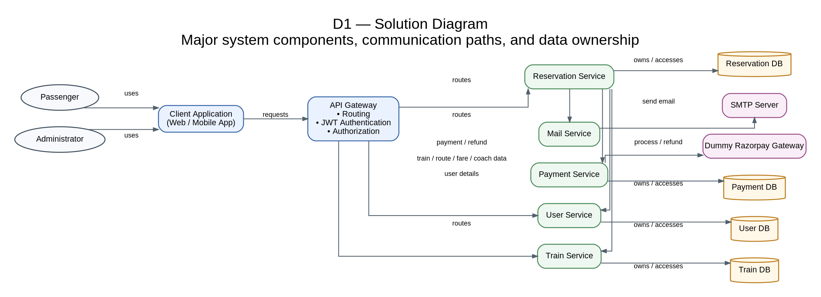
Figure 1. Solution Diagram (D1).
The Gateway routes client requests only to User, Train and Reservation services. Reservation Service coordinates User, Train, Payment and Mail interactions. Payment Service communicates with the Dummy Razorpay Gateway, while Mail Service communicates with the external SMTP Server. User, Train, Reservation and Payment services own their respective databases; Mail Service has no database in the current scope.

5. Use Case Diagram
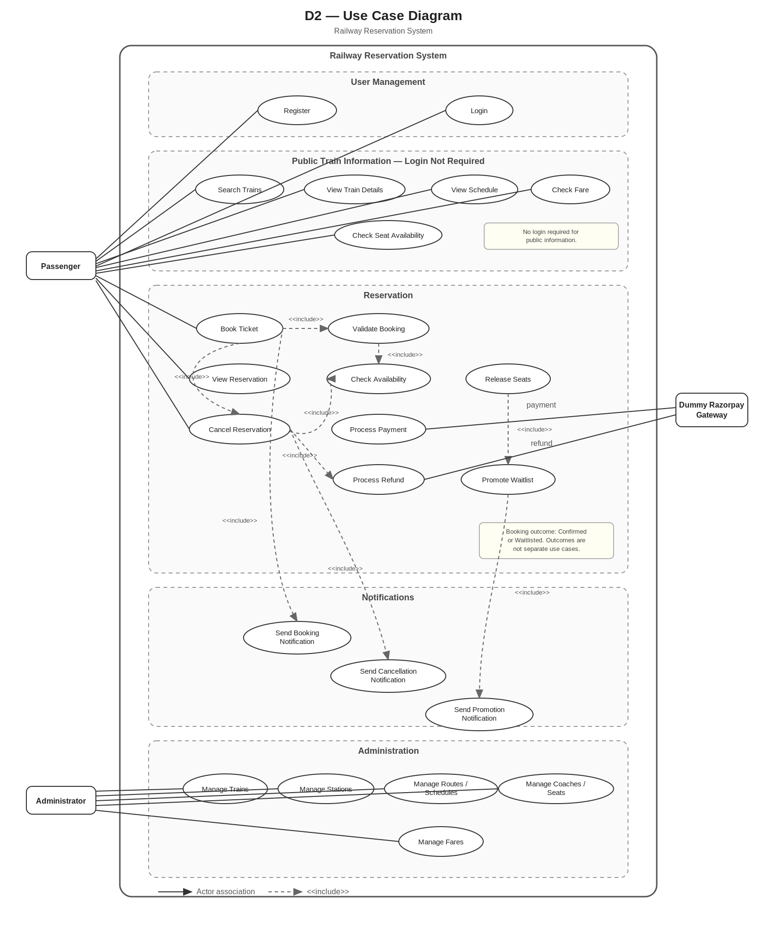
Figure 2. Use Case Diagram (D2).
The use-case model distinguishes public train-information operations from authenticated reservation operations. Passenger functions include registration, login, public train search/details/schedule/fare/availability, booking, reservation viewing and cancellation. Booking, cancellation and promotion include the important validation, payment/refund, seat-release, waitlist and notification behaviors. Administrator functions cover railway master data. The Dummy Razorpay Gateway participates in payment and refund processing; SMTP is an implementation dependency of Mail Service rather than a use-case actor.

6. Domain Model

6.1 User Service
User contains account identity/contact data and a RoleId reference to the Role entity. Role is a persisted User DB entity with a unique Name; the initial roles are Passenger and Administrator. UserService uses IUserRepository and IRoleRepository. Normal registration assigns Passenger and does not accept a client-supplied RoleId. Login retrieves the user role and places the role name in the JWT claims used for authorization.
Entity | Purpose
User | Account identity, contact data, password hash, RoleId and creation time.
Role | Persisted role definition; initial roles are Passenger and Administrator.

6.2 Train Service
Entity | Purpose
Train | Train master data.
Station | Station code and name.
RouteStop | Ordered stop with arrival/departure time.
Coach | Coach number and class.
Seat | Physical seat belonging to a coach.
Fare | Fare for train, station pair and coach type.

Route is represented by ordered RouteStop records. Seat availability is dynamic and is not stored as an IsAvailable flag.

6.3 Reservation Service
Entity | Purpose
Booking | PNR, user/train references, journey, class, quota, status and total fare.
BookingPassenger | Passenger details; one booking contains 1–6 passengers.
SeatAllocation | Passenger-to-seat mapping plus journey segment.
WaitlistEntry | FIFO position for a waitlisted booking.

6.4 Payment Service
Payment Service owns Payment persistence and exposes ProcessPayment and Refund through IPaymentService. It uses IPaymentGateway, implemented by DummyRazorpayGateway in the current project. The dummy gateway represents an external Razorpay-like dependency; it does not own a business database and no raw card/CVV/bank credentials are stored.
Entity | Purpose
Payment | Amount, status, transaction reference and BookingId logical reference.
PaymentStatus | Pending, Successful, Failed or Refunded.

6.5 Mail Service
Mail Service receives internal notification requests, selects/builds the required template, and sends mail through SmtpMailSender to the external SMTP Server. It does not persist email history in the current scope. Supported notification templates are BookingConfirmed, BookingWaitlisted, Cancellation and WaitlistPromotion.

7. Class Design

7.1 Project Structure
RailwayReservationSystem
├── ApiGateway
├── UserService
├── TrainService
├── ReservationService
├── PaymentService
├── MailService
├── DummyRazorpayGateway
├── UserService.Tests
├── TrainService.Tests
├── ReservationService.Tests
├── PaymentService.Tests
├── MailService.Tests
└── ApiGateway.Tests
GlobalExceptionMiddleware is registered in each HTTP-facing application to provide consistent exception-to-HTTP handling. Mail Service additionally contains SmtpMailSender and has no repository/DbContext in the current scope.

7.2 UML Class Diagram
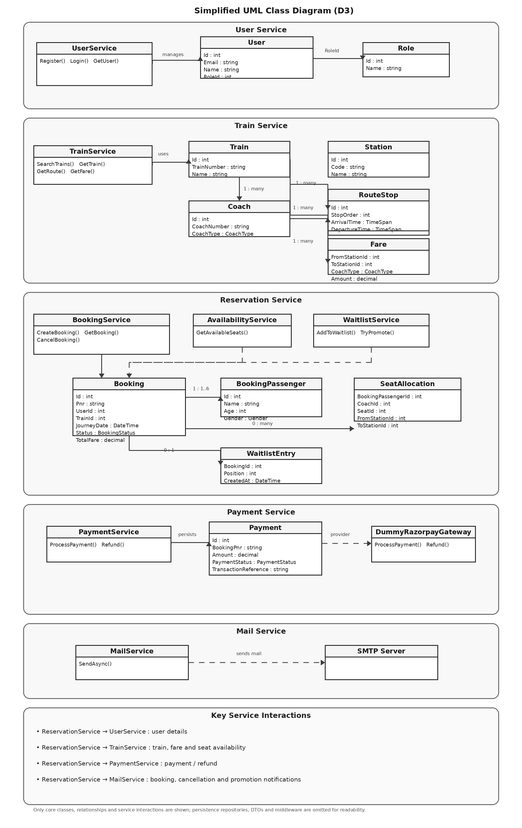
Figure 3. UML Class Diagram (D3).

8. Solution Steps / Business Flows

8.1 Registration
- Client submits registration data.
- Gateway routes to User Service.
- Validate required fields and email/phone uniqueness.
- Hash password, assign the default Passenger role from the Roles table, and create the user.
- Return success response.

8.2 Login
- Client submits registered email or phone and password.
- User Service authenticates the user.
- Generate a signed JWT on success, including the authenticated user identity and role claim.
- Client sends the JWT as a Bearer token for authenticated operations; the API Gateway validates the token and enforces role-based authorization.

8.3 Train Search
- Client submits source, destination and journey criteria.
- Train Service validates route criteria and searches ordered RouteStops.
- Return matching trains and schedule information.
- Fare is obtained from Train Service and current seat availability is obtained from Reservation Service when requested.

8.4 Confirmed Booking
- Validate user, passenger count, journey, route, class and quota.
- Get train/route information and current fare.
- Check segment-based availability for all passengers.
- Process full payment.
- Create booking, passenger rows and seat allocations.
- Generate PNR and return confirmation.

8.5 Waitlisted Booking
- If sufficient seats are unavailable for all passengers, do not partially confirm.
- Process full payment.
- Create Waitlisted booking and FIFO WaitlistEntry.
- Generate PNR and return position.

8.6 Cancellation & Promotion
- Validate PNR, ownership, status and journey date.
- Mark booking Cancelled and release allocations.
- Process full refund.
- Process waitlisted bookings in strict FIFO order. Repeatedly evaluate the earliest waiting booking and promote it when enough currently available seats exist for the entire booking. After a successful promotion, continue with the next FIFO booking while seats remain available. If the next FIFO booking cannot be fully promoted, stop; do not skip it to promote later entries.
- Promote only if enough seats exist for the entire waiting booking; allocate seats, confirm the booking, remove the waitlist entry and notify the owner without charging again.

9. Flow & Sequence Diagrams

9.1 Flow Diagram (D5)
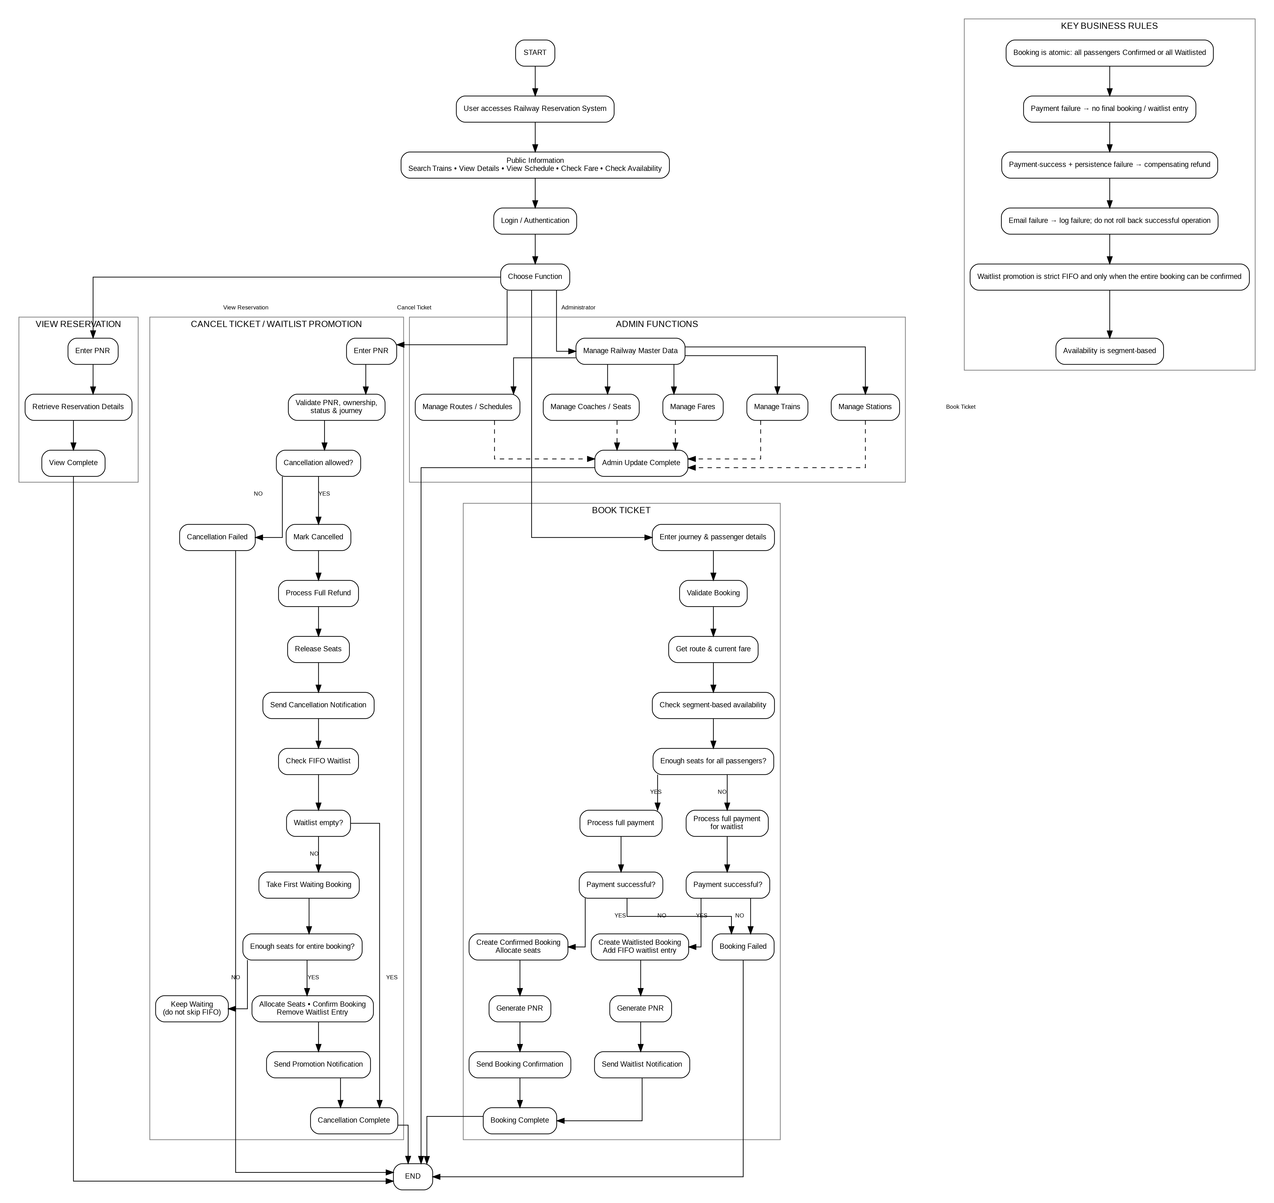
Figure 5. Overall Project Flow (D5): public information, user management, booking, reservation viewing, cancellation/waitlist and administration.

9.2 Sequence Diagram (D7)
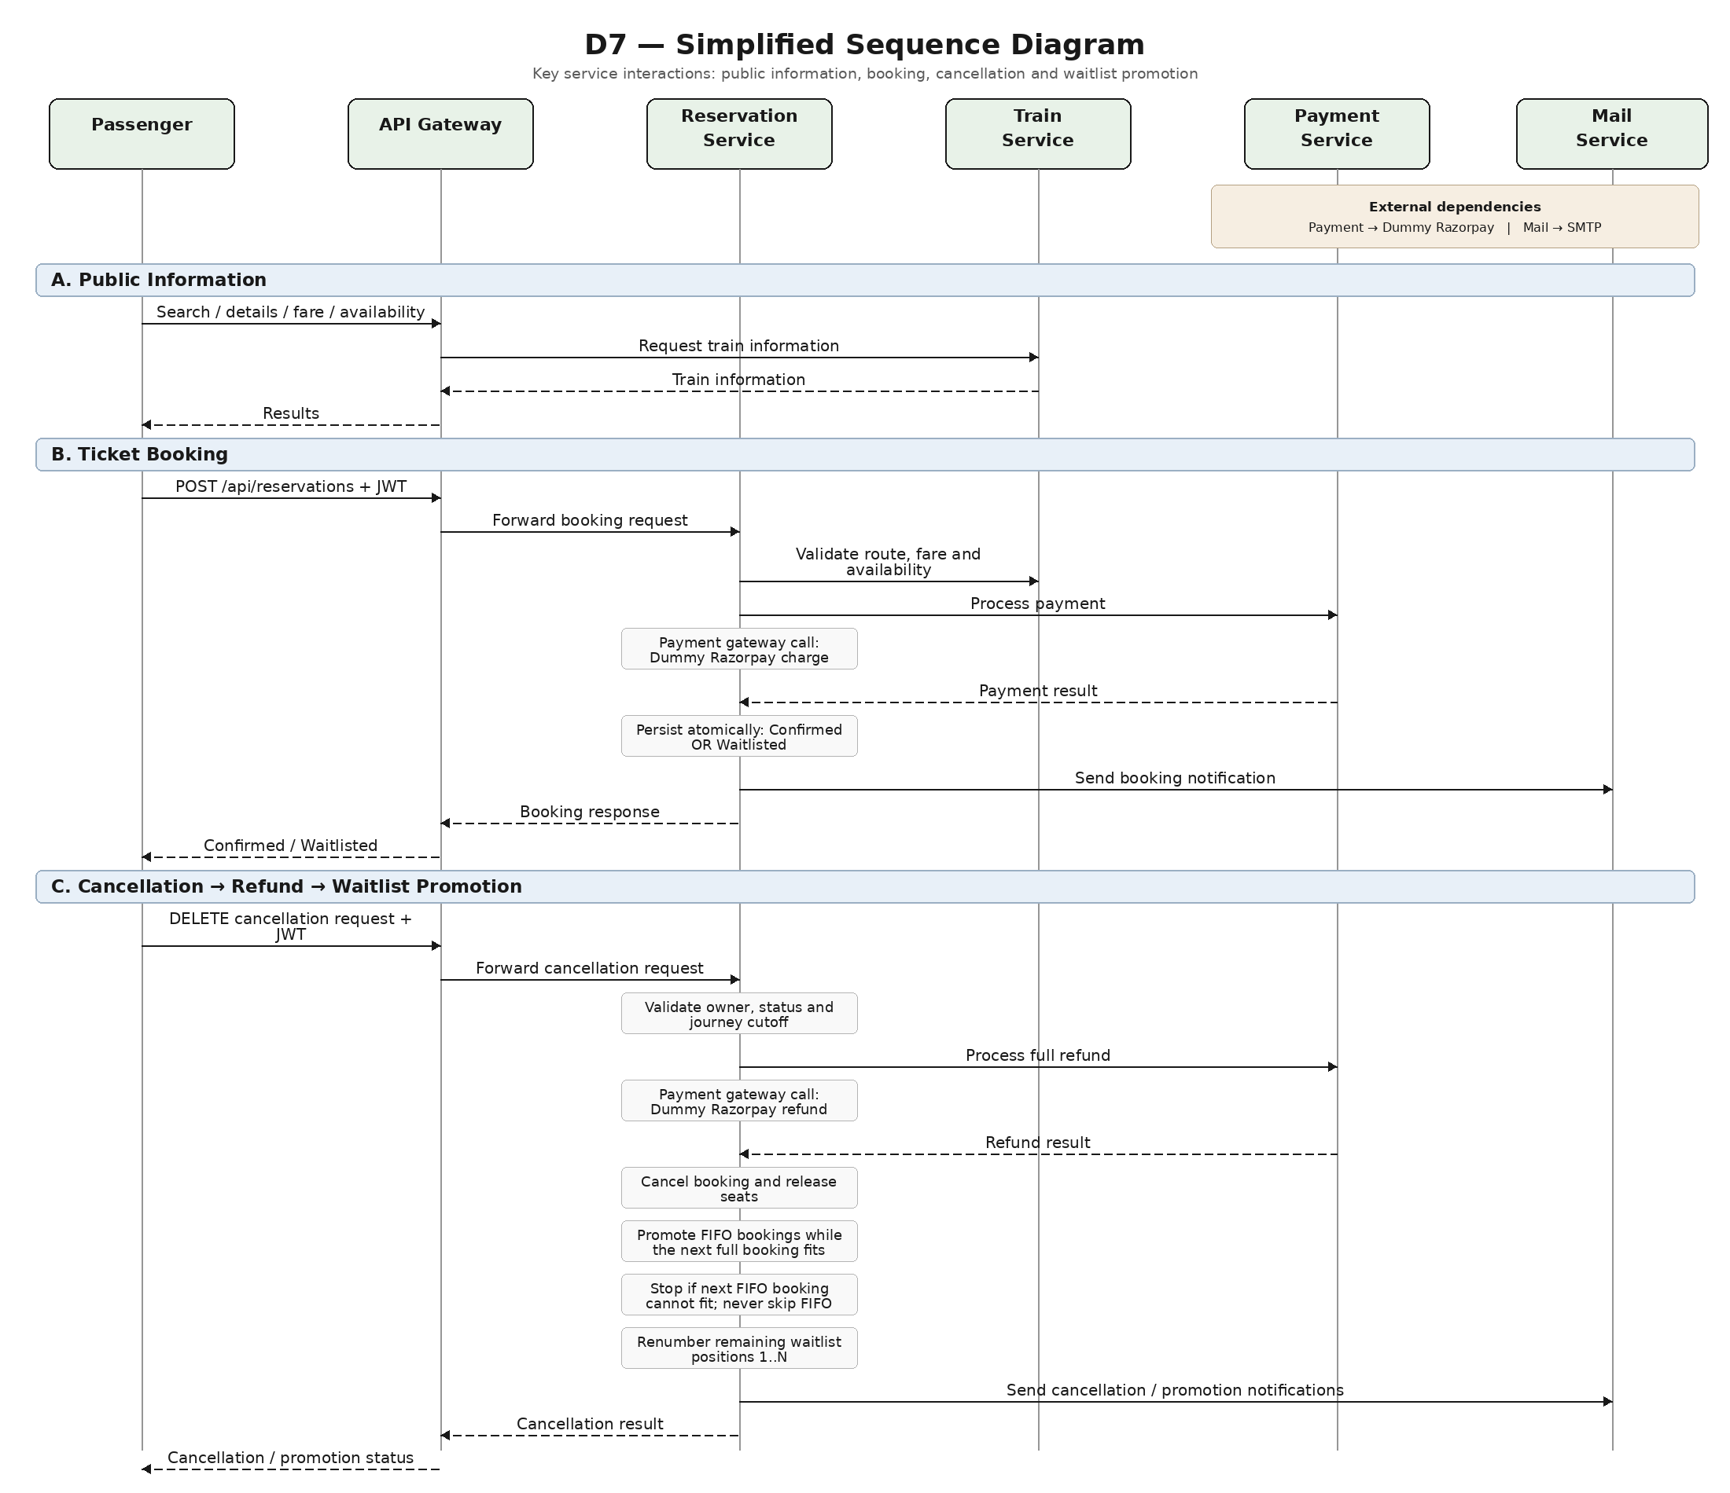
Figure 7. Sequence Diagram (D7): public information, JWT-authenticated booking, cancellation and FIFO waitlist promotion. Payment uses the Dummy Razorpay Gateway and notifications use SMTP.
Note: Booking, Availability and Waitlist processing are internal components/services of Reservation Service, not separate microservices. D7 uses three interaction regions: public information, ticket booking, and cancellation with FIFO waitlist promotion.

10. Validations & Business Rules

10.1 Validation Matrix
Area | Validation
Passenger count | 1–6 passengers.
Source / Destination | Both valid route stops; source precedes destination.
Journey date | Valid bookable journey date.
Coach type | Supported coach class.
Quota | General or Ladies. Ladies quota requires every passenger to be female; General has no gender restriction. Both quotas share the same physical seat pool.
Passenger data | Name, age, gender and address required.
Cancellation | Owner only; booking must not already be cancelled; cancellation is permitted until scheduled departure from the booking's FromStation.
Payment | Full fare required before final booking/waitlist state; payment success followed by persistence failure requires a compensating refund.
Waitlist | Strict FIFO; The system can promote multiple consecutive waitlisted bookings from seats released by a cancellation.
Coach / Seat identity | Referenced coach/seat identifiers must not be deleted or reused for different physical master data.

10.2 Segment Overlap
A physical seat may be reused for non-overlapping journey segments. The conflict rule is:
In this rule, existingFromOrder, existingToOrder, requestedFromOrder and requestedToOrder are the RouteStops.StopOrder values of the corresponding stations for the train.
existingFromOrder < requestedToOrder
&& requestedFromOrder < existingToOrder
Example: A→C conflicts with B→D, but A→C can be followed by C→E.

11. Database Architecture
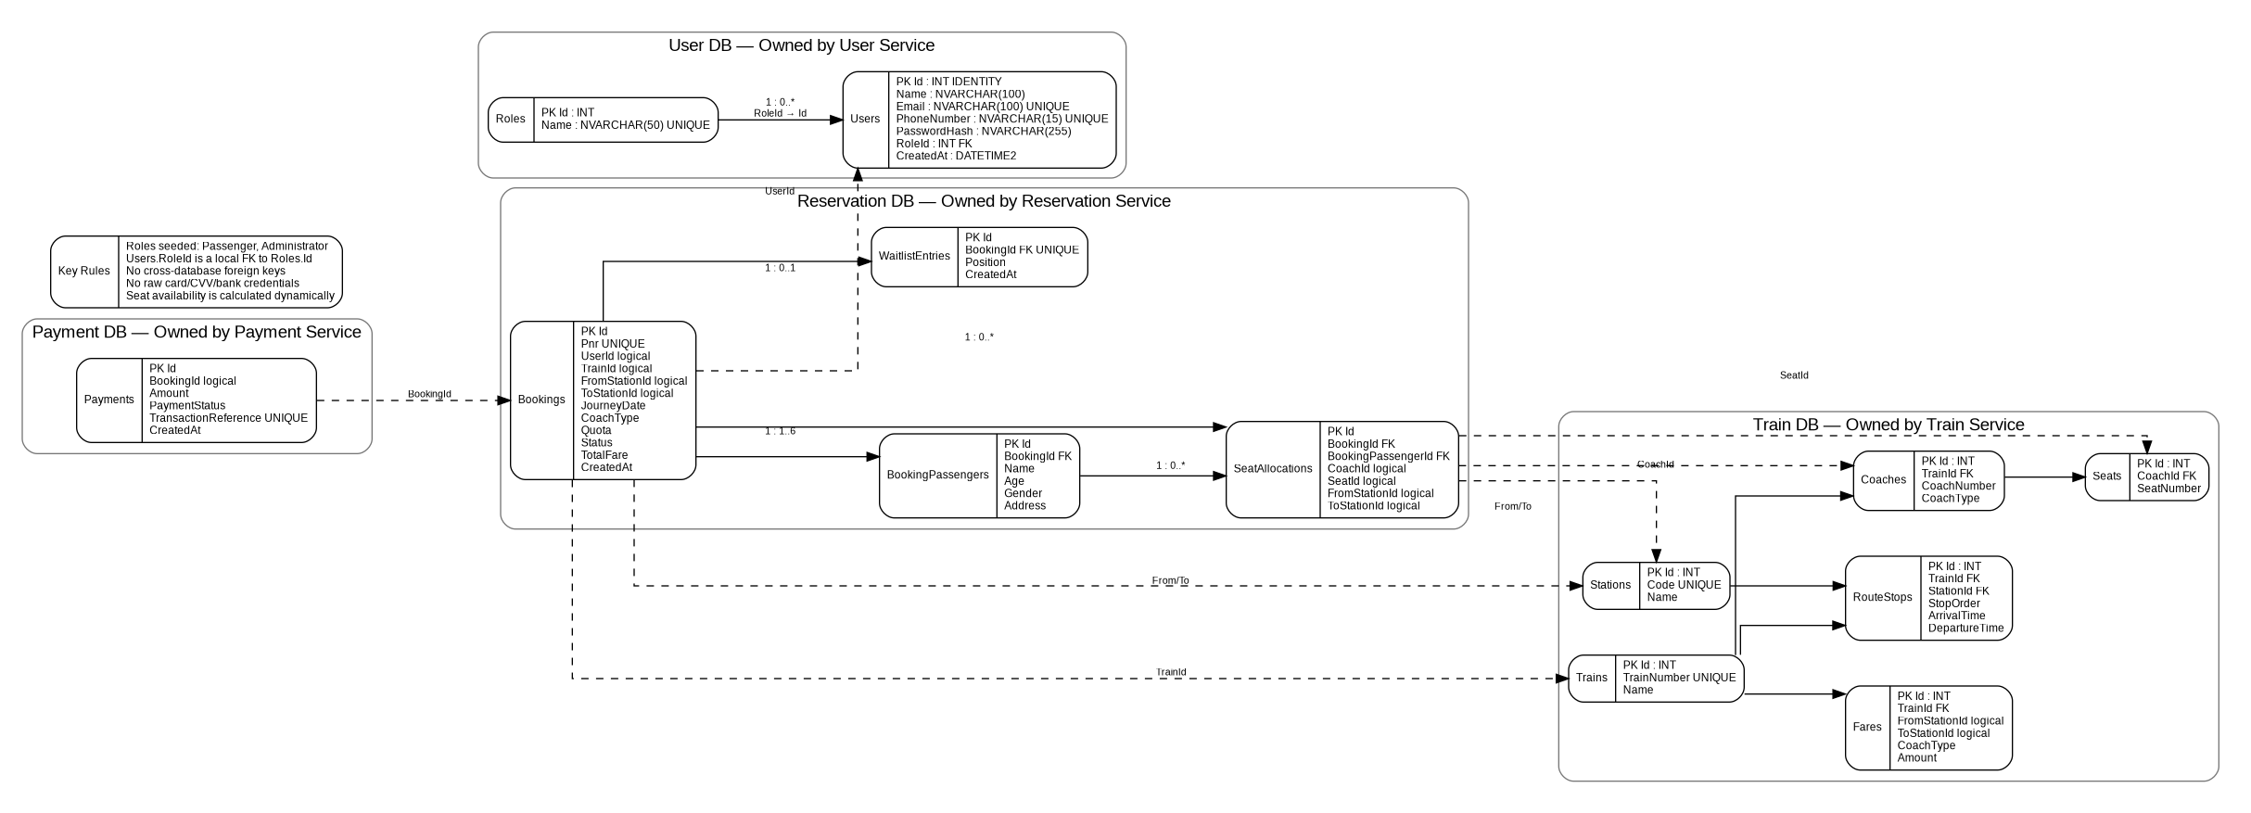
Figure 4. Database Architecture (D4).
User, Train, Reservation and Payment services each own a separate database. Mail Service, API Gateway, Dummy Razorpay Gateway and SMTP Server do not have application databases in the current scope.

12. ER Diagram
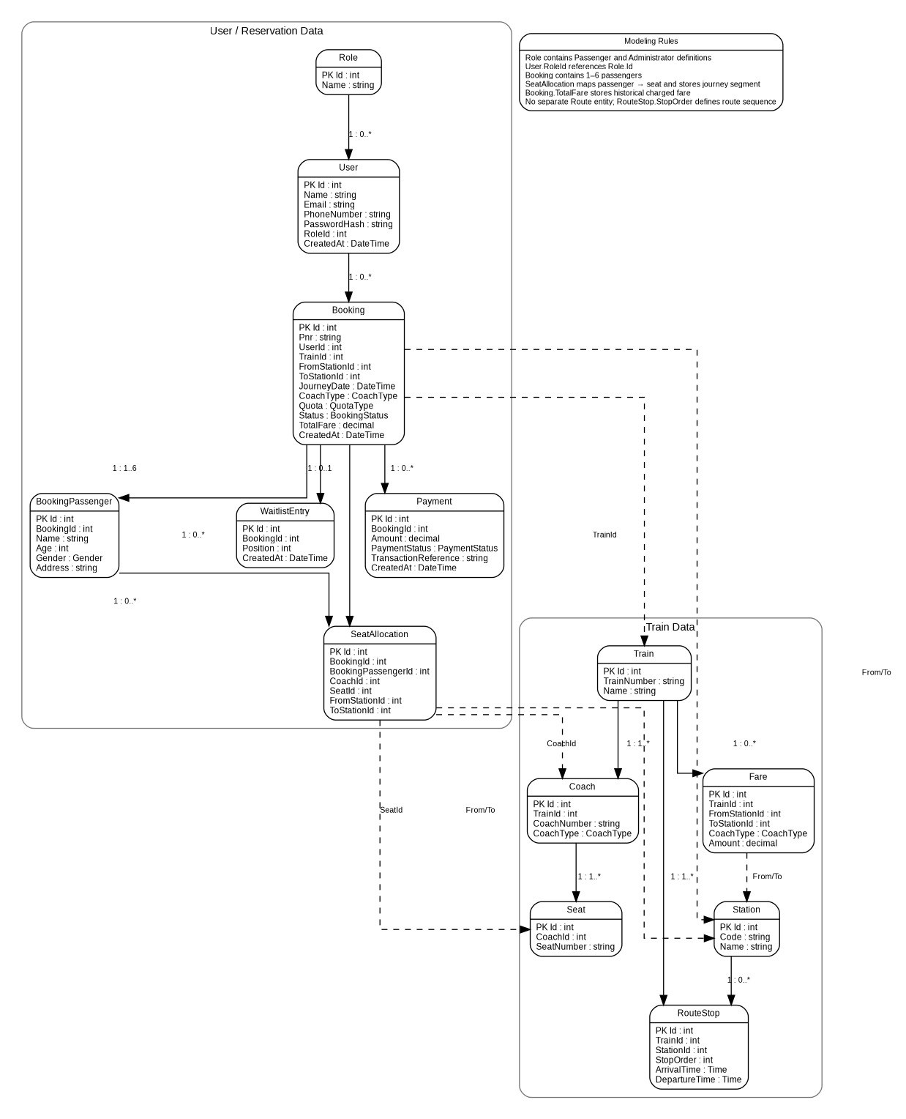
Figure 6. ER Diagram (D6).
The ER view reflects the finalized service-owned database model. The User DB contains Users and Roles, with Users.RoleId as a local foreign key to Roles.Id. Cross-service identifiers are logical references; only relationships within a service database are enforced with database foreign keys. Section 14 is authoritative for table definitions.

13. Data Model / Tables

13.1 User DB
User DB contains Users and Roles. Users.RoleId is a local foreign key to Roles.Id and Role.Name is unique. Initial roles are seeded as Passenger and Administrator. Normal registration assigns Passenger and does not accept a client-supplied RoleId.
Table | Column | Type | Constraints
Users | Id | INT | PK, Identity
Users | Name | NVARCHAR(100) | NOT NULL
Users | Email | NVARCHAR(100) | NOT NULL, UNIQUE
Users | PhoneNumber | NVARCHAR(15) | NOT NULL, UNIQUE
Users | PasswordHash | NVARCHAR(255) | NOT NULL
Users | RoleId | INT | NOT NULL, FK → Roles.Id
Users | CreatedAt | DATETIME2 | NOT NULL
Roles | Id | INT | PK, Identity
Roles | Name | NVARCHAR(50) | NOT NULL, UNIQUE

13.2 Train DB
Table | Key Fields / Constraints
Trains | Id PK; TrainNumber UNIQUE; Name
Stations | Id PK; Code UNIQUE; Name
RouteStops | Id PK; TrainId FK; StationId FK; StopOrder UNIQUE per Train; ArrivalTime; DepartureTime
Coaches | Id PK; TrainId FK; CoachNumber UNIQUE per Train; CoachType
Seats | Id PK; CoachId FK; SeatNumber UNIQUE per Coach
Fares | Id PK; TrainId/FromStationId/ToStationId; CoachType; Amount; unique composite key

13.3 Reservation DB
Table | Key Fields / Constraints
Bookings | Id PK; Pnr UNIQUE; UserId/TrainId/stations logical refs; JourneyDate; CoachType; Quota; Status; TotalFare; CreatedAt; UpdatedAt; CancelledAt
BookingPassengers | Id PK; BookingId FK; Name; Age; Gender; Address
SeatAllocations | Id PK; BookingId FK; BookingPassengerId FK; CoachId/SeatId/stations logical refs; segment-based allocation
WaitlistEntries | Id PK; BookingId FK UNIQUE; Position; CreatedAt

13.4 Payment DB
Table | Key Fields / Constraints
Payments | Id PK; BookingId logical ref; Amount; PaymentStatus; TransactionReference UNIQUE; IdempotencyKey UNIQUE; CreatedAt; no raw card/CVV/bank credentials

14. HTTP Status Codes
Status | Usage
200 | Successful GET/PUT/cancellation.
201 | Registration or booking created, including Waitlisted booking.
204 | Optional success with no body.
400 | Validation or invalid business input.
401 | Missing/invalid JWT.
402 | Payment failed.
403 | Insufficient permissions.
404 | Resource not found.
409 | Duplicate, invalid state or concurrency conflict.
500 | Unexpected server error.
503 | Required downstream service unavailable.

Global Exception Middleware
Each HTTP-facing ASP.NET Core application registers GlobalExceptionMiddleware early in the request pipeline, before authentication/authorization and endpoint execution, so it wraps downstream middleware and application services. It catches unhandled/application exceptions, logs them with a trace identifier, maps known exceptions to the standard HTTP status codes in Section 20.2, and returns ErrorResponse without exposing stack traces or sensitive implementation details. Business outcomes such as payment failure or a normal waitlist decision remain application-service behavior and are not implemented as middleware behavior.
Exception | HTTP
ValidationException | 400
NotFoundException | 404
UnauthorizedException | 401
ForbiddenException | 403
ConflictException | 409
ExternalServiceException | 503
Unhandled exception | 500

Stack traces and internal implementation details are not returned to API clients. Global Exception Middleware logs exception details with a trace identifier and returns the standardized ErrorResponse.

15. Unit Testing (NUnit)
Testing framework: NUnit. Moq (or equivalent mocking support) may be used for mocked dependencies.
UserService.Tests
TrainService.Tests
ReservationService.Tests
PaymentService.Tests
MailService.Tests
ApiGateway.Tests (where gateway authorization/middleware behavior is covered)
DummyRazorpayGateway.Tests (where gateway behavior is covered)
Service | Priority Tests
User | Registration, duplicate email/phone, login, password hashing and JWT.
Train | Search, public route/schedule and fare lookup; admin CRUD.
Reservation | Validation, segment overlap, all-or-nothing, payment, waitlist FIFO, promotion, cancellation, concurrency and notification triggering.
Payment | Success, failure, refund, idempotency and Dummy Razorpay integration behavior.
Mail | Template selection, SMTP success/failure and notification request handling.
API Gateway | JWT validation, Passenger/Administrator authorization and middleware error handling.

