**Atul Kumar Maurya**

**(Physics , Exp- 3Years, JEE and NEET)**

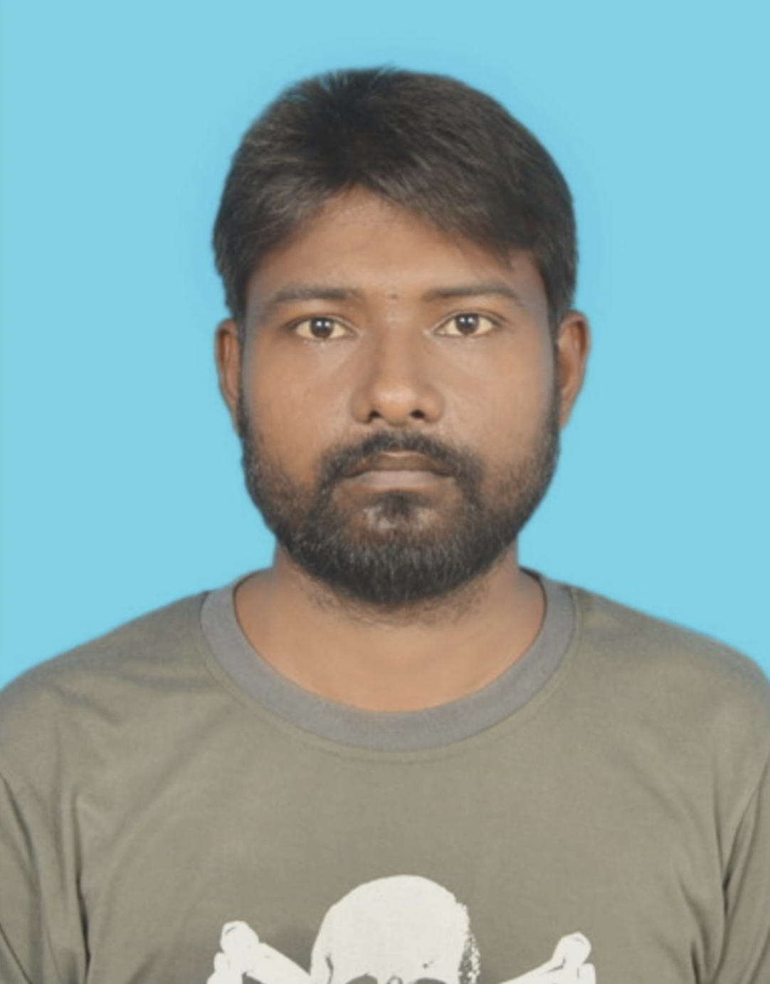**atulmaurya.rkgit@gmail.com**

+91 8373992899

**CAREER OBJECTIVE**

To build career in teaching profession for JEE Mains and NEET to help and motivate students in achieving their goals through my best knowledge and efforts.

**SKILLS**

Classroom Management

Students Motivation

Hard Working

Flexible

**EXPERIENCE**

Jul 2023 - current - JEE Mains and NEET

(Physics)

May 2022 - May 2023 - JEE Mains and NEET

Jul 2021 - May 2022 - D.D Academy Jalalpur(UP)

**EDUCATION**

**Degree/Course Year of passing Percent**

B.Tech ( Computer science and engineering). 2017 69%

R.K.G.I.T Ghaziabad

Intermediate 2011 68%

N.D.I.C Jalalpur Ambedkar Nagar

High school 2009 75%

N.D.I.C Jalalpur Ambedkar Nagar

**PERSONAL DETAILS**

Address Ayodhya, Uttar Pradesh, 224149

Date of Birth 01/08/1996

Gender Male

Languages Known Hindi, English