1. **ReactJS-HOL**

**I have already installed NodeJS in my system**

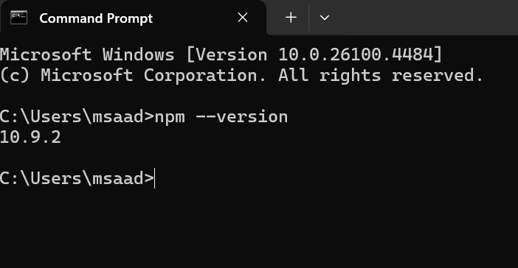

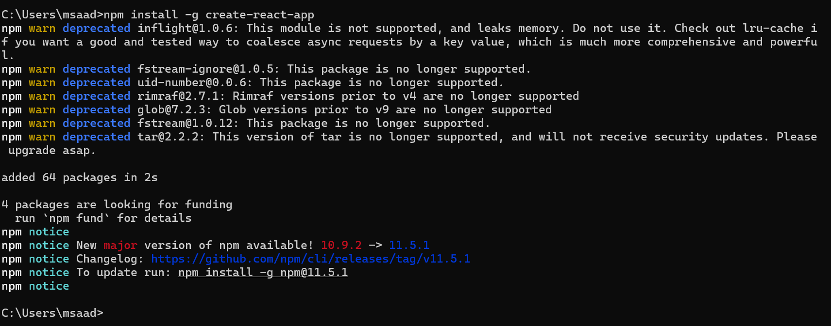

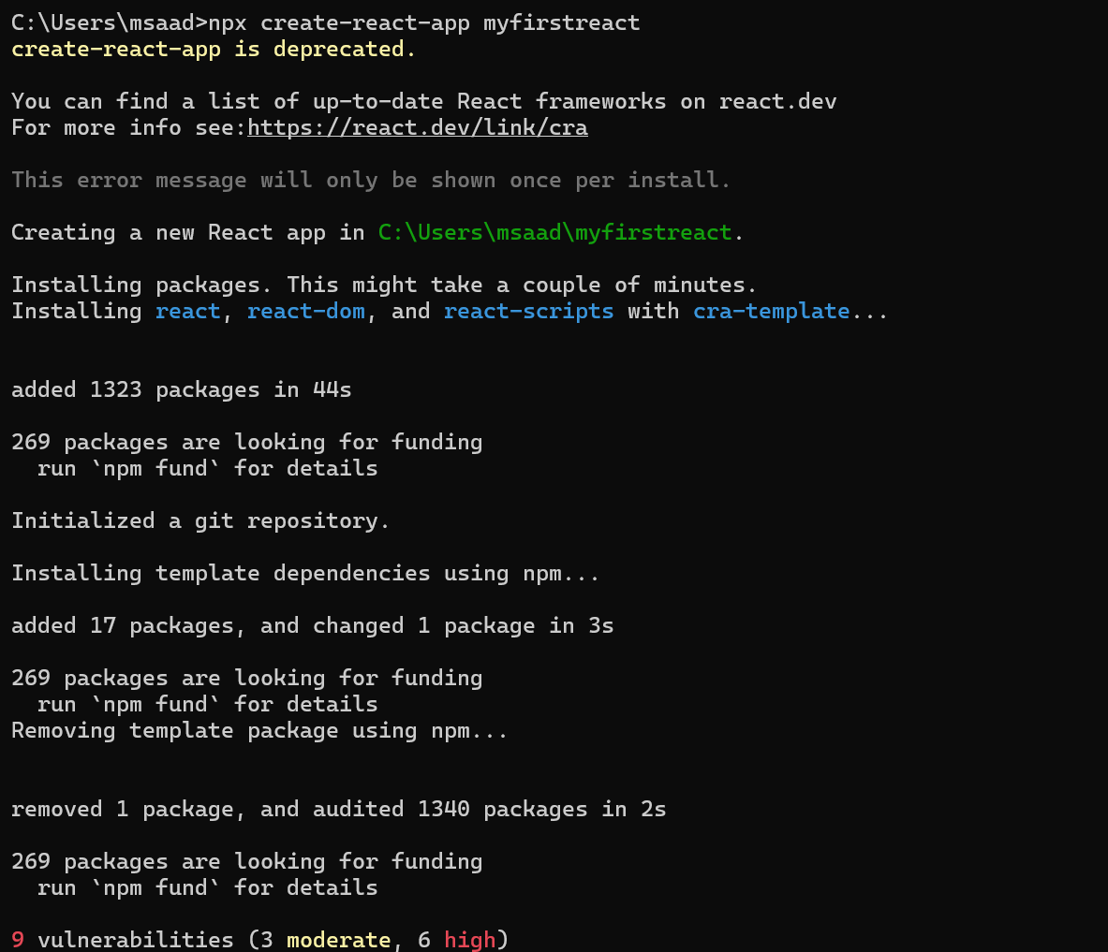

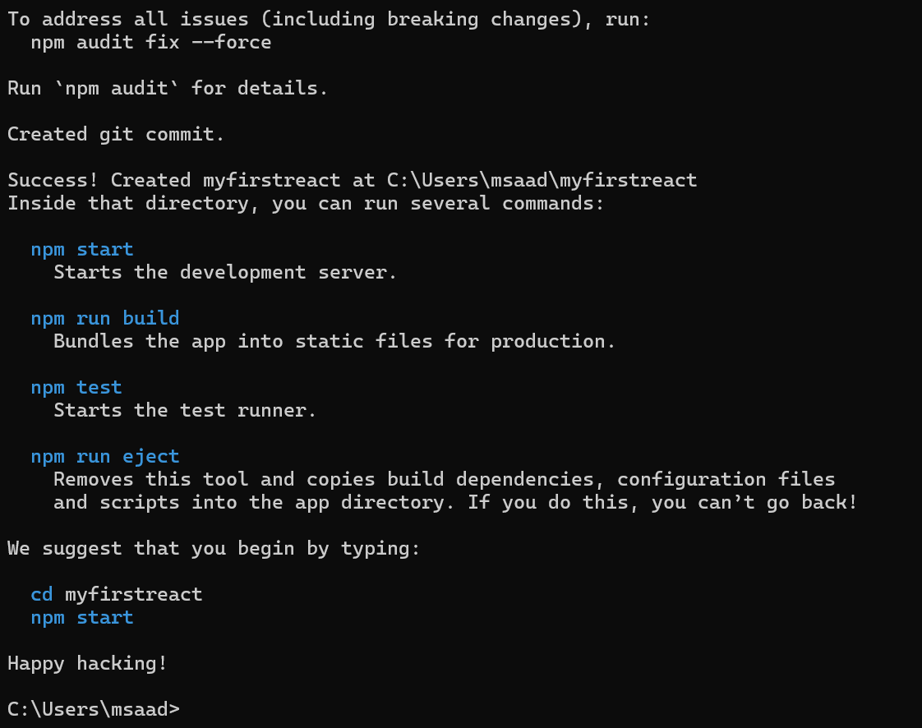

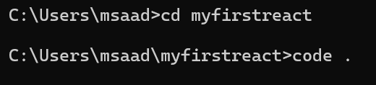

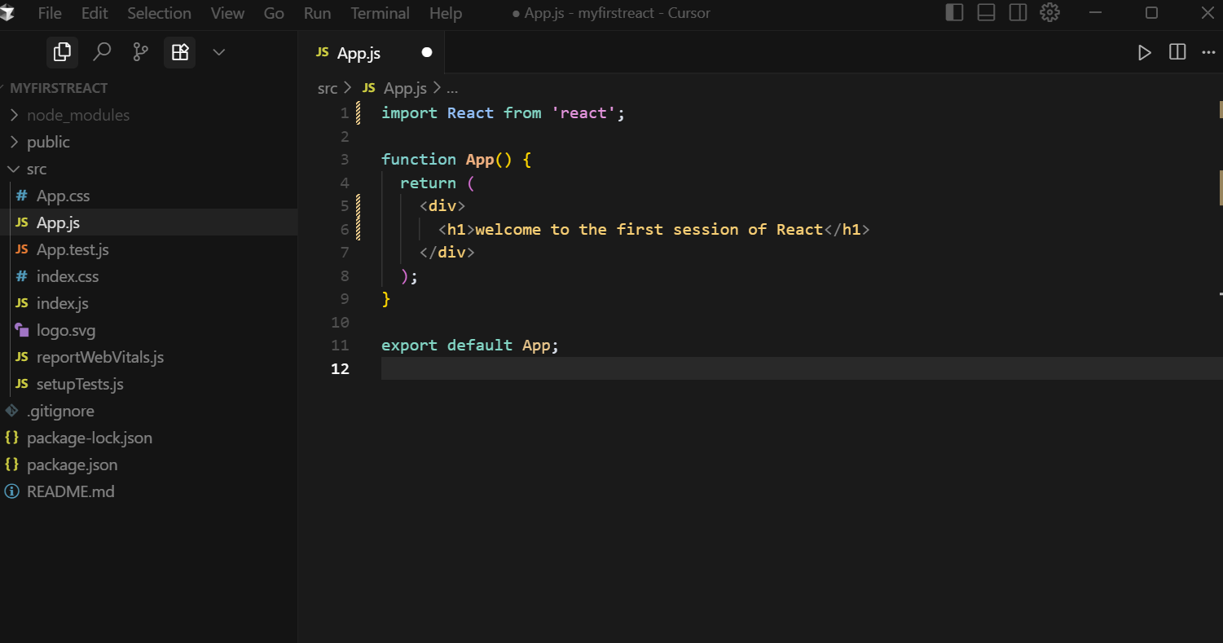

**Output**

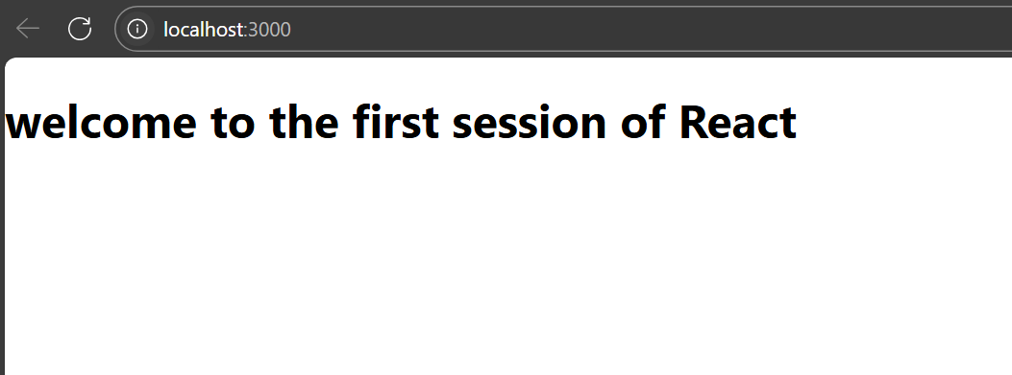

1. **ReactJS-HOL**

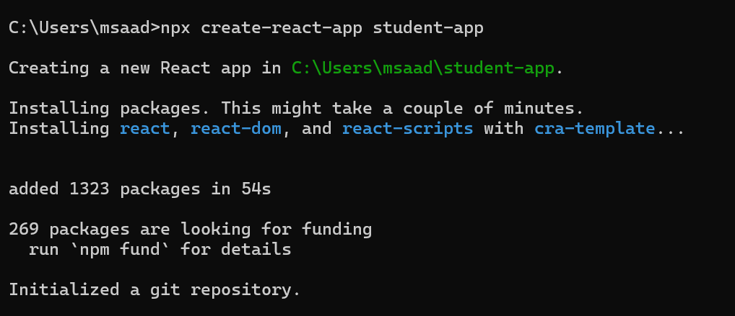

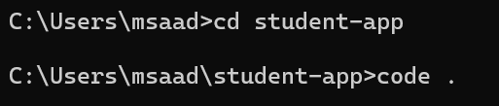

**Folder Structure:**

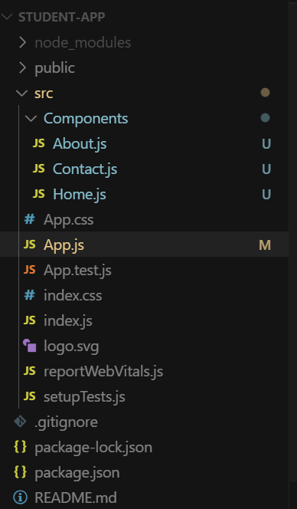

**Home.js**

import React from 'react';

class Home extends React.Component {

  render() {

    return (

      <div>

        <h2>Welcome to the Home page of Student Management Portal</h2>

      </div>

    );

  }

}

export default Home;

**About.js**

import React from 'react';

class About extends React.Component {

  render() {

    return (

      <div>

        <h2>Welcome to the About page of the Student Management Portal</h2>

      </div>

    );

  }

}

export default About;

**Contact.js**

import React from 'react';

class Contact extends React.Component {

  render() {

    return (

      <div>

        <h2>Welcome to the Contact page of the Student Management Portal</h2>

      </div>

    );

  }

}

export default Contact;

**App.js**

import React from 'react';

import Home from './Components/Home';

import About from './Components/About';

import Contact from './Components/Contact';

function **App**() {

  return (

    <div>

      <Home />

      <About />

      <Contact />

    </div>

  );

}

export default App;

**Output:**

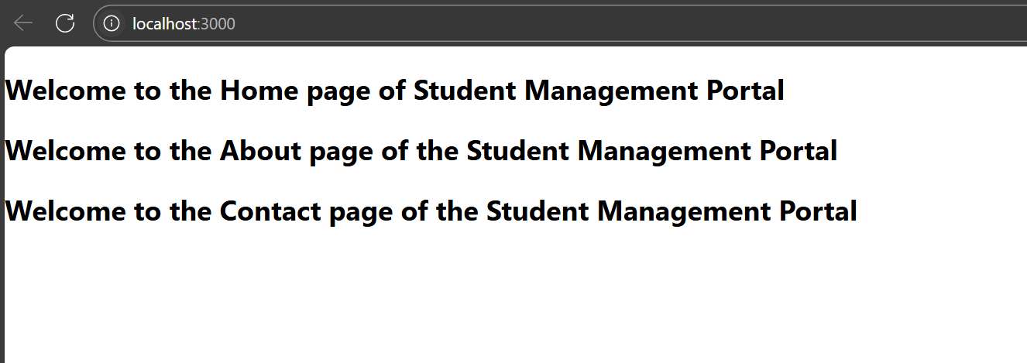

**3. ReactJS-HOL**

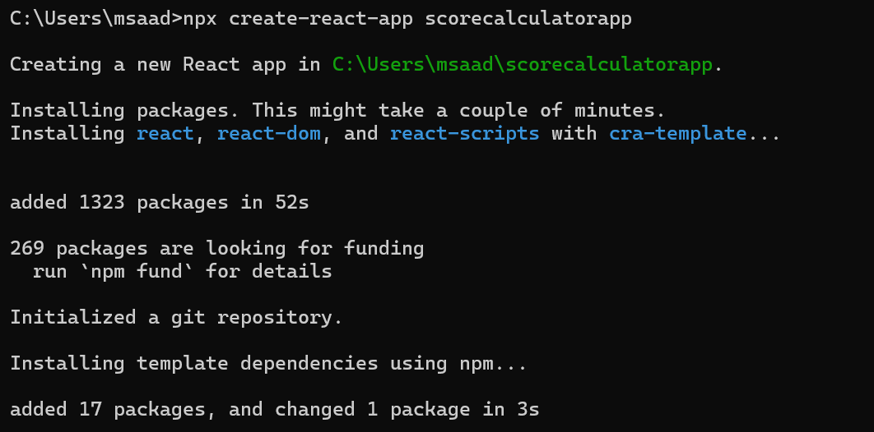

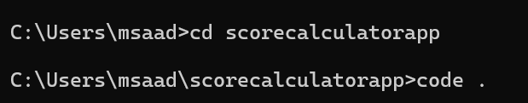

**Folder Structure:**

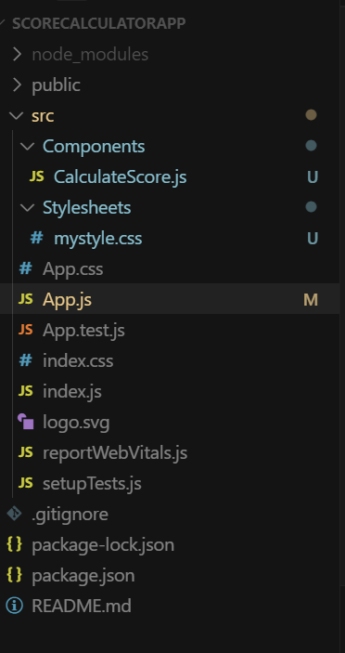

**CalculateScore.js**

import React from 'react';

import '../Stylesheets/mystyle.css';

function CalculateScore(*props*) {

  const average = *props*.total / *props*.goal;

  return (

    <div *className*="container">

      <h2>Student Score Calculator</h2>

      <p><strong>Name:</strong> {*props*.name}</p>

      <p><strong>School:</strong> {*props*.school}</p>

      <p><strong>Total Marks:</strong> {*props*.total}</p>

      <p><strong>Goal:</strong> {*props*.goal}</p>

      <p><strong>Average Score:</strong> {average}</p>

    </div>

  );

}

export default CalculateScore;

**mystyle.css**

.container {

    width: 50%;

    margin: 30px auto;

    padding: 20px;

    border: 2px solid #4CAF50;

    border-radius: 10px;

    background-color: #f9f9f9;

    font-family: Arial, sans-serif;

  }

  h2 {

    color: #4CAF50;

    text-align: center;

  }

  p {

    font-size: 16px;

  }

**App.js**

import React from 'react';

import CalculateScore from './Components/CalculateScore';

function **App**() {

  return (

    <div>

      <CalculateScore *name*="Mohammed Saad" *school*="ABC Public School" *total*={450} *goal*={5} />

    </div>

  );

}

export default App;

**Output:**

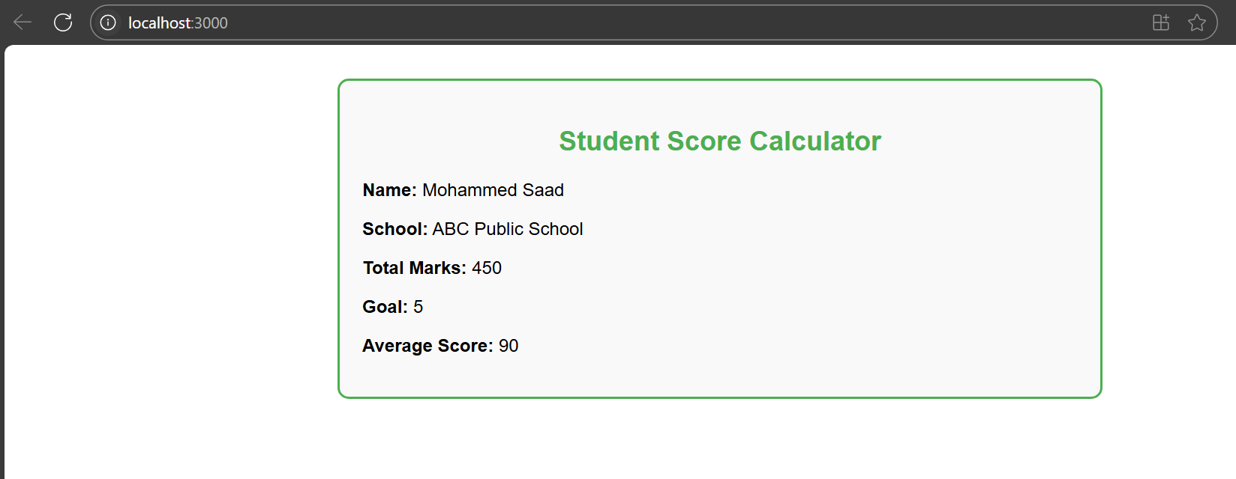

**4. ReactJS-HOL**

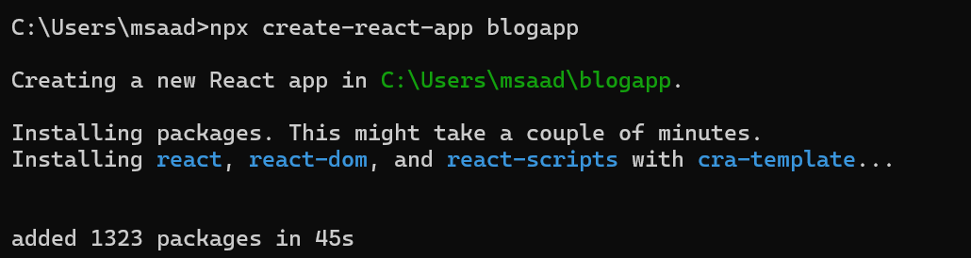

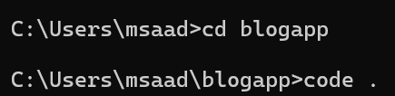

**Folder Structure:**

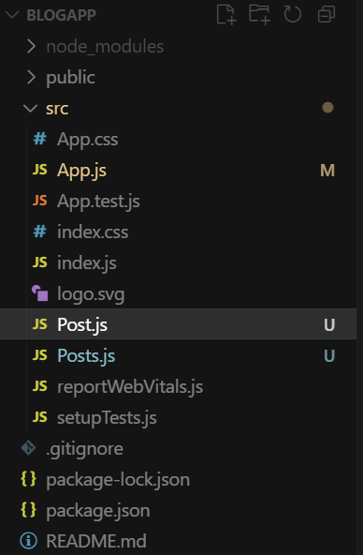

**Post.js**

class Post {

    constructor(*userId*, *id*, *title*, *body*) {

      this.userId = *userId*;

      this.id = *id*;

      this.title = *title*;

      this.body = *body*;

    }

  }

  export default Post;

**Posts.js**

import React, { Component } from 'react';

import Post from './Post';

class Posts extends Component {

  constructor(*props*) {

*super*(*props*);

    this.state = {

      posts: [],

      hasError: false

    };

  }

*// Fetching posts from API*

**loadPosts** = () => {

    fetch('https://jsonplaceholder.typicode.com/posts')

      .then((*response*) => *response*.json())

      .then((*data*) => {

        const loadedPosts = *data*.map(

          (*item*) => new Post(*item*.userId, *item*.id, *item*.title, *item*.body)

        );

        this.setState({ posts: loadedPosts });

      })

      .catch((*error*) => {

        this.setState({ hasError: true });

        console.error('Error fetching posts:', *error*);

      });

  };

*// Called after component mounts*

**componentDidMount**() {

    this.loadPosts();

  }

*// Catch rendering errors*

**componentDidCatch**(*error*, *info*) {

    alert('An error occurred while rendering posts.');

    console.error(*error*, *info*);

  }

**render**() {

    return (

      <div>

        <h2>Blog Posts</h2>

        {this.state.hasError ? (

          <p *style*={{ color: 'red' }}>Failed to load posts.</p>

        ) : (

          this.state.posts.map((*post*) => (

            <div *key*={*post*.id}>

              <h3>{*post*.title}</h3>

              <p>{*post*.body}</p>

            </div>

          ))

        )}

      </div>

    );

  }

}

export default Posts;

**App.js**

import React from 'react';

import Posts from './Posts';

function **App**() {

  return (

    <div *className*="App">

      <Posts />

    </div>

  );

}

export default App;

**Output:**

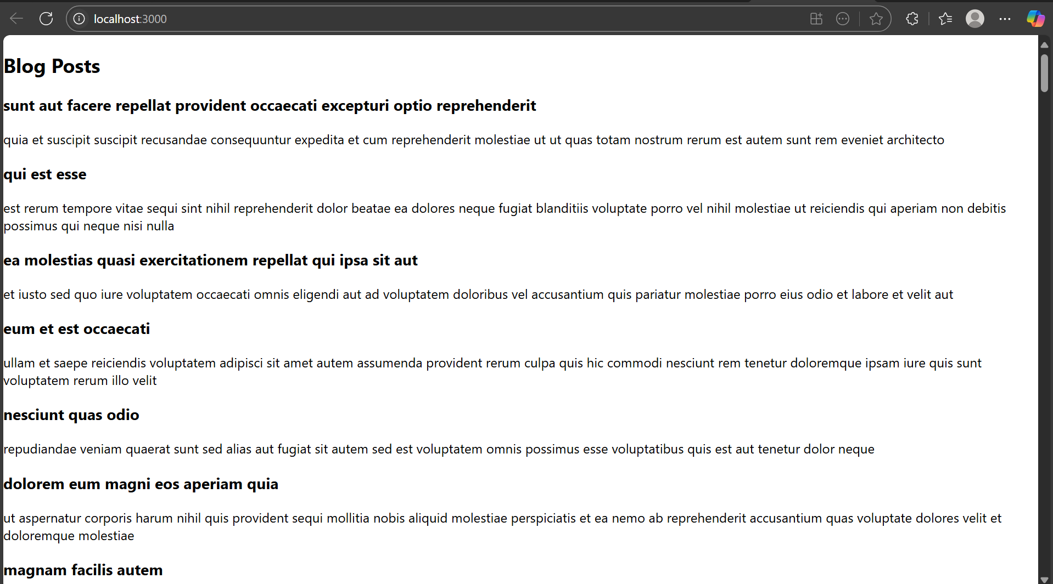

**5. ReactJS-HOL**

**I am unable to download the react .zip file as it is missing in the document, so I will be building it from scratch**

**Folder Structure:**

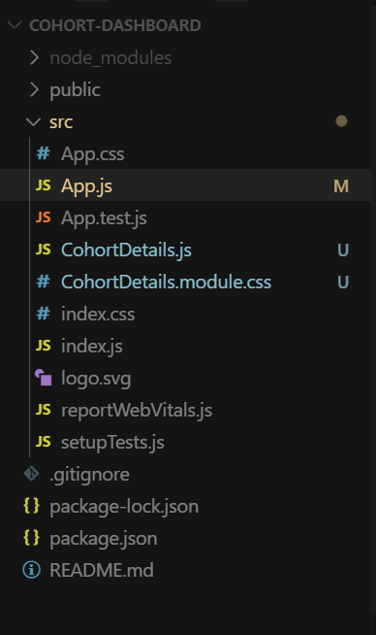

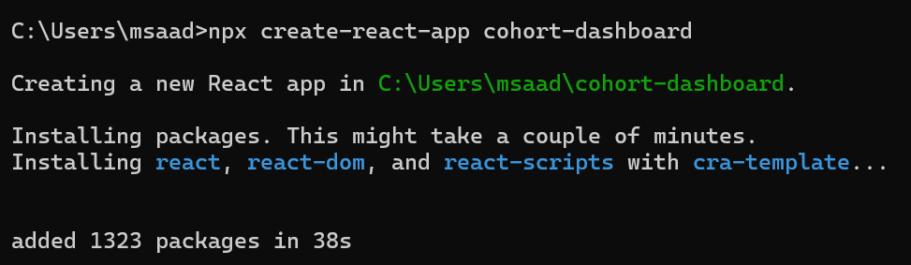

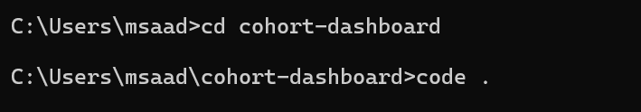

**Folder Structure:**

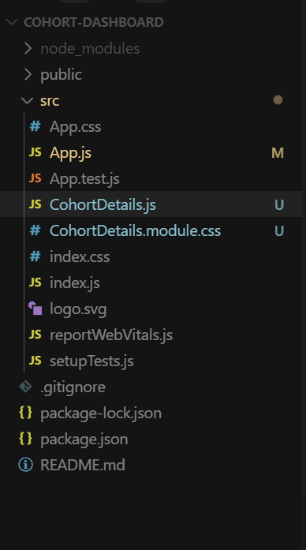

**CohortDetails.js**

import React from 'react';

import styles from './CohortDetails.module.css';

const CohortDetails = ({ *name*, *trainer*, *status* }) => {

  const statusStyle = {

    color: *status*.toLowerCase() === 'ongoing' ? 'green' : 'blue'

  };

  return (

    <div *className*={styles.box}>

      <h3 *style*={statusStyle}>{*name*}</h3>

      <dl>

        <dt>Trainer:</dt>

        <dd>{*trainer*}</dd>

        <dt>Status:</dt>

        <dd>{*status*}</dd>

      </dl>

    </div>

  );

};

export default CohortDetails;

**CohortDetails.module.css**

.box {

    width: 300px;

    display: inline-block;

    margin: 10px;

    padding: 10px 20px;

    border: 1px solid black;

    border-radius: 10px;

  }

  dt {

    font-weight: 500;

  }

**App.js**

import React from 'react';

import CohortDetails from './CohortDetails';

function App() {

  return (

    <div>

      <CohortDetails *name*="React Bootcamp" *trainer*="John Doe" *status*="ongoing" />

      <CohortDetails *name*="Java Spring Batch" *trainer*="Jane Smith" *status*="completed" />

    </div>

  );

}

export default App;

**Output:**



